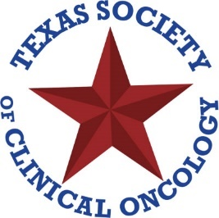

The Texas Society of Clinical Oncology (TxSCO) invites fellows, residents, and medical students with an interest in oncology to submit an abstract for presentation at the 2025 TxSCO Annual Conference, taking place Friday, September 19 through Saturday, September 20, 2025, at The Westin Galleria Houston.

Four (4) top abstracts will be selected by the committee for oral presentation to oncology professionals from across the state. First authors of these winning abstracts will be invited to attend the conference, with travel expenses covered, and will each receive a monetary award of up to $1,500. In addition, all accepted first authors awarded will have the opportunity to display their research poster at the conference, with travel expenses also covered.

Eligibility: First authors must be currently residing and training in the state of Texas. Only one submission per first author is permitted.

Deadline: Abstracts must be submitted electronically by Friday, July 18, 2025, at txsco2025.exordo.com.
Note: You will be prompted to create a free account to submit your abstract if you haven’t done so previously.

Abstract categories may address the myriads of issues facing oncology and can be previously evaluated. One submission per first author. Suggested topics are, but not limited to:

● | Medical Oncology | ● | Hematology | ● | Radiation Oncology
● | Surgical Oncology | ● | Palliative Care | ● | Neuro-Oncology
● | Survivorship | ● | Clinical Trials/Interventions | ● | Retrospective Chart Review
● | Developmental Therapeutics | ● | Pediatric Oncology/Hematology or Bone Marrow Transplantation as a modality | ● | Pilot Studies

Submission Instructions

- Abstracts are limited to 250 words, excluding spaces, authors, and institutions.
- The title should include significant words reflecting the content but should not reference results or conclusions. Avoid proprietary names in the title or body. If necessary, list the proprietary name in parentheses after the generic name on first use.
- Spell out terms on first use, placing abbreviations in parentheses. Abbreviations may be used throughout the remainder of the abstract. Please ensure chemotherapy regimens are accurately detailed.
- Include:
  - Disclosures
  - Full name, institution, address, phone number, and email
  - Names and institutions of all co-authors

As the first author/presenter, you will receive all correspondence from TxSCO. Please confirm that all co-authors are aware of and support the abstract’s contents.

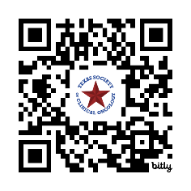
Abstracts will be judged solely on the data provided. Phrases such as “further data will be available” are discouraged.

Questions? Email Amanda Impellizzeri at aimpellizzeri@accc-cancer.org

