**SUPPLEMENT.**

**FIGURE S1.**

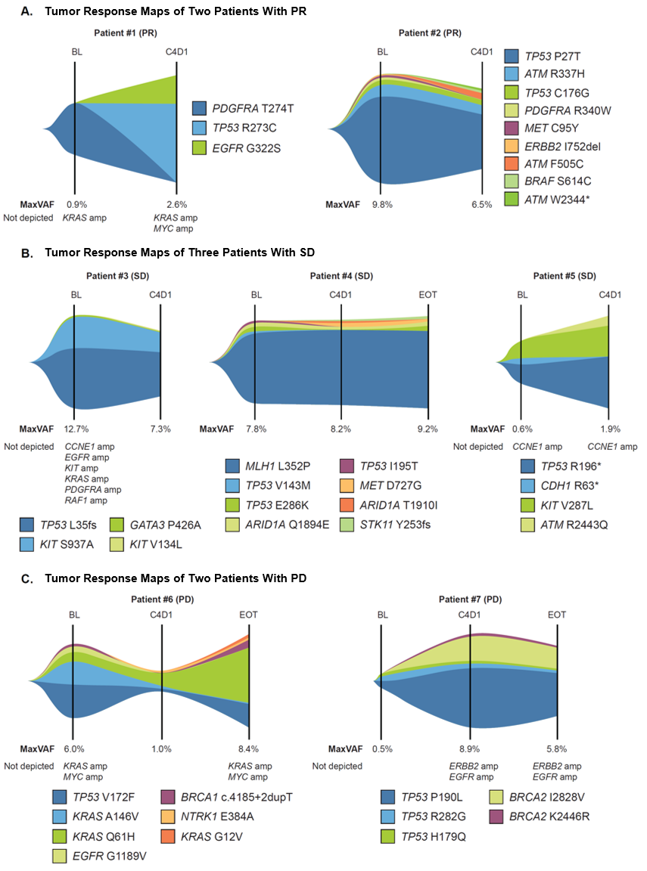

**FIGURE S1.** **Longitudinal ctDNA Fraction From 7 Patients With *ERBB2* Amplification–Negative Disease With Long Treatment Duration**

Pretreatment (baseline), on-treatment (C4D1), and end-of-treatment blood collection time points for Guardant360 ctDNA analysis are shown, with corresponding ctDNA maxVAF for 2 patients with PR (A), 3 patients with SD (B), and 2 patients with PD (C). Overall plot size represents the maxVAF at each time point. Each color and plot size represents an individual somatic variant detected and VAF at each time point. Note: the asterisk denotes a stop codon.

amp, amplification; BOR, best overall response; C4D1, cycle 4 day 1; CBR, clinical benefit rate; cfDNA, cell-free DNA; CR, confirmed response; ctDNA, circulating tumor DNA; *ERBB2,* erythroblastic oncogene B2; maxVAF, maximal variant allele frequency; PD, progressive disease; PR, partial response; SD, stable disease; TL, target lesion.

**Figure S2. Distribution of *ERBB2* Variants Detected in ctDNAa**



aPlot generated from cumulative data. All somatic *ERBB2* SNVs/indels are shown.

†Other includes 4 silent mutations (synonymous variants) and 3 deletions in splice regions, with no corresponding changes in protein sequence.

ctDNA, circulating tumor DNA; *ERBB2*, erythroblastic oncogene B2; indel, insertion-deletion; SNV, single nucleotide variant; SV, structural variant.

**SUPPLEMENT TABLE.** Additional Details on the 7 Patients Included in the Longitudinal Analysis Shown in **Figure S1**

| **Patient ID (BOR)** | **Best Target Lesion Change** | **Comments** |
| --- | --- | --- |
| Patient 1 (PR) | −33% | * Low ctDNA at baseline is generally associated with good prognosis * Net increase in ctDNA at C4D1 observed but with low mutant molecule count owing to low cfDNA yield (<5 ng) and low ctDNA maxVAF at baseline and C4D1; may suggest low-shedding/slow-growing tumors * Apparent net increase in ctDNA at C4D1 should be viewed with caution, as C4D1 sample input was below range supported for clinical ctDNA testing * EOT not tested |
| Patient 2 (PR) | −70% | * Net decrease in ctDNA at C4D1 is suggestive of treatment response * EOT not tested |
| Patient 3 (SD) | 0 | * Net decrease in ctDNA at C4D1 is suggestive of treatment response * EOT not tested |
| Patient 4 (SD) | +2.3% | * Minimal net change in ctDNA from baseline through EOT is consistent with SD |
| Patient 5 (SD) | −6% | * Low ctDNA at baseline is generally associated with good prognosis * Minimal net change in ctDNA at C4D1 consistent with benefit; low maxVAF at baseline and C4D1 may suggest low-shedding/slow-growing tumors * EOT not tested |
| Patient 6 (PD) | −41% | * Net decrease in ctDNA at C4D1 is suggestive of initial treatment response * Subclonal *KRAS* Q61H detected at baseline became dominant clone by EOT * Presence of *KRAS* activating variants is generally associated with worse prognosis * High ctDNA at EOT is associated with PD |
| Patient 7 (PD) | −10% | * *ERBB2* amp not detected at baseline but detected at C4D1 and EOT * Net increase in ctDNA at C4D1 is suggestive of no initial response * Subclonal *TP53* P190L detected at baseline became dominant clone by C4D1, but VAFs of other known oncogenic variants remained low (<1%), suggesting low-shedding/slow-growing tumors * Net increase in ctDNA by EOT is associated with PD |
| Collective | CBR 71.4% (5/7) | * 7 patients tested for ctDNA at C4D1, 3 patients of 7 tested at EOT * Net decrease or minimal net change in ctDNA from baseline to C4D1 is suggestive of initial treatment response in 4 patients * Subclonal *KRAS* and *TP53* SNVs at baseline emerged as dominant clones by EOT for 2 patients with PD |

amp, amplification; BOR, best overall response; C4D1, cycle 4 day 1; cfDNA, cell-free DNA; ctDNA, circulating tumor DNA; EOT, end of treatment; *ERBB2*, erythroblastic oncogene B2; maxVAF, maximal tumor somatic VAF; SD, stable disease; SNV, single nucleotide variant; VAF, variant allele frequency.

**List of genes tested in the Guardant360® panel**

**Single nucleotide variants** (73 genes): *AKT1, ALK, APC, AR, ARAF, ARID1A, ATM, BRAF, BRCA1, BRCA2, CCND1, CCND2, CCNE1, CDH1, CDK4, CDK6, CDKN2A, CTNNB1, DDR2, EGFR, ERBB2 (HER2), ESR1, EZH2, FBXW7, FGFR1, FGFR2, FGFR3, GATA3, GNA11, GNAQ, GNAS, HNF1A, HRAS, IDH1, IDH2, JAK2, JAK3, KIT, KRAS, MAP2K1/MEK1, MAP2K2/MEK2, MAPK1/ERK2, MAPK3/ERK1, MET, MLH1, MPL, MTOR, MYC, NF1, NFE2L2, NOTCH1, NPM1, NRAS, NTRK1, NTRK3, PDGFRA, PIK3CA, PTEN, PTPN11, RAF1, RB1, RET, RHEB, RHOA, RIT1, ROS1, SMAD4, SMO, STK11, TERT, TP53, TSC1, VHL*

**Insertion-deletions** (23 genes): *ATM, APC, ARID1A, BRCA1, BRCA2, CDH1, CDKN2A, EGFR, ERBB2, GATA3, KIT, MET, MLH1, MTOR, NF1, PDGFRA, PTEN, RB1, SMAD4, STK11, TP53, TSC1, VHL*

**Amplifications** (18 genes): *AR, BRAF, CCND1, CCND2, CCNE1, CDK4, CDK6, EGFR, ERBB2, FGFR1, FGFR2, KIT, KRAS, MET, MYC, PDGFRA, PIK3CA, RAF1*

**Fusions** (6 genes): *ALK, FGFR2, FGFR3, NTRK1, RET, ROS1*

**Note**: All cycle 1, day 1 (C1D1) samples were tested on Guardant360 (v2.10), corresponding to the gene list shown. All C4D1 and end-of-treatment samples were provided at a later date and tested on Guardant360 (v2.11) based on the same gene list but with expanded coverage to detect point mutations in *CDK12* and amplifications in *ESR1*.

**Patient history**

**Patient 1**

Patient 1 was a man in his early 60s who received first-line trastuzumab with modified oxaliplatin + leucovorin calcium + fluorouracil (mFOLFOX6) for HER2 IHC3+ GEA. He entered the CP-MGAH22-05 study after PD on first-line treatment and received 32 cycles of margetuximab + pembrolizumab. After cycle 17, the patient experienced RECIST-confirmed PR. PFS based on radiographic assessment was 806 days. The patient died 10 months after study treatment discontinuation. The best RECIST response was confirmed PR (responder).

**Patient 2**

Patient 2 was a man in his late 70s who received 8 cycles of first-line trastuzumab with capecitabine and cisplatin for HER2 IHC3+ GEA. He entered the CP-MGAH22-05 study after PD on first-line treatment and received 26 cycles of margetuximab + pembrolizumab. After cycle 9, the patient experienced RECIST-confirmed PR; PFS based on radiographic assessment was 623 days. The patient died 3 months after study treatment discontinuation. The best RECIST response was confirmed PR (responder).

**Patient 3**

Patient 3 was a man in his late 40s who received gastrectomy for HER2 IHC3+ GEA and, after recurrence, received 9 cycles of trastuzumab and capecitabine together with 6 cycles of cisplatin as first-line treatment. After PD on first-line treatment, the patient entered study CP-MGAH22-05 and received 6 cycles of margetuximab + pembrolizumab. After cycle 3, he experienced SD based on RECIST; PFS based on radiographic assessment was 124 days. The patient died 6 months after study treatment discontinuation. The best RECIST response was SD (nonresponder).

**Patient 4**

Patient 4 was a man in his early 70s who received 4 cycles of leucovorin calcium + fluorouracil + irinotecan hydrochloride + oxaliplatin (FOLFIRINOX), radiation, and 19 cycles of trastuzumab maintenance for HER2 IHC3+ GEA. He entered the CP-MGAH22-05 study after PD on maintenance treatment and received 5 cycles of margetuximab + pembrolizumab. After cycle 3, the patient experienced SD based on RECIST; PFS based on radiographic assessment was 84 days. The patient died 4 months after study treatment discontinuation. The best RECIST response was SD (nonresponder).

**Patient 5**

Patient 5 was a woman in her late 60s who received neoadjuvant chemoradiation of carboplatin + paclitaxel with radiation for HER2 IHC2+/FISH+ GEA. After surgical resection, she received 5 cycles of first-line trastuzumab with mFOLFOX6, followed by maintenance trastuzumab. The patient entered the CP-MGAH22-05 study after PD on maintenance trastuzumab and received 8 cycles of margetuximab + pembrolizumab. After cycle 3, the patient experienced SD, based on RECIST; PFS based on radiographic assessment was 175 days. The patient died 8 months after study treatment discontinuation. The best RECIST response was SD (nonresponder).

**Patient 6**

Patient 6 was a man in his early 50s who received paclitaxel and carboplatin as neoadjuvant therapy and received surgical resection. The surgical specimen revealed HER2 IHC2+/FISH+ GEA. After disease recurrence, the patient received 6 cycles of first-line trastuzumab with capecitabine and oxaliplatin, followed by 12 cycles of maintenance trastuzumab. After PD on maintenance treatment consisting of 4 cycles of second-line trastuzumab plus 5-FU infusion, he entered the study. In the CP-MGAH22-05 study, the patient received 10 cycles of margetuximab + pembrolizumab. After cycle 3, the patient experienced radiographic PD, but the patient stayed clinically stable and received 6 more cycles of study treatment beyond PD. PFS based on radiographic assessment was 49 days and study treatment duration was 218 days. The patient died 1 year after study treatment discontinuation. The best RECIST response was PD (nonresponder).

**Patient 7**

Patient 7 was a man in his early 50s who received 9 cycles of first-line trastuzumab with capecitabine and oxaliplatin for HER2 IHC3+ GEA. He entered the CP-MGAH22-05 study after PD on first-line therapy and received 3 cycles of margetuximab + pembrolizumab. The patient discontinued the study treatment because of PD after cycle 4. The PFS based on radiographic assessment was 50 days. The patient died 4 months after study treatment discontinuation. The best RECIST response was PD (nonresponder).

**[Key - Patient history]**

5-FU, 5-fluorouracil; FISH, fluorescence in situ hybridization; GEA, gastroesophageal adenocarcinoma; IHC, immunohistochemistry; PD, progressive disease; PFS, progression-free survival; PR, partial response; SD, stable disease.