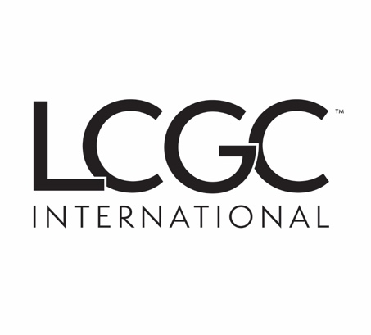 | 2024–2025 Survey of  New HPLC and Mass Spectrometry Systems, Modules, or Data Software

We will make all reasonable efforts to ensure the accuracy of published information, but LCGC International cannot be responsible for errors in or omissions from the information submitted on this form or by other means.

PLEASE NOTE: This survey is not limited only to new products that will be introduced at Pittcon 2025.
You may submit any product introduced since our 2024 coverage.
(One form per product: Maximum of 5 per company)

DEADLINE: Extended to March 8, 2025

Send the completed form to: jchasse@mjhlifesciences.com

Manufacturer:

Information Submitted by:
Title
Phone
E-Mail
Your booth number at Pittcon, if exhibiting:

Name of a product manager or other person who may be contacted with questions:
Title
Phone
E-Mail

Please provide a direct link to a webpage with information about the product submitted on this form:

Product Name and Type (HPLC, MS, CDS, etc.)
Literature Included? (y/n)
Please include a specification sheet and brochure if possible

Used for HPLC or UHPLC?

Description of system or component

Suggested applications of the system and/or component

Primary benefit(s) to the chromatographer (compared to current products)

Include relevant supporting data or chromatograms if appropriate.

Unique features worthy of mention

