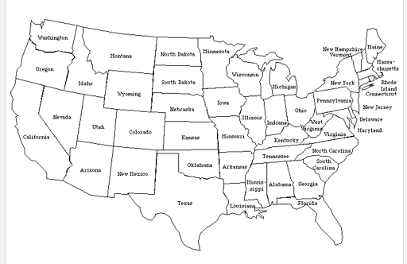

Employee Access to their personnel File by State.
Hawaii Alaska
Green - no Law
Red – Very specific law defining access – check your state’s website or the book website (http://www.wbsonline.com/resources/who-can-see-personnel-files/)

