Figure S1. Mean (SE) anticipatory and peak compensatory center of pressure (COP) displacements across all groups and conditions.

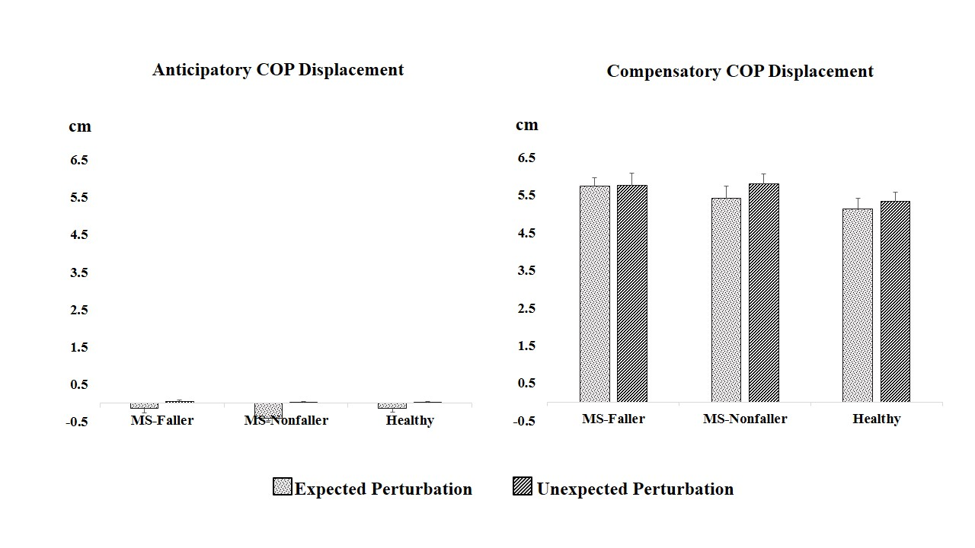

Table S1. Onsets of muscle activity in MS faller, MS nonfaller, and control groups in expected and unexpected conditions
Unexpected |  |  |  | Expected
 | Control  (n=15) | MS nonfaller  (n=17) | MS faller  (n=17) |  | Control  (n=15) | MS nonfaller  (n=17) | MS faller  (n=17)
 | 114.22 ± 6.28 | 88.43 ± 10.06 | 134.15 ± 7.49 |  | -55.69 ± 4.72 | -40.86 ± 6.22 | -24.70 ± 4.77 |  | RA_{r}
 | 111.34 ± 6.58 | 104.78 ± 8.25 | 128.49 ± 10.27 |  | -52.18 ± 4.22 | -42.31 ± 6.00 | -30.91 ± 5.44 |  | RA_{l}
 | 105.06 ± 8.08 | 114.57 ± 9.20 | 121.34 ± 7.48 |  | -58.04 ± 8.11 | -41.11 ± 8.54 | -4.00 ± 10.13 |  | ES_{r}
 | 108.89 ± 8.96 | 117.41 ± 6.81 | 124.79 ± 11.63 |  | -59.88 ± 8.60 | -45.74 ± 7.47 | -21.73 ± 9.65 |  | ES_{l}
 | 112.19 ± 3.69 | 134.14 ± 7.11 | 143.66 ± 3.90 |  | -42.34 ± 3.86 | -25.08 ± 5.24 | -12.63 ± 4.63 |  | RF_{r}
 | 108.14 ± 3.84 | 126.79 ± 9.37 | 146.55 ± 5.77 |  | -39.88 ± 2.56 | -20.48 ± 5.17 | -1.58 ± 6.89 |  | RF_{l}
 | 114.09 ± 4.86 | 135.89 ± 5.29 | 143.93 ± 6.41 |  | -36.59 ± 3.06 | -30.85 ± 6.44 | -10.11 ± 6.54 |  | BF_{r}
 | 120.52 ± 5.69 | 121.27 ± 6.46 | 137.86 ± 7.40 |  | -39.84 ± 6.67 | -34.74 ± 5.58 | -3.74 ± 8.18 |  | BF_{l}
 | 109.00 ± 5.36 | 136.89 ± 7.20 | 140.10 ± 4.61 |  | -40.59 ± 2.03 | -21.79 ± 5.41 | -13.20 ± 6.44 |  | TA_{r}
 | 111.17 ± 2.97 | 138.16 ± 5.65 | 139.48 ± 4.91 |  | -43.10 ± 3.11 | -22.76 ± 4.84 | -10.15 ± 6.94 |  | TA_{l}
 | 115.69 ± 4.88 | 107.13 ± 13.59 | 139.35 ± 7.81 |  | -52.55 ± 6.49 | -40.57 ± 5.73 | -27.07 ± 9.62 |  | MG_{r}
 | 110.20 ± 4.96 | 92.49 ± 11.21 | 136.53 ± 5.78 |  | -46.77 ± 5.78 | -39.81 ± 4.41 | -11.03 ± 7.22 |  | MG_{l}

Note: Data are given as mean ± SE.
Abbreviations: MS: multiple sclerosis; RA: rectus abdominis, ES: erector spinae, RF: rectus femoris, BF: biceps femoris, TA: tibialis anterior, MG: medial gastrocnemius.

