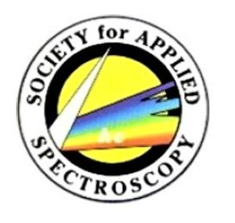
New York/New Jersey Section
Society for Applied Spectroscopy

NY/NJ SAS March 2021 Invitational Announcement

Date: Thursday March 18, 2021 Time: 12:00 – 1:00 pm EST (Login: 11:45 am EST)

Please join us on March 18, 2021 at 12 noon EST for two exciting presentations by Heinz Siesler and Marina de Gea Neves, from the University of Duisburg-Essen.

The titles of both presentations are as follows:

Marina de Gea Neves, Food Authentication and Classification Using Vibrational Spectroscopy in Tandem with Chemometrics Tools

Heinz Siesler, Handheld Near-Infrared Spectrometers: On-Site Quality Control and Protection against Product Counterfeiting

Please see below for additional information AND mark your calendars for these exciting talks!!!

NY/NJ SAS Meeting Information

Microsoft Teams meeting
Join on your computer or mobile app
Click here to join the meeting

Or call in (audio only)
+1 908-409-1059,,93048104# United States, Elizabeth

(833) 733-5876,,93048104# United States (Toll-free)

Phone Conference ID: 930 481 04# Audio for this meeting can be heard in the Microsoft Teams client. Please check your audio device settings before you join the call. If you see phone numbers above, you can use them to join the meeting’s audio if necessary.

