Press Release
23 January 2024
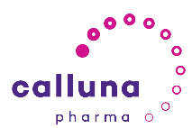
Calluna Pharma launches and announces EUR 75 million Series A financing to develop novel therapies for inflammatory and fibrotic diseases
- Clinical stage company formed from the merger of Oxitope Pharma and Arxx Therapeutics
- Calluna Pharma has a pipeline of selective antibodies targeting immunological diseases
- New company to complete multiple clinical proofs-of-concept, across programs
- Series A led by Forbion, with participation from Norwegian investors Sarsia, p53, and Investinor

Naarden, The Netherlands, and Oslo, Norway, 23 January 2024: Oxitope Pharma (Oxitope) and Arxx Therapeutics (Arxx), companies with a shared goal of leveraging the innate immune system to discover and develop disease modulating therapies, today announced their merger to form Calluna Pharma Inc. (Calluna). Calluna has raised EUR 75 million in a series A financing and is backed by Oxitope and Arxx’s existing lead investors, Forbion, Sarsia, p53, and Investinor. The new company will combine expertise in the field of innate immunity, based on damage-associated molecular patterns (DAMPs), with a pipeline of selective antibodies that target inflammatory and fibrotic indications, including several first-in-class clinical candidates.
Calluna is developing novel therapies that harness the transformative potential of the body's immune system. The Company’s unique approach involves precision targeting of upstream innate immune amplifiers, enabling disruption of a comprehensive range of disease-associated downstream signaling pathways while maintaining a favorable safety profile. As a result, Calluna has developed a robust pipeline of selective antibodies, targeting immunological diseases. These include novel therapeutic candidates that fulfil unmet clinical needs across a spectrum of diseases, driven by acute or chronic inflammation and non-resolving tissue fibrosis.
Calluna has four promising therapies in its pipeline. Its clinical stage lead program, CAL101, is a monoclonal antibody that neutralizes the bioactivity of S100A4, a DAMP protein implicated in serious and life-threatening diseases such as idiopathic pulmonary fibrosis, chronic kidney disease, systemic sclerosis, rheumatoid arthritis, and severe (steroid insensitive) asthma. Of particular interest is another of its programs, CAL102, a monoclonal antibody neutralizing oxidized phospholipids – these play a significant role in onset and progression of a wide range of acute and chronic inflammatory and fibrotic diseases. CAL102 demonstrated efficacy in several preclinical disease models.
John Montana, PhD., Chief Executive Officer of Calluna Pharma, commented: “In joining forces, these two key players in the innate immunology space have created an exciting new clinical company that has four promising therapies in its pipeline with excellent preclinical proof-of-concept data. By innovating beyond traditional treatment strategies, Calluna offers clinical candidates with superior efficacy, improved patient tolerance, and minimal adverse side effects which have real potential to redefine patient outcomes.”
Antoine Boulanger, PhD., Principal at Forbion, added: “The merger of Oxitope Pharma and Arxx Therapeutics to create Calluna Pharma is a prime example of our Forbion Ventures Fund’s strategy where we both build new and enable existing companies. As a result, we recognized the strength of combining these two companies’ pioneering approaches to disrupt the treatment of inflammatory and fibrotic diseases, the complementarity of management skills, and the resulting robust clinical pipeline. We look forward to continuing our support of potentially life changing clinical assets moving into the next phases of clinical development.”
Sveinung Hole, MBA, Managing Partner at Sarsia (ex-Chair at Arxx Therapeutics) and Susanne Stuffers MD, PhD, Managing Partner at p53, commented: “Sarsia and p53 strive to bring cutting edge ideas and therapies from early-phase to clinical development and beyond to benefit patients and transform people’s lives. Calluna Pharma epitomizes this, and we are enthusiastic to join forces with Forbion and to contribute to the success of this new entity.”
The company’s board of directors will include John Montana, Operating Partner (Forbion), as Chief Executive Officer, Antoine Boulanger, Principal (Forbion), Susanne Stuffers (p53), Farzad Abdi-Dezfuli General Partner (Sarsia), and Marco Boorsma, General Partner (Forbion) as Chairman. The Company is raising further financing to develop its pipeline to multiple key clinical milestones over the next 2.5 years.
ENDS

Notes to Editors:
John Montana, PhD., CEO, Calluna Pharma

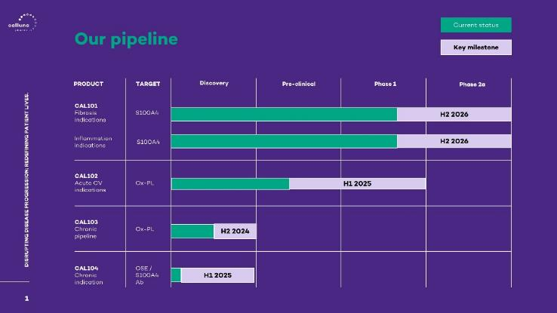
For high resolution images please contact Zyme Communications
To opt-out from receiving press releases from Zyme Communications please email info@zymecommunications.com. To view our privacy policy, please click here.
Media Contact
Lorna Cuddon
Zyme Communications
Email: lorna.cuddon@zymecommunications.com
Tel: +44 (0) 7811 996 942
About Calluna Pharma www.callunapharma.com
Calluna Pharma is a clinical stage company pioneering a breakthrough approach to treating inflammatory and fibrotic diseases by leveraging the body’s innate immune system. The Company’s therapeutic approach targets upstream amplifiers of disease, offering potential applicability across a diverse array of medical conditions. Calluna has a robust pipeline of selective antibodies targeting immunological diseases with enhanced efficacy, including several first-in-class clinical candidates.
Calluna Pharma was formed in 2023 following the merger of Oxitope Pharma and Arxx Therapeutics. The Company is based in Oslo, Norway, with Forbion, Sarsia, p53 and Investinor as lead investors.
About CAL101
Calluna’s clinical stage lead program, CAL101, is a monoclonal antibody that neutralizes the bioactivity of S100A4, a DAMP protein implicated in serious and life-threatening diseases such as idiopathic pulmonary fibrosis, chronic kidney disease, systemic sclerosis, rheumatoid arthritis, and severe (steroid insensitive) asthma. In chronically diseased tissue, S100A4’s inappropriate upregulation switches self-limiting tissue repair responses into chronic activation of inflammatory signaling pathways with sustained fibrogenesis. Calluna completed a first close of its Series A to develop CAL101 to clinical proof-of-concept. The Company is raising further financing to develop its pipeline to multiple key clinical milestones.
About Forbion www.forbion.com
Forbion is a dedicated life sciences venture capital firm with offices in The Netherlands and Germany. Forbion invests in life sciences companies that are active in the (bio-)pharmaceutical space. Forbion manages €3 billion across multiple fund strategies that cover all stages of (bio-) pharmaceutical drug development. Forbion’s current team consists of over 30 life sciences investment professionals that have built an impressive performance track record since the late nineties with investments in over 100 companies across 8 funds. Forbion’s record of sourcing, building and guiding life sciences companies has resulted in many breakthrough therapies and valuable exits. Besides financial objectives, Forbion selects investments that will positively impact the health and well-being of patients. The firm is a signatory to the United Nations Principles for Responsible Investment. Forbion operates a joint venture with BGV, the manager of seed and early-stage funds, especially focused on Benelux and Germany.
About Sarsia www.sarsia.com
Sarsia is the largest early-phase Life-Science investor in Norway and one of the best performing in Scandinavia. Sarsia invests in early-stage life-science companies founded on groundbreaking technologies with compelling value propositions serving unmet clinical needs. Amongst the fund’s portfolio of companies is Nykode AS (www.nykode.com Euronext: ticker NYKD).
About p53 www.p53.no
A Norway-based healthcare investor, p53 identifies and invests in innovative healthcare companies, particularly in the fields of biotechnology and digital health.
p53 seeks to contribute to the development and commercialization of groundbreaking ideas that will transform people’s lives, increase accessibility to cutting-edge treatments and innovative solutions with positive effects on quality of life and well-being.
About Investinor www.investinor.no/en/
Investinor AS is an early-stage investment company owned by the state of Norway. Together with founders, entrepreneurs, and other investors, Investinor invests risk capital in some of the most promising Norwegian companies in their respective markets. With assets of around NOK 8 billion Investinor is Norway’s largest venture capital investor.

