Press Release

The green-tech company Cetasol Secures €2M Seed Round to Accelerate Sustainability in Maritime Segment

- Cetasol’s iHelm solution supports energy reduction of 10-25% by optimizing energy usage and insights for sustainable choices.
- Cetasol offers unique data-based digital twin modeling of vessels and this investment transition Cetasol towards volume sales.
- Funding will be used to double R&D and invest in optimization of AI and software for volume sales globally.
- The new investors are located globally, reflecting Cetasol’s global reach and expansion possibilities.

Gothenburg, Sweden – [April 24th 2024] – Cetasol, an innovative technology firm dedicated to revolutionizing energy efficiency in the maritime industry, has successfully closed a seed round of €2M. The new funding by Sarsia (Norway), ShipsFocus (Singapore), and Impact X Capital (United Kingdom) will enable Cetasol to expand its market reach and enhance its innovative product offerings. By doubling R&D, and investing in optimizing software development, Cetasol will move towards volume sales of the products.

Maritime sustainability is more relevant than ever, with operations needing to consider this to future-proof their operations. Given the tightening regulatory landscape and increasingly ambitious IMO objectives, optimizing energy utilization becomes imperative.

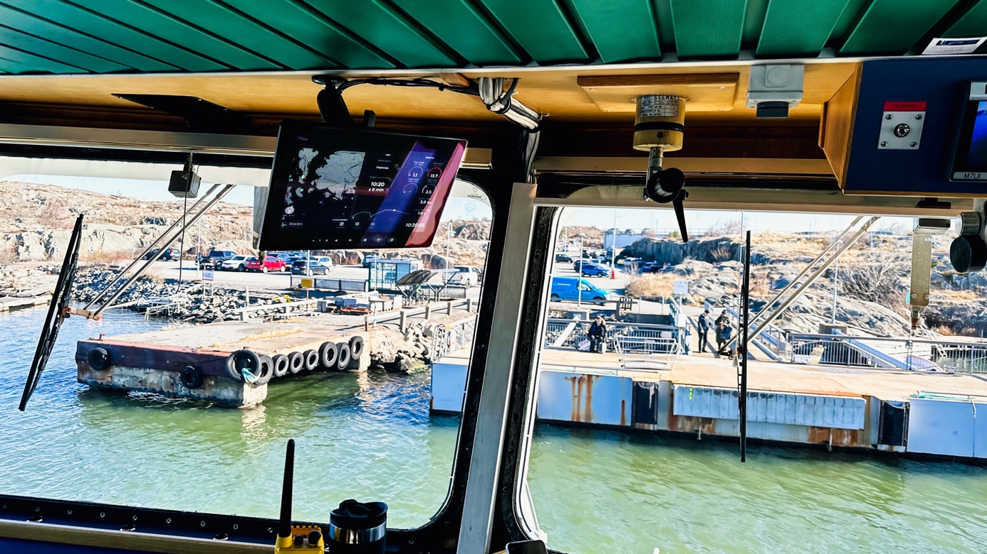

The expense associated with fuel has experienced a twofold increase since 2002, resulting in augmented operational costs and diminishing profit margins. Approximately 30-50% of maritime organizations' operating expenses comprise fuel expenditures. In many operations there is also a matter of insights where most operations lack a full overview of the actions and outcomes. They are not certain how to reduce CO2 and don't know what actions to take or what impact it has.

Cetasol was founded to resolve these problems. Ethan Faghani, Cetasol’s founder, previously held the position of Chief Engineer of AI and automation at Volvo Penta. Identifying fluctuations attributable to human factors, he realized that by mitigating these variances, fuel savings of 10-25% were attainable. The intelligent decision support platform iHelm was born, and given its brand-independent nature, Cetasol emerged as an independent startup in 2020.

Since securing its first investment from Volvo Penta and others in 2021, the company has made significant progress. With installations worldwide, Cetasol provides its intelligent decision support solution, iHelm, to increase insights, manage operations, and optimize energy consumption. Over the past couple of years, the product has been developed. Since Q4 2023, it has transitioned from the pilot phase to commercial availability for fleet installations, laying the groundwork for expansion and volume sales.

The inteligent iHelm solution
Cetasol's main solution is the iHelm platform. An AI-based decision support solution for increased insights and emission reduction by energy optimization. iHelm is applicable to any vessel, regardless of engine brand and driveline. The purpose of iHelm is to make sustainability a simple choice with actionable insights and real-time actionable support.

iHelm consists of three parts, PC, onboard, and cloud. Onboard the captain has access to our Captain Display where insights into speed and directional support will be visible for direct emission reduction. iHelm gathers all the data from the vessel, engines, and its surroundings and transmits it to our cloud. In the cloud crew, managers and owners will have access to all the data, analyzed and presented in an actionable way. Ready-made emissions and summarized reports can be downloaded. All to save time and support sustainable choices.

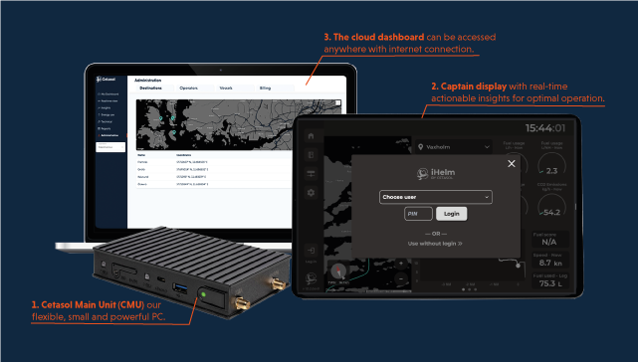

iHelm is built on advanced data modeling and AI, eliminating the need for case-by-case or vessel-specific programming. This scalability allows the solution to be sold in mass volumes. Additionally, Cetasol's data-based digital modeling of vessels is unique.

The iHelm platform relies on Cetasol's innovative technology to create a fully data-based digital twin of operations with minimal sensor inputs. This data-based digital modeling enables the creation of models while the vessels are running, requiring minimal supervision.

Investment to Power Sustainable Marine Technologies
This latest funding round, featuring contributions from esteemed investors including Sarsia, ShipsFocus, and Impact X Capital, marks a pivotal moment in Cetasol’s journey. The investment underscores strong confidence in Cetasol’s mission to deliver sustainable and cutting-edge energy solutions to the maritime sector. The investors are based in different parts of the world, showcasing Cetasol's ambition for worldwide reach.

“What we see in Cetasol is AI/ML driven technology to route and fuel optimization, based on deep engine know-how from Volvo, a team with a drive to build the business, and in a setting where new regulations are coming from EU and IMO for the mid-size vessel market. What you get is real and substantial fuel savings for the marine sector, an important part of the green shift. We look forward to working with the team and partners to scale the business worldwide." Jon-Kåre Hansen, Partner at Sarsia.

“This investment is about the 3 core foundations of sustainability, technology and scale that Cetasol is built upon. We particularly like Ethan as a talented and rare technologist with a flexible mind and unique ability to solve problems applying commercial simplicity and operational tenacity. His clear vision, strong attitude and global ambition for Cetasol compelled our team to say “Yes!”.” Chye Poh Chua, General Partner of ShipsFocus Ventures.

"Impact X is excited to partner with Cetasol which leverages AI and ML to help small and medium sized ships find the fastest most fuel-efficient route to their destination, resulting in fuel cost savings of 10 to 25%. Cetasol’s staff is 40% female, demonstrating that diverse teams can deliver outsized results which positively impact sustainability and the world."
Paula Groves, Impact X Chief Investment Officer

Future Outlook and Goals
Ethan Faghani, CEO and Founder of Cetasol commented on the investment “With this global investment, we have shown the range of Cetasol and iHelm. The impact of our solution is noticeable globally and can impact maritime sustainability in operations all over the world. We have shown the potential of iHelm and with this investment we are able to take Cetasol to the next level, we are ready to scale up.”

With the new investment, Cetasol will double its R&D, expanding sales and sales channels beyond Europe. Investing in AI and product optimization will be utilized to move toward volume sales. Cetasol will expand the team vital to the continuous growth of the company with product owners and data engineers. With this investment, Cetasol expects to have an off-the-shelf volume product. The investment in Cetasol will support the growth and expansion of iHelm globally, making sustainability a simple choice for fleet managers and captains worldwide.

About Cetasol
Cetasol (www.cetasol.com) is a technology leader specializing in energy management solutions for the maritime industry. Founded on the principles of innovation, efficiency, and sustainability, Cetasol is dedicated to transforming the maritime sector through advanced technology that promotes energy conservation and operational efficiency.

Press contact: veronica.soderbergh@cetasol.com

About Sarsia
Sarsia is an early-stage venture capital fund that invests in a greener and healthier future. Based out of the Nordics, they look for technologies and founders capable of accelerating the green transition and building sustainable companies for the future.

About ShipsFocus
ShipsFocus is a venture studio and VC fund to develop startups with practical solutions that generate high recurring value in maritime commerce. It operates at the fringe rather than the center as futurist system thinkers, designers, and developers of digital platforms to transit the maritime supply chain into a digital one.

About Impact X
Impact X is a double-bottom-line venture capital company, founded to support diverse entrepreneurs across Europe and the United States. Having identified a diverse and undersaturated niche of founders with compelling business models, Impact X sources uniquely differentiated deal flow to generate returns for investors.

