Building credit as a newcomer to the United States can be challenging, but it is an important step in achieving personal and professional goals. Here are some ways to start building credit in the US:

Apply for a secured credit card: A secured credit card is backed by a cash deposit that you make upfront. The deposit amount is usually the same as your credit limit.
Establish a relationship with a US bank: Opening a checking or savings account with a US bank can help you establish a relationship with the bank, which may make it easier to get approved for a credit product in the future.
Apply for US credit with a co-signer: If you have a friend or family member with good credit who is willing to cosign for you, this can help you get approved for a loan or credit card.
Become an authorized user: Becoming an authorized user on someone else’s credit card can help you build credit. As an authorized user, you’ll have access to the credit card and the payment history will be reported on your credit report.
The best way to get a credit card without anyone’s help would be to get a secured card. Let us know more about secured cards, and how we can apply one.
A secured credit card is a type of credit card that is backed by a cash deposit from the cardholder. This deposit acts as collateral on the account, providing the card issuer with security in case the cardholder can’t make payments. The deposit amount is usually the same as your credit limit. Because the deposit protects the issuer from losing money, secured cards are easier for people with bad credit or no credit to qualify for. The issuer holds the deposit in case you don’t pay your bill; you get the deposit back when you upgrade to a regular “unsecured” card or close the account in good standing.
The best way to improve your credit score is by Keeping the credit balance relatively low and paying the bill on time every month, and you can begin to strengthen your credit.
To apply for a secured credit card, you can visit the website of a bank or financial institution that offers secured credit cards and fill out an online application. Some popular options include the BankAmerica Secured Credit Card from Bank of America, the Discover it Secured Credit Card, and the PNC Secured Visa credit card.
Some of the best secured cards can be found here.
In this article, we will do a walk-through of applying a secured card through capital one.
Step 1: click the link above, it will direct you to the page with multiple credit card options. Select Capital one.

Step 2: Click Apply Now.

Step 3: Once you in Capitalone website, you should see something like below.
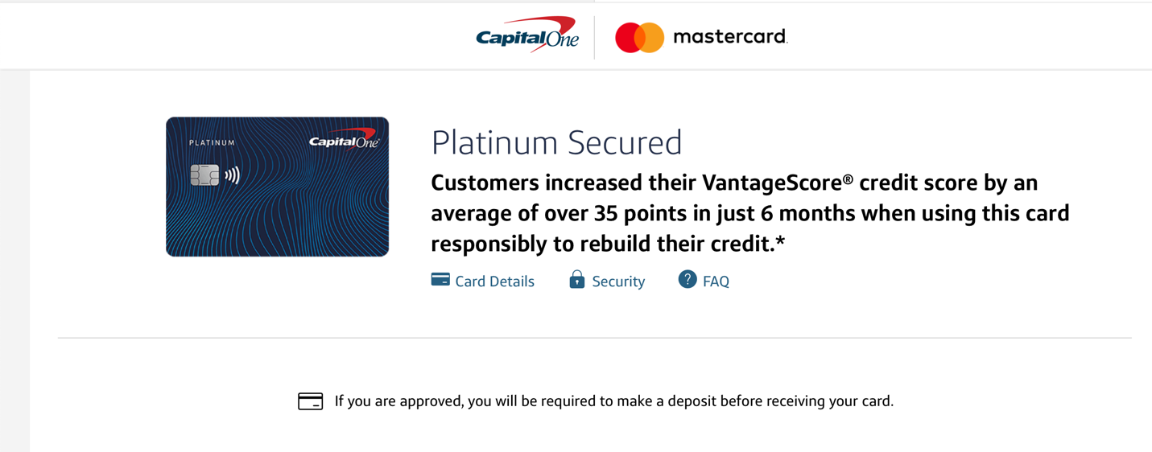
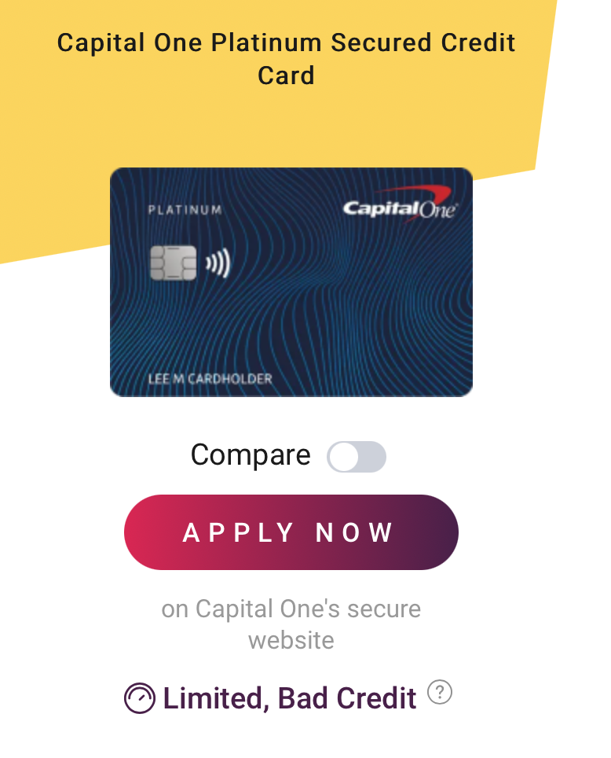

Step 4: fill out the personal information section. Applicants must be at least 18 years of age and possess a valid Social Security number, ITIN, or passport, along with a physical U.S. address (not a P.O. Box). Additionally, when applying for most secured credit cards, you'll need to specify your desired deposit amount, which typically establishes your credit line. The timing and method of deposit payment vary by issuer.
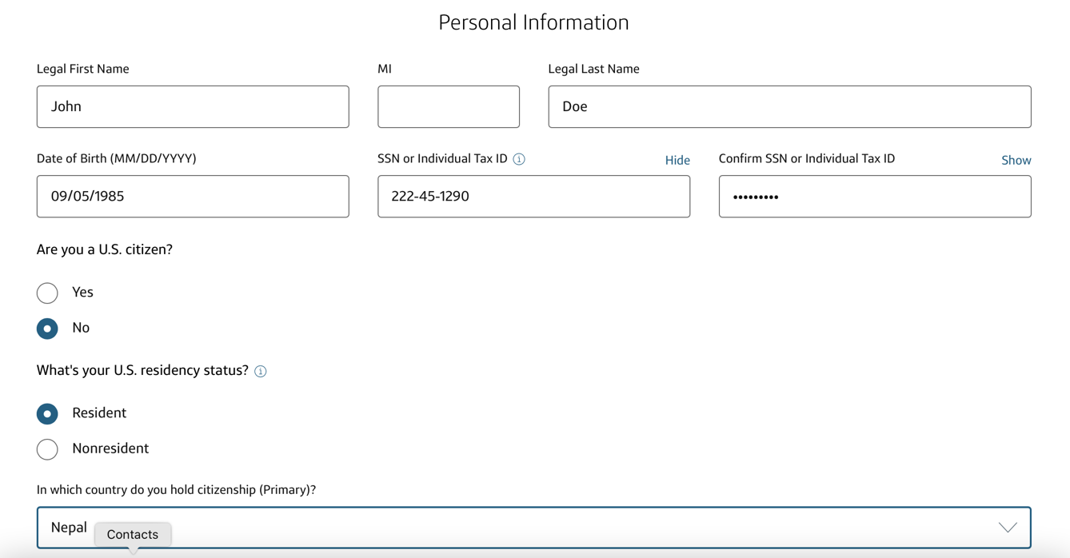
Step 5: Once you complete the personal information section, fill out you address info.
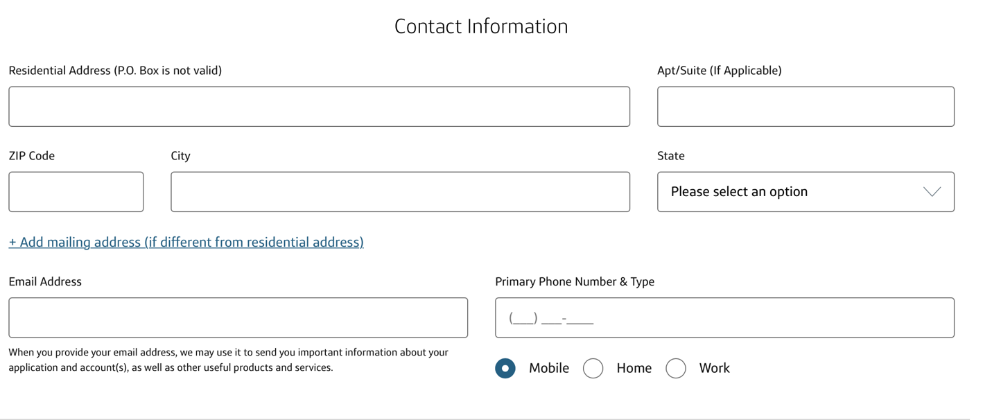

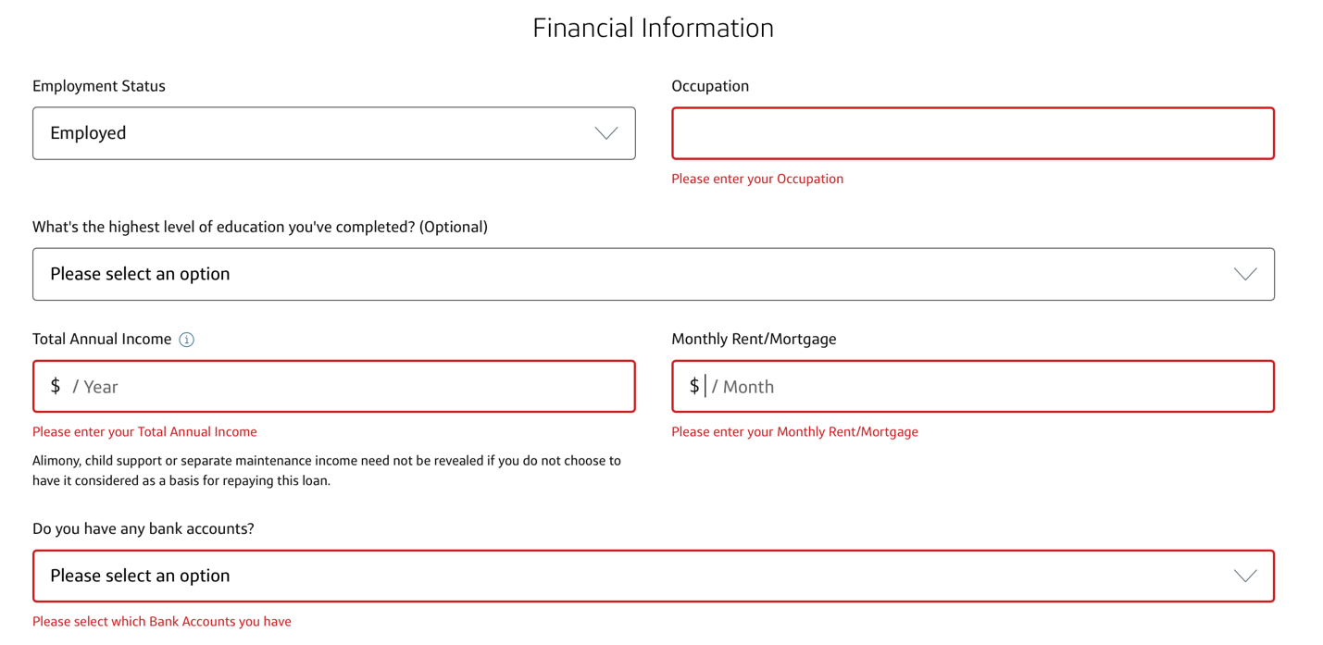
Step 6: Complete the financial information section. All the fields are mandatory. During the application process, you'll need to be ready to supply your bank account details or establish a savings account with the card issuer for deposit payment. However, some issuers do offer the option to pay the deposit at a later stage.

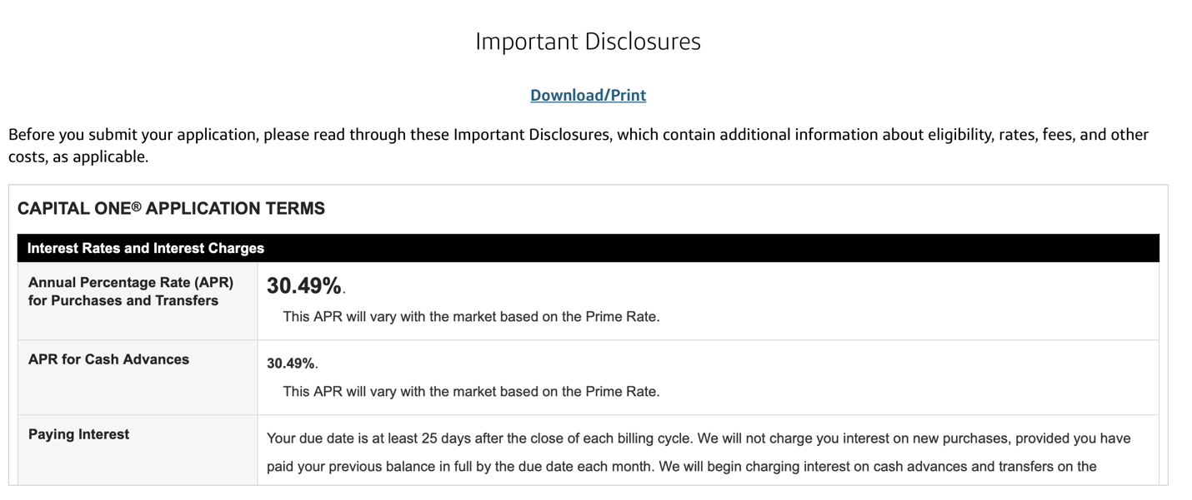
Step 7: Once all the information is entered, you have to read and agree the terms and conditions for using the card. Some of the terms can include the following.
Applicants should check the APR for purchases and for Cash Advance. In the above screenshot, the APR is 30.49%, that means the cost you pay each year to borrow money. Some of the key areas to focus can be something like below.

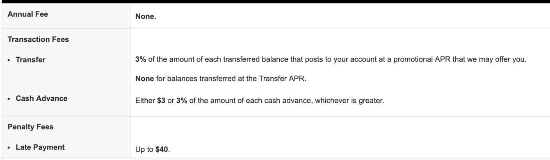
Once all the terms and conditions are signed off, continue the application, and submit it.
It can take a little over a week from the time you apply to when you have your new secured card in hand (assuming you’re approved). The approval process for a secured credit card can vary depending on the issuer and your individual circumstances. Some issuers offer instant approval, where you can get approved in minutes. However, if the issuer needs more information to decide, it could take longer. Once you’re approved, many issuers, including Capital One, say you can expect to receive your card in the mail within 7-10 days of being approved. Keep in mind, if you’re approved for a secured credit card, you’ll have to fund the deposit before the card ships.
Another option is to visit a local branch of a bank that offers secured credit cards and apply in person. When applying, you’ll need to provide personal information such as your name, address, and Social Security number, as well as financial information such as your income and employment status. You’ll also need to make a cash deposit, which usually ranges from $200 to $500, to serve as collateral for the account.

