PANDA Health Care Provider Campaign - Communications Pack
PANDA supports the mental wellbeing of expecting and new parents. Have you heard about the free services we offer families?
PANDA appreciates health care providers sharing information about PANDA’s services, so that we can work together to better support expecting and new parents.
Below you’ll find copy and graphics you can use to talk about our services. Share them on social media, or in your email newsletter.
You can use also these assets to promote PANDA services at any time in the future.
Thank you for your work supporting expecting and new parents and their families.
SUGGESTTED SOCIAL AND NEWSLETTER COPY & LINKS
PANDA General
PANDA provides free counselling and support for expecting and new parents with a child up to the age of 12 months. We support all parents, especially those facing barriers accessing mainstream services.
PANDA’s website has information on a wide range of mental health and wellbeing topics, including articles translated into 40 languages. You can download or order free printed resources for your clinic or service on our website: https://panda.org.au/learn/resources-for-download
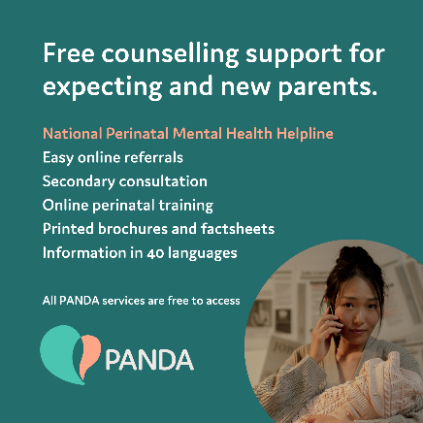

PANDA National Helpline
PANDA provides free counselling and support for expecting and new parents with a child up to the age of 12 months. We support all families, especially those facing barriers accessing mainstream services. The PANDA Helpline is staffed by qualified counsellors and peer support workers.
Our Helpline, 1300 726 306, operates Monday to Saturday (and public holidays) from 9am – 7:30pm Monday to Friday, and 9-4pm Saturdays.
https://panda.org.au/articles/what-happens-when-i-call-the-panda-helpline
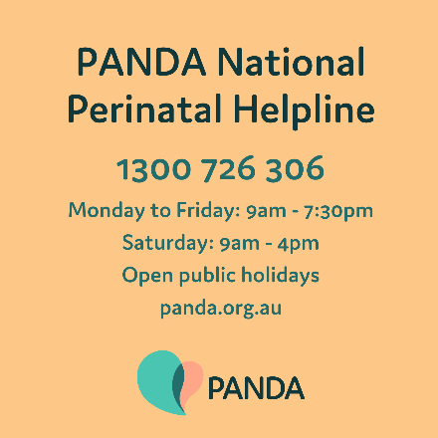
Secondary Consultation
PANDA provides secondary consultations to health care providers supporting individuals and families during the perinatal period. Secondary consultation can be for clinical consultations, risk assessment or professional development. We speak to health care providers from every sector of perinatal care.
https://panda.org.au/articles/secondary-consultation-service-support-for-health-professionals
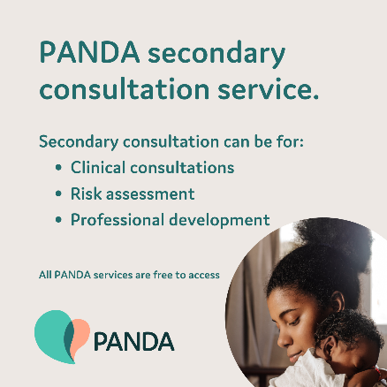

Referral Service
You can refer a patient or client to PANDA at any time, using our website. PANDA provides free counselling and support for expecting and new parents with a child up to the age of 12 months. We provide you with confirmation of receipt of referral and initial engagement via email.
https://panda.org.au/articles/referring-to-panda
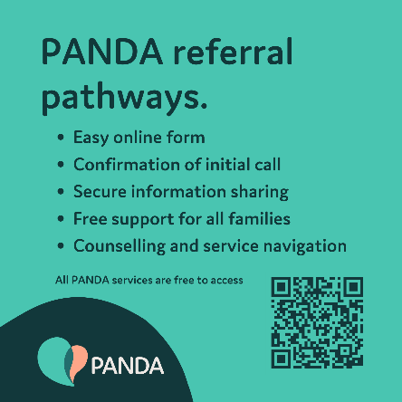
PANDA Learning Hub
PANDA provides free education and resources for health care providers who support the mental health and wellbeing of families. Our interactive online courses cover the core knowledge and skills related to perinatal mental health, conditions, and associated risks. Our latest course explores Perinatal Psychosis.
https://panda.org.au/panda-learning-hub
