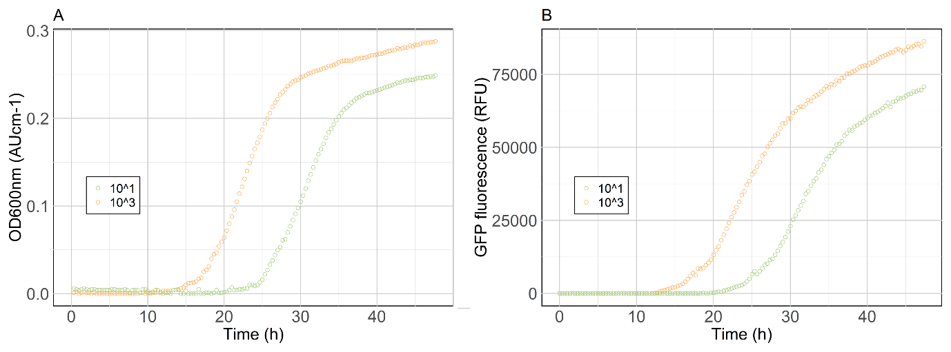
Figure S 1. V. anguillarum 90-11-286 at two different initial concentrations (CFU mL⁻¹), as measured by absorbance at 600 nm (A) and fluorescent signal (B).

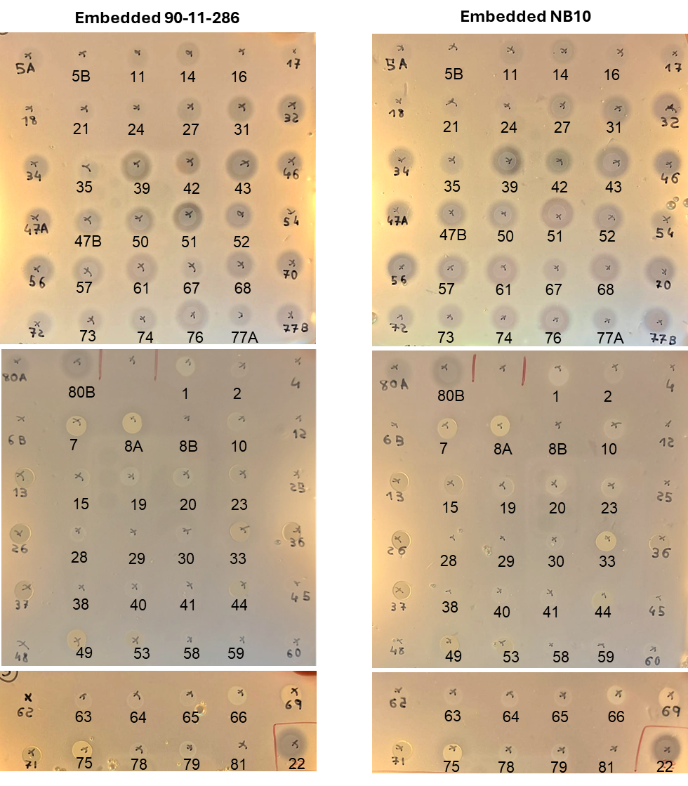
Figure S 2. Antagonistic activity assay of 82 bacterial strains isolated from the inhibitory microbiome of I. galbana against V. anguillarum embedded in IOCG agar. Spotted cultures are identified by isolate number.

Table S 1. Unique barcodes and primers used to amplify the V3-V4 region of the 16S rRNA gene in DNA from the microbiomes of Isochrysis galbana cultures (Klindworth et al., 2013).
Barcode no. | Barcode | Forward primer (5’-3’) (w/ barcode) | Reverse primer (5’-3’) (w/ barcode)
1 | TTTTAATC | TTTTAATCCCTACGGGNGGCWGCAG | TTTTAATCGACTACHVGGGTATCTAATCC
2 | ATAATTAG | ATAATTAGCCTACGGGNGGCWGCAG | ATAATTAGGACTACHVGGGTATCTAATCC
3 | ACCAAATT | ACCAAATTCCTACGGGNGGCWGCAG | ACCAAATTGACTACHVGGGTATCTAATCC
4 | CTTATCAA | CTTATCAACCTACGGGNGGCWGCAG | CTTATCAAGACTACHVGGGTATCTAATCC
5 | TGATCATT | TGATCATTCCTACGGGNGGCWGCAG | TGATCATTGACTACHVGGGTATCTAATCC
6 | AGAATCTA | AGAATCTACCTACGGGNGGCWGCAG | AGAATCTAGACTACHVGGGTATCTAATCC
7 | TCAAGAAA | TCAAGAAACCTACGGGNGGCWGCAG | TCAAGAAAGACTACHVGGGTATCTAATCC
8 | ATCGAAAT | ATCGAAATCCTACGGGNGGCWGCAG | ATCGAAATGACTACHVGGGTATCTAATCC
9 | ACATTTAC | ACATTTACCCTACGGGNGGCWGCAG | ACATTTACGACTACHVGGGTATCTAATCC
10 | TAGAAAAC | TAGAAAACCCTACGGGNGGCWGCAG | TAGAAAACGACTACHVGGGTATCTAATCC
11 | TTATCACC | TTATCACCCCTACGGGNGGCWGCAG | TTATCACCGACTACHVGGGTATCTAATCC
12 | AATAGGGT | AATAGGGTCCTACGGGNGGCWGCAG | AATAGGGTGACTACHVGGGTATCTAATCC
13 | ATTGCTGA | ATTGCTGACCTACGGGNGGCWGCAG | ATTGCTGAGACTACHVGGGTATCTAATCC
14 | TGAGTTCT | TGAGTTCTCCTACGGGNGGCWGCAG | TGAGTTCTGACTACHVGGGTATCTAATCC
15 | GGCTATTT | GGCTATTTCCTACGGGNGGCWGCAG | GGCTATTTGACTACHVGGGTATCTAATCC
16 | CAAGAGAT | CAAGAGATCCTACGGGNGGCWGCAG | CAAGAGATGACTACHVGGGTATCTAATCC
17 | GGAATACA | GGAATACACCTACGGGNGGCWGCAG | GGAATACAGACTACHVGGGTATCTAATCC
18 | AAGGCAAT | AAGGCAATCCTACGGGNGGCWGCAG | AAGGCAATGACTACHVGGGTATCTAATCC
19 | ACAAAACG | ACAAAACGCCTACGGGNGGCWGCAG | ACAAAACGGACTACHVGGGTATCTAATCC
21 | TTGAGTGA | TTGAGTGACCTACGGGNGGCWGCAG | TTGAGTGAGACTACHVGGGTATCTAATCC
22 | GCTTCTGA | GCTTCTGACCTACGGGNGGCWGCAG | GCTTCTGAGACTACHVGGGTATCTAATCC
23 | GGCAAGAT | GGCAAGATCCTACGGGNGGCWGCAG | GGCAAGATGACTACHVGGGTATCTAATCC
24 | GTGCTTTC | GTGCTTTCCCTACGGGNGGCWGCAG | GTGCTTTCGACTACHVGGGTATCTAATCC
30 | GCTTGGTT | GCTTGGTTCCTACGGGNGGCWGCAG | GCTTGGTTGACTACHVGGGTATCTAATCC

Table S 2. DNA concentration and amount provided for extraction for 16S rRNA gene amplicon sequencing and number of sequences obtained after pairing and denoising.
Sample name | DNA concentration after extraction (ng/µL) | Amount of DNA provided for sequencing (ng) | Nr of sequences obtained
C4_LB | 0.142 | 5.68 | 4735
FC_NB10_4_R2 | 42 | 250 | 352452
C5_LB | 0.274 | 10.96 | 11814
FC_286_4_R1 | 57.2 | 250 | 286397
FC_286_4_R3 | 50 | 250 | 224731
C2_SC | 0.298 | 11.92 | 10965
FC_R1 | 63 | 250 | 57266
FC_286_4_R2 | 64.6 | 250 | 233223
C3_LB | 0.124 | 4.96 | 3595
FC_NB10_4_R3 | 67 | 250 | 222900
FM_NB10_2_R2 | 38 | 250 | 125853
FM_286_2_R1 | 35.8 | 250 | 283007
FM_286_2_R3 | 53.2 | 250 | 229604
IG_3 | 32.2 | 250 | 219098
C1_SC | 0.192 | 7.68 | 4675
FM_NB10_2_R3 | 69.2 | 250 | 242671
FC_R3 | 64.8 | 250 | 158369
FM_R3 | 41.2 | 250 | 376811
FC_R2 | 42 | 250 | 117167
FM_R2 | 53 | 250 | 64002
FM_R1 | 41 | 250 | 18072
IG_2 | 42.2 | 250 | 86498
IG_1 | 54.8 | 250 | 213220
FM_286_2_R2 | 37.8 | 250 | 269488

Table S 3. Top BLAST (Sayers et al., 2022) hits for the amplified 16S rRNA gene sequence of the isolated strains and inhibitory effect observed ( “+” and “–“ indicate presence and absence of clearing zone, respectively). *Sample quality was too low.
Isolate nr | Top BLAST hit (NCBI) | Genus | Family | ID (%) | Coverage (%) | E value | Clearing zone
1 | Alteromonas sp. | Alteromonas | Alteromonadaceae | 99.71 | 99 | 0.0 | -
2 | Labrenzia sp. | Labrenzia | Rhodobacteraceae |  |  |  | -
3 | *
4 | Ruegeria sp. | Ruegeria | Rhodobacteraceae | 98.76 | 100 | 0.0 | -
5A | Phaeobacter sp. | Phaeobacter | Rhodobacteraceae | 99.38 | 100 | 0.0 | -
5B | Phaeobacter sp. | Phaeobacter | Rhodobacteraceae | 99.93 | 100 | 0.0 | -
6A | *
6B | Flagellimonas sp. | Flagellimonas | Flavobacteriaceae | 99.13 | 100 | 0.0 | -
7 | Halomonas sp. | Halomonas | Halomonadaceae | 98.73 | 100 | 0.0 | -
8A | Halomonas sp. | Halomonas | Halomonadaceae | 99.50 | 100 | 0.0 | -
8B | Flagellimonas sp. | Flagellimonas | Flavobacteriaceae | 99.50 | 100 | 0.0 | -
9 | *
10 | Alteromonas sp. | Alteromonas | Alteromonadaceae | 99.42 | 99 | 0.0 | -
11 | Phaeobacter sp. | Phaeobacter | Rhodobacteraceae | 99.44 | 100 | 0.0 | -
12 | Roseovarius sp. | Roseovarius | Rhodobacteraceae | 99.76 | 100 | 0.0 | -
13 | Alteromonas sp. | Alteromonas | Alteromonadaceae | 99.18 | 100 | 0.0 | -
14 | Phaeobacter sp. | Phaeobacter | Rhodobacteraceae | 99.54 | 100 | 0.0 | +
15 | Alteromonas sp. | Alteromonas | Alteromonadaceae | 99.61 | 100 | 0.0 | -
16 | Phaeobacter sp. | Phaeobacter | Rhodobacteraceae | 99.77 | 99 | 0.0 | -
17 | Phaeobacter sp. | Phaeobacter | Rhodobacteraceae | 99.84 | 100 | 0.0 | -
18 | Phaeobacter sp. | Phaeobacter | Rhodobacteraceae | 99.53 | 100 | 0.0 | -
19 | Alteromonas sp. | Alteromonas | Alteromonadaceae | 99.04 | 100 | 0.0 | -
20 | Alteromonas sp. | Alteromonas | Alteromonadaceae | 100 | 100 | 0.0 | -
21 | Phaeobacter sp. | Phaeobacter | Rhodobacteraceae | 97.82 | 100 | 0.0 | +
22 | Phaeobacter sp. | Phaeobacter | Rhodobacteraceae | 99.40 | 100 | 0.0 | +
23 | Alteromonas sp. | Alteromonas | Alteromonadaceae | 98.74 | 100 | 0.0 | -
24 | Phaeobacter sp. | Phaeobacter | Rhodobacteraceae | 100 | 100 | 0.0 | -
25 | Labrenzia sp. | Labrenzia | Rhodobacteraceae | 99.85 | 99 | 0.0 | -
26 | Alteromonas sp. | Alteromonas | Alteromonadaceae | 98.28 | 100 | 0.0 | -
27 | Phaeobacter sp. | Phaeobacter | Rhodobacteraceae | 99.37 | 100 | 0.0 | +
28 | Labrenzia sp. | Labrenzia | Rhodobacteraceae | 98.72 | 100 | 0.0 | -
29 | Sulfitobacter sp. | Sulfitobacter | Rhodobacteraceae | 99.78 | 100 | 0.0 | -
30 | Labrenzia sp. | Labrenzia | Rhodobacteraceae | 99.78 | 100 | 0.0 | -
31 | Phaeobacter sp. | Phaeobacter | Rhodobacteraceae | 100 | 100 | 0.0 | +
32 | Phaeobacter sp. | Phaeobacter | Rhodobacteraceae | 100 | 99 | 0.0 | +
33 | Halomonas sp. | Halomonas | Halomonadaceae | 99.18 | 100 | 0.0 | -
34 | Phaeobacter sp. | Phaeobacter | Rhodobacteraceae | 99.52 | 100 | 0.0 | +
35 | Phaeobacter sp. | Phaeobacter | Rhodobacteraceae | 99.76 | 100 | 0.0 | +
36 | Alteromonas sp. | Alteromonas | Alteromonadaceae | 98.22 | 100 | 0.0 | -
37 | Alteromonas sp. | Alteromonas | Alteromonadaceae | 98.91 | 100 | 0.0 | -
38 | Labrenzia sp. | Labrenzia | Rhodobacteraceae | 99.77 | 100 | 0.0 | -
39 | Phaeobacter sp. | Phaeobacter | Rhodobacteraceae | 99.85 | 100 | 0.0 | +
40 | Labrenzia sp. | Labrenzia | Rhodobacteraceae | 99.78 | 100 | 0.0 | -
41 | Labrenzia sp. | Labrenzia | Rhodobacteraceae | 99.01 | 100 | 0.0 | -
42 | Phaeobacter sp. | Phaeobacter | Rhodobacteraceae | 99.35 | 100 | 0.0 | +
43 | Phaeobacter sp. | Phaeobacter | Rhodobacteraceae | 99.43 | 100 | 0.0 | +
44 | Alteromonas sp. | Alteromonas | Alteromonadaceae | 98.71 | 100 | 0.0 | -
45 | Labrenzia sp. | Labrenzia | Rhodobacteraceae | 99.55 | 100 | 0.0 | -
46 | Phaeobacter sp. | Phaeobacter | Rhodobacteraceae | 100 | 100 | 0.0 | +
47A | Phaeobacter sp. | Phaeobacter | Rhodobacteraceae | 100 | 100 | 0.0 | +
47B | Phaeobacter sp. | Phaeobacter | Rhodobacteraceae | 99.13 | 100 | 0.0 | +
48 | Flagellimonas sp. | Flagellimonas | Flavobacteriaceae | 99.28 | 100 | 0.0 | -
49 | Halomonas sp. | Halomonas | Halomonadaceae | 98.53 | 100 | 0.0 | -
50 | Phaeobacter sp. | Phaeobacter | Rhodobacteraceae | 99.08 | 100 | 0.0 | +
51 | Phaeobacter sp. | Phaeobacter | Rhodobacteraceae | 99.62 | 100 | 0.0 | +
52 | Phaeobacter sp. | Phaeobacter | Rhodobacteraceae | 99.84 | 100 | 0.0 | +
53 | Alteromonas sp. | Alteromonas | Alteromonadaceae | 98.95 | 100 | 0.0 | -
54 | Phaeobacter sp. | Phaeobacter | Rhodobacteraceae | 100 | 100 | 0.0 | +
55 | *
56 | Phaeobacter sp. | Phaeobacter | Rhodobacteraceae | 99.67 | 100 | 0.0 | +
57 | Phaeobacter sp. | Phaeobacter | Rhodobacteraceae | 99.33 | 100 | 0.0 | +
58 | Labrenzia sp. | Labrenzia | Rhodobacteraceae | 99.55 | 100 | 0.0 | -
59 | Labrenzia sp. | Labrenzia | Rhodobacteraceae | 99.07 | 100 | 0.0 | -
60 | Labrenzia sp. | Labrenzia | Rhodobacteraceae | 99.77 | 100 | 0.0 | -
61 | Phaeobacter sp. | Phaeobacter | Rhodobacteraceae | 99.69 | 100 | 0.0 | +
62 | Labrenzia sp. | Labrenzia | Rhodobacteraceae | 99.63 | 100 | 0.0 | -
63 | Labrenzia sp. | Labrenzia | Rhodobacteraceae | 99.85 | 100 | 0.0 | -
64 | Labrenzia sp. | Labrenzia | Rhodobacteraceae | 99.28 | 100 | 0.0 | -
65 | Labrenzia sp. | Labrenzia | Rhodobacteraceae | 99.46 | 100 | 0.0 | -
66 | Alteromonas sp. | Alteromonas | Alteromonadaceae | 98.67 | 100 | 0.0 | -
67 | Phaeobacter sp. | Phaeobacter | Rhodobacteraceae | 99.53 | 100 | 0.0 | +
68 | Phaeobacter sp. | Phaeobacter | Rhodobacteraceae | 98.94 | 100 | 0.0 | +
69 | Halomonas sp. | Halomonas | Halomonadaceae | 99.85 | 99 | 0.0 | -
70 | Phaeobacter sp. | Phaeobacter | Rhodobacteraceae | 99.46 | 100 | 0.0 | +
71 | Alteromonas sp. | Alteromonas | Alteromonadaceae | 99.49 | 100 | 0.0 | -
72 | Phaeobacter sp. | Phaeobacter | Rhodobacteraceae | 98.87 | 100 | 0.0 | +
73 | Phaeobacter sp. | Phaeobacter | Rhodobacteraceae | 99.35 | 100 | 0.0 | +
74 | Phaeobacter sp. | Phaeobacter | Rhodobacteraceae | 99.76 | 100 | 0.0 | +
75 | Halomonas sp. | Halomonas | Halomonadaceae | 98.83 | 100 | 0.0 | -
76 | Phaeobacter sp. | Phaeobacter | Rhodobacteraceae | 99.76 | 100 | 0.0 | +
77A | Phaeobacter sp. | Phaeobacter | Rhodobacteraceae | 99.54 | 99 | 0.0 | +
77B | Phaeobacter sp. | Phaeobacter | Rhodobacteraceae | 99.29 | 100 | 0.0 | +
78 | Labrenzia sp. | Labrenzia | Rhodobacteraceae | 99.39 | 100 | 0.0 | -
79 | Labrenzia sp. | Labrenzia | Rhodobacteraceae | 99.46 | 100 | 0.0 | -
80A | Phaeobacter sp. | Phaeobacter | Rhodobacteraceae | 99.69 | 100 | 0.0 | +
80B | Phaeobacter sp. | Phaeobacter | Rhodobacteraceae | 99.34 | 100 | 0.0 | +

