Supplementary Tables and Figures

Table S1. List of thirty unique barcodes and primers used to amplify the V3-V4 region of the 16S rRNA gene in DNA from the microbiomes of Isochrysis galbana cultures. Primers and barcodes from (86).

Table S2. Algal and bacterial counts of different algal cultures (AXT, AXI, NT, NI and NNI) used in the Vibrio inhibition assay, before and after up-concentration (“Before” and “After”), and from different algal sample fractions (Full culture, FC and Filtered microbiome, FM). Counts are reported as mean ± standard deviation. In cases where standard deviation is not reported, data originated from unreplicated experimental conditions.

Table S3. DNA concentration after extraction, DNA amount provided for sequencing and number of sequences obtained from each sample (after denoising and filtering). Sample names indicate replicate (“R1”, “R2”) source culture (“NI”, “NNI”), sample fraction (Full culture: “FC”, Filtered microbiome: “FM”), dilution factor of the algal microbiome (0 to -5), and starting inoculum of V. anguillarum NB10_gfp (“V3”, “V5” for 3 or 5 log CFU mL⁻¹) for samples obtained after the inhibition assay. The algal cultures were sampled before up-concentrating and filtering (“raw”, triplicates), and each fraction (FC and FM) was sampled before the enrichment assay (“bf”). Sterile media controls were included (“MB-ctrl”).

Table S4. 64 bacterial strains isolated from the native („Raw culture”, 19 strains) or enriched inhibitory („Full culture”: FC, or „Filtered microbiome”: FM, 45 strains) microbiome of Isochrysis galbana, and tentatively identified using full-length 16S rRNA gene sequencing. The isolates originate from two different I. galbana cultures (NI and NNI), acquired at different times from the same aquaculture unit.

Table S5. Inhibition of nine V. anguillarum strains by the co-culture of Vreelandella alkaliphila (isolate D2) and Sulfitobacter pontiacus (isolate D3). Phaeobacter piscinae isolate H2 was used as positive control. Clearing zone of different degrees (+, ++, +++), a faint clearing zone (*), or no clearing zone (-) after 24 hours of incubation. Virulence ranks as defined by Rønneseth et al (54).

Table S6. Biosynthetic gene clusters (BGCs) predicted by antiSMASH in the genomes of Vreelandella alkaliphila D2 and Sulfitobacter pontiacus D3.

Figure S1. Inhibition assay by Isochrysis galbana (left) and Tetraselmis suecica (right) microbiomes against Vibrio anguillarum NB10_gfp, at a starting concentration of 3.1 ± 0.3 log CFU mL⁻¹, as measured by absorbance at 600 nm. The inhibitory effect of serial dilutions (10⁻¹ (), 10⁻² (), 10⁻³ (), 10⁻⁴ (), 10⁻⁵ ()) of different fractions of the algal cultures have been tested: full culture (FC; S1A and S1D), with algal and bacterial cells; filtered microbiome (FM; S1B and S1E), where algal cells have been removed; and axenic (AX; S1C and S1F) cultures, where the algae cells are free of bacteria.

Figure S2. Native microbiome composition (top 10 most abundant genera) of two Isochrysis galbana cultures of different age based on the 16S rRNA amplicon sequencing results. One culture, NNI has been newly provided by an aquaculture facility and has a relatively freshly recruited microbiome (left). The other culture, NI has been regularly subcultured under laboratory conditions for almost four years (right).

Figure S3. Inhibition of Vibrio anguillarum NB10_gfp by 64 isolates from the Isochrysis galbana microbiome. 16 isolates showed a clearing zone of varying size (all identified as Phaeobacter sp.), and 13 isolates showed a faint halo, or a rough agar surface around the colony (identified as Alteromonas, Sulfitobacter, Qipengyuania and Croceibacter sp.).

Table S1. List of thirty unique barcodes and primers used to amplify the V3-V4 region of the 16S rRNA gene in DNA from the microbiomes of Isochrysis galbana cultures. Primers and barcodes from (86).
Barcode no. | Barcode | Forward primer (with barcode) | Reverse primer (with barcode)
1 | TTTTAATC | TTTTAATCCCTACGGGNGGCWGCAG | TTTTAATCGACTACHVGGGTATCTAATCC
2 | ATAATTAG | ATAATTAGCCTACGGGNGGCWGCAG | ATAATTAGGACTACHVGGGTATCTAATCC
3 | ACCAAATT | ACCAAATTCCTACGGGNGGCWGCAG | ACCAAATTGACTACHVGGGTATCTAATCC
4 | CTTATCAA | CTTATCAACCTACGGGNGGCWGCAG | CTTATCAAGACTACHVGGGTATCTAATCC
5 | TGATCATT | TGATCATTCCTACGGGNGGCWGCAG | TGATCATTGACTACHVGGGTATCTAATCC
6 | AGAATCTA | AGAATCTACCTACGGGNGGCWGCAG | AGAATCTAGACTACHVGGGTATCTAATCC
7 | TCAAGAAA | TCAAGAAACCTACGGGNGGCWGCAG | TCAAGAAAGACTACHVGGGTATCTAATCC
8 | ATCGAAAT | ATCGAAATCCTACGGGNGGCWGCAG | ATCGAAATGACTACHVGGGTATCTAATCC
9 | ACATTTAC | ACATTTACCCTACGGGNGGCWGCAG | ACATTTACGACTACHVGGGTATCTAATCC
10 | TAGAAAAC | TAGAAAACCCTACGGGNGGCWGCAG | TAGAAAACGACTACHVGGGTATCTAATCC
11 | TTATCACC | TTATCACCCCTACGGGNGGCWGCAG | TTATCACCGACTACHVGGGTATCTAATCC
12 | AATAGGGT | AATAGGGTCCTACGGGNGGCWGCAG | AATAGGGTGACTACHVGGGTATCTAATCC
13 | ATTGCTGA | ATTGCTGACCTACGGGNGGCWGCAG | ATTGCTGAGACTACHVGGGTATCTAATCC
14 | TGAGTTCT | TGAGTTCTCCTACGGGNGGCWGCAG | TGAGTTCTGACTACHVGGGTATCTAATCC
15 | GGCTATTT | GGCTATTTCCTACGGGNGGCWGCAG | GGCTATTTGACTACHVGGGTATCTAATCC
16 | CAAGAGAT | CAAGAGATCCTACGGGNGGCWGCAG | CAAGAGATGACTACHVGGGTATCTAATCC
17 | GGAATACA | GGAATACACCTACGGGNGGCWGCAG | GGAATACAGACTACHVGGGTATCTAATCC
18 | AAGGCAAT | AAGGCAATCCTACGGGNGGCWGCAG | AAGGCAATGACTACHVGGGTATCTAATCC
19 | ACAAAACG | ACAAAACGCCTACGGGNGGCWGCAG | ACAAAACGGACTACHVGGGTATCTAATCC
21 | TTGAGTGA | TTGAGTGACCTACGGGNGGCWGCAG | TTGAGTGAGACTACHVGGGTATCTAATCC
22 | GCTTCTGA | GCTTCTGACCTACGGGNGGCWGCAG | GCTTCTGAGACTACHVGGGTATCTAATCC
23 | GGCAAGAT | GGCAAGATCCTACGGGNGGCWGCAG | GGCAAGATGACTACHVGGGTATCTAATCC
24 | GTGCTTTC | GTGCTTTCCCTACGGGNGGCWGCAG | GTGCTTTCGACTACHVGGGTATCTAATCC
25 | ACACACTG | ACACACTGCCTACGGGNGGCWGCAG | ACACACTGGACTACHVGGGTATCTAATCC
26 | CGATTCTG | CGATTCTGCCTACGGGNGGCWGCAG | CGATTCTGGACTACHVGGGTATCTAATCC
27 | GCAGAGTT | GCAGAGTTCCTACGGGNGGCWGCAG | GCAGAGTTGACTACHVGGGTATCTAATCC
30 | GCTTGGTT | GCTTGGTTCCTACGGGNGGCWGCAG | GCTTGGTTGACTACHVGGGTATCTAATCC
31 | ACAGGCTT | ACAGGCTTCCTACGGGNGGCWGCAG | ACAGGCTTGACTACHVGGGTATCTAATCC
40 | GAGAGGGA | GAGAGGGACCTACGGGNGGCWGCA | GAGAGGGAGACTACHVGGGTATCTAATCC
Table S2. Algal and bacterial counts of different algal cultures (AXT, AXI, NT, NI and NNI) used in the Vibrio inhibition assay, before and after up-concentration (“Before” and “After”), and from different algal sample fractions (Full culture, FC and Filtered microbiome, FM). Counts are reported as mean ± standard deviation. In cases where standard deviation is not reported, data originated from unreplicated experimental conditions.

Algal culture | Algal counts  (log cells/mL) |  |  | Bacterial counts  (log CFU/mL)
 | Before | After |  | Before | After, FC | After, FM
AXT | 5.2 | 7.2 |  | N/A | N/A | N/A
AXI | 5.9 | 7.2 |  | N/A | N/A | N/A
NT | 5.7 | 7.4 |  | 6.6 | 8.4 | 8.1
NI | 6.4 ± 0.1 | 8.0 ± 0.1 |  | 6.0 ± 0.3 | 7.6 ± 0.2 | 7.8 ± 0.2
NNI | 6.2 ± 0.6 | 7.5 ± 0.4 |  | 5.7 ± 0.6 | 7.7 ± 0.4 | 7.6 ± 0.3

Table S3. DNA concentration after extraction, DNA amount provided for sequencing and number of sequences obtained from each sample (after denoising and filtering). Sample names indicate replicate (“R1”, “R2”), source culture (“NI”, “NNI”), sample fraction (Full culture: “FC”, Filtered microbiome: “FM”), dilution factor of the algal microbiome (0 to -5), and starting inoculum of V. anguillarum NB10_gfp (“V3”, “V5” for 3 or 5 log CFU mL⁻¹) for samples obtained after the inhibition assay. The algal cultures were sampled before up-concentrating and filtering (“raw”, triplicates), and each fraction (FC and FM) was sampled before the enrichment assay (“bf”). Sterile media controls were included (“MB-ctrl”).

Sample name | DNA concentration after extraction (ng/μL) | Amount of DNA provided for sequencing (ng) | Number of sequences obtained
R1-NNI-FC_0_V5 | 43.2 | 250 | 172,237
R1-NNI-FC_-3_V5 | 60.8 | 250 | 659,903
R1-NNI-FC_-4_V5 | 54.8 | 250 | 141,745
R1-NNI-FC_-5_V3 | 36.8 | 250 | 125,582
R1-NNI-FC_bf | 33.2 | 250 | 42,434
R1-NNI-FM_0_V5 | 100 | 250 | 37,770
R1-NNI-FM_-2_V5 | 66.4 | 250 | 283,545
R1-NNI-FM_-3_V5 | 47.8 | 250 | 211,372
R1-NNI-FM_-3_V3 | 77.6 | 250 | 422,921
R1-NNI-FM_-4_V3 | 112 | 250 | 275,217
R1-NNI-FM_bf | 4.1 | 192,7 | 175,885
R1-NNI-MB-ctrl | 0.834 | 39,198 | 11,352
R1-NNI-raw1 | 55.4 | 250 | 162,772
R1-NNI-raw2 | 85.4 | 250 | 54,564
R1-NNI-raw3 | 71.6 | 250 | 40,223
R2-NNI-FC_0_V5 | 58.4 | 250 | 75,491
R2-NNI-FC_-1_V5 | 39 | 250 | 550,497
R2-NNI-FC_-3_V3 | 95.4 | 250 | 106,340
R2-NNI-FC_-5_V3 | 73.4 | 250 | 324,687
R2-NNI-FC_bf | 85 | 250 | 62,636
R2-NNI-FM_0_V5 | 75.4 | 250 | 238,018
R2-NNI-FM_-3_V3 | 120 | 250 | 162,818
R2-NNI-FM_-4_V3 | 48 | 250 | 294,405
R2-NNI-FM_bf | 17.3 | 250 | 145,227
R2-NNI-raw1 | 43.4 | 250 | 25,781
R2-NNI-raw2 | 72.4 | 250 | 49,342
R2-NNI-raw3 | 72.8 | 250 | 74,725
R2-NI-FC_0_V5 | 81.2 | 250 | 291,271
R2-NI-FC_-2_V5 | 16.2 | 250 | 391,227
R2-NI-FC_-3_V3 | 61.6 | 250 | 297,668
R2-NI-FC_-4_V3 | 74.4 | 250 | 224,317
R2-NI-FC_bf | 120 | 250 | 33,188
R2-NI-FM_0_V5 | 95.2 | 250 | 474,932
R2-NI-FM_-1_V5 | 61 | 250 | 265,940
R2-NI-FM_-2_V3 | 75 | 250 | 229,292
R2-NI-FM_-4_V3 | 50 | 250 | 226,214
R2-NI-FM_bf | 16.4 | 250 | 367,349
R2-NI-MB-ctrl | 1.98 | 93,06 | 39,985
R2-NI-raw1 | 86.8 | 250 | 43,457
R2-NI-raw2 | 92.2 | 250 | 169,394
R2-NI-raw3 | 73.4 | 250 | 409,195

Table S4. 64 bacterial strains isolated from the native („Raw culture”, 19 strains) or enriched inhibitory („Full culture”: FC, or „Filtered microbiome”: FM, 45 strains) microbiome of Isochrysis galbana, and tentatively identified using full-length 16S rRNA gene sequencing. The isolates originate from two different I. galbana cultures (NI and NNI), acquired at different times from the same aquaculture unit.

Isolate | Source | Best BLAST hit | Query Cover | E value | ID%
A1 | Raw culture, NNI | Alteromonas marina | 99% | 0.0 | 98.14%
A2 | Raw culture, NNI | Sulfitobacter pacificus | 99% | 0.0 | 99.17%
A3 | Raw culture, NNI | Roseovarius nubinhibens | 99% | 0.0 | 98.61%
A4 | Raw culture, NNI | Roseovarius nubinhibens | 100% | 0.0 | 98.88%
A5 | Raw culture, NNI | Sulfitobacter sp. | 100% | 0.0 | 98.63%
A6 | Raw culture, NNI | Sulfitobacter pacificus | 100% | 0.0 | 99.71%
A7 | Raw culture, NNI | Qipengyuania nanhaisediminis | 100% | 0.0 | 99.54%
A8 | Raw culture, NNI | Qipengyuania aquimaris | 99% | 0.0 | 98.90%
A9 | Raw culture, NNI | Ruegeria sp. | 100% | 0.0 | 98.29%
B1 | Raw culture, NNI | Alteromonas macleodii | 100% | 0.0 | 97.96%
B2 | Raw culture, NNI | Qipengyuania xiamenensis | 99% | 0.0 | 99.56%
B3 | Raw culture, NI | Croceibacter sp. | 100% | 0.0 | 99.22%
B4 | Raw culture, NI | Mameliella alba | 99% | 0.0 | 98.43%
B5 | Raw culture, NI | Sulfitobacter sp. LZD014 | 99% | 0.0 | 99.34%
B6 | Raw culture, NI | Sulfitobacter sp. | 100% | 0.0 | 98.82%
B7 | Raw culture, NI | Phaeobacter piscinae | 100% | 0.0 | 99.57%
B9 | Raw culture, NI | Phaeobacter piscinae | 99% | 0.0 | 99.43%
C1 | Raw culture, NI | Sulfitobacter sp. | 99% | 0.0 | 99.57%
C2 | FC, NNI | Roseovarius nubinhibens | 99% | 0.0 | 99.31%
C3 | FC, NNI | Phaeobacter piscinae | 99% | 0.0 | 99.43%
C5 | FC, NNI | Roseovarius nubinhibens | 100% | 0.0 | 99.37%
C6 | FC, NNI | Sulfitobacter sp. LZD014 | 100% | 0.0 | 98.86%
C7 | FC, NNI | Roseovarius nubinhibens | 100% | 0.0 | 99.62%
C8 | FC, NNI | Alteromonas tagae | 99% | 0.0 | 97.35%
C9 | FC, NNI | Sulfitobacter pacificus | 99% | 0.0 | 99.24%
D1 | FC, NNI | Sulfitobacter sp. LZD014 | 99% | 0.0 | 99.52%
D2 | FC, NNI | Halomonas alkaliphila | 99% | 0.0 | 98.89%
D3 | FC, NNI | Sulfitobacter sp. | 99% | 0.0 | 97.53%
D4 | FC, NNI | Phaeobacter piscinae | 99% | 0.0 | 99.14%
D5 | FC, NNI | Alteromonas sp. | 98% | 0.0 | 98.10%
D6 | FC, NI | Phaeobacter piscinae | 100% | 0.0 | 99.24%
E2 | FC, NI | Alteromonas macleodii | 99% | 0.0 | 99.14%
E3 | FC, NI | Phaeobacter piscinae | 99% | 0.0 | 99.05%
E4 | FC, NI | Phaeobacter piscinae | 100% | 0.0 | 99.42%
E5 | FC, NI | Sulfitobacter sp. LZD014 | 100% | 0.0 | 99.33%
E6 | FC, NI | Phaeobacter sp. M8-4.3 | 99% | 0.0 | 98.24%
E7 | FC, NI | Sulfitobacter sp. LZD014 | 99% | 0.0 | 99.23%
E8 | FC, NI | Phaeobacter piscinae | 100% | 0.0 | 99.42%
E9 | FC, NI | Phaeobacter piscinae | 100% | 0.0 | 98.90%
F1 | FC, NI | Sulfitobacter sp. | 100% | 0.0 | 98.82%
F2 | FC, NI | Vibrio anguillarum | 100% | 0.0 | 97.43%
F3 | FC, NI | Phaeobacter sp. M8-4.3 | 99% | 0.0 | 98.07%
F4 | FC, NI | Sulfitobacter sp. | 94% | 0.0 | 96.22%
F5 | FM, NNI | Vibrio sp. | 100% | 0.0 | 98.70%
F6 | FM, NNI | Phaeobacter piscinae | 100% | 0.0 | 98.72%
F7 | FM, NNI | Sulfitobacter sp. | 99% | 0.0 | 99.33%
F8 | FM, NNI | Roseovarius nubinhibens | 99% | 0.0 | 99.44%
F9 | FM, NNI | Roseovarius nubinhibens | 99% | 0.0 | 99.71%
G1 | FM, NNI | Sulfitobacter sp. | 99% | 0.0 | 99.43%
G2 | FM, NNI | Phaeobacter piscinae | 100% | 0.0 | 99.23%
G3 | FM, NNI | Alteromonas sp. | 97% | 0.0 | 97.75%
G5 | FM, NNI | Roseovarius nubinhibens | 100% | 0.0 | 98.91%
G7 | FM, NNI | Vibrio sp. | 99% | 0.0 | 97.46%
G8 | FM, NNI | Roseovarius nubinhibens | 99% | 0.0 | 99.05%
H1 | FM, NI | Sulfitobacter sp. LZD014 | 99% | 0.0 | 99.61%
H2 | FM, NI | Phaeobacter piscinae | 100% | 0.0 | 98.96%
H3 | FM, NI | Phaeobacter piscinae | 99% | 0.0 | 99.33%
H4 | FM, NI | Phaeobacter sp. M8-4.3 | 99% | 0.0 | 98.33%
H8 | FM, NI | Phaeobacter piscinae | 99% | 0.0 | 99.33%
H9 | FM, NI | Alteromonas macleodii | 100% | 0.0 | 91.23%
I1 | FM, NI | Phaeobacter piscinae | 100% | 0.0 | 99.14%
I2 | FM, NI | Phaeobacter piscinae | 99% | 0.0 | 99.04%
I3 | FM, NI | Phaeobacter piscinae | 100% | 0.0 | 99.24%
I4 | Raw culture, NI | Phaeobacter piscinae | 99% | 0.0 | 98.94%

Table S5. Inhibition of nine V. anguillarum strains by the co-culture of Vreelandella alkaliphila (isolate D2) and Sulfitobacter pontiacus (isolate D3). Phaeobacter piscinae isolate H2 was used as positive control. Clearing zone of different degrees (+, ++, +++), a faint clearing zone (*), or no clearing zone (-) after 24 hours of incubation. Virulence ranks as defined by Rønneseth et al (54).
V. anguillarum strain | Virulence rank | Inhibition by H. campaniensis D2 monoculture | Inhibition by S. pontiacus D3 monoculture | Inhibition by co-culture of H. campaniensis D2 and S. pontiacus D3 | Inhibition by P. piscinae H2
90-11-286 | High | - | - | - | +++
DSM21597 | High | - | - | - | +++
PF7 | High | - | - | * | +++
PF4 | High | - | - | - | +++
9014/8 | Medium | - | - | - | +++
S2 2/9 | Medium | - | - | - | +++
4299 | Low | * | - | ++ | +++
NB10 | Low | * | - | ++ | +++
775 | N/A | + | - | + | +++

Table S6. Biosynthetic gene clusters (BGCs) predicted by antiSMASH 7.0 in the genomes of Vreelandella alkaliphila D2 and Sulfitobacter pontiacus D3.
Strain | Cluster | Type of BGC | Most similar known BGC in MIBiG | Similarity
V. alkaliphila D2 | 1 | NI-siderophore | BGC0001572 | 66%
 | 2 | ranthipeptide | BGC0000413 | 2%
 | 3 | redox-cofactor | BGC0001131 | 25%
 | 4 | RiPP-like | / | /
 | 5 | T1PKS | / | /
 | 6 | betalactone | BGC0001103 | 20%
 | 7 | ectoine | BGC0000859 | 75%
S. pontiacus D3 | 1 | RiPP-like | / | /
 | 2 | betalactone | / | /
 | 3 | hserlactone | / | /
 | 4 | redox-cofactor | / | /

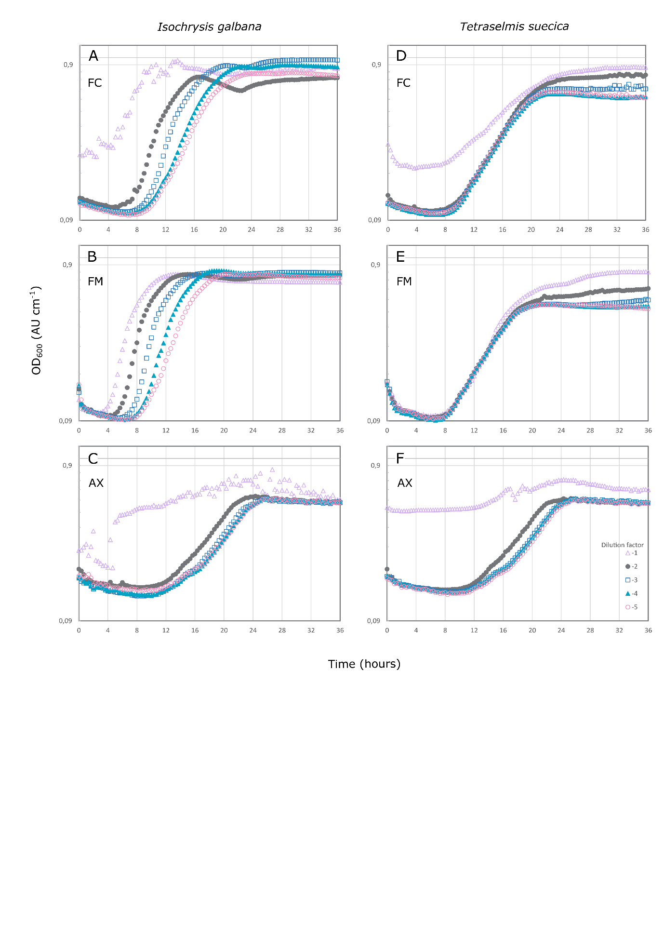
Figure S1. Inhibition assay by Isochrysis galbana (left) and Tetraselmis suecica (right) microbiomes against Vibrio anguillarum NB10_gfp, at a starting concentration of 3.1 ± 0.3 log CFU mL⁻¹, as measured by absorbance at 600 nm. The inhibitory effect of serial dilutions (10⁻¹ (), 10⁻² (), 10⁻³ (), 10⁻⁴ (), 10⁻⁵ ()) of different fractions of the algal cultures have been tested: full culture (FC; S1A and S1D), with algal and bacterial cells; filtered microbiome (FM; S1B and S1E), where algal cells have been removed; and axenic (AX; S1C and S1F) cultures, where the algae cells are free of bacteria.

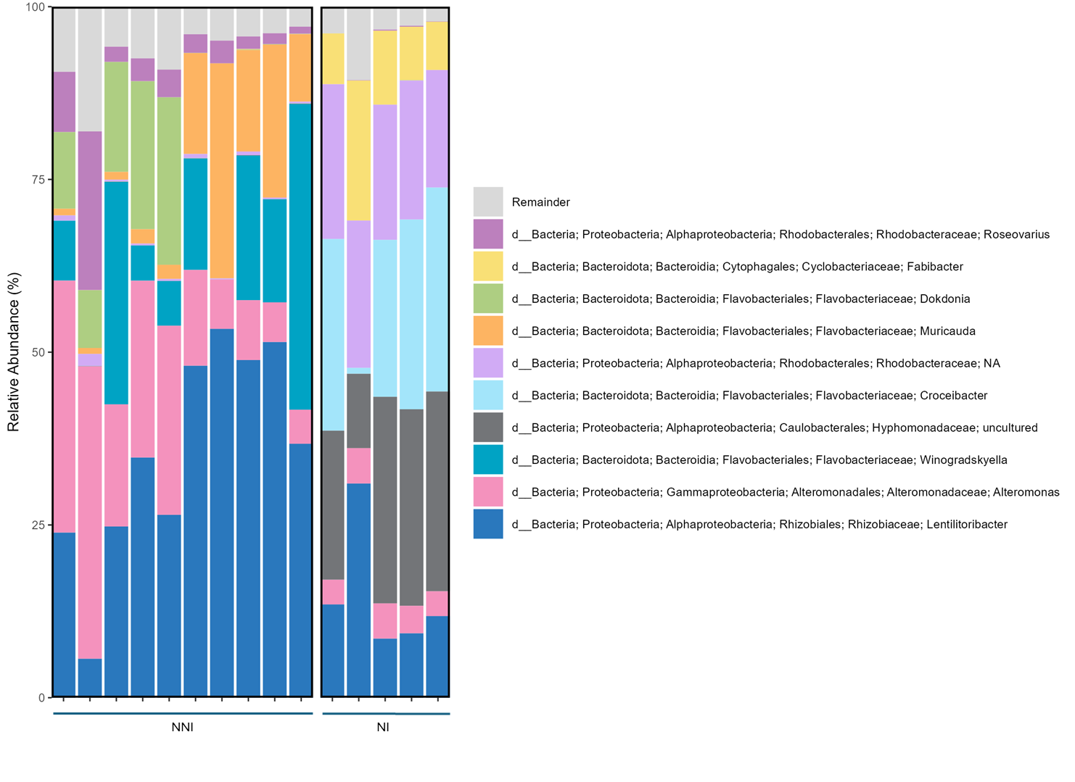
Figure S2. Native microbiome composition (top 10 most abundant genera) of two Isochrysis galbana cultures of different age based on the 16S rRNA amplicon sequencing results. One culture, NNI, has been newly provided by an aquaculture facility and has a relatively freshly recruited microbiome (left). The other culture, NI has been regularly subcultured under laboratory conditions for almost four years (right).

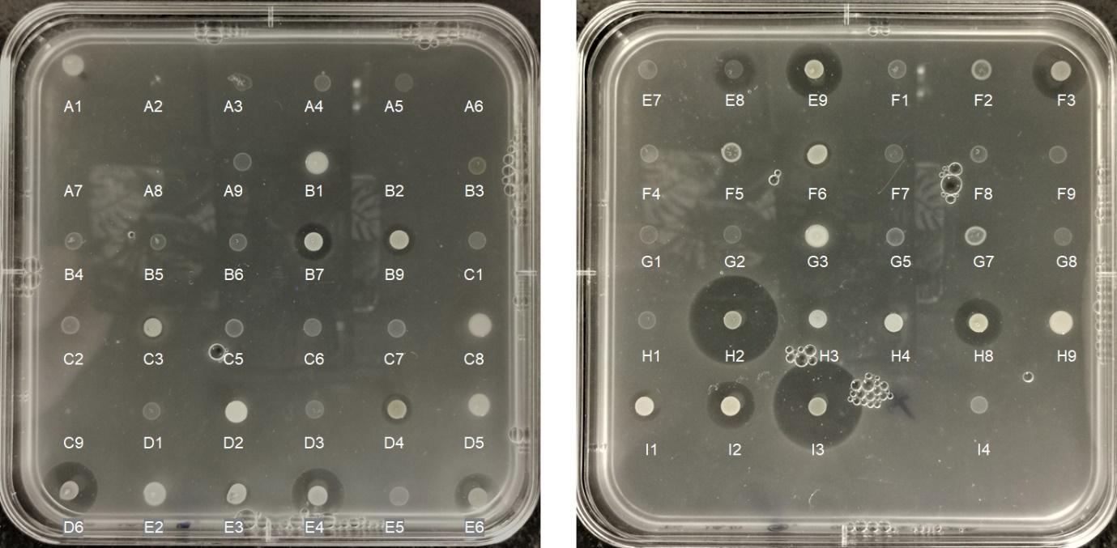

Figure S3. Inhibition of Vibrio anguillarum NB10_gfp by 64 isolates from the Isochrysis galbana microbiome.

