Supplementary information for :

Host evolutionary history drives prokaryotic diversity in the globally distributed sponge family Petrosiidae
N. van der Windt, B. Paix, K. Biesmeijer, R. Ambo-Rappe, Y.M. Huang, K.G.S. Nirbadha, D. Sipkema, N.J. de Voogd
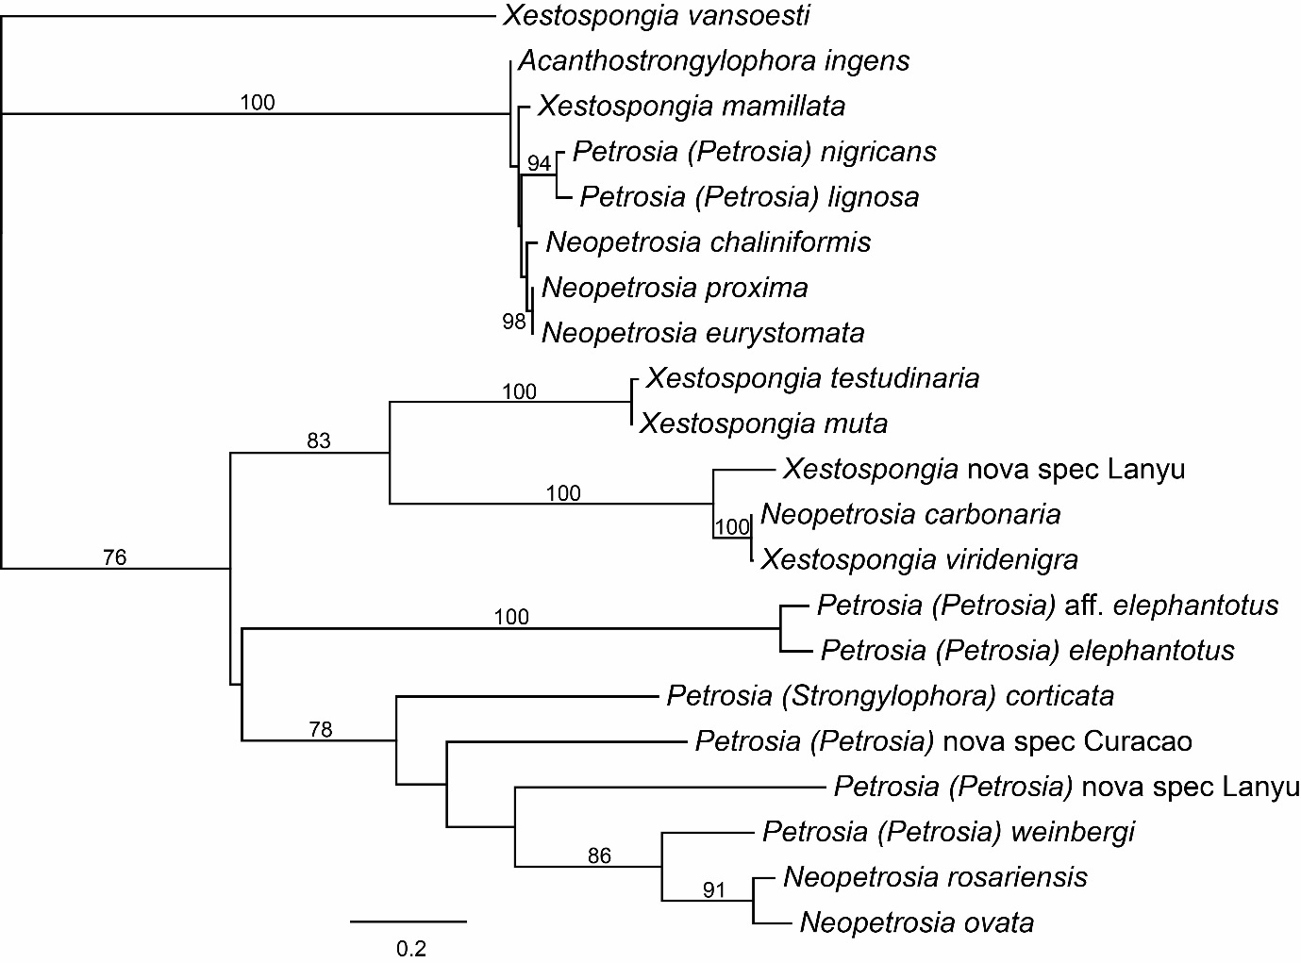
Figure S1. Maximum-likelihood phylogeny based on the generated consensus sequences of all sequences per species of 28S rRNA. The phylogeny was constructed using RAxML version 8 (Stamatakis, 2014) in Geneious 2025.0.3 with rapid bootstrapping and search for the best-scoring ML tree (1000 replicates) using the GTR GAMMA I nucleotide model. Numbers on the branches indicate the bootstrap values. Only bootstrap values higher than 75 are displayed.

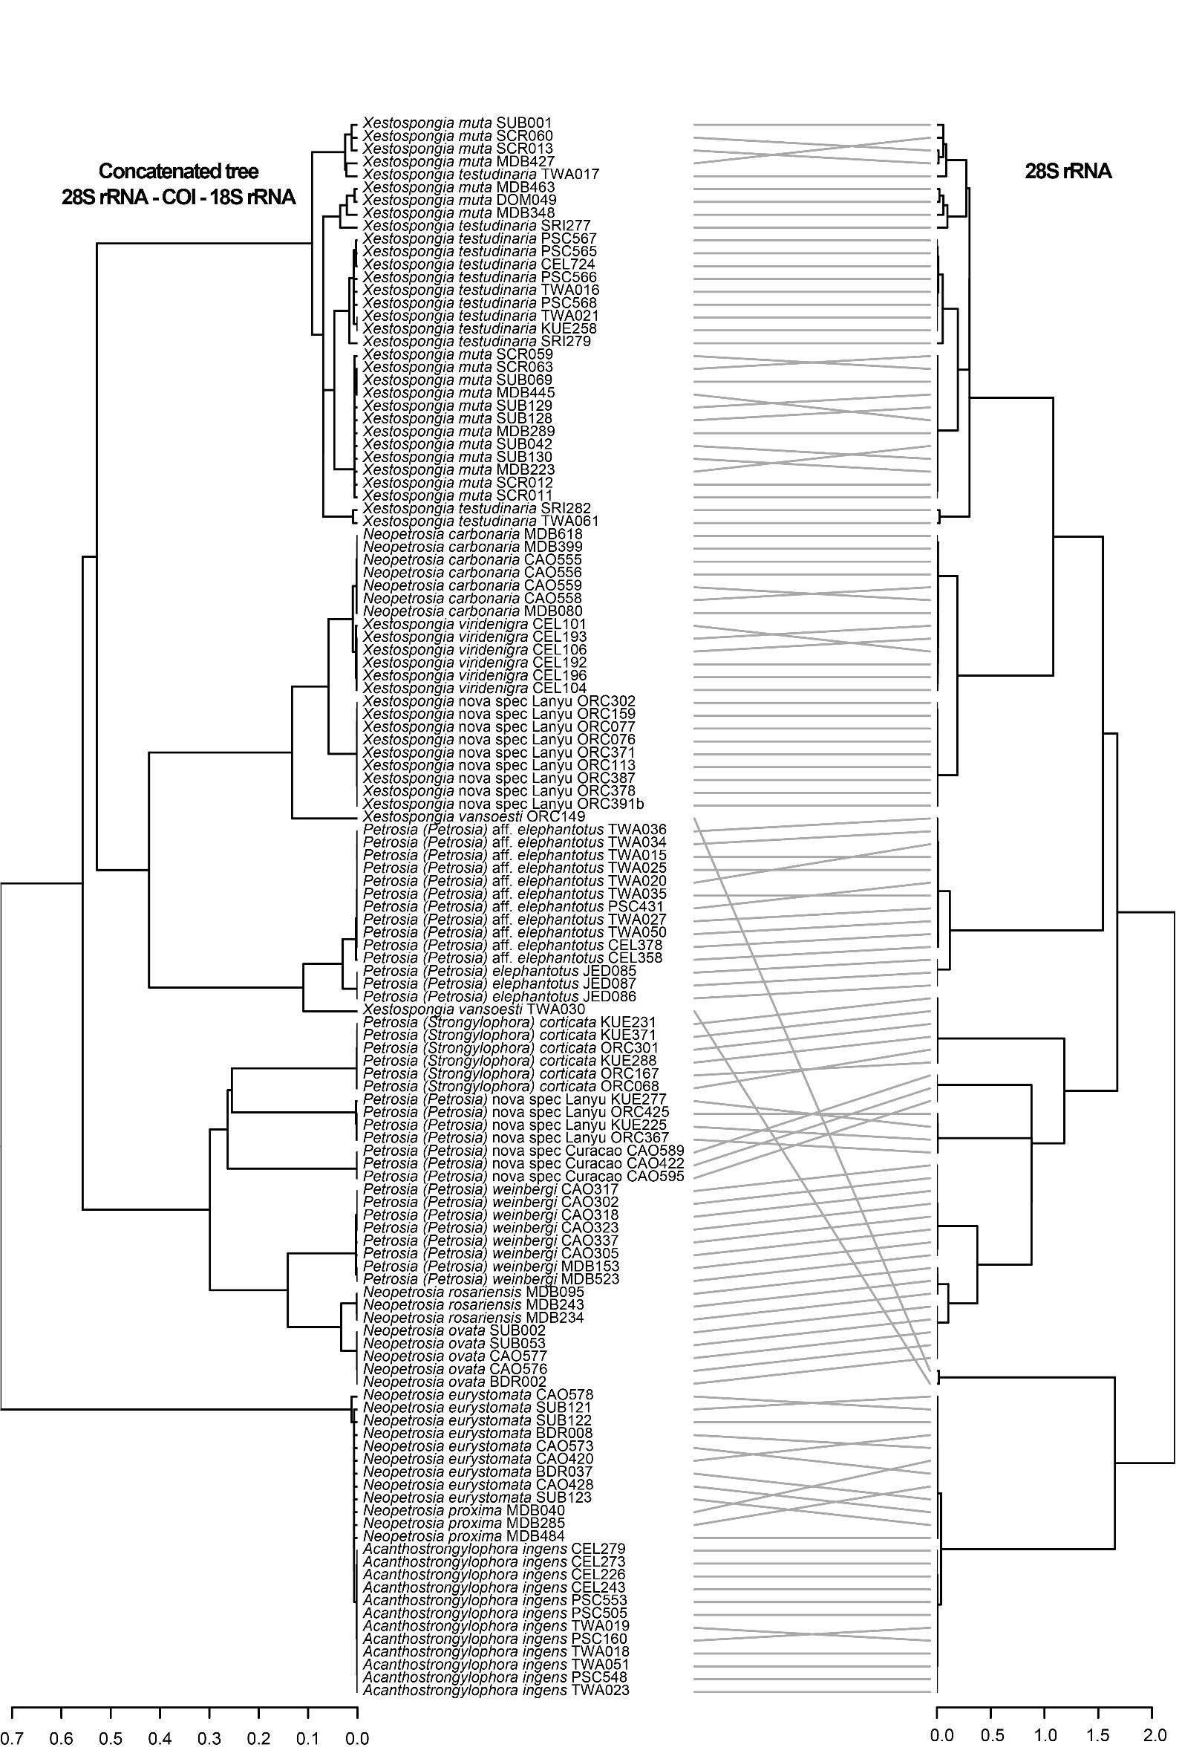
Figure S2 Congruence of the maximum-likelihood phylogenies based on the concatenated markers 28S rRNA, COI and 18S rRNA versus 28S rRNA, only using the samples for which all concatenated markers are available for a fair comparison. Phylogenies were constructed using RAxML version 8 (Stamatakis, 2014) in Geneious 2025.0.3 with rapid bootstrapping and search for the best-scoring ML tree (1000 replicates) using the GTR GAMMA I nucleotide model. Tip labels indicate the species and field ID.

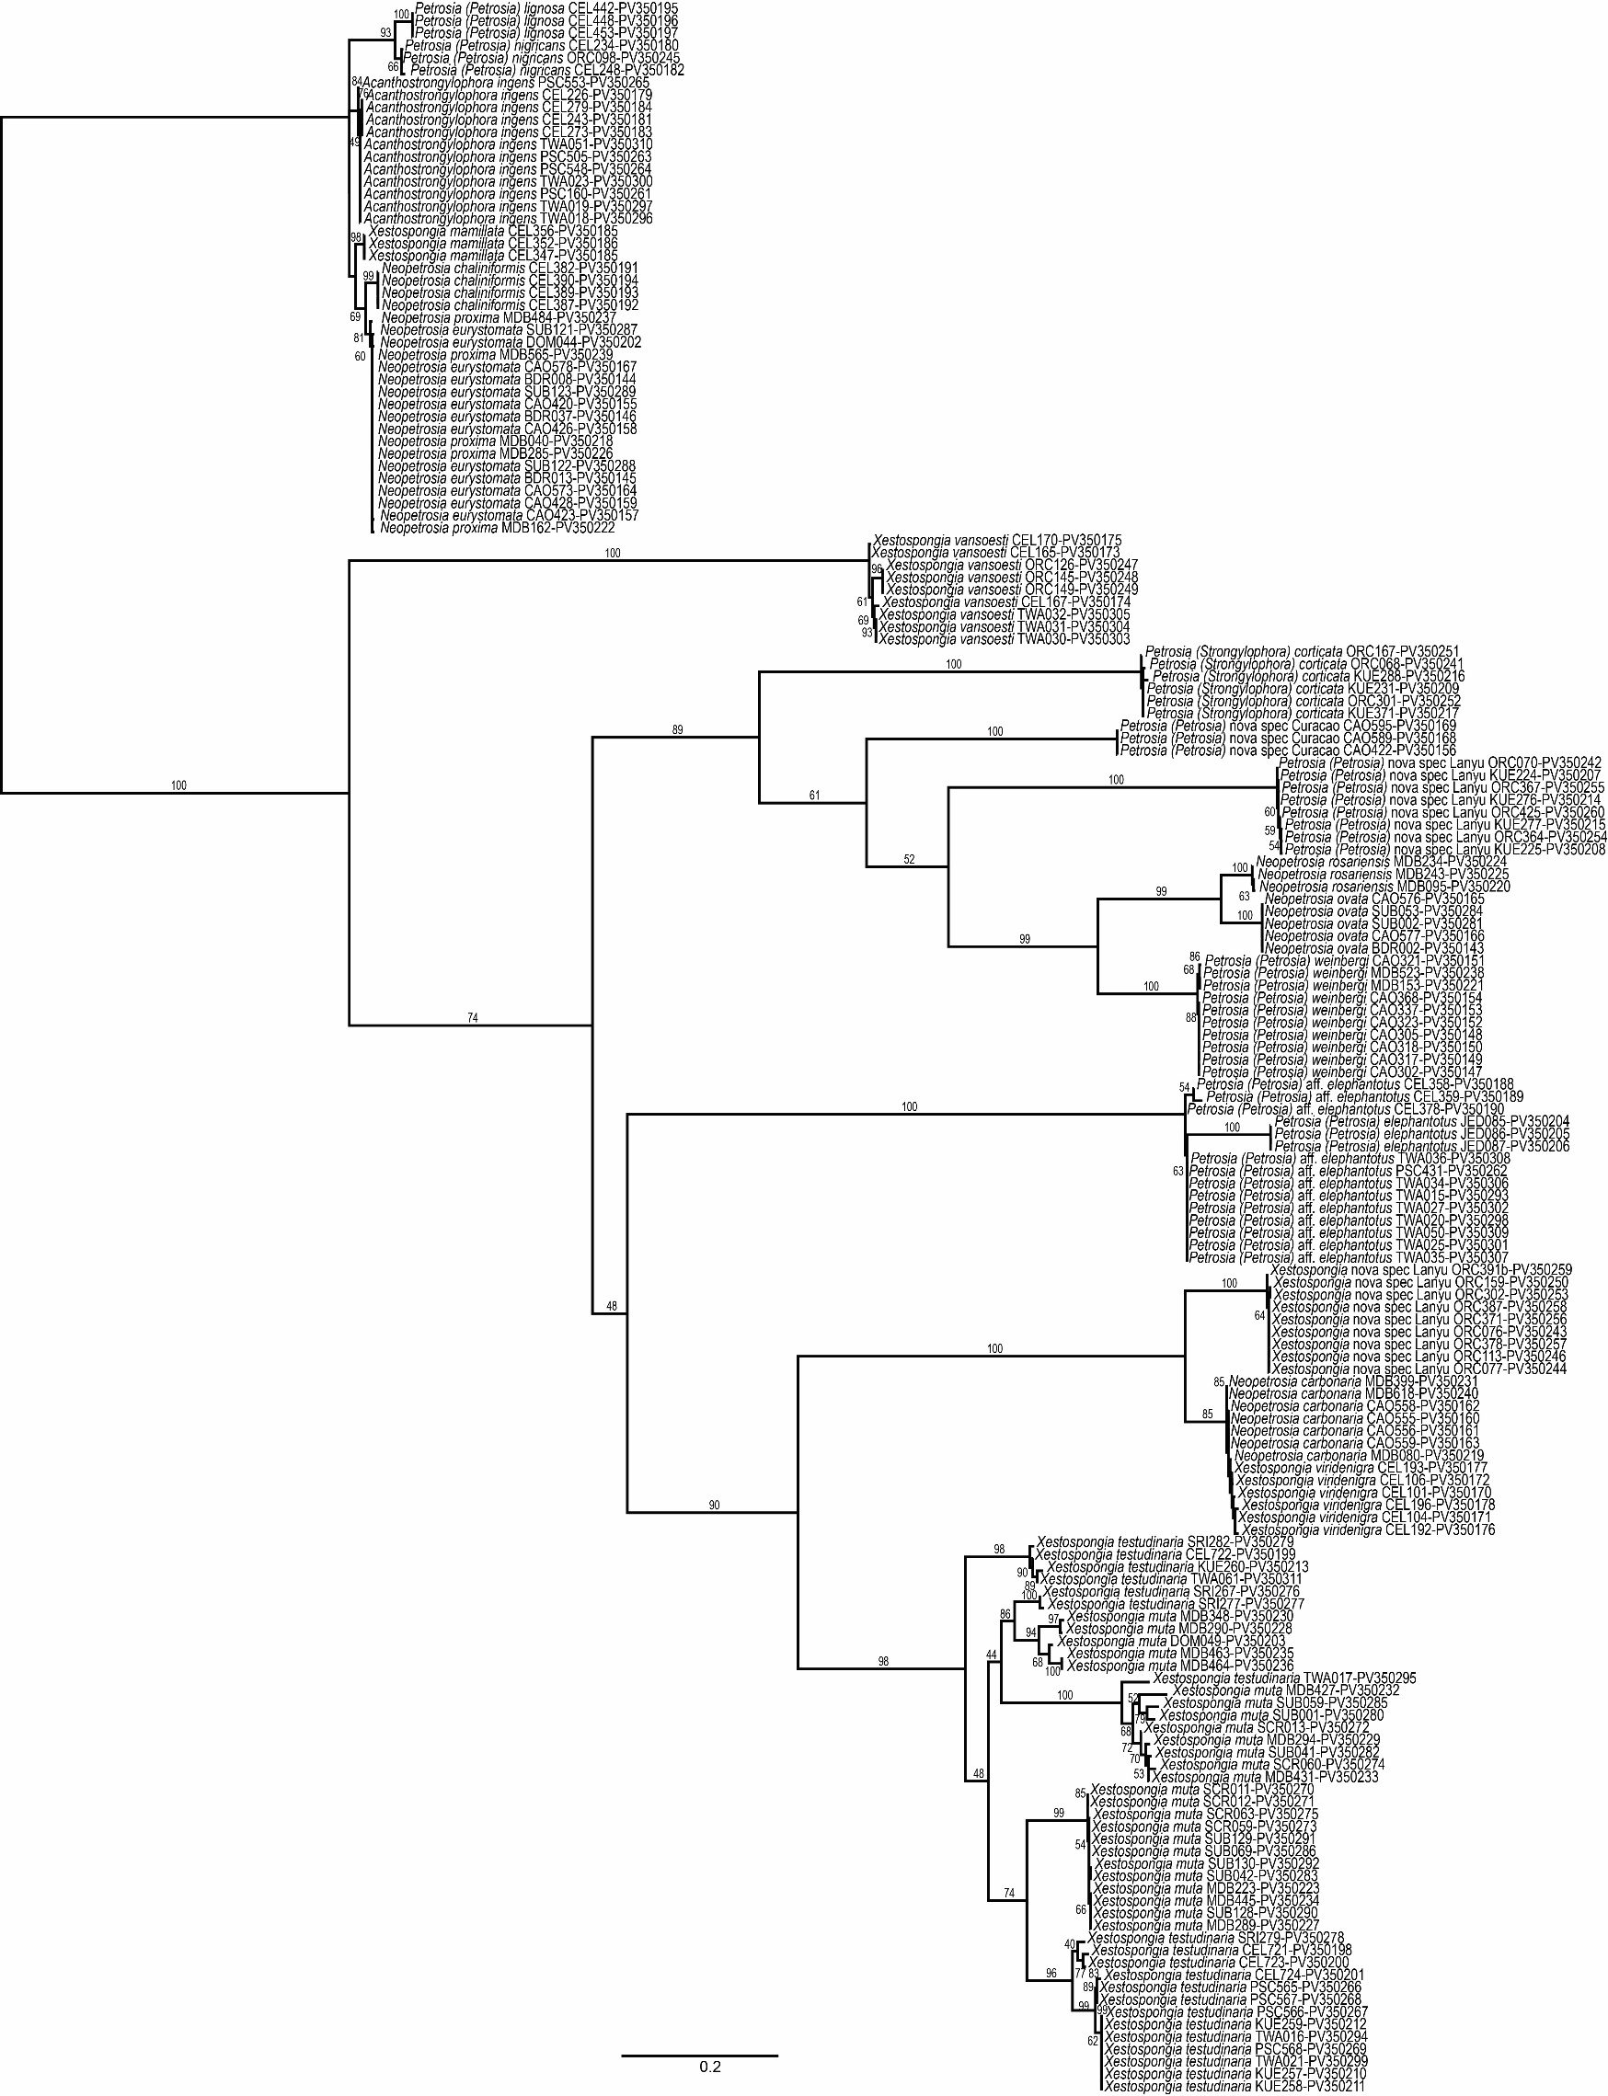
Figure S3. Maximum-Likelihood phylogeny of the samples included in this study based on 28S rRNA. The phylogeny was constructed using RAxML version 8 (Stamatakis, 2014) in Geneious 2025.0.3 with rapid bootstrapping and search for the best-scoring ML tree (1000 replicates) using the GTR GAMMA I nucleotide model. Numbers on the branches indicate the bootstrap values. Only bootstrap values higher than 50 or major node support are displayed. Tip labels indicate the sample species followed by the sample ID-GenBank Accession number of the corresponding sequence. A high quality PDF version of this figure is uploaded to https://github.com/nielsvanderwindt/2025_Petrosiidae-phylosymbiosis.

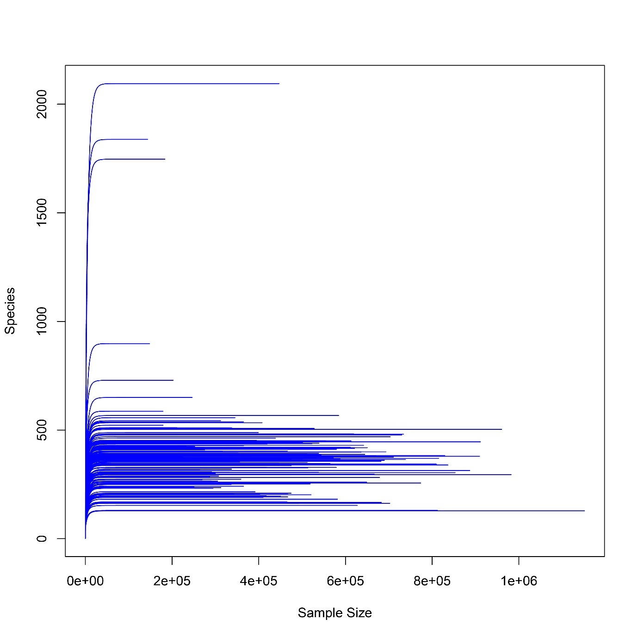
Figure S4. Rarefaction curves of the 16S rRNA gene reads.
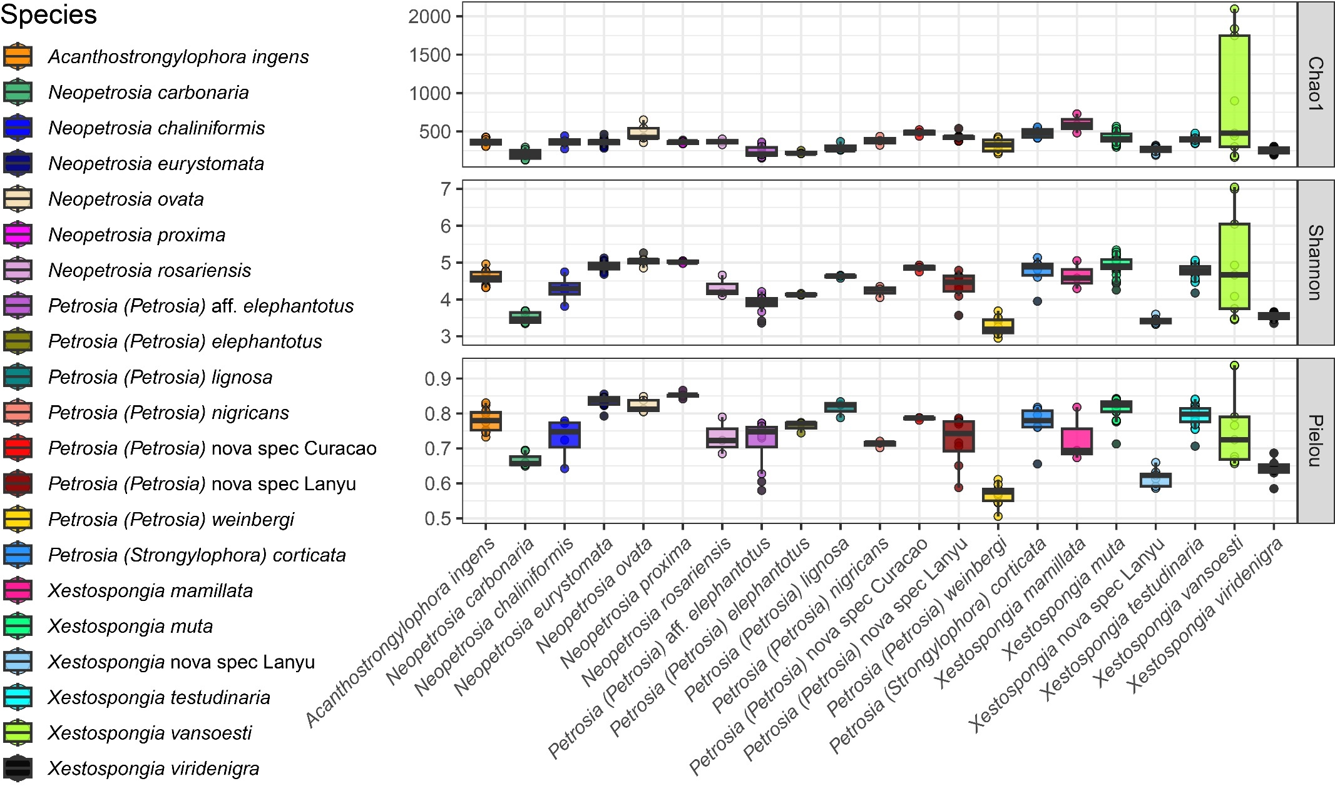
Figure S5. Alpha diversity analyses of sponge-associated prokaryotic communities.
Figure S6. Scatterplots of the mantel test correlations between host phylogenetic distance and prokaryotic community dissimilarities of the beta diversity calculated using Bray-Curtis, Unweighted UniFrac and Weighted UniFrac distance metrics.

Table S1. Detailed information on the samples included in t53is study. This table can also be found as a spreadsheet on the GitHub page linked to this manuscript (https://github.com/nielsvanderwindt/2025_Petrosiidae-phylosymbiosis).
extract ID | Field nr | Museum Voucher | Species | COI GenBank Accession Number | 18S GenBank Accession Number | 28S GenBank Accession Number | Country | Marine Realm | Marine Ecoregion | Latitude | Longitude | Collection Depth Range | Approximate Collection Depth | Collection Depth (m) | Sampling date (YYYY-MM-DD)
e1100004418 | KUE259 |  | Xestospongia testudinaria | PV351187 |  | PV350212 | Taiwan | Central Indo-Pacific | South Kuroshio | 22.05638 | 121.5067 | <30m | 15 | 15 | 2019-07-31
e1100004419 | KUE371 |  | Petrosia (Strongylophora) corticata | PV351188 | PV351460 | PV350217 | Taiwan | Central Indo-Pacific | South Kuroshio | 22.08007 | 121.5596 | <30m | 4 | 3-5 | 2019-08-10
e1100004421 | ORC149 |  | Xestospongia vansoesti | PV351189 | PV351461 | PV350249 | Taiwan | Central Indo-Pacific | South Kuroshio | 22.00809 | 121.5947 | <30m | 15 | 15 | 2018-08-12
e1100004422 | ORC364 |  | Petrosia (Petrosia) nova spec Lanyu | PV351190 |  | PV350254 | Taiwan | Central Indo-Pacific | South Kuroshio | 22.00809 | 121.5947 | <30m | 4 | 3-5 | 2018-10-08
e1100004425 | PSC568 |  | Xestospongia testudinaria | PV351191 | PV351462 | PV350269 | Taiwan | Central Indo-Pacific | Southern China | 23.55396 | 119.6423 | <30m | 5 | 5 | 2016-08-07
e1100004426 | JED087 | RMNH.POR.9592 | Petrosia (Petrosia) elephantotus | PV351192 | PV351463 | PV350206 | Saudi Arabia | Western Indo-Pacific | Northern and Central Red Sea | 22.25519 | 39.02564 | <30m | 20 | 20 | 2014-11-10
e1100004430 | KUE260 |  | Xestospongia testudinaria | PV351193 |  | PV350213 | Taiwan | Central Indo-Pacific | South Kuroshio | 22.05638 | 121.5067 | <30m | 15 | 15 | 2019-07-31
e1100004431 | ORC068 |  | Petrosia (Strongylophora) corticata | PV351194 | PV351464 | PV350241 | Taiwan | Central Indo-Pacific | South Kuroshio | 22.00809 | 121.5947 | <30m | 4 | 3-5 | 2018-08-11
e1100004433 | ORC159 |  | Xestospongia nova spec Lanyu | PV351195 | PV351465 | PV350250 | Taiwan | Central Indo-Pacific | South Kuroshio | 22.00809 | 121.5947 | <30m | 4 | 3-5 | 2018-08-13
e1100004434 | ORC367 |  | Petrosia (Petrosia) nova spec Lanyu | PV351196 | PV351466 | PV350255 | Taiwan | Central Indo-Pacific | South Kuroshio | 22.00809 | 121.5947 | <30m | 4 | 3-5 | 2018-10-08
e1100004435 | ORC425 |  | Petrosia (Petrosia) nova spec Lanyu | PV351197 | PV351467 | PV350260 | Taiwan | Central Indo-Pacific | South Kuroshio | 22.00809 | 121.5947 | <30m | 4 | 3-5 | 2018-10-11
e1100004436 | PSC505 |  | Acanthostrongylophora ingens | PV351198 | PV351468 | PV350263 | Taiwan | Central Indo-Pacific | Southern China |  |  | <30m | 6 | 6 | 2016-08-06
e1100004439 | MDB080 |  | Neopetrosia carbonaria | PV351199 | PV351469 | PV350219 | Martinique | Tropical Atlantic | Eastern Caribbean | 14.4934 | -61.0911 | <30m | 13.6 | 13.6 | 2016-09-07
e1100004442 | KUE276 |  | Petrosia (Petrosia) nova spec Lanyu | PV351200 | PV351470 | PV350214 | Taiwan | Central Indo-Pacific | South Kuroshio | 22.07503 | 121.5681 | <30m | 4 | 3-5 | 2019-08-01
e1100004443 | ORC070 |  | Petrosia (Petrosia) nova spec Lanyu | PV351201 |  | PV350242 | Taiwan | Central Indo-Pacific | South Kuroshio | 22.00809 | 121.5947 | <30m | 4 | 3-5 | 2018-08-11
e1100004444 | ORC113 |  | Xestospongia nova spec Lanyu | PV351202 | PV351471 | PV350246 | Taiwan | Central Indo-Pacific | South Kuroshio | 22.00809 | 121.5947 | <30m | 15 | 15 | 2018-08-13
e1100004445 | ORC167 |  | Petrosia (Strongylophora) corticata | PV351203 | PV351472 | PV350251 | Taiwan | Central Indo-Pacific | South Kuroshio | 22.00809 | 121.5947 | <30m | 4 | 3-5 | 2018-08-13
e1100004446 | ORC371 |  | Xestospongia nova spec Lanyu | PV351204 | PV351473 | PV350256 | Taiwan | Central Indo-Pacific | South Kuroshio | 22.00809 | 121.5947 | <30m | 4 | 3-5 | 2018-10-08
e1100004451 | MDB095 |  | Neopetrosia rosariensis | PV351205 | PV351474 | PV350220 | Martinique | Tropical Atlantic | Eastern Caribbean | 14.6386 | -61.1397 | <30m | 12 | 12 | 2016-09-08
e1100004452 | MDB234 |  | Neopetrosia rosariensis | PV351206 | PV351475 | PV350224 | Martinique | Tropical Atlantic | Eastern Caribbean | 14.4421 | -61.0396 | <30m | 15.7 | 15.7 | 2016-09-14
e1100004453 | KUE224 |  | Petrosia (Petrosia) nova spec Lanyu | PV351207 |  | PV350207 | Taiwan | Central Indo-Pacific | South Kuroshio | 22.07503 | 121.5681 | <30m | 4 | 3-5 | 2019-08-01
e1100004454 | KUE277 |  | Petrosia (Petrosia) nova spec Lanyu | PV351208 | PV351476 | PV350215 | Taiwan | Central Indo-Pacific | South Kuroshio | 22.07503 | 121.5681 | <30m | 4 | 3-5 | 2019-08-01
e1100004455 | ORC076 |  | Xestospongia nova spec Lanyu | PV351209 | PV351477 | PV350243 | Taiwan | Central Indo-Pacific | South Kuroshio | 22.00809 | 121.5947 | <30m | 4 | 3-5 | 2018-08-11
e1100004458 | ORC378 |  | Xestospongia nova spec Lanyu | PV351210 | PV351478 | PV350257 | Taiwan | Central Indo-Pacific | South Kuroshio | 22.00809 | 121.5947 | <30m | 4 | 3-5 | 2018-10-09
e1100004460 | PSC548 |  | Acanthostrongylophora ingens | PV351211 | PV351479 | PV350264 | Taiwan | Central Indo-Pacific | Southern China |  |  | <30m | 6 | 6 | 2016-08-06
e1100004465 | KUE225 |  | Petrosia (Petrosia) nova spec Lanyu | PV351212 | PV351480 | PV350208 | Taiwan | Central Indo-Pacific | South Kuroshio | 22.07503 | 121.5681 | <30m | 4 | 3-5 | 2019-08-01
e1100004467 | ORC077 |  | Xestospongia nova spec Lanyu | PV351213 | PV351481 | PV350244 | Taiwan | Central Indo-Pacific | South Kuroshio | 22.00809 | 121.5947 | <30m | 4 | 3-5 | 2018-08-11
e1100004468 | ORC126 |  | Xestospongia vansoesti |  |  | PV350247 | Taiwan | Central Indo-Pacific | South Kuroshio | 22.05138 | 121.5101 | <30m | 15 | 15 | 2018-08-12
e1100004469 | ORC301 |  | Petrosia (Strongylophora) corticata | PV351214 | PV351482 | PV350252 | Taiwan | Central Indo-Pacific | South Kuroshio | 22.00809 | 121.5947 | <30m | 4 | 3-5 | 2018-10-07
e1100004470 | ORC387 |  | Xestospongia nova spec Lanyu | PV351215 | PV351483 | PV350258 | Taiwan | Central Indo-Pacific | South Kuroshio | 22.00809 | 121.5947 | <30m | 4 | 3-5 | 2018-10-09
e1100004472 | PSC553 |  | Acanthostrongylophora ingens | PV351216 | PV351484 | PV350265 | Taiwan | Central Indo-Pacific | Southern China |  |  | <30m | 6 | 6 | 2016-08-06
e1100004475 | MDB153 |  | Petrosia (Petrosia) weinbergi | PV351217 | PV351485 | PV350221 | Martinique | Tropical Atlantic | Eastern Caribbean | 14.4446 | -60.8999 | <30m | 14.7 | 14.7 | 2016-09-10
e1100004476 | MDB243 |  | Neopetrosia rosariensis | PV351218 | PV351486 | PV350225 | Martinique | Tropical Atlantic | Eastern Caribbean | 14.4421 | -61.0396 | <30m | 15.7 | 15.7 | 2016-09-14
e1100004477 | KUE231 |  | Petrosia (Strongylophora) corticata | PV351219 | PV351487 | PV350209 | Taiwan | Central Indo-Pacific | South Kuroshio | 22.00809 | 121.5947 | <30m | 4 | 3-5 | 2019-07-30
e1100004481 | ORC302 |  | Xestospongia nova spec Lanyu | PV351220 | PV351488 | PV350253 | Taiwan | Central Indo-Pacific | South Kuroshio | 22.00809 | 121.5947 | <30m | 4 | 3-5 | 2018-10-07
e1100004484 | PSC565 |  | Xestospongia testudinaria | PV351221 | PV351489 | PV350266 | Taiwan | Central Indo-Pacific | Southern China | 23.55396 | 119.6423 | <30m | 5 | 5 | 2016-08-07
e1100004487 | MDB162 |  | Neopetrosia proxima |  | PV351490 | PV350222 | Martinique | Tropical Atlantic | Eastern Caribbean | 14.4446 | -60.8999 | <30m | 18.6 | 18.6 | 2016-09-10
e1100004489 | KUE257 |  | Xestospongia testudinaria | PV351222 |  | PV350210 | Taiwan | Central Indo-Pacific | South Kuroshio | 22.05638 | 121.5067 | <30m | 15 | 15 | 2019-07-31
e1100004492 | ORC145 |  | Xestospongia vansoesti |  | PV351491 | PV350248 | Taiwan | Central Indo-Pacific | South Kuroshio | 22.05138 | 121.5101 | <30m | 15 | 15 | 2018-08-12
e1100004494 | ORC391b |  | Xestospongia nova spec Lanyu | PV351223 | PV351492 | PV350259 | Taiwan | Central Indo-Pacific | South Kuroshio | 22.00809 | 121.5947 | <30m | 4 | 3-5 | 2018-10-09
e1100004495 | PSC160 |  | Acanthostrongylophora ingens | PV351224 | PV351493 | PV350261 | Taiwan | Central Indo-Pacific | Southern China | 23.25597 | 119.5102 | <30m | 4 | 4 | 2016-07-22
e1100004496 | PSC566 |  | Xestospongia testudinaria | PV351225 | PV351494 | PV350267 | Taiwan | Central Indo-Pacific | Southern China | 23.55396 | 119.6423 | <30m | 5 | 5 | 2016-08-07
e1100004497 | JED085 | RMNH.POR.9590 | Petrosia (Petrosia) elephantotus | PV351226 | PV351495 | PV350204 | Saudi Arabia | Western Indo-Pacific | Northern and Central Red Sea | 22.25519 | 39.02564 | <30m | 20 | 20 | 2014-11-10
e1100004501 | KUE258 |  | Xestospongia testudinaria | PV351227 | PV351496 | PV350211 | Taiwan | Central Indo-Pacific | South Kuroshio | 22.05638 | 121.5067 | <30m | 15 | 15 | 2019-07-31
e1100004502 | KUE288 |  | Petrosia (Strongylophora) corticata | PV351228 | PV351497 | PV350216 | Taiwan | Central Indo-Pacific | South Kuroshio | 22.08171 | 121.5113 | <30m | 4 | 3-5 | 2019-08-02
e1100004503 | ORC098 |  | Petrosia (Petrosia) nigricans |  | PV351498 | PV350245 | Taiwan | Central Indo-Pacific | South Kuroshio | 22.00809 | 121.5947 | <30m | 4 | 3-5 | 2018-08-12
e1100004507 | PSC431 |  | Petrosia (Petrosia) aff. elephantotus | PV351229 | PV351499 | PV350262 | Taiwan | Central Indo-Pacific | Southern China | 23.59397 | 119.5082 | <30m | 12 | 12 | 2016-08-04
e1100004508 | PSC567 |  | Xestospongia testudinaria | PV351230 | PV351500 | PV350268 | Taiwan | Central Indo-Pacific | Southern China | 23.55396 | 119.6423 | <30m | 5 | 5 | 2016-08-07
e1100004509 | JED086 | RMNH.POR.9591 | Petrosia (Petrosia) elephantotus | PV351231 | PV351501 | PV350205 | Saudi Arabia | Western Indo-Pacific | Northern and Central Red Sea | 22.25519 | 39.02564 | <30m | 20 | 20 | 2014-11-10
e1100004510 | MDB040 |  | Neopetrosia proxima | PV351232 | PV351502 | PV350218 | Martinique | Tropical Atlantic | Eastern Caribbean | 14.5333 | -61.0879 | <30m | 13 | 13 | 2016-09-06
e1100004511 | MDB223 |  | Xestospongia muta | PV351233 | PV351503 | PV350223 | Martinique | Tropical Atlantic | Eastern Caribbean | 14.4421 | -61.0396 | <30m | 16 | 16 | 2016-09-14
e1100004514 | MDB445 |  | Xestospongia muta | PV351234 | PV351504 | PV350234 | Martinique | Tropical Atlantic | Eastern Caribbean | 14.9144 | -61.149 | >30m | 75 | 60-90 | 2016-09-25
e1100004518 | CAO368 |  | Petrosia (Petrosia) weinbergi | PV351235 |  | PV350154 | Curacao | Tropical Atlantic | Southern Caribbean | 12.06531 | -68.8602 | <30m | 15 |  | 2022-04-24
e1100004519 | CAO422 |  | Petrosia (Petrosia) nova spec Curacao | PV351236 | PV351505 | PV350156 | Curacao | Tropical Atlantic | Southern Caribbean | 12.08319 | -68.8973 | >30m | 138 | 138 | 2022-04-23
e1100004520 | CAO556 |  | Neopetrosia carbonaria | PV351237 | PV351506 | PV350161 | Curacao | Tropical Atlantic | Southern Caribbean | 12.07071 | -68.86 | <30m | 1 | 1 | 2022-04-29
e1100004524 | CEL378 |  | Petrosia (Petrosia) aff. elephantotus | PV351238 | PV351507 | PV350190 | Indonesia | Central Indo-Pacific | Sulawesi Sea/Makassar Strait | -4.96928 | 119.3282 | <30m | 10 | 10 | 2018-05-07
e1100004525 | MDB285 |  | Neopetrosia proxima | PV351239 | PV351508 | PV350226 | Martinique | Tropical Atlantic | Eastern Caribbean | 14.4407 | -61.0291 | <30m | 15 | 15-18 | 2016-09-15
e1100004526 | MDB463 |  | Xestospongia muta | PV351240 | PV351509 | PV350235 | Martinique | Tropical Atlantic | Eastern Caribbean | 14.9144 | -61.149 | >30m | 75 | 60-90 | 2016-09-26
e1100004527 | MDB565 |  | Neopetrosia proxima |  | PV351510 | PV350239 | Martinique | Tropical Atlantic | Eastern Caribbean | 14.5538 | -61.0261 | <30m | 15 |  | 2016-10-06
e1100004529 | CAO323 |  | Petrosia (Petrosia) weinbergi | PV351241 | PV351511 | PV350152 | Curacao | Tropical Atlantic | Southern Caribbean | 12.06531 | -68.8602 | <30m | 17.4 | 17.4 | 2022-04-24
e1100004531 | CAO423 |  | Neopetrosia eurystomata |  | PV351512 | PV350157 | Curacao | Tropical Atlantic | Southern Caribbean | 12.08319 | -68.8973 | >30m | 115 | 115 | 2022-04-23
e1100004532 | CAO558 |  | Neopetrosia carbonaria | PV351242 | PV351513 | PV350162 | Curacao | Tropical Atlantic | Southern Caribbean | 12.07071 | -68.86 | <30m | 1 | 1 | 2022-04-29
e1100004534 | CEL243 |  | Acanthostrongylophora ingens | PV351243 | PV351514 | PV350181 | Indonesia | Central Indo-Pacific | Sulawesi Sea/Makassar Strait | -5.12543 | 119.3437 | <30m | 13 | 13 | 2018-05-02
e1100004536 | CEL382 |  | Neopetrosia chaliniformis |  | PV351515 | PV350191 | Indonesia | Central Indo-Pacific | Sulawesi Sea/Makassar Strait | -4.96928 | 119.3282 | <30m | 2 | 2 | 2018-05-07
e1100004537 | MDB289 |  | Xestospongia muta | PV351244 | PV351516 | PV350227 | Martinique | Tropical Atlantic | Eastern Caribbean | 14.4407 | -61.0291 | <30m | 15 | 15-18 | 2016-09-15
e1100004538 | MDB464 |  | Xestospongia muta | PV351245 |  | PV350236 | Martinique | Tropical Atlantic | Eastern Caribbean | 14.9144 | -61.149 | >30m | 75 | 60-90 | 2016-09-26
e1100004539 | MDB618 |  | Neopetrosia carbonaria | PV351246 | PV351517 | PV350240 | Martinique | Tropical Atlantic | Eastern Caribbean | 14.5763 | -61.0548 | <30m | 7.1 | 7.1 | 2016-10-09
e1100004540 | CAO317 |  | Petrosia (Petrosia) weinbergi | PV351247 | PV351518 | PV350149 | Curacao | Tropical Atlantic | Southern Caribbean | 12.06531 | -68.8602 | <30m | 15 |  | 2022-04-24
e1100004544 | CAO559 |  | Neopetrosia carbonaria | PV351248 | PV351519 | PV350163 | Curacao | Tropical Atlantic | Southern Caribbean | 12.07071 | -68.86 | <30m | 1 | 1 | 2022-04-29
e1100004547 | CEL347 |  | Xestospongia mamillata |  |  | PV350185 | Indonesia | Central Indo-Pacific | Sulawesi Sea/Makassar Strait | -4.92538 | 119.3982 | <30m | 10 | 10 | 2018-05-06
e1100004548 | CEL387 |  | Neopetrosia chaliniformis |  | PV351520 | PV350192 | Indonesia | Central Indo-Pacific | Sulawesi Sea/Makassar Strait | -4.96928 | 119.3282 | <30m | 2 | 2 | 2018-05-07
e1100004549 | MDB290 |  | Xestospongia muta | PV351249 |  | PV350228 | Martinique | Tropical Atlantic | Eastern Caribbean | 14.4407 | -61.0291 | <30m | 15 | 15-18 | 2016-09-15
e1100004550 | MDB484 |  | Neopetrosia proxima | PV351250 | PV351521 | PV350237 | Martinique | Tropical Atlantic | Eastern Caribbean | 14.5185 | -61.0977 | <30m | 11.7 | 11.7 | 2016-09-30
e1100004552 | CAO318 |  | Petrosia (Petrosia) weinbergi | PV351251 | PV351522 | PV350150 | Curacao | Tropical Atlantic | Southern Caribbean | 12.06531 | -68.8602 | <30m | 15 |  | 2022-04-24
e1100004557 | CEL192 |  | Xestospongia viridenigra | PV351252 | PV351523 | PV350176 | Indonesia | Central Indo-Pacific | Sulawesi Sea/Makassar Strait | -5.04839 | 119.3292 | <30m | 1 | 1 | 2018-04-30
e1100004558 | CEL248 |  | Petrosia (Petrosia) nigricans |  | PV351524 | PV350182 | Indonesia | Central Indo-Pacific | Sulawesi Sea/Makassar Strait | -5.12543 | 119.3437 | <30m | 13 | 13 | 2018-05-02
e1100004559 | CEL352 |  | Xestospongia mamillata |  |  | PV350186 | Indonesia | Central Indo-Pacific | Sulawesi Sea/Makassar Strait | -4.92538 | 119.3982 | <30m | 10 | 10 | 2018-05-06
e1100004560 | CEL389 |  | Neopetrosia chaliniformis |  | PV351525 | PV350193 | Indonesia | Central Indo-Pacific | Sulawesi Sea/Makassar Strait | -4.96928 | 119.3282 | <30m | 2 | 2 | 2018-05-07
e1100004561 | MDB294 |  | Xestospongia muta | PV351253 |  | PV350229 | Martinique | Tropical Atlantic | Eastern Caribbean | 14.4407 | -61.0291 | <30m | 15 | 15-18 | 2016-09-15
e1100004563 | CAO302 |  | Petrosia (Petrosia) weinbergi | PV351254 | PV351526 | PV350147 | Curacao | Tropical Atlantic | Southern Caribbean | 12.06865 | -68.8623 | <30m | 25.5 | 25.5 | 2022-04-20
e1100004567 | CAO426 |  | Neopetrosia eurystomata |  | PV351527 | PV350158 | Curacao | Tropical Atlantic | Southern Caribbean | 12.08319 | -68.8973 | >30m | 113 | 113 | 2022-04-23
e1100004568 | CEL101 |  | Xestospongia viridenigra | PV351255 | PV351528 | PV350170 | Indonesia | Central Indo-Pacific | Sulawesi Sea/Makassar Strait | -4.85673 | 119.3847 | <30m | 1 | 1 | 2018-04-27
e1100004569 | CEL193 |  | Xestospongia viridenigra | PV351256 | PV351529 | PV350177 | Indonesia | Central Indo-Pacific | Sulawesi Sea/Makassar Strait | -5.04839 | 119.3292 | <30m | 1 | 1 | 2018-04-30
e1100004571 | CEL356 |  | Xestospongia mamillata |  |  | PV350187 | Indonesia | Central Indo-Pacific | Sulawesi Sea/Makassar Strait | -4.92538 | 119.3982 | <30m | 10 | 10 | 2018-05-06
e1100004572 | CEL390 |  | Neopetrosia chaliniformis |  | PV351530 | PV350194 | Indonesia | Central Indo-Pacific | Sulawesi Sea/Makassar Strait | -4.96928 | 119.3282 | <30m | 2 | 2 | 2018-05-07
e1100004573 | MDB348 |  | Xestospongia muta | PV351257 | PV351531 | PV350230 | Martinique | Tropical Atlantic | Eastern Caribbean | 14.6462 | -60.8508 | <30m | 17 | 16.9-30 | 2016-09-18
e1100004574 | MDB523 |  | Petrosia (Petrosia) weinbergi | PV351258 | PV351532 | PV350238 | Martinique | Tropical Atlantic | Eastern Caribbean | 14.7867 | -61.2184 | <30m | 15 |  | 2016-10-03
e1100004578 | CAO420 |  | Neopetrosia eurystomata | PV351259 | PV351533 | PV350155 | Curacao | Tropical Atlantic | Southern Caribbean | 12.08319 | -68.8973 | >30m | 101 | 101 | 2022-04-23
e1100004579 | CAO428 |  | Neopetrosia eurystomata | PV351260 | PV351534 | PV350159 | Curacao | Tropical Atlantic | Southern Caribbean | 12.08319 | -68.8973 | >30m | 114 | 114 | 2022-04-23
e1100004580 | CEL104 |  | Xestospongia viridenigra | PV351261 | PV351535 | PV350171 | Indonesia | Central Indo-Pacific | Sulawesi Sea/Makassar Strait | -4.85673 | 119.3847 | <30m | 1 | 1 | 2018-04-27
e1100004581 | CEL196 |  | Xestospongia viridenigra | PV351262 | PV351536 | PV350178 | Indonesia | Central Indo-Pacific | Sulawesi Sea/Makassar Strait | -5.04839 | 119.3292 | <30m | 1 | 1 | 2018-04-30
e1100004582 | CEL273 |  | Acanthostrongylophora ingens | PV351263 | PV351537 | PV350183 | Indonesia | Central Indo-Pacific | Sulawesi Sea/Makassar Strait | -5.12543 | 119.3437 | <30m | 14.3 | 14.3 | 2018-05-03
e1100004583 | CEL358 |  | Petrosia (Petrosia) aff. elephantotus | PV351264 | PV351538 | PV350188 | Indonesia | Central Indo-Pacific | Sulawesi Sea/Makassar Strait | -4.92538 | 119.3982 | <30m | 10 | 10 | 2018-05-06
e1100004585 | MDB427 |  | Xestospongia muta | PV351265 | PV351539 | PV350232 | Martinique | Tropical Atlantic | Eastern Caribbean | 14.9178 | -61.1487 | >30m | 75 | 60-90 | 2016-09-25
e1100004588 | CAO321 |  | Petrosia (Petrosia) weinbergi | PV351266 |  | PV350151 | Curacao | Tropical Atlantic | Southern Caribbean | 12.06865 | -68.8623 | <30m | 14 | 14 | 2022-04-20
e1100004592 | CEL106 |  | Xestospongia viridenigra | PV351267 | PV351540 | PV350172 | Indonesia | Central Indo-Pacific | Sulawesi Sea/Makassar Strait | -4.85673 | 119.3847 | <30m | 1 | 1 | 2018-04-27
e1100004593 | CEL226 |  | Acanthostrongylophora ingens | PV351268 | PV351541 | PV350179 | Indonesia | Central Indo-Pacific | Sulawesi Sea/Makassar Strait | -5.12543 | 119.3437 | <30m | 16 | 16 | 2018-05-02
e1100004594 | CEL279 |  | Acanthostrongylophora ingens | PV351269 | PV351542 | PV350184 | Indonesia | Central Indo-Pacific | Sulawesi Sea/Makassar Strait | -5.12543 | 119.3437 | <30m | 10.7 | 10.7 | 2018-05-03
e1100004595 | CEL359 |  | Petrosia (Petrosia) aff. elephantotus |  | PV351543 | PV350189 | Indonesia | Central Indo-Pacific | Sulawesi Sea/Makassar Strait | -4.92538 | 119.3982 | <30m | 16 | 16 | 2018-05-06
e1100004597 | MDB431 |  | Xestospongia muta | PV351270 |  | PV350233 | Martinique | Tropical Atlantic | Eastern Caribbean | 14.9178 | -61.1487 | >30m | 75 | 60-90 | 2016-09-25
e1100004599 | CAO305 |  | Petrosia (Petrosia) weinbergi | PV351271 | PV351544 | PV350148 | Curacao | Tropical Atlantic | Southern Caribbean | 12.06865 | -68.8623 | <30m | 15.8 | 15.8 | 2022-04-20
e1100004601 | CAO337 |  | Petrosia (Petrosia) weinbergi | PV351272 | PV351545 | PV350153 | Curacao | Tropical Atlantic | Southern Caribbean | 12.37496 | -69.1587 | <30m | 15.6 | 15.6 | 2022-04-26
e1100004603 | CAO555 |  | Neopetrosia carbonaria | PV351273 | PV351546 | PV350160 | Curacao | Tropical Atlantic | Southern Caribbean | 12.07071 | -68.86 | <30m | 1 | 1 | 2022-04-29
e1100004605 | CEL234 |  | Petrosia (Petrosia) nigricans |  | PV351547 | PV350180 | Indonesia | Central Indo-Pacific | Sulawesi Sea/Makassar Strait | -5.12543 | 119.3437 | <30m | 13.6 | 13.6 | 2018-05-02
e1100004611 | SRI267 |  | Xestospongia testudinaria | PV351274 |  | PV350276 | Sri Lanka | Western Indo-Pacific | South India and Sri Lanka | 8.29155 | 79.74012 | <30m | 16 | 16 | 2019-04-23
e1100004612 | SUB121 |  | Neopetrosia eurystomata | PV351275 | PV351548 | PV350287 | Curacao | Tropical Atlantic | Southern Caribbean | 12.08319 | -68.8973 | >30m | 85 | 85 | 2018-11
e1100004614 | SCR011 |  | Xestospongia muta | PV351276 | PV351549 | PV350270 | Curacao | Tropical Atlantic | Southern Caribbean | 12.08456 | -68.8983 | >30m | 52 | 52 | 2015-11
e1100004618 | TWA018 |  | Acanthostrongylophora ingens | PV351277 | PV351550 | PV350296 | Taiwan | Central Indo-Pacific | Southern China | 23.53745 | 119.5456 | <30m | 5 | 5 | 2023-04-18
e1100004619 | TWA031 |  | Xestospongia vansoesti |  | PV351551 | PV350304 | Taiwan | Central Indo-Pacific | Southern China | 23.25597 | 119.5102 | <30m | 10 | 10 | 2023-04-21
e1100004622 | CEL453 |  | Petrosia (Petrosia) lignosa |  | PV351552 | PV350197 | Indonesia | Central Indo-Pacific | Sulawesi Sea/Makassar Strait | -4.70905 | 118.9646 | <30m | 20 |  | 2018-05-09
e1100004623 | SRI277 |  | Xestospongia testudinaria | PV351278 | PV351553 | PV350277 | Sri Lanka | Western Indo-Pacific | South India and Sri Lanka | 8.29155 | 79.74012 | <30m | 13 | 13 | 2019-04-26
e1100004624 | SUB122 |  | Neopetrosia eurystomata | PV351279 | PV351554 | PV350288 | Curacao | Tropical Atlantic | Southern Caribbean | 12.08319 | -68.8973 | >30m | 102 | 102 | 2018-11
e1100004626 | SCR012 |  | Xestospongia muta | PV351280 | PV351555 | PV350271 | Curacao | Tropical Atlantic | Southern Caribbean | 12.08456 | -68.8983 | >30m | 48 | 48 | 2015-11
e1100004630 | TWA019 |  | Acanthostrongylophora ingens | PV351281 | PV351556 | PV350297 | Taiwan | Central Indo-Pacific | Southern China | 23.53745 | 119.5456 | <30m | 5 | 5 | 2023-04-18
e1100004631 | TWA032 |  | Xestospongia vansoesti |  | PV351557 | PV350305 | Taiwan | Central Indo-Pacific | Southern China | 23.25597 | 119.5102 | <30m | 10 | 10 | 2023-04-21
e1100004634 | CEL721 |  | Xestospongia testudinaria | PV351282 |  | PV350198 | Indonesia | Central Indo-Pacific | Sulawesi Sea/Makassar Strait | -5.12543 | 119.3437 | <30m | 15 | 15 | 2018-04-28
e1100004635 | SRI279 |  | Xestospongia testudinaria | PV351283 | PV351558 | PV350278 | Sri Lanka | Western Indo-Pacific | South India and Sri Lanka | 8.29155 | 79.74012 | <30m | 13 | 13 | 2019-04-26
e1100004636 | SUB123 |  | Neopetrosia eurystomata | PV351284 | PV351559 | PV350289 | Curacao | Tropical Atlantic | Southern Caribbean | 12.08319 | -68.8973 | >30m | 91 | 91 | 2018-11
e1100004638 | SCR013 |  | Xestospongia muta | PV351285 | PV351560 | PV350272 | Curacao | Tropical Atlantic | Southern Caribbean | 12.08456 | -68.8983 | >30m | 48 | 48 | 2015-11
e1100004642 | TWA020 |  | Petrosia (Petrosia) aff. elephantotus | PV351286 | PV351561 | PV350298 | Taiwan | Central Indo-Pacific | Southern China | 23.53745 | 119.5456 | <30m | 5 | 5 | 2023-04-18
e1100004643 | TWA034 |  | Petrosia (Petrosia) aff. elephantotus | PV351287 | PV351562 | PV350306 | Taiwan | Central Indo-Pacific | Southern China | 23.25597 | 119.5102 | <30m | 13 | 13 | 2023-04-21
e1100004646 | CEL722 |  | Xestospongia testudinaria | PV351288 |  | PV350199 | Indonesia | Central Indo-Pacific | Sulawesi Sea/Makassar Strait | -5.12543 | 119.3437 | <30m | 14.6 | 14.6 | 2018-04-28
e1100004647 | SRI282 |  | Xestospongia testudinaria | PV351289 | PV351563 | PV350279 | Sri Lanka | Western Indo-Pacific | South India and Sri Lanka | 8.29155 | 79.74012 | <30m | 12 | 12 | 2019-04-26
e1100004648 | SUB128 |  | Xestospongia muta | PV351290 | PV351564 | PV350290 | Curacao | Tropical Atlantic | Southern Caribbean | 12.06531 | -68.8602 | <30m | 26 | 26 | 2018-11
e1100004650 | SCR059 |  | Xestospongia muta | PV351291 | PV351565 | PV350273 | Curacao | Tropical Atlantic | Southern Caribbean | 12.08456 | -68.8983 | <30m | 27 | 27 | 2015-11
e1100004654 | TWA021 |  | Xestospongia testudinaria | PV351292 | PV351566 | PV350299 | Taiwan | Central Indo-Pacific | Southern China | 23.53745 | 119.5456 | <30m | 5 | 5 | 2023-04-18
e1100004655 | TWA035 |  | Petrosia (Petrosia) aff. elephantotus | PV351293 | PV351567 | PV350307 | Taiwan | Central Indo-Pacific | Southern China | 23.25597 | 119.5102 | <30m | 13 | 13 | 2023-04-21
e1100004658 | CEL723 |  | Xestospongia testudinaria | PV351294 |  | PV350200 | Indonesia | Central Indo-Pacific | Sulawesi Sea/Makassar Strait | -5.12543 | 119.3437 | <30m | 15.1 | 15.1 | 2018-04-28
e1100004659 | SUB041 |  | Xestospongia muta | PV351295 |  | PV350282 | Curacao | Tropical Atlantic | Southern Caribbean | 11.98713 | -68.6474 | >30m | 104 | 104 | 2018-08-29
e1100004660 | SUB129 |  | Xestospongia muta | PV351296 | PV351568 | PV350291 | Curacao | Tropical Atlantic | Southern Caribbean | 12.06531 | -68.8602 | <30m | 28 | 28 | 2018-11
e1100004661 | BDR002 |  | Neopetrosia ovata | PV351297 | PV351569 | PV350143 | Bonaire | Tropical Atlantic | Southern Caribbean | 11.9821 | -68.6452 | >30m | 149 | 149 | 2013-05-27
e1100004662 | SCR060 |  | Xestospongia muta | PV351298 | PV351570 | PV350274 | Curacao | Tropical Atlantic | Southern Caribbean | 12.08456 | -68.8983 | <30m | 27 | 27 | 2015-11
e1100004666 | TWA023 |  | Acanthostrongylophora ingens | PV351299 | PV351571 | PV350300 | Taiwan | Central Indo-Pacific | Southern China | 23.53745 | 119.5456 | <30m | 5 | 5 | 2023-04-18
e1100004667 | TWA036 |  | Petrosia (Petrosia) aff. elephantotus | PV351300 | PV351572 | PV350308 | Taiwan | Central Indo-Pacific | Southern China | 23.25597 | 119.5102 | <30m | 10 | 10 | 2023-04-21
e1100004670 | CEL724 |  | Xestospongia testudinaria | PV351301 | PV351573 | PV350201 | Indonesia | Central Indo-Pacific | Sulawesi Sea/Makassar Strait | -5.12543 | 119.3437 | <30m | 10.1 | 10.1 | 2018-04-28
e1100004671 | SUB053 |  | Neopetrosia ovata | PV351302 | PV351574 | PV350284 | Curacao | Tropical Atlantic | Southern Caribbean | 11.98713 | -68.6474 | >30m | 167 | 167 | 2018-08
e1100004672 | SUB130 |  | Xestospongia muta | PV351303 | PV351575 | PV350292 | Curacao | Tropical Atlantic | Southern Caribbean | 12.06531 | -68.8602 | <30m | 28 | 28 | 2018-11
e1100004673 | BDR008 |  | Neopetrosia eurystomata | PV351304 | PV351576 | PV350144 | Bonaire | Tropical Atlantic | Southern Caribbean | 12.1469 | -68.2821 | >30m | 108 | 108 | 2013-05-30
e1100004674 | SCR063 |  | Xestospongia muta | PV351305 | PV351577 | PV350275 | Curacao | Tropical Atlantic | Southern Caribbean | 12.08456 | -68.8983 | <30m | 27 | 27 | 2015-11
e1100004676 | DOM044 |  | Neopetrosia eurystomata |  | PV351578 | PV350202 | Dominica | Tropical Atlantic | Eastern Caribbean | 15.42367 | 61.34653 | >30m | 144 | 144 | 2016-03-17
e1100004677 | TWA015 |  | Petrosia (Petrosia) aff. elephantotus | PV351306 | PV351579 | PV350293 | Taiwan | Central Indo-Pacific | Southern China | 23.53745 | 119.5456 | <30m | 5 | 5 | 2023-04-18
e1100004678 | TWA025 |  | Petrosia (Petrosia) aff. elephantotus | PV351307 | PV351580 | PV350301 | Taiwan | Central Indo-Pacific | Southern China | 23.25597 | 119.5102 | <30m | 8 | 8 | 2023-04-21
e1100004679 | TWA050 |  | Petrosia (Petrosia) aff. elephantotus | PV351308 | PV351581 | PV350309 | Taiwan | Central Indo-Pacific | Southern China | 23.24941 | 119.6142 | <30m | 8 | 8 | 2023-04-21
e1100004681 | CEL442 |  | Petrosia (Petrosia) lignosa |  | PV351582 | PV350195 | Indonesia | Central Indo-Pacific | Sulawesi Sea/Makassar Strait | -4.70905 | 118.9646 | <30m | 20 |  | 2018-05-08
e1100004683 | SUB059 |  | Xestospongia muta | PV351309 |  | PV350285 | Curacao | Tropical Atlantic | Southern Caribbean | 11.98713 | -68.6474 | <30m | 15 | 15 | 2018-08
e1100004685 | BDR013 |  | Neopetrosia eurystomata |  | PV351583 | PV350145 | Bonaire | Tropical Atlantic | Southern Caribbean | 12.1469 | -68.2821 | >30m | 111 | 111 | 2013-05-30
e1100004688 | DOM049 |  | Xestospongia muta | PV351310 | PV351584 | PV350203 | Dominica | Tropical Atlantic | Eastern Caribbean | 15.42367 | 61.34653 | >30m | 140 | 140 | 2016-03-17
e1100004689 | TWA016 |  | Xestospongia testudinaria | PV351311 | PV351585 | PV350294 | Taiwan | Central Indo-Pacific | Southern China | 23.53745 | 119.5456 | <30m | 5 | 5 | 2023-04-18
e1100004690 | TWA027 |  | Petrosia (Petrosia) aff. elephantotus | PV351312 | PV351586 | PV350302 | Taiwan | Central Indo-Pacific | Southern China | 23.25597 | 119.5102 | <30m | 10 | 10 | 2023-04-21
e1100004691 | TWA051 |  | Acanthostrongylophora ingens | PV351313 | PV351587 | PV350310 | Taiwan | Central Indo-Pacific | Southern China | 23.24941 | 119.6142 | <30m | 7 | 7 | 2023-04-21
e1100004693 | CEL448 |  | Petrosia (Petrosia) lignosa |  | PV351588 | PV350196 | Indonesia | Central Indo-Pacific | Sulawesi Sea/Makassar Strait | -4.70905 | 118.9646 | <30m | 20 |  | 2018-05-09
e1100004695 | SUB069 |  | Xestospongia muta | PV351314 | PV351589 | PV350286 | Curacao | Tropical Atlantic | Southern Caribbean | 11.98713 | -68.6474 | <30m | 13 | 13 | 2018-08
e1100004697 | BDR037 |  | Neopetrosia eurystomata | PV351315 | PV351590 | PV350146 | Bonaire | Tropical Atlantic | Southern Caribbean | 12.137 | -68.286 | >30m | 88 | 88 | 2013-05-31
e1100004701 | TWA017 |  | Xestospongia testudinaria | PV351316 | PV351591 | PV350295 | Taiwan | Central Indo-Pacific | Southern China | 23.53745 | 119.5456 | <30m | 5 | 5 | 2023-04-18
e1100004702 | TWA030 |  | Xestospongia vansoesti | PV351317 | PV351592 | PV350303 | Taiwan | Central Indo-Pacific | Southern China | 23.25597 | 119.5102 | <30m | 10 | 10 | 2023-04-21
e1100004703 | TWA061 |  | Xestospongia testudinaria | PV351318 | PV351593 | PV350311 | Taiwan | Central Indo-Pacific | Southern China | 23.49014 | 119.5247 | <30m | 10 | 10 | 2023-04-23
e1100034946 | MDB399 |  | Neopetrosia carbonaria | PV351319 | PV351594 | PV350231 | Martinique | Tropical Atlantic | Eastern Caribbean | 14.7577 | -60.8809 | <30m | 2 | 2 | 2016-09-22
e1100034947 | CAO573 |  | Neopetrosia eurystomata | PV351320 | PV351595 | PV350164 | Curacao | Tropical Atlantic | Southern Caribbean | 12.08319 | -68.8973 | >30m | 102 | 102 | 2023-03-30
e1100034958 | SUB001 |  | Xestospongia muta | PV351321 | PV351596 | PV350280 | Curacao | Tropical Atlantic | Southern Caribbean | 11.98713 | -68.6474 | >30m | 144 | 144 | 2018-08
e1100034959 | CAO576 |  | Neopetrosia ovata | PV351322 | PV351597 | PV350165 | Curacao | Tropical Atlantic | Southern Caribbean | 12.08319 | -68.8973 | >30m | 188 | 188 | 2023-03-30
e1100034970 | SUB002 |  | Neopetrosia ovata | PV351323 | PV351598 | PV350281 | Curacao | Tropical Atlantic | Southern Caribbean | 11.98713 | -68.6474 | >30m | 165 | 165 | 2018-08
e1100034971 | CAO577 |  | Neopetrosia ovata | PV351324 | PV351599 | PV350166 | Curacao | Tropical Atlantic | Southern Caribbean | 12.08319 | -68.8973 | >30m | 189 | 189 | 2023-03-30
e1100034983 | CAO578 |  | Neopetrosia eurystomata | PV351325 | PV351600 | PV350167 | Curacao | Tropical Atlantic | Southern Caribbean | 12.08319 | -68.8973 | >30m | 104 | 104 | 2023-03-30
e1100034988 | CEL165 |  | Xestospongia vansoesti |  |  | PV350173 | Indonesia | Central Indo-Pacific | Sulawesi Sea/Makassar Strait | -5.0547 | 119.4265 | <30m | 6 | 6 | 2018-04-29
e1100034995 | CAO589 |  | Petrosia (Petrosia) nova spec Curacao | PV351326 | PV351601 | PV350168 | Curacao | Tropical Atlantic | Southern Caribbean | 12.08319 | -68.8973 | >30m | 151 | 151 | 2023-03-30
e1100035000 | CEL167 |  | Xestospongia vansoesti |  |  | PV350174 | Indonesia | Central Indo-Pacific | Sulawesi Sea/Makassar Strait | -5.0547 | 119.4265 | <30m | 6 | 6 | 2018-04-29
e1100035006 | SUB042 |  | Xestospongia muta | PV351327 | PV351602 | PV350283 | Curacao | Tropical Atlantic | Southern Caribbean | 11.98713 | -68.6474 | >30m | 85 | 85 | 2018-08-29
e1100035007 | CAO595 |  | Petrosia (Petrosia) nova spec Curacao | PV351328 | PV351603 | PV350169 | Curacao | Tropical Atlantic | Southern Caribbean | 12.08319 | -68.8973 | >30m | 153 | 153 | 2023-03-30
e1100035012 | CEL170 |  | Xestospongia vansoesti |  |  | PV350175 | Indonesia | Central Indo-Pacific | Sulawesi Sea/Makassar Strait | -5.0547 | 119.4265 | <30m | 6 | 6 | 2018-04-29

Table S2. PCR reaction mixes and thermal cycling conditions used to amplify sponge DNA markers for molecular identification. Each reaction was performed in a final volume of 25 µl. *Thermal cycling included 30 cycles, excluding the initial denaturation and final extension steps.
 | PCR mix |  | Thermal Cycler conditions PCR1
 | Chemical and concentration | Reaction (µl) | Temp. | Time
28S rRNA | mQ water  ThermoFisher Phire HS II Buffer (5x)  Qiagen MgCl₂ (25 mM)  Promega BSA (10 mg/ml)  Qiagen Q-solution  Forward primer (10 pMol/µl)  Reverse primer (10 pMol/µl)  dNTP (2.5 mM)  ThermoFisher Phire HS II Taq  Template DNA (1:10 dilution) | 7.9  5  1  1  5  1.3  1.3  0.5  0.5  1.5 | 98°C  98°C  51°C  72°C  72°C | 0:00:30  0:00:10*  0:00:10*  0:00:15*  0:05:00
18S rRNA | mQ water  ThermoFisher Phire HS II Buffer (5x)  Qiagen MgCl₂ (25 mM)  Promega BSA (10 mg/ml)  Forward primer (10 pMol/µl)  Reverse primer (10 pMol/µl)  dNTP (2.5 mM)  ThermoFisher Phire HS II Taq  Template DNA (1:10 dilution) | 7.9  5  1  1  1.3  1.3  0.5  0.5  1.5 | 98°C  98°C  55°C  72°C  72°C | 0:00:30  0:00:10*  0:00:10*  0:00:30*  0:05:00
COI | mQ water  ThermoFisher Phire HS II Buffer (5x)  Qiagen MgCl₂ (25 mM)  Promega BSA (10 mg/ml)  Forward primer (10 pMol/µl)  Reverse primer (10 pMol/µl)  dNTP (2.5 mM)  ThermoFisher Phire HS II Taq  Template DNA (1:10 dilution) | 7.9  5  1  1  1.3  1.3  0.5  0.5  1.5 | 98°C  98°C  53°C  72°C  72°C | 0:00:30  0:00:10*  0:00:10*  0:00:15*  0:05:00

Table S3. Results of the PERMANOVA test conducted with sponge species, collection depth and marine ecoregions as factors.
 | D.f. | Sum of squares | R² | F | p
Species | 18 | 36.57677 | 0.53482 | 15.7793 | 0.001
Collection Depth | 1 | 0.381506 | 0.005578 | 2.962482 | 0.001
Marine Ecoregion | 4 | 2.439412 | 0.035669 | 4.735654 | 0.001
Residual | 143 | 18.4154 | 0.269267 | - | -
Total | 168 | 68.39081 | 1 | - | -

Table S4. Results of the multivariate pairwise Adonis test comparing each individual sponge species. Insignificant p-values are highlighted in red.
Pairwise comparisons | Sum of squares | F.Model | R² | p value
Acanthostrongylophora ingens vs Neopetrosia carbonaria | 3.34945519 | 28.14681278 | 0.623450717 | 0.001
Acanthostrongylophora ingens vs Neopetrosia chaliniformis | 0.926314353 | 6.280189628 | 0.309671149 | 0.001
Acanthostrongylophora ingens vs Neopetrosia eurystomata | 2.633854422 | 21.90590902 | 0.487817962 | 0.001
Acanthostrongylophora ingens vs Neopetrosia ovata | 2.211372648 | 16.73053883 | 0.527269295 | 0.001
Acanthostrongylophora ingens vs Neopetrosia proxima | 1.291529645 | 9.701387008 | 0.39274665 | 0.001
Acanthostrongylophora ingens vs Neopetrosia rosariensis | 0.960342239 | 6.811637883 | 0.343820028 | 0.003
Acanthostrongylophora ingens vs Petrosia (Petrosia) aff. elephantotus | 3.597648981 | 25.14355023 | 0.533340194 | 0.001
Acanthostrongylophora ingens vs Petrosia (Petrosia) lignosa | 1.313384291 | 9.562234335 | 0.42381593 | 0.004
Acanthostrongylophora ingens vs Petrosia (Petrosia) nigricans | 1.661047456 | 10.95244032 | 0.457257806 | 0.003
Acanthostrongylophora ingens vs Petrosia (Petrosia) nova spec Curacao | 1.336146268 | 9.620242506 | 0.425293518 | 0.003
Acanthostrongylophora ingens vs Petrosia (Petrosia) weinbergi | 3.733371399 | 25.35167368 | 0.559001942 | 0.001
Acanthostrongylophora ingens vs Xestospongia mamillata | 1.030298794 | 6.5406119 | 0.334718889 | 0.002
Acanthostrongylophora ingens vs Xestospongia muta | 3.102800229 | 18.06844988 | 0.340474424 | 0.001
Acanthostrongylophora ingens vs Xestospongia viridenigra | 3.040929914 | 26.16144146 | 0.620506334 | 0.001
Neopetrosia carbonaria vs Neopetrosia chaliniformis | 1.989081198 | 22.06600448 | 0.710294254 | 0.002
Neopetrosia carbonaria vs Neopetrosia eurystomata | 3.681929225 | 43.84079194 | 0.708929989 | 0.001
Neopetrosia carbonaria vs Neopetrosia ovata | 2.420984568 | 33.21200448 | 0.768582825 | 0.002
Neopetrosia carbonaria vs Neopetrosia proxima | 2.414296335 | 32.48354877 | 0.764614768 | 0.002
Neopetrosia carbonaria vs Neopetrosia rosariensis | 1.743137239 | 24.07968206 | 0.75062097 | 0.014
Neopetrosia carbonaria vs Petrosia (Petrosia) aff. elephantotus | 3.279017075 | 29.42891336 | 0.63384885 | 0.001
Neopetrosia carbonaria vs Petrosia (Petrosia) lignosa | 1.672770523 | 25.16026641 | 0.758747415 | 0.012
Neopetrosia carbonaria vs Petrosia (Petrosia) nigricans | 1.686158711 | 18.79011513 | 0.701382396 | 0.01
Neopetrosia carbonaria vs Petrosia (Petrosia) nova spec Curacao | 1.752588223 | 25.40586176 | 0.760521071 | 0.009
Neopetrosia carbonaria vs Petrosia (Petrosia) weinbergi | 3.20260644 | 28.39899079 | 0.654369843 | 0.001
Neopetrosia carbonaria vs Xestospongia mamillata | 1.583935224 | 15.95674746 | 0.666064852 | 0.01
Neopetrosia carbonaria vs Xestospongia muta | 4.002500186 | 25.24345889 | 0.456949282 | 0.001
Neopetrosia carbonaria vs Xestospongia viridenigra | 1.794019331 | 32.55907255 | 0.747469371 | 0.001
Neopetrosia chaliniformis vs Neopetrosia ovata | 1.506250653 | 13.6767105 | 0.661454853 | 0.007
Neopetrosia chaliniformis vs Petrosia (Petrosia) lignosa | 1.053110098 | 9.175736227 | 0.647284633 | 0.023
Neopetrosia chaliniformis vs Xestospongia mamillata | 0.798111785 | 4.772862872 | 0.488379192 | 0.026
Neopetrosia chaliniformis vs Xestospongia viridenigra | 1.875058603 | 23.14587475 | 0.743144154 | 0.007
Neopetrosia eurystomata vs Neopetrosia chaliniformis | 1.508430869 | 14.56302303 | 0.4926094 | 0.001
Neopetrosia eurystomata vs Neopetrosia ovata | 2.219001861 | 24.13007106 | 0.601296495 | 0.001
Neopetrosia eurystomata vs Petrosia (Petrosia) lignosa | 1.517040411 | 16.66699828 | 0.543483197 | 0.004
Neopetrosia eurystomata vs Xestospongia mamillata | 1.222024858 | 11.13443421 | 0.44299522 | 0.004
Neopetrosia eurystomata vs Xestospongia viridenigra | 3.346172073 | 42.18333394 | 0.712756973 | 0.001
Neopetrosia proxima vs Neopetrosia chaliniformis | 0.989556004 | 8.821642776 | 0.557568067 | 0.007
Neopetrosia proxima vs Neopetrosia eurystomata | 0.692826192 | 7.461536361 | 0.318032726 | 0.001
Neopetrosia proxima vs Neopetrosia ovata | 1.644127802 | 18.71295405 | 0.700519831 | 0.014
Neopetrosia proxima vs Petrosia (Petrosia) aff. elephantotus | 2.413385565 | 19.37837527 | 0.563679206 | 0.001
Neopetrosia proxima vs Petrosia (Petrosia) lignosa | 1.177517366 | 13.9678595 | 0.699517116 | 0.02
Neopetrosia proxima vs Petrosia (Petrosia) nigricans | 1.413825416 | 12.2616773 | 0.671443104 | 0.019
Neopetrosia proxima vs Petrosia (Petrosia) nova spec Curacao | 1.032050172 | 11.77683358 | 0.662482074 | 0.021
Neopetrosia proxima vs Xestospongia mamillata | 0.9300405 | 7.265478256 | 0.547698177 | 0.019
Neopetrosia proxima vs Xestospongia muta | 1.208880596 | 7.155237458 | 0.203532616 | 0.001
Neopetrosia proxima vs Xestospongia viridenigra | 2.276591427 | 35.32401267 | 0.796949792 | 0.004
Neopetrosia rosariensis vs Neopetrosia chaliniformis | 0.770551988 | 6.203103082 | 0.553695082 | 0.032
Neopetrosia rosariensis vs Neopetrosia eurystomata | 1.165667781 | 12.34878568 | 0.468666216 | 0.002
Neopetrosia rosariensis vs Neopetrosia ovata | 1.303379731 | 14.51506847 | 0.707532051 | 0.011
Neopetrosia rosariensis vs Neopetrosia proxima | 0.774301932 | 8.400230421 | 0.583340001 | 0.017
Neopetrosia rosariensis vs Petrosia (Petrosia) aff. elephantotus | 1.605147104 | 12.24592342 | 0.485065379 | 0.003
Neopetrosia rosariensis vs Petrosia (Petrosia) lignosa | 1.017025962 | 11.90555729 | 0.74851557 | 0.1
Neopetrosia rosariensis vs Petrosia (Petrosia) nigricans | 1.173962252 | 8.898493451 | 0.689886263 | 0.1
Neopetrosia rosariensis vs Petrosia (Petrosia) nova spec Curacao | 0.96662878 | 10.69013736 | 0.727708469 | 0.1
Neopetrosia rosariensis vs Petrosia (Petrosia) weinbergi | 1.730795916 | 12.68067989 | 0.53548631 | 0.003
Neopetrosia rosariensis vs Xestospongia mamillata | 0.856121947 | 5.67028884 | 0.58636189 | 0.1
Neopetrosia rosariensis vs Xestospongia muta | 0.969590482 | 5.520498853 | 0.175139958 | 0.002
Neopetrosia rosariensis vs Xestospongia viridenigra | 1.676156907 | 28.20958933 | 0.801190524 | 0.009
Petrosia (Petrosia) aff. elephantotus vs Neopetrosia chaliniformis | 1.996610172 | 14.43720427 | 0.507687188 | 0.002
Petrosia (Petrosia) aff. elephantotus vs Neopetrosia eurystomata | 4.245265581 | 37.03325485 | 0.616879011 | 0.001
Petrosia (Petrosia) aff. elephantotus vs Neopetrosia ovata | 2.51245454 | 20.3293404 | 0.575423718 | 0.001
Petrosia (Petrosia) aff. elephantotus vs Petrosia (Petrosia) lignosa | 1.568168978 | 12.30498918 | 0.486267316 | 0.001
Petrosia (Petrosia) aff. elephantotus vs Petrosia (Petrosia) nova spec Curacao | 1.78514823 | 13.84055044 | 0.515658219 | 0.002
Petrosia (Petrosia) aff. elephantotus vs Xestospongia mamillata | 1.389196054 | 9.411015561 | 0.419928117 | 0.003
Petrosia (Petrosia) aff. elephantotus vs Xestospongia muta | 4.82265133 | 28.69872467 | 0.45053845 | 0.001
Petrosia (Petrosia) aff. elephantotus vs Xestospongia viridenigra | 2.942016883 | 27.19415174 | 0.629579483 | 0.001
Petrosia (Petrosia) elephantotus vs Acanthostrongylophora ingens | 1.664866621 | 13.06783154 | 0.501301058 | 0.002
Petrosia (Petrosia) elephantotus vs Neopetrosia carbonaria | 1.797853523 | 35.73052677 | 0.817061431 | 0.006
Petrosia (Petrosia) elephantotus vs Neopetrosia chaliniformis | 1.317730674 | 14.82211169 | 0.747756441 | 0.029
Petrosia (Petrosia) elephantotus vs Neopetrosia eurystomata | 1.858462633 | 22.72459579 | 0.618784096 | 0.004
Petrosia (Petrosia) elephantotus vs Neopetrosia ovata | 1.505757937 | 24.94471889 | 0.806105849 | 0.021
Petrosia (Petrosia) elephantotus vs Neopetrosia proxima | 1.398745581 | 22.29249722 | 0.787929642 | 0.015
Petrosia (Petrosia) elephantotus vs Neopetrosia rosariensis | 1.159364927 | 21.83802087 | 0.845189381 | 0.1
Petrosia (Petrosia) elephantotus vs Petrosia (Petrosia) aff. elephantotus | 1.181566955 | 10.0565368 | 0.436168575 | 0.004
Petrosia (Petrosia) elephantotus vs Petrosia (Petrosia) lignosa | 1.115460556 | 27.02328519 | 0.87106459 | 0.1
Petrosia (Petrosia) elephantotus vs Petrosia (Petrosia) nigricans | 1.244267775 | 14.17460384 | 0.779912672 | 0.1
Petrosia (Petrosia) elephantotus vs Petrosia (Petrosia) nova spec Curacao | 1.284838949 | 27.76483348 | 0.87407458 | 0.1
Petrosia (Petrosia) elephantotus vs Petrosia (Petrosia) weinbergi | 1.911309963 | 15.86973386 | 0.590617456 | 0.006
Petrosia (Petrosia) elephantotus vs Xestospongia mamillata | 1.074050556 | 10.05315943 | 0.715366497 | 0.1
Petrosia (Petrosia) elephantotus vs Xestospongia muta | 1.844716427 | 10.92564626 | 0.29588233 | 0.002
Petrosia (Petrosia) elephantotus vs Xestospongia nova spec Lanyu | 2.036771346 | 74.91502283 | 0.882235208 | 0.007
Petrosia (Petrosia) elephantotus vs Xestospongia viridenigra | 1.673540892 | 48.94641377 | 0.874880273 | 0.011
Petrosia (Petrosia) lignosa vs Neopetrosia ovata | 1.376094327 | 16.79790579 | 0.736817932 | 0.017
Petrosia (Petrosia) nigricans vs Neopetrosia chaliniformis | 1.258919003 | 8.283769759 | 0.623600823 | 0.027
Petrosia (Petrosia) nigricans vs Neopetrosia eurystomata | 1.801214195 | 17.26832714 | 0.552262584 | 0.004
Petrosia (Petrosia) nigricans vs Neopetrosia ovata | 1.440174282 | 12.75358719 | 0.68006121 | 0.016
Petrosia (Petrosia) nigricans vs Petrosia (Petrosia) aff. elephantotus | 1.669566627 | 11.77820133 | 0.475345291 | 0.001
Petrosia (Petrosia) nigricans vs Petrosia (Petrosia) lignosa | 1.175484588 | 9.786190037 | 0.709854573 | 0.1
Petrosia (Petrosia) nigricans vs Petrosia (Petrosia) nova spec Curacao | 1.169414124 | 9.346737622 | 0.700301294 | 0.1
Petrosia (Petrosia) nigricans vs Xestospongia mamillata | 1.049939685 | 5.654686104 | 0.585693418 | 0.1
Petrosia (Petrosia) nigricans vs Xestospongia muta | 1.796186185 | 9.925224819 | 0.276274536 | 0.001
Petrosia (Petrosia) nigricans vs Xestospongia viridenigra | 1.618172619 | 20.42061827 | 0.744717645 | 0.014
Petrosia (Petrosia) nova spec Curacao vs Neopetrosia chaliniformis | 1.000047704 | 8.420065204 | 0.627423569 | 0.031
Petrosia (Petrosia) nova spec Curacao vs Neopetrosia eurystomata | 1.231428651 | 13.32014142 | 0.487557558 | 0.003
Petrosia (Petrosia) nova spec Curacao vs Neopetrosia ovata | 1.164184859 | 13.65571156 | 0.694745215 | 0.01
Petrosia (Petrosia) nova spec Curacao vs Petrosia (Petrosia) lignosa | 1.101686737 | 14.01441754 | 0.77795563 | 0.1
Petrosia (Petrosia) nova spec Curacao vs Xestospongia mamillata | 0.901590701 | 6.253650091 | 0.609895016 | 0.1
Petrosia (Petrosia) nova spec Curacao vs Xestospongia viridenigra | 1.686034151 | 30.36556516 | 0.812661739 | 0.014
Petrosia (Petrosia) nova spec Lanyu vs Acanthostrongylophora ingens | 2.907673102 | 22.67729382 | 0.557492687 | 0.001
Petrosia (Petrosia) nova spec Lanyu vs Neopetrosia carbonaria | 3.087040386 | 38.06592217 | 0.745427098 | 0.001
Petrosia (Petrosia) nova spec Lanyu vs Neopetrosia chaliniformis | 1.734474933 | 15.82199528 | 0.612733257 | 0.002
Petrosia (Petrosia) nova spec Lanyu vs Neopetrosia eurystomata | 3.285594626 | 34.74544881 | 0.646481694 | 0.001
Petrosia (Petrosia) nova spec Lanyu vs Neopetrosia ovata | 2.360654693 | 25.61094123 | 0.699543371 | 0.001
Petrosia (Petrosia) nova spec Lanyu vs Neopetrosia proxima | 2.033776489 | 21.75799926 | 0.664204156 | 0.001
Petrosia (Petrosia) nova spec Lanyu vs Neopetrosia rosariensis | 1.548332906 | 16.12688422 | 0.641817906 | 0.004
Petrosia (Petrosia) nova spec Lanyu vs Petrosia (Petrosia) aff. elephantotus | 3.367024432 | 27.8122275 | 0.607091797 | 0.001
Petrosia (Petrosia) nova spec Lanyu vs Petrosia (Petrosia) elephantotus | 1.808311015 | 23.67250511 | 0.724539028 | 0.006
Petrosia (Petrosia) nova spec Lanyu vs Petrosia (Petrosia) lignosa | 1.575583388 | 17.35991472 | 0.658572492 | 0.013
Petrosia (Petrosia) nova spec Lanyu vs Petrosia (Petrosia) nigricans | 1.671200202 | 14.99800296 | 0.624968794 | 0.006
Petrosia (Petrosia) nova spec Lanyu vs Petrosia (Petrosia) nova spec Curacao | 1.615550322 | 17.37502198 | 0.658768057 | 0.003
Petrosia (Petrosia) nova spec Lanyu vs Petrosia (Petrosia) weinbergi | 3.282640687 | 26.57283242 | 0.624173467 | 0.001
Petrosia (Petrosia) nova spec Lanyu vs Xestospongia mamillata | 1.423150196 | 11.86973844 | 0.568753579 | 0.004
Petrosia (Petrosia) nova spec Lanyu vs Xestospongia muta | 3.310130344 | 20.35330648 | 0.396338773 | 0.001
Petrosia (Petrosia) nova spec Lanyu vs Xestospongia nova spec Lanyu | 3.486442103 | 56.62227588 | 0.790567951 | 0.001
Petrosia (Petrosia) nova spec Lanyu vs Xestospongia viridenigra | 2.868827193 | 38.63451078 | 0.763007486 | 0.001
Petrosia (Petrosia) weinbergi vs Neopetrosia chaliniformis | 2.013921113 | 13.94073493 | 0.537407092 | 0.001
Petrosia (Petrosia) weinbergi vs Neopetrosia eurystomata | 4.171760837 | 35.99316461 | 0.631534761 | 0.001
Petrosia (Petrosia) weinbergi vs Neopetrosia ovata | 2.510612593 | 19.76591847 | 0.603246281 | 0.001
Petrosia (Petrosia) weinbergi vs Neopetrosia proxima | 2.499380984 | 19.50868464 | 0.600106859 | 0.001
Petrosia (Petrosia) weinbergi vs Petrosia (Petrosia) aff. elephantotus | 3.819700341 | 27.12428589 | 0.575590386 | 0.001
Petrosia (Petrosia) weinbergi vs Petrosia (Petrosia) lignosa | 1.816584195 | 13.74163052 | 0.555405211 | 0.002
Petrosia (Petrosia) weinbergi vs Petrosia (Petrosia) nigricans | 1.631221704 | 10.9400045 | 0.498632737 | 0.007
Petrosia (Petrosia) weinbergi vs Petrosia (Petrosia) nova spec Curacao | 1.74624305 | 13.03038691 | 0.542246238 | 0.005
Petrosia (Petrosia) weinbergi vs Xestospongia mamillata | 1.539617668 | 9.867101941 | 0.472854447 | 0.006
Petrosia (Petrosia) weinbergi vs Xestospongia muta | 4.639814225 | 26.96163419 | 0.449648088 | 0.001
Petrosia (Petrosia) weinbergi vs Xestospongia viridenigra | 2.957604601 | 27.09172564 | 0.659298806 | 0.001
Petrosia (Strongylophora) corticata vs Acanthostrongylophora ingens | 2.83222374 | 21.8087886 | 0.576817968 | 0.001
Petrosia (Strongylophora) corticata vs Neopetrosia carbonaria | 2.675388767 | 35.70777344 | 0.764493163 | 0.001
Petrosia (Strongylophora) corticata vs Neopetrosia chaliniformis | 1.787561627 | 16.51042975 | 0.673608334 | 0.011
Petrosia (Strongylophora) corticata vs Neopetrosia eurystomata | 3.125528108 | 33.91714388 | 0.666124242 | 0.001
Petrosia (Strongylophora) corticata vs Neopetrosia ovata | 2.125396195 | 24.40438764 | 0.730574316 | 0.003
Petrosia (Strongylophora) corticata vs Neopetrosia proxima | 2.071998533 | 23.36534031 | 0.721924753 | 0.004
Petrosia (Strongylophora) corticata vs Neopetrosia rosariensis | 1.544502039 | 17.05310292 | 0.708977257 | 0.017
Petrosia (Strongylophora) corticata vs Petrosia (Petrosia) aff. elephantotus | 2.875950448 | 23.60921977 | 0.596053644 | 0.001
Petrosia (Strongylophora) corticata vs Petrosia (Petrosia) elephantotus | 1.696712325 | 25.96606546 | 0.787660435 | 0.013
Petrosia (Strongylophora) corticata vs Petrosia (Petrosia) lignosa | 1.551461287 | 18.50928548 | 0.725590119 | 0.014
Petrosia (Strongylophora) corticata vs Petrosia (Petrosia) nigricans | 1.543924068 | 13.98554648 | 0.666437088 | 0.016
Petrosia (Strongylophora) corticata vs Petrosia (Petrosia) nova spec Curacao | 1.570972791 | 18.1245093 | 0.721387593 | 0.012
Petrosia (Strongylophora) corticata vs Petrosia (Petrosia) nova spec Lanyu | 2.592453687 | 28.04846343 | 0.700363036 | 0.001
Petrosia (Strongylophora) corticata vs Petrosia (Petrosia) weinbergi | 2.80951778 | 22.52188589 | 0.616668207 | 0.001
Petrosia (Strongylophora) corticata vs Xestospongia mamillata | 1.432555296 | 11.81165555 | 0.627890274 | 0.015
Petrosia (Strongylophora) corticata vs Xestospongia muta | 3.154064852 | 19.01008123 | 0.395960197 | 0.001
Petrosia (Strongylophora) corticata vs Xestospongia nova spec Lanyu | 3.000422793 | 56.24347891 | 0.812256689 | 0.001
Petrosia (Strongylophora) corticata vs Xestospongia vansoesti | 1.948474569 | 7.337237182 | 0.360778463 | 0.002
Petrosia (Strongylophora) corticata vs Xestospongia viridenigra | 2.521172249 | 38.14335292 | 0.792287005 | 0.001
Xestospongia mamillata vs Neopetrosia ovata | 1.247902618 | 9.933408583 | 0.623432741 | 0.02
Xestospongia mamillata vs Petrosia (Petrosia) lignosa | 0.996950079 | 7.163422993 | 0.641686963 | 0.1
Xestospongia mamillata vs Xestospongia viridenigra | 1.524769175 | 16.91725028 | 0.707324215 | 0.02
Xestospongia muta vs Neopetrosia chaliniformis | 1.476144485 | 8.305636531 | 0.23524959 | 0.001
Xestospongia muta vs Neopetrosia eurystomata | 2.92630425 | 19.15716212 | 0.347319575 | 0.001
Xestospongia muta vs Neopetrosia ovata | 2.514783599 | 14.92983331 | 0.347772916 | 0.001
Xestospongia muta vs Petrosia (Petrosia) lignosa | 1.586187745 | 9.125597174 | 0.259799061 | 0.002
Xestospongia muta vs Petrosia (Petrosia) nova spec Curacao | 1.47961293 | 8.47496374 | 0.245829519 | 0.003
Xestospongia muta vs Xestospongia mamillata | 1.249484049 | 6.794238417 | 0.207177808 | 0.002
Xestospongia muta vs Xestospongia viridenigra | 3.580271542 | 22.60331055 | 0.438020552 | 0.001
Xestospongia nova spec Lanyu vs Acanthostrongylophora ingens | 3.628163093 | 36.42864848 | 0.657216971 | 0.001
Xestospongia nova spec Lanyu vs Neopetrosia carbonaria | 3.292687428 | 72.18053498 | 0.837550324 | 0.001
Xestospongia nova spec Lanyu vs Neopetrosia chaliniformis | 2.068974652 | 33.43809949 | 0.752464661 | 0.003
Xestospongia nova spec Lanyu vs Neopetrosia eurystomata | 4.369809705 | 63.2821908 | 0.759852619 | 0.001
Xestospongia nova spec Lanyu vs Neopetrosia ovata | 2.701273144 | 54.17986943 | 0.81867598 | 0.003
Xestospongia nova spec Lanyu vs Neopetrosia proxima | 2.542931331 | 49.81434745 | 0.805870312 | 0.001
Xestospongia nova spec Lanyu vs Neopetrosia rosariensis | 1.747019146 | 38.95557882 | 0.795733188 | 0.007
Xestospongia nova spec Lanyu vs Petrosia (Petrosia) aff. elephantotus | 4.067694934 | 43.82524195 | 0.697573787 | 0.001
Xestospongia nova spec Lanyu vs Petrosia (Petrosia) lignosa | 1.928199347 | 48.05860805 | 0.827760252 | 0.007
Xestospongia nova spec Lanyu vs Petrosia (Petrosia) nigricans | 1.798740972 | 30.63077642 | 0.753881149 | 0.002
Xestospongia nova spec Lanyu vs Petrosia (Petrosia) nova spec Curacao | 1.880077612 | 44.63512343 | 0.816967559 | 0.007
Xestospongia nova spec Lanyu vs Petrosia (Petrosia) weinbergi | 3.730100023 | 40.62459334 | 0.704987072 | 0.001
Xestospongia nova spec Lanyu vs Xestospongia mamillata | 1.72387003 | 25.98319525 | 0.722092495 | 0.004
Xestospongia nova spec Lanyu vs Xestospongia muta | 4.86209183 | 33.6330059 | 0.512440432 | 0.001
Xestospongia nova spec Lanyu vs Xestospongia viridenigra | 3.091781791 | 84.53775623 | 0.866718279 | 0.001
Xestospongia testudinaria vs Acanthostrongylophora ingens | 2.037258183 | 11.04220475 | 0.269045116 | 0.001
Xestospongia testudinaria vs Neopetrosia carbonaria | 3.592792404 | 20.97988954 | 0.456284035 | 0.001
Xestospongia testudinaria vs Neopetrosia chaliniformis | 1.238503276 | 6.302505525 | 0.22268366 | 0.001
Xestospongia testudinaria vs Neopetrosia eurystomata | 3.374967269 | 20.82630778 | 0.401848186 | 0.001
Xestospongia testudinaria vs Neopetrosia ovata | 2.43295471 | 13.19489205 | 0.36455122 | 0.001
Xestospongia testudinaria vs Neopetrosia proxima | 1.582351885 | 8.552915078 | 0.271065765 | 0.001
Xestospongia testudinaria vs Neopetrosia rosariensis | 0.961108821 | 4.933516341 | 0.190237077 | 0.001
Xestospongia testudinaria vs Petrosia (Petrosia) aff. elephantotus | 4.016000627 | 22.28594318 | 0.42623202 | 0.001
Xestospongia testudinaria vs Petrosia (Petrosia) elephantotus | 1.646433464 | 8.83264449 | 0.296073132 | 0.002
Xestospongia testudinaria vs Petrosia (Petrosia) lignosa | 1.32675057 | 6.889980422 | 0.247041422 | 0.001
Xestospongia testudinaria vs Petrosia (Petrosia) nigricans | 1.681022339 | 8.345849203 | 0.284396241 | 0.002
Xestospongia testudinaria vs Petrosia (Petrosia) nova spec Curacao | 1.376269023 | 7.111975246 | 0.25298739 | 0.002
Xestospongia testudinaria vs Petrosia (Petrosia) nova spec Lanyu | 3.086093392 | 17.57227163 | 0.403290234 | 0.001
Xestospongia testudinaria vs Petrosia (Petrosia) weinbergi | 4.222254263 | 22.71988243 | 0.447948247 | 0.001
Xestospongia testudinaria vs Petrosia (Strongylophora) corticata | 2.883679742 | 15.96095255 | 0.399413716 | 0.001
Xestospongia testudinaria vs Xestospongia mamillata | 1.105526464 | 5.391501996 | 0.20428932 | 0.002
Xestospongia testudinaria vs Xestospongia muta | 3.30720643 | 17.19876517 | 0.285699634 | 0.001
Xestospongia testudinaria vs Xestospongia nova spec Lanyu | 4.342255325 | 28.24690323 | 0.511284825 | 0.001
Xestospongia testudinaria vs Xestospongia vansoesti | 2.576505637 | 10.06834999 | 0.271615812 | 0.001
Xestospongia testudinaria vs Xestospongia viridenigra | 3.214971563 | 18.73691895 | 0.438424655 | 0.001
Xestospongia vansoesti vs Acanthostrongylophora ingens | 2.421068896 | 9.890206739 | 0.342337693 | 0.001
Xestospongia vansoesti vs Neopetrosia carbonaria | 2.273786164 | 9.369791466 | 0.400936032 | 0.001
Xestospongia vansoesti vs Neopetrosia chaliniformis | 1.372199828 | 4.388630052 | 0.285186533 | 0.003
Xestospongia vansoesti vs Neopetrosia eurystomata | 2.779450367 | 13.42788061 | 0.401697038 | 0.001
Xestospongia vansoesti vs Neopetrosia ovata | 1.753657485 | 6.268557067 | 0.343133672 | 0.001
Xestospongia vansoesti vs Neopetrosia proxima | 1.712873927 | 6.096824976 | 0.336900256 | 0.001
Xestospongia vansoesti vs Neopetrosia rosariensis | 1.225135022 | 3.819917272 | 0.276406667 | 0.007
Xestospongia vansoesti vs Petrosia (Petrosia) aff. elephantotus | 2.511338516 | 10.55120398 | 0.357048193 | 0.001
Xestospongia vansoesti vs Petrosia (Petrosia) elephantotus | 1.38844652 | 4.581360551 | 0.314192941 | 0.01
Xestospongia vansoesti vs Petrosia (Petrosia) lignosa | 1.279895375 | 4.050323509 | 0.288272616 | 0.005
Xestospongia vansoesti vs Petrosia (Petrosia) nigricans | 1.153716521 | 3.448049047 | 0.256397715 | 0.006
Xestospongia vansoesti vs Petrosia (Petrosia) nova spec Curacao | 1.245846835 | 3.917787992 | 0.281495019 | 0.003
Xestospongia vansoesti vs Petrosia (Petrosia) nova spec Lanyu | 2.263523014 | 9.22037845 | 0.380686803 | 0.001
Xestospongia vansoesti vs Petrosia (Petrosia) weinbergi | 2.264508269 | 8.91191172 | 0.343931078 | 0.001
Xestospongia vansoesti vs Xestospongia mamillata | 1.01514128 | 2.966323399 | 0.228771357 | 0.013
Xestospongia vansoesti vs Xestospongia muta | 2.87670506 | 12.46543697 | 0.280339918 | 0.001
Xestospongia vansoesti vs Xestospongia nova spec Lanyu | 2.665687248 | 13.05609581 | 0.449341023 | 0.001
Xestospongia vansoesti vs Xestospongia viridenigra | 2.106808779 | 8.468375611 | 0.394458145 | 0.001
Xestospongia viridenigra vs Neopetrosia ovata | 2.293341628 | 36.48257923 | 0.80212204 | 0.004
Xestospongia viridenigra vs Petrosia (Petrosia) lignosa | 1.584286228 | 30.0803156 | 0.811220593 | 0.014

Table S5. Results of the Kruskal-Wallis test comparing the Shannon, Chao1, and Pielou indices across different sponge species to assess whether alpha diversity differs significantly across species. A significant p-value (< 0.05) suggests that at least one species significantly differs in the respective alpha diversity index compared to the others.
 | Chi-square | Df | p
Shannon | 123.2046 | 20 | < 0.001
Chao1 | 101.4229 | 20 | < 0.001
Pielou | 125.3356 | 20 | < 0.001

Table S6. Results of the pairwise Wilcoxon rank-sum test comparing the Shannon index between individual sponge species. The table provides p-values for each pairwise comparison, where values < 0.05 indicates significant differences. The final column provides a letter-based summary of similarities and differences, computed using ‘multcompLetters’ from the ‘multcompView’ package in R (Piepho, 2004).
 | Acanthostrongylophora ingens | Neopetrosia carbonaria | Neopetrosia chaliniformis | Neopetrosia eurystomata | Neopetrosia ovata | Neopetrosia proxima | Neopetrosia rosariensis | Petrosia (Petrosia) aff. elephantotus | Petrosia (Petrosia) elephantotus | Petrosia (Petrosia) lignosa | Petrosia (Petrosia) nigricans | Petrosia (Petrosia) nova spec Curacao | Petrosia (Petrosia) nova spec Lanyu | Petrosia (Petrosia) weinbergi | Petrosia (Strongylophora) corticata | Xestospongia mamillata | Xestospongia muta | Xestospongia nova spec Lanyu | Xestospongia testudinaria | Xestospongia vansoesti | Xestospongia viridenigra
Acanthostrongylophora ingens | 1 | 0.008 | 1 | 0.054 | 0.136 | 0.068 | 1 | 0.000 | 0.923 | 1 | 1 | 1 | 1 | 0.001 | 1 | 1 | 0.268 | 0.001 | 1 | 1 | 0.023 | ab
Neopetrosia carbonaria | 0.008 | 1 | 1 | 0.005 | 0.530 | 0.530 | 1 | 1 | 1 | 1 | 1 | 1 | 0.457 | 1 | 0.245 | 1 | 0.000 | 1 | 0.000 | 1 | 1 | cde
Neopetrosia chaliniformis | 1 | 1 | 1 | 0.706 | 1 | 1 | 1 | 1 | 1 | 1 | 1 | 1 | 1 | 0.420 | 1 | 1 | 0.477 | 0.587 | 1 | 1 | 1 | abcde
Neopetrosia eurystomata | 0.054 | 0.005 | 0.706 | 1 | 1 | 1 | 0.750 | 0.000 | 0.750 | 0.750 | 0.750 | 1 | 0.008 | 0.000 | 1 | 1 | 1 | 0.001 | 1 | 1 | 0.015 | a
Neopetrosia ovata | 0.136 | 0.530 | 1 | 1 | 1 | 1 | 1 | 0.068 | 1 | 1 | 1 | 1 | 0.326 | 0.140 | 1 | 1 | 1 | 0.210 | 0.656 | 1 | 0.909 | abcde
Neopetrosia proxima | 0.068 | 0.530 | 1 | 1 | 1 | 1 | 1 | 0.068 | 1 | 1 | 1 | 1 | 0.326 | 0.140 | 1 | 1 | 1 | 0.210 | 0.656 | 1 | 0.909 | abcde
Neopetrosia rosariensis | 1 | 1 | 1 | 0.750 | 1 | 1 | 1 | 1 | 1 | 1 | 1 | 1 | 1 | 1 | 1 | 1 | 1 | 1 | 1 | 1 | 1 | abcde
Petrosia (Petrosia) aff. elephantotus | 0.000 | 1 | 1 | 0.000 | 0.068 | 0.068 | 1 | 1 | 1 | 0.923 | 1 | 0.923 | 0.860 | 0.044 | 0.430 | 0.923 | 0.000 | 0.274 | 0.000 | 1 | 1 | cd
Petrosia (Petrosia) elephantotus | 0.923 | 1 | 1 | 0.750 | 1 | 1 | 1 | 1 | 1 | 1 | 1 | 1 | 1 | 1 | 1 | 1 | 0.128 | 1 | 0.474 | 1 | 1 | abcde
Petrosia (Petrosia) lignosa | 1 | 1 | 1 | 0.750 | 1 | 1 | 1 | 0.923 | 1 | 1 | 1 | 1 | 1 | 1 | 1 | 1 | 1 | 1 | 1 | 1 | 1 | abcde
Petrosia (Petrosia) nigricans | 1 | 1 | 1 | 0.750 | 1 | 1 | 1 | 1 | 1 | 1 | 1 | 1 | 1 | 1 | 1 | 1 | 0.513 | 1 | 0.949 | 1 | 1 | abcde
Petrosia (Petrosia) nova spec Curacao | 1 | 1 | 1 | 1 | 1 | 1 | 1 | 0.923 | 1 | 1 | 1 | 1 | 1 | 1 | 1 | 1 | 1 | 1 | 1 | 1 | 1 | abcde
Petrosia (Petrosia) nova spec Lanyu | 1 | 0.457 | 1 | 0.008 | 0.326 | 0.326 | 1 | 0.860 | 1 | 1 | 1 | 1 | 1 | 0.019 | 1 | 1 | 0.063 | 0.035 | 0.666 | 1 | 0.559 | bc
Petrosia (Petrosia) weinbergi | 0.001 | 1 | 0.420 | 0.000 | 0.140 | 0.140 | 1 | 0.044 | 1 | 1 | 1 | 1 | 0.019 | 1 | 0.052 | 1 | 0.000 | 1 | 0.000 | 0.055 | 1 | e
Petrosia (Strongylophora) corticata | 1 | 0.245 | 1 | 1 | 1 | 1 | 1 | 0.430 | 1 | 1 | 1 | 1 | 1 | 0.052 | 1 | 1 | 1 | 0.084 | 1 | 1 | 0.455 | abcde
Xestospongia mamillata | 1 | 1 | 1 | 1 | 1 | 1 | 1 | 0.923 | 1 | 1 | 1 | 1 | 1 | 1 | 1 | 1 | 1 | 1 | 1 | 1 | 1 | abcde
Xestospongia muta | 0.268 | 0.000 | 0.477 | 1 | 1 | 1 | 1 | 0.000 | 0.128 | 1 | 0.513 | 1 | 0.063 | 0.000 | 1 | 1 | 1 | 0.000 | 1 | 1 | 0.001 | ab
Xestospongia nova spec Lanyu | 0.001 | 1 | 0.587 | 0.001 | 0.210 | 0.210 | 1 | 0.274 | 1 | 1 | 1 | 1 | 0.035 | 1 | 0.084 | 1 | 0.000 | 1 | 0.000 | 0.164 | 1 | de
Xestospongia testudinaria | 1 | 0.000 | 1 | 1 | 0.656 | 0.656 | 1 | 0.000 | 0.474 | 1 | 0.949 | 1 | 0.666 | 0.000 | 1 | 1 | 1 | 0.000 | 1 | 1 | 0.002 | ab
Xestospongia vansoesti | 1 | 1 | 1 | 1 | 1 | 1 | 1 | 1 | 1 | 1 | 1 | 1 | 1 | 0.055 | 1 | 1 | 1 | 0.164 | 1 | 1 | 1 | abcde
Xestospongia viridenigra | 0.023 | 1 | 1 | 0.015 | 0.909 | 0.909 | 1 | 1 | 1 | 1 | 1 | 1 | 0.559 | 1 | 0.455 | 1 | 0.001 | 1 | 0.002 | 1 | 1 | cde

Supplementary references
Piepho, H.-P. (2004). An Algorithm for a Letter-Based Representation of All-Pairwise Comparisons. Journal of Computational and Graphical Statistics, 13(2), 456–466. https://doi.org/10.1198/1061860043515
Stamatakis, A. (2014). RAxML version 8: A tool for phylogenetic analysis and post-analysis of large phylogenies. Bioinformatics (Oxford, England), 30(9), 1312–1313. https://doi.org/10.1093/bioinformatics/btu033

