Write examples of actions where you repeat what you do
Action | Steps that repeat

Write a clear description of the word repeat, in programming

Write examples of loops that occur in the world around you

Match the code to the description

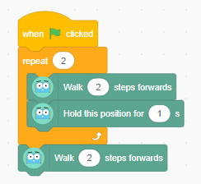 | Kick left foot,  Kick right foot,  Kick left foot,  Kick right foot
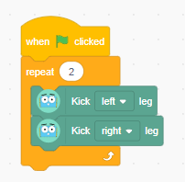 | Walk 2 steps,  Pause,  Walk 4 steps,  Pause,  Walk 2 steps
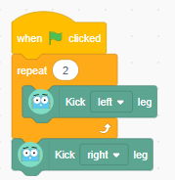 | Kick left foot 2 times,  Kick right foot
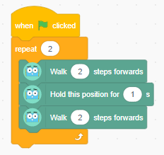 | Walk 2 steps,  Pause,  Walk 2 steps,  Pause,  Walk 2 steps

Record your plan for a shape loop
Detail any challenges you faced and how you overcame them.

