Match the name to the fraction

Circle the fraction word for the shape.

This shape is a

third half fourth

This shape is a

third half fourth

This shape is a

third half fourth

About how long is the smaller shape?
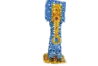

This How big is the smaller shape?

A half of the shape

How big is the smaller shape?

How big is the smaller shape?

How big is the smaller shape?

How big is the smaller shape?

How can you check if a shape is about half as big as another one?

