Name _____________________________

Get Marty Around Something
Draw a plan for Marty | Draw the steps they took

Get Marty to the Checkpoint
Draw a plan for Marty | Draw the steps they took

Did Marty go around something?
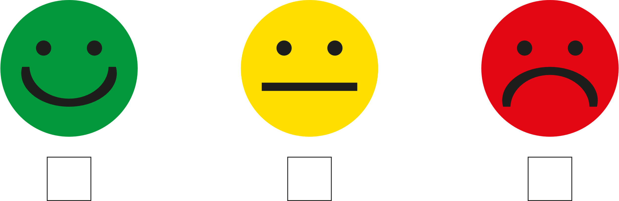

Did Marty get to a checkpoint?

