Name _____________________________

Did Marty move and stop?
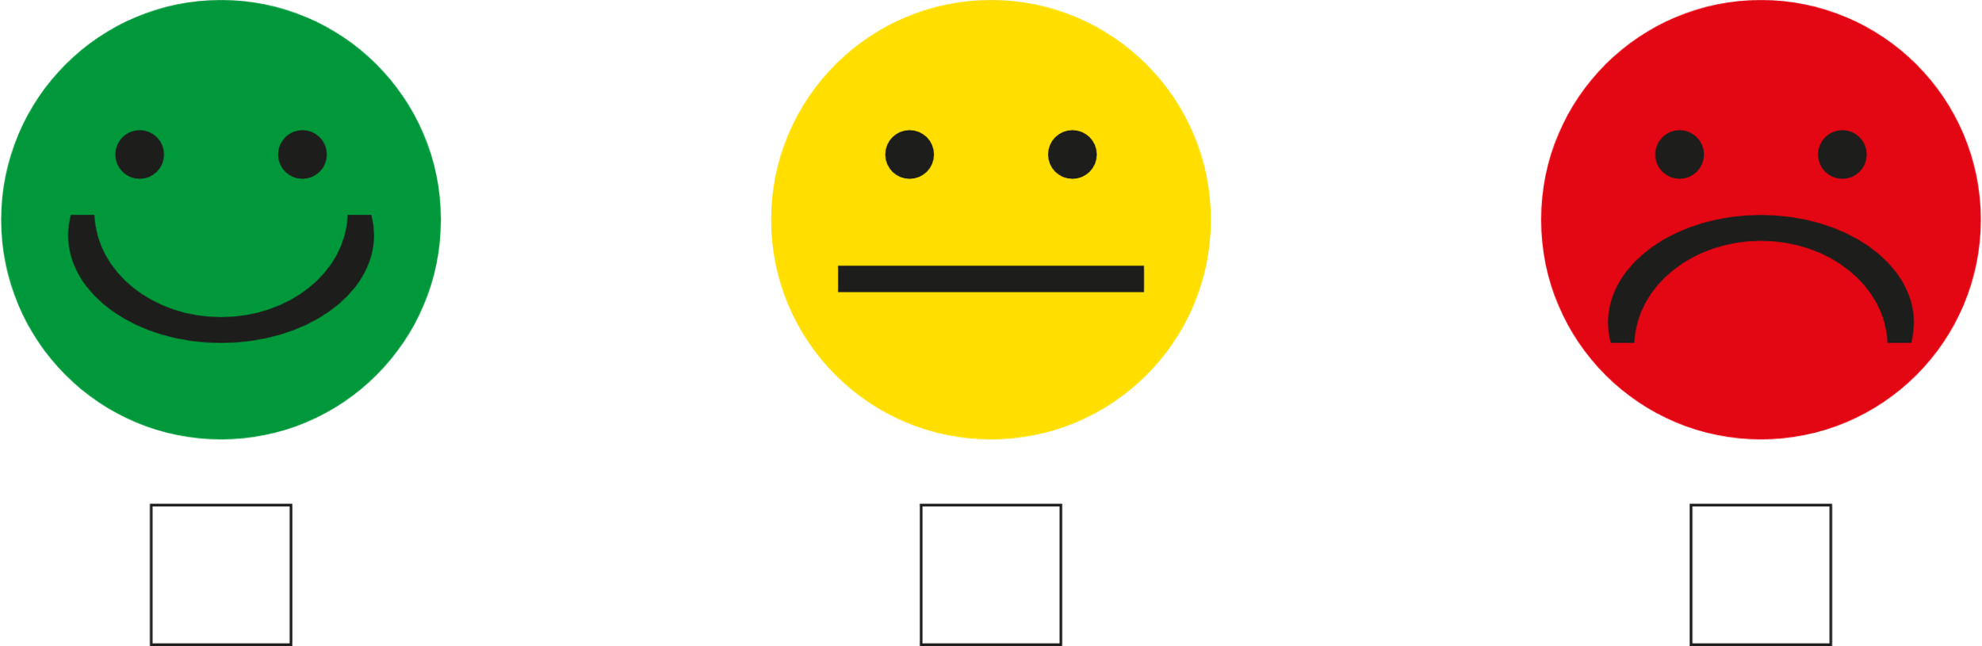

Can you recycle items?

