Timing actions?
What blocks can be used to make sure actions don’t happen too quickly or take too long?

Running different parts at the same time
In your life, when do you need to do more than one thing at a time?
Planning Time
Write down some reasons as to why planning might actually save you some time.

Plan how you will use different actions.

One important idea to think about is when and how the different lights will be used.

Suggested blocks for coding Marty’s Disco Eyes

These blocks are not necessary to use, just a suggestion.

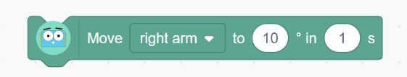
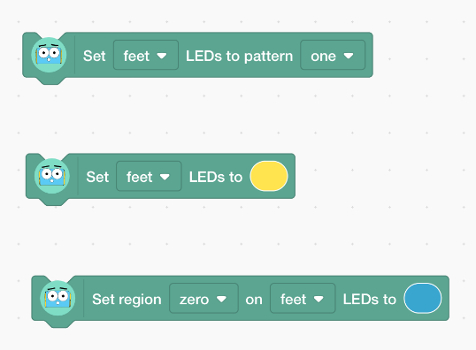
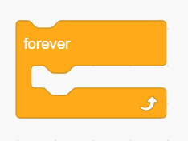

Describe any bugs you encountered.

