Put the clock times in order from least to greatest angle
Times: 8:28, 10:30, 1:10, 2:20, 3:00, 4:45, 6:00,

Order (least to most) | Clock face | Straight, Right, Acute or Obtuse?
1:10 | 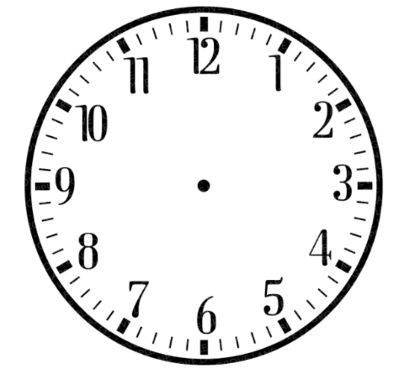 | acute

