Name ___________________________
Planning for and / or
Here is the shape we use: Take your ruler and trace over the shapes:

Example for And logic blocks  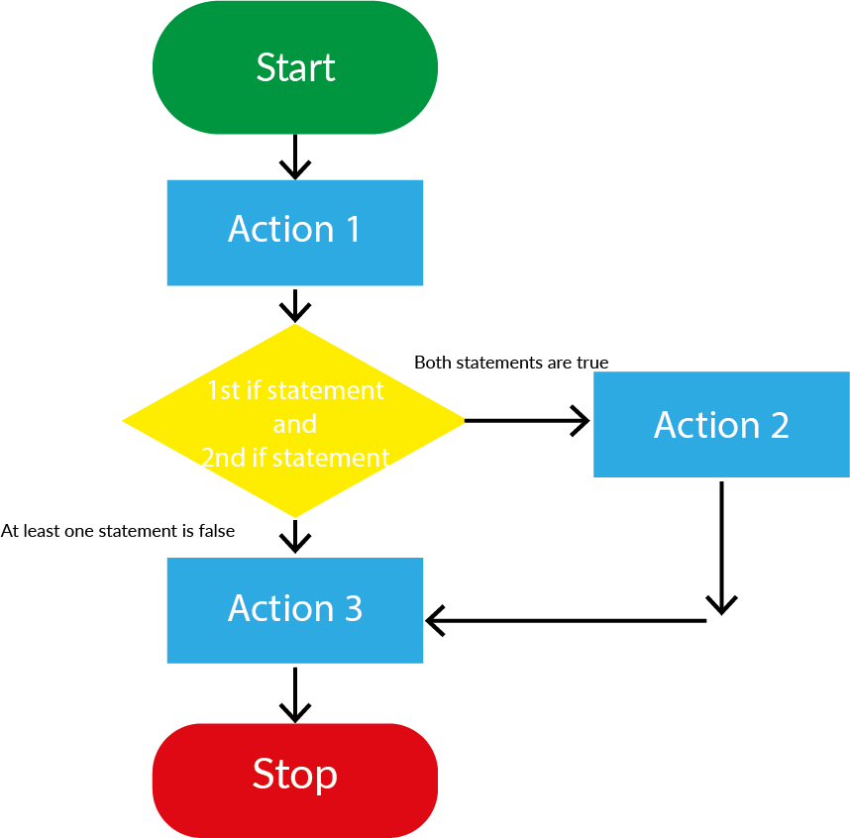 | Example for Or logic blocks  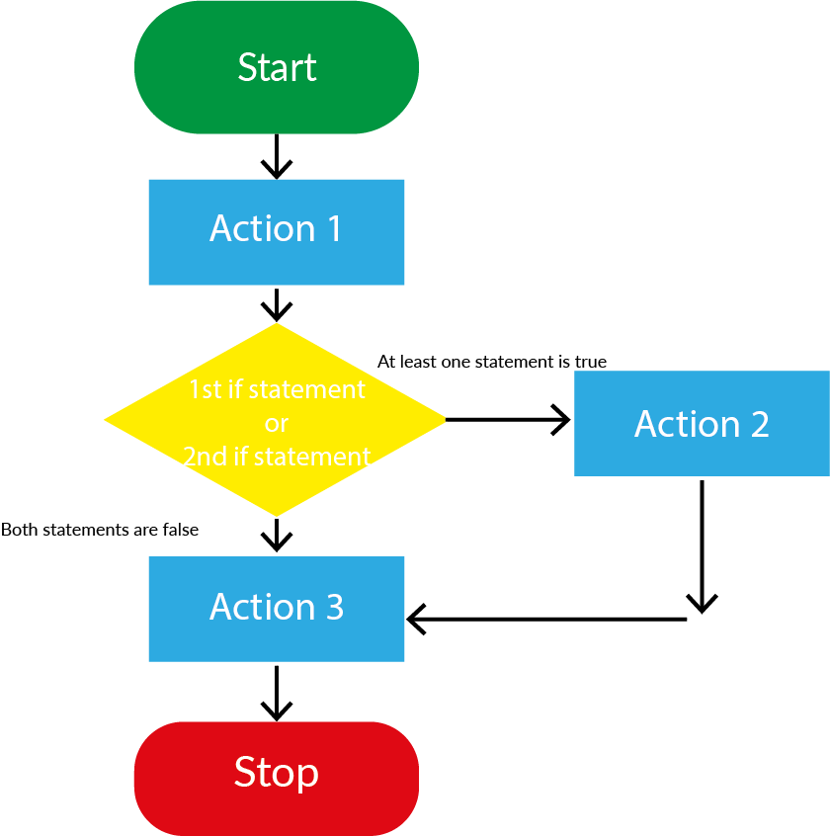

What is the difference?
Draw a line to match the statement, on the left, with the meaning, on the right
If you like the color blue or you like the color green | You like blue, or you like green, or you like blue and green.
If you like the color blue and you like the color green | You have to both run fast and like the smell of flowers.
If you are a fast runner or you like the smell of flowers | You run fast, or like the smell of flowers, or you run fast and like the smell of flowers.
If you are a fast runner and you like the smell of flowers | You need to have both a fish and a plant.
If you have a plant at home or you have a pet fish | You have to like two colors, blue and green.
If you have a plant at home and you have a pet fish | You have a fish, or you have a plant, or you have a plant and a fish

What could Marty do?
Think of some actions you know of that Marty could complete and list there here:

What could you make Marty do, that uses a logic block? Draw a plan and use the symbols.
Did you have any bugs? How did you fix them?

