About how Far?
Scale Map | About How Far
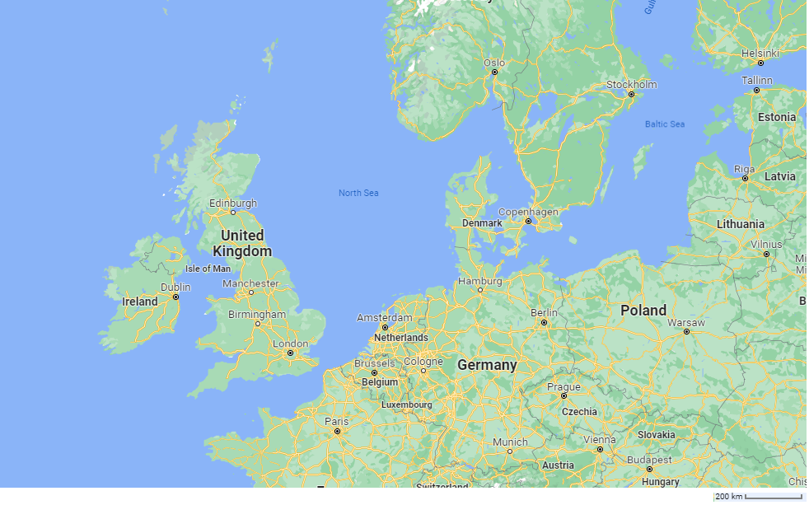 | Warsaw to Edinburgh  _____ cm  _____ km
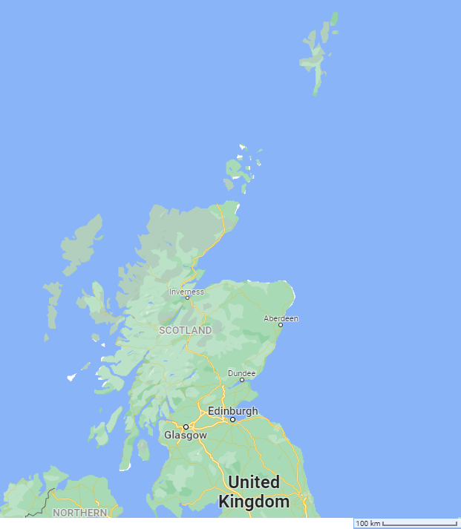 | Glasgow to Aberdeen  _____ cm  _____ km
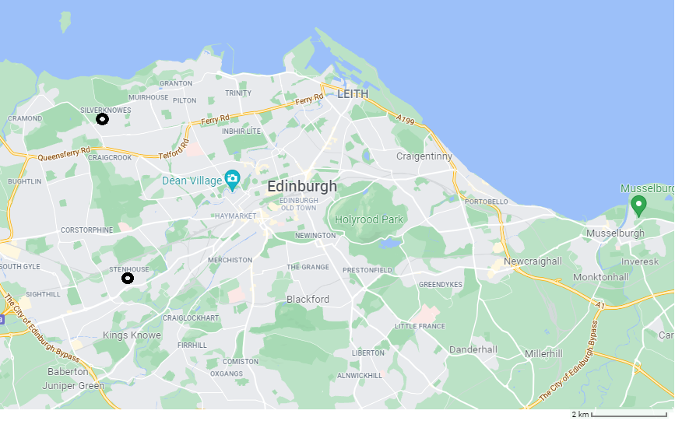 | Stenhouse to Silverknowes  _____ cm  _____ km
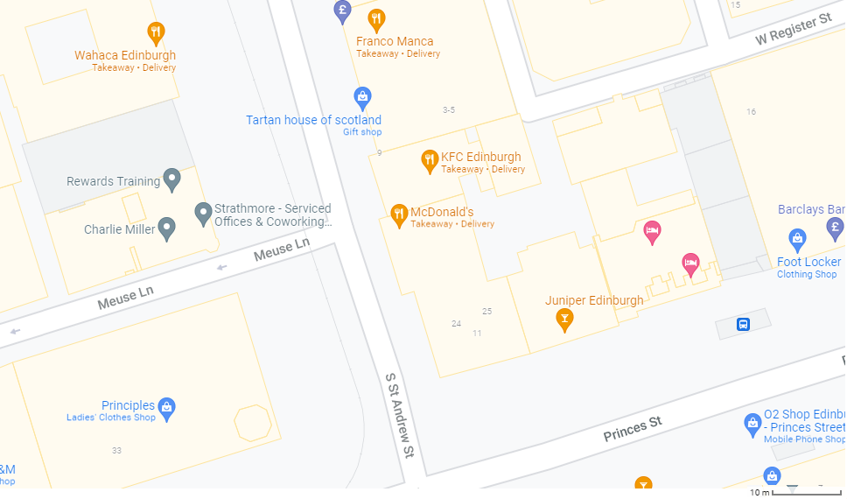 | Tartan House of Scotland to Foot Locker  _____ cm  _____ km

Vehicle emissions
A plane emits 750 kg of CO₂ for a 6500 km journey.
A boat emits 2000 kg of CO₂ for a 400 km journey. If a boat took 16 journeys, that would be almost 6500 km. How many kg of CO₂ would there be for 16 journeys?
A car emits 270 kg of CO₂ for an 880 km journey. If a train took 7 and a half journeys, that would be almost 6500 km. How many kg of CO₂ would there be for 7 ½ journeys?
A train emits 72 kg of CO₂ for a 1280 km journey. If a train took 5 journeys, that would be almost 6500 km. How many kg of CO₂ would there be for 5 journeys?
A person emits 0 kg of CO₂ for a 40 km journey. If a person took 160 journeys, that would be almost 6500 km. How many kg of CO₂ would there be for 160 journeys?

Order the Modes of Transport
Put the modes of transport in order from lowest emission to highest.

Record Your Plan for Marty to Walk the Map Route
How many steps will Marty need for each measured part of the map?
Describe any bugs or challenges you encountered.

