Name ___________________________
The Repeat Symbol for Planning
Practice drawing the planning symbol.

Repeat (number of times)
Where are the Blocks?
The repeat blocks are in the control section. You will need to decide which one you want to use depending on the code.
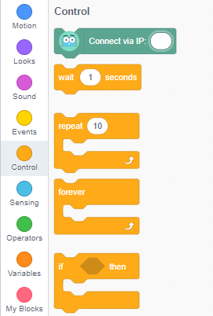

Update the Plan with a Repeat Symbol
Walk forward 2 steps
Start
Slide 2 times to the right
Walk forward 2 steps
Slide 2 times to the right
Walk forward 2 steps
Slide 2 times to the right

Dance
Start
Wave right arm
Wave left arm
Wave right arm
Wave left arm
Dance
Kick left leg
Kick right leg
Walk 2 steps forward
Walk 4 steps forward
Kick right leg
Walk 2 steps forward
Kick left leg
Start
Did you have any bugs with the repeat block? How did you fix them?

