When might we use timings for coding?

Which blocks will allow us to time commands, in MartyBlocks?
Which blocks allow us to repeat code, instead of writing it twice?
Draw a plan for you code, below

Display your results for the values you used in your code.

Value used | Result | Action to take

Suggested blocks for coding Marty’s Disco Eyes

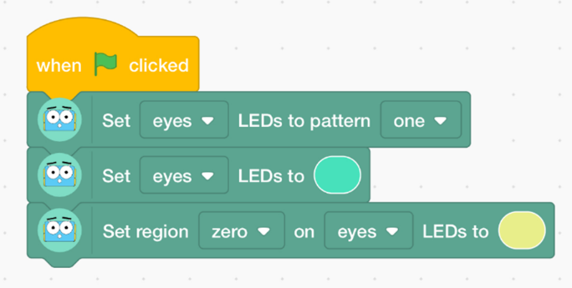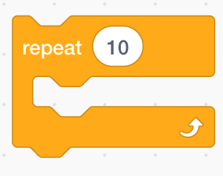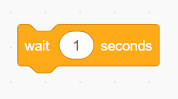

Describe any bugs you encountered.

