Name _____________________________

I can find mistakes?
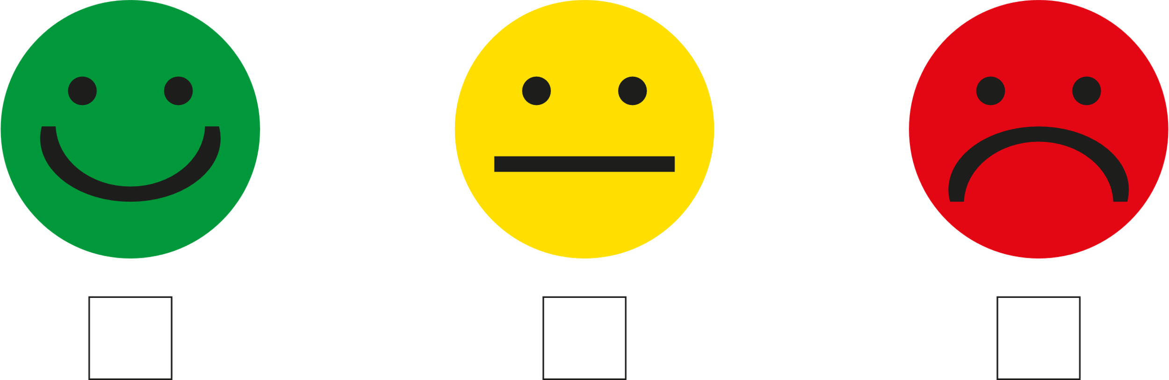

I can fix mistakes?

