Name ___________________________
The if Symbol for Planning
Practice drawing the planning symbol.

Where are the blocks?
The if then block is in the control section | The = block is in the operators section | The left color sensor is in the sensing section
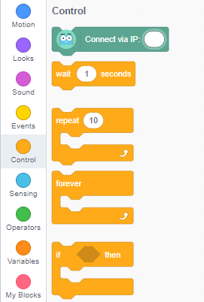 | 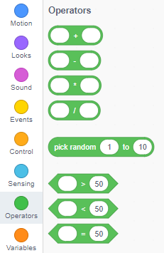 | 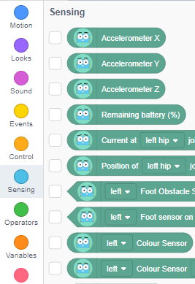

What could Marty do?
Think of some actions you know of that Marty could complete and list there here:

What could you make Marty do, that needs an if-then block? Draw a plan and use the new symbol.
Did you have any bugs? How did you fix them?

