What do we need for the recipe?
Ingredients | 1 cake | _____ cakes
flour | _____ tbsp | _____ tbsp
Sugar | _____ tbsp | _____ tbsp
cocoa | _____ tbsp | _____ tbsp
Salt | _____ pinch | _____ pinches
Milk | _____ tbsp | _____ tbsp
Vanilla essence | _____ tsp | _____ tsp
Oil | _____ tbsp | _____ tbsp
Chocolate chunks | _____ g | _____ g

What is the variable in Marty’s program? (from the 1st video)

s):

Steps for using variables in MartyBlocks
Declare a variable – what will you name your color variable?

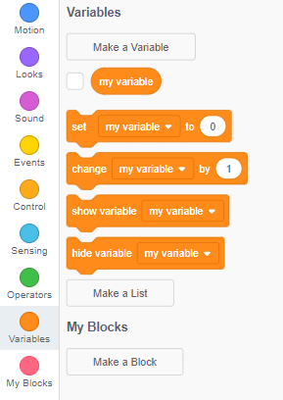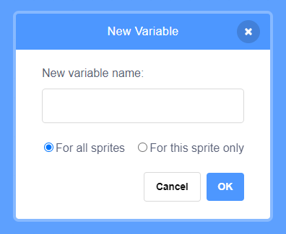
Start with an event block and give your variable a value – how will you tell your variable to be the color Marty senses?

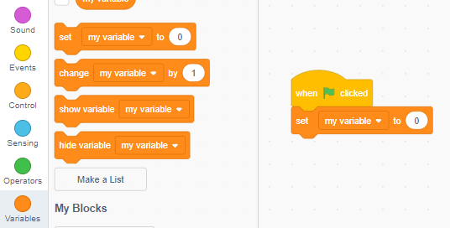

Make an if statement for each of the colors that Marty knows. How many if statements will you need?

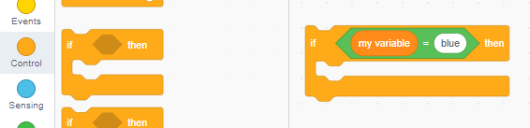

Give each if statement a then part. What commands will you create? It doesn’t have to be the same as Marty Unplugged.

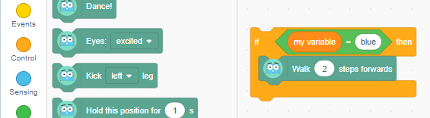

Just now, Marty will only check the color once. What commands do you know that will tell Marty to check the color a 2nd or 3rd time, or more?

Record a plan for Marty to use the variable

Did you face any challenges? How did you overcome them?

