Parallel Programming
What was good about the recipe when you could do more than one thing at a time?

Single Sequence Programming
What was good about the recipe when you waited to finish one thing before starting a second one?
Think of some things in life that are good to do in parallel
Make a list of pairs that can be done together, one has been done for you.

Washing and drying dishes

Think of some things in life that are good to do one at a time?
Make a list of pairs that should not be done together, one has been done for you.

Cycling and using a device

Plan how you will use different actions, with the disco feet.

Suggested blocks for coding Marty’s Disco Eyes

These blocks are not necessary to use, just a suggestion.

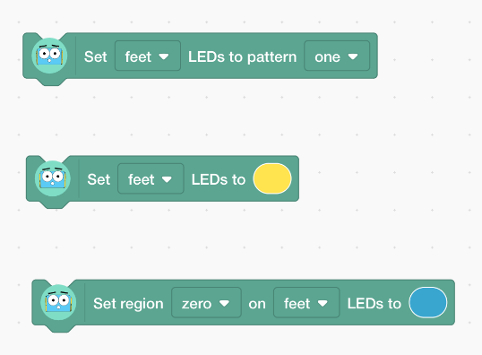

Describe any bugs you encountered.

