Below is an example of an if statement.
The secret number is 72.

If a person guesses something less than 35 (< 35), say, ‘That is too low.’

This tells Marty that any number less than 35 will return, ‘That is too low.’

Write an if statement for a person who guesses ___. (Fill in a number)
The secret number is __ (fill in a number)

Below is an example of two if statements working together
The secret number is 72

If a person guesses > 65 AND if a person guesses < 80, say, ‘That is very close.’

The AND tells Marty that both things must be true.

Write two if statements for a person who guesses ___ (Fill in a number)
The secret number is ___

Plan your if statements for your secret number

Remember to give a clue for when the number is very close

Suggested blocks for coding Marty’s Disco Arms

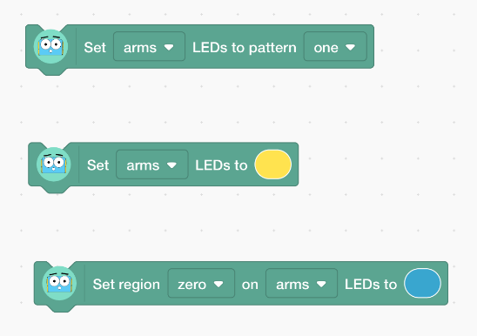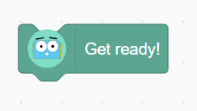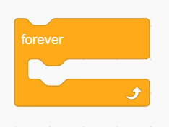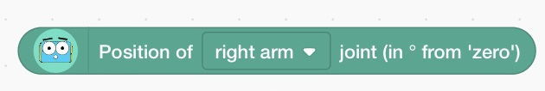

Describe any bugs you encountered.

