Name ___________________________
Compare the Blocks
MartyBlocks Jr | MartyBlocks | Which Block is Better? Explain.
 | 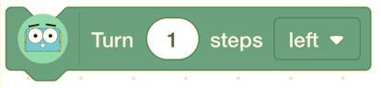
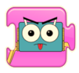 | 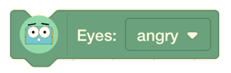
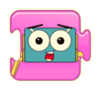
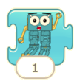 | 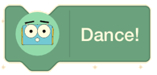

What was the Difference?
Witches without text | Witches with text
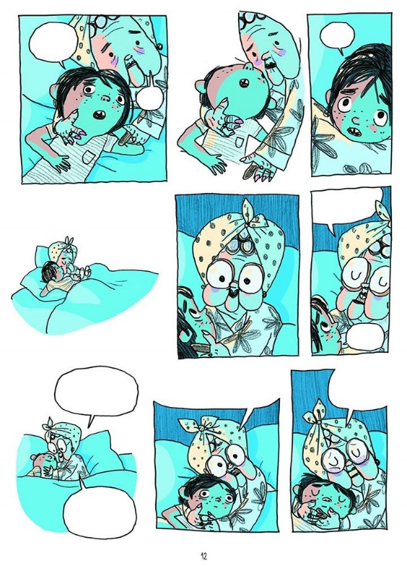 | 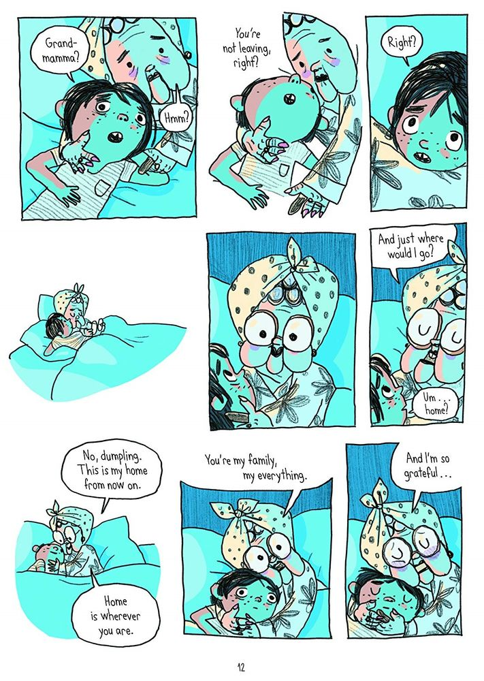

Do these New Blocks Need Text?
Could you think of a picture that would mean the same? Or, is the text needed?
MartyBlocks | Does it need words? | Add a drawing, if you can
 | Yes / No
 | Yes / No
 | Yes / No
 | Yes / No
 | Yes / No

Practice the Planning Shapes
Process
Start

What is the
order?
What Did You Build?
Create a plan for some Marty actions, using the shapes.

