Adding up the cupcakes

What is the fraction when you add the parts together?
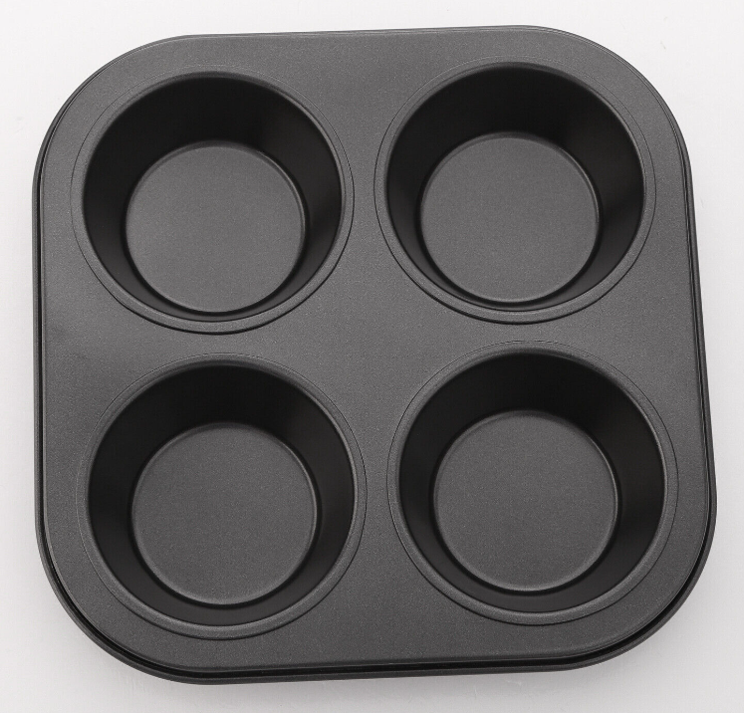
Altogether, there

are ___ out of ___

The fraction is ____

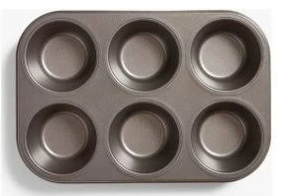

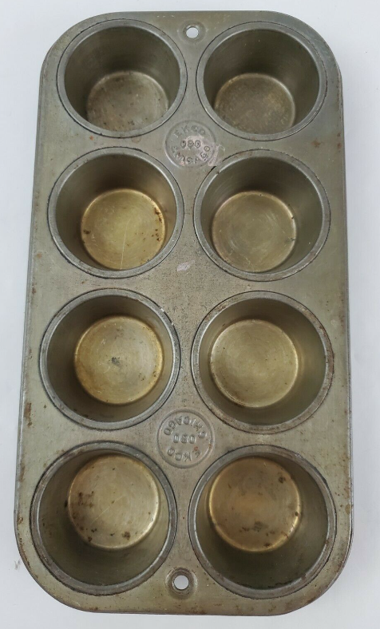
Altogether, there are ___ out of ___. The fraction is ____

Altogether, there are ___ out of ___

The fraction is ____

Adding the shape pieces? Then write the question with fractions
 | and |  | makes how much? ____

 | and |  | makes how much? ____

 | and |  | makes how much? ____

Answer the following addition questions

7 | + | 1 | = |  |  | 5 | + | 2 | =
8 |  | 8 |  |  |  | 8 |  | 8
3 | + | 3 | = |  |  | 3 | + | 2 | =
4 |  | 4 |  |  |  | 4 |  | 4
2 | + | 2 | = |  |  | 1 | + | 2 | =
3 |  | 3 |  |  |  | 3 |  | 3
3 | + | 3 | = |  |  | 1 | + | 2 | =
6 |  | 6 |  |  |  | 6 |  | 6
7 | + | 6 | = |  |  | 6 | + | 5 | =
10 |  | 10 |  |  |  | 10 |  | 10

What did you think?

Was there any success you achieved or challenges you faced that you would like to write about?

