Name _____________________________

Did a partner move forward?
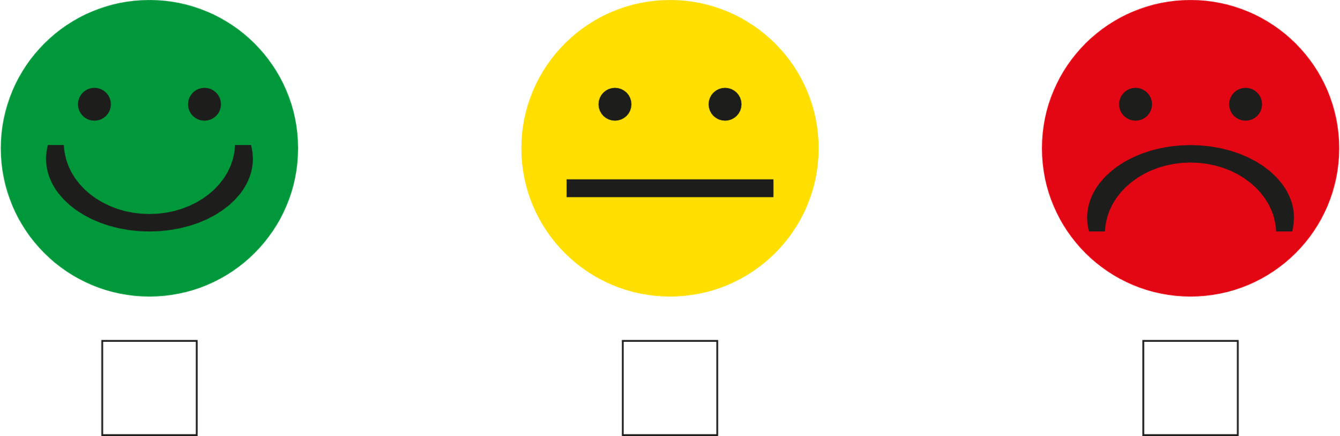

Did a partner stop?

