What is the equation for perimeter and how does it work?
When you have the perimeter and one side of a rectangle, how do you solve for the other side?
When you have the perimeter and one side of a quadrilateral, that has two pairs of equal sides, how do you solve for the other side?
Identify the missing side of these rectangles and show your work.
P = 32
w = 5
l =

P = 17
w = 2
l =

P = 63
w = 20
l =

P = 40
w =
l = 12

P = 19
w =
l = 1

P = 22
w =
l = 8

P = 35
w = 7
l =

What about these other quadrilaterals?
Drawings are not to scale.

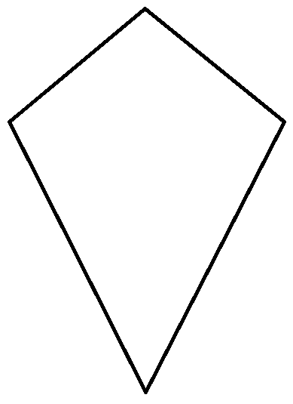
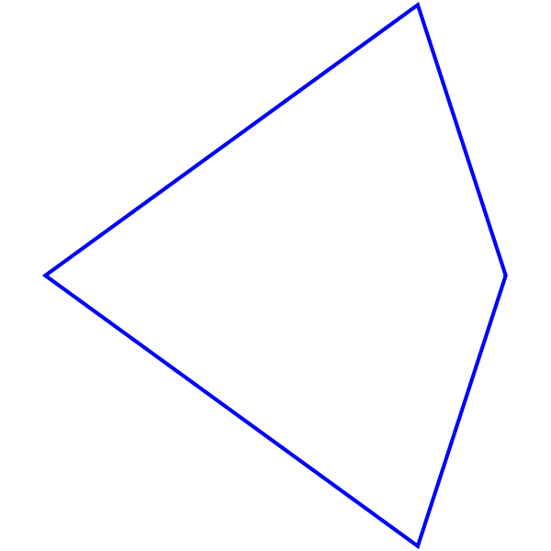
Parallelogram
P = 39
side 1 =
side 2 = 17
Kite
P = 52
side 1 = 10
side 2 =
Kite
P = 21
side 1 =
side 2 = 5
Parallelogram
P = 16
side 1 = 3
side 2 =

