Name __________________________
Where are the Blocks?
The repeat blocks are in the control section. You will need to decide which one you want to use depending on the code. Start by describing each:
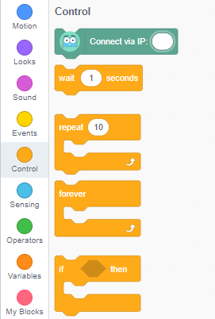
The repeat 10 block: _____________________________________________
_________________________________________________________________

The forever block: _______________________________________________
_________________________________________________________________

What actions repeat?
List the actions that repeat from the two Martys in the video.
Plan for the repeating Martys
|Choose one or more of the videos and think about how you could code them. Give the video a title – what did you see Marty do – and then you can either write the steps below that or use MartyBlocks to create the programs.
1 |  | 2
3 |  | 4

