Name ___________________________
What is the program for? Can you find and fix the bug?
The Code | What is supposed to happen?
 | What is the bug?

What moves should Marty have?
The Code | What is supposed to happen?
 | What is the bug?

This is a map for the code on the next page.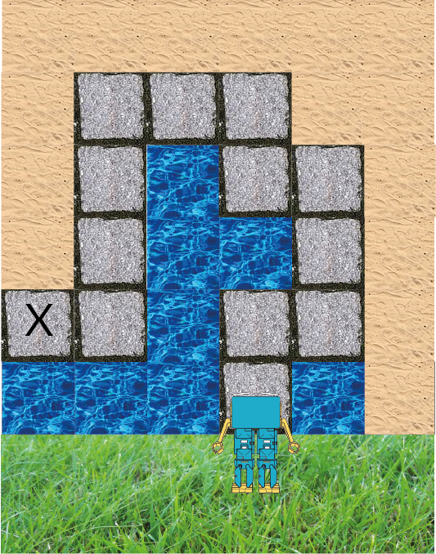

Does Marty make it to the X?

The Code | What is supposed to happen?
 | What is the bug?

Does the code look OK?
The Code | What is supposed to happen?
 | What is the bug?

Was anything hard to do?

