Mark where the fractions should go on the number line.
1/2
1
1/2
1
    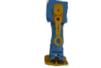  Place 1/2, 1/3, and 1/5.  1/5  1/4  0  0  0  1/3 |  | Place 2/3, and 3/5.  1/3  1/5  0  0  0
Place 3/4, and 2/5.  1/4  0  0 | Place 2/4, and 4/5.  0  0
0
1
1/5

