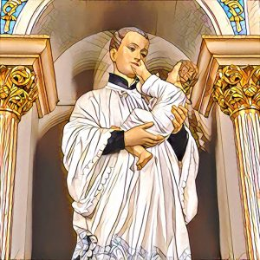
St. Stanislaus Kostka Parish
8 St. Ann Street, Hamilton, ON L8L 6P8; Tel: 905-544-0726
ststanislaushamilton@hamiltondiocese.com

Forma Rejestracyjna do I Komunii Świętej
First Reconciliation & First Eucharist Request Form 2025-2026

Dear Fr. Marian Gil OMI:
Drogi O. Marianie,

☐ | I/we wish for my/our child to receive the sacraments of First Reconciliation and First Eucharist at St. Stanislaus Kostka Parish. Please complete sections A & B and bring the completed form to the church or email to our parish office by June 30th, 2025
 | Chcielibyśmy, aby nasze dziecko uczestniczyło w programie przygotowującym do I Komunii św. w parafii św. Stanisława Kostki w Hamilton. Proszę wypełnić ten formularz i przynieść go do zakrystii lub przesłać emailem na adres parafii do 30 czerwca, 2025 roku.
Section A – please print
Child’s name: |  | School:
 | Signature of parent/guardian |  | Signature of parent/guardian
Section B – please print
Child’s address |  |  |  |  | Postal code
Phone |  |  | Home email
Date of birth
Current parish/place of worship

Mother’s full birth name |  |  |  |  | Religion
Contact information  same as above ☐ or | Address
Contact information  same as above ☐ or | Phone |  | Email

Father’s name |  |  |  |  | Religion
Contact information  same as above ☐ or | Address
Contact information  same as above ☐ or | Phone |  | Email
Child’s Baptismal Information
☐ My/our child is baptized. (Please provide the baptismal information below. A copy of the Baptism certificate will be required if the child was baptized at a church other than St. Stanislaus Kostka Parish.
☐ My/our child is not baptized. Please contact me/us to discuss Baptism for my/our child.
Date of Baptism |  |  | Religion
Place of Baptism | Name of Church
Place of Baptism | Complete address

