*INSTALLATION INSTRUCTIONS*

**MODELS:**

FS-50 / TF142-SODP20 manual reset, 20-ft capillary

FS-53 / TF142-SOAP20 automatic reset, 20-ft capillary

FS-61 / TF142-SODP10 manual reset, 10-ft capillary

FS-64 / TF142-SOAP10 automatic reset, 10-ft capillary

SETPOINT RANGE: 34OF to 70OF (1.1OC to 21OC)

DIFFERENTIAL: 4.5OF (2.5OC)

ACCURACY: +/- 2OC (+/- 3.6OF)

SWITCH ACTION: 2xSPDT (DPDT)

SWITCH RATING:

Inductive: 14A @ 120VAC, 12A @ 240VAC

Pilot Duty: 720VA max @ 120 to 600VAC,

144VA max @ 24VAC

**hazard.jpgMOUNTING**

*The control enclosure must be mounted where the ambient temperature will always be warmer than the temperature sensed by the capillary element.*

* Avoid locations subject to excessive vibration.
* Mount to duct or flat surface using mounting holes in rear of enclosure.
* Do not kink or apply excessive force to the capillary.

*hazard.jpg Do not bend the first 1-inch of the capillary*

*where it exits the bellows housing. Doing so*

*may break the capillary at the bellows housing.*

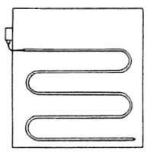

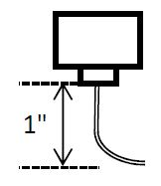

* Install the capillary in a horizontal serpentine pattern on the downstream side of the coil so it is exposed to all areas where low temperatures will occur.
* Using capillary mounting clips or other means, fasten the capillary at sufficient points to prevent damage from air movement or vibration.

**WIRING**

* A 1/2” conduit connector can be installed in the wiring access hole in the bottom of the control case.
* Recommended wire size is 14 AWG solid copper wire with ends stripped 3/8” and inserted under cup washers on the switch block.

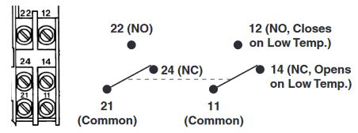

FS-50, FS-60, TF142 Series

2xSPDT Low Limit Controls

**OPERATION**

* On a fall in temperature below the set point, the switch contacts in the relays will reverse and put the control in the lockout mode.
* On automatic reset models, the control will remain in lockout mode until the temperature sensed by the capillary rises by 1.8OF (1OC) or more above the set point. The control will then automatically return to normal operation.
* On manual reset models, the control will remain in lockout until the reset button on the top of the enclosure is manually pushed. However, the temperature sensed by the capillary must have risen 1.8OF (1OC) or more above set point before pushing the reset button will allow the control to return to normal operation.

**SET POINT ADJUSTMENT**

* To change the set point, use a screwdriver or wrench to turn the adjustment screw located at the top of the spring housing. Clockwise rotation decreases the set point. Counterclockwise rotation increases the set point.

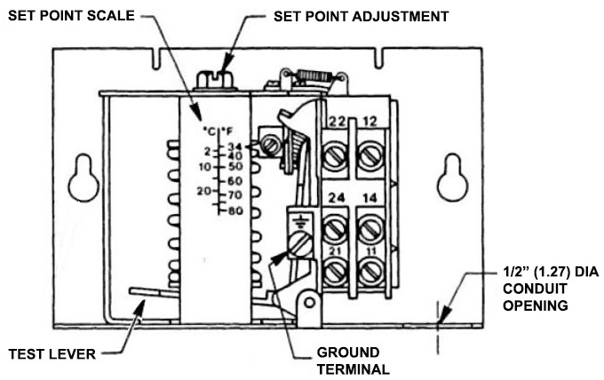

**TEST LEVER**

* For circuit testing, the switch action can be manually operated by depressing the test lever located below and to the left of the controller spring. The switches will be in lockout positions when the lever is held down.

*Note: On manual reset models, the switches will remain in lockout positions after the test lever is depressed and released. The reset mechanism (located behind the top of the switch block) must be depressed and released to put the switches back in normal mode.*

***These devices are designed for use only as an operating control. When an operating control failure would result in personal injury and/or loss of property, it is the installer’s responsibility to add devices (safety, limit controls) or systems (alarm, supervisory systems) to protect against, or warn of control failure.***