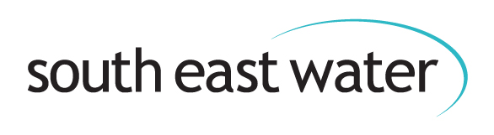**Beginning of document.**

How South East Water is adapting   
to a changing climate

**A summery of our Climate Change Adaptation Report Round 4, 2024**

**Contents**

About us 2

Introduction 3

The purpose of this report 4

Key risks 6

Water scarcity 6

The resilience of our infrastructure 6

Water quality deterioration 6

Our risk matrix 7

Water scarcity risking water supply 8

What’s the risk? 8

Action we’re currently taking 10

Plans for the future 12

Asset resilience 14

What’s the risk? 14

Action we’re currently taking 16

Plans for the future 18

Water quality deterioration 20

What’s the risk? 20

Action we’re currently taking 22

Plans for the future 24

Publication details 26

Company details 26

# About us

**We supply top quality drinking water to 2.3 million people in the south east of England. This involves distributing 544 million litres of water every day through a network of 9,000 miles of pipe.**

**Below image:** a map showing the areas of south east England where South East Water provides customers with drinking water.

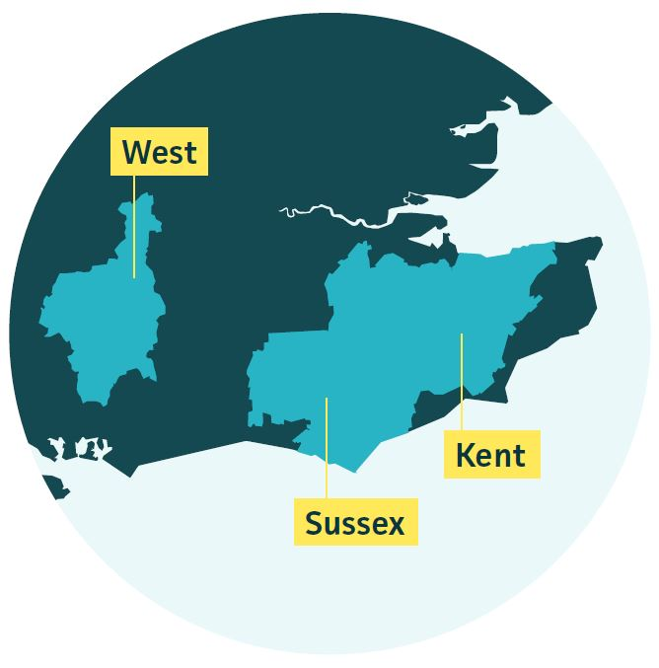

**Key facts**

• 2.3 million people.

• 900,000 households.

• Each customer uses an average of 144 litres a day.

• The average daily household bill is 67p (2024-2025 figures).

• Operate 88 treatment works.

• Deliver water 24/7 through 9,000 miles of high-pressure pipe.

• Manage 33 sites of Special Scientific Interest.

• One million water quality tests undertaken each year.

# Introduction

Each of our 2.3 million customers across the south east of England trust.

that we will provide them with a reliable supply of top-quality drinking water, every hour of every day, now and into the future.

This is the fourth time we’ve created a Climate Change Adaptation Report, and within it we provide an overview of the risks climate change poses to our water supply both now and in the future, as well as highlight what we’re doing to make our operations more resilient to its effects.

[You can read our detailed Climate Change Adaptation Report, Round 4](https://cdn.southeastwater.co.uk/SewHousehold/our-environment/SEW_Climate_Change_Adaptation_Report_Round_4.pdf).

To do that we’re abstracting, treating and pumping 544 million litres of water a day through a complex network of high-pressure pipelines. Both the water supply system and the environment are closely linked. The majority, 73 per cent, of the water we supply comes from underground, 19 per cent from rivers and reservoirs and eight per cent from other water companies.

Drinking water supplies in the south east are coming under increasing pressure from a changing climate, population growth and new requirements to protect the environment. The south east is already experiencing water resources challenges and is designated as ‘an area of serious water stress’ by the Environment Agency owing to the region’s warm and dry climate, as well as its growing population.

Since publishing our last Climate Change Adaptation Report in 2021, we’ve faced a number of climate related issues which have impacted supplies to customers.

**Below image:** graphic shows a timeline of climate related issues South East Water has experienced since 2020 which has affected the supply of drinking water to households we service.

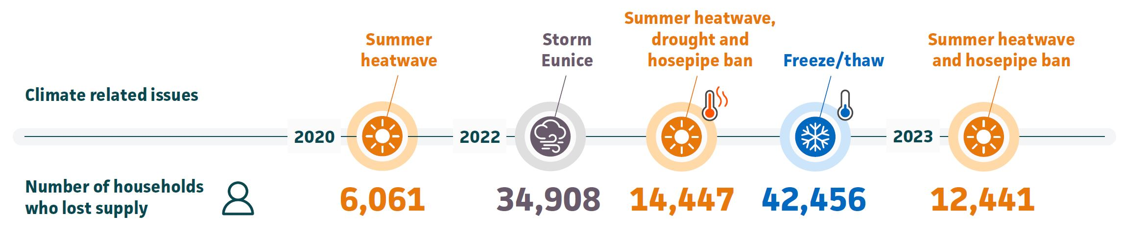

# The purpose of this report

This report outlines the actions we’re taking to adapt to the risks of climate change now and into the future. It focuses on the progress we’ve made since 2021 and the actions we’re planning to take up to 2030.

We’re submitting this report to Defra in response to their invitation to report under the fourth round of the Adaptation Reporting Powers, which falls under the Climate Change Act of 2008. This report supports the government in understanding the climate risks and adaptations being undertaken in the infrastructure sector.

We recognise the huge challenge of adapting to climate change and reducing the risk it poses on our ability to supply water. Our reporting aligns with Defra’s objectives for this round, which are:

• Supporting climate change risk management and how it  
integrates within our organisation and;

• Building understanding of our level of preparedness to climate change.

Actioning the plans highlighted in this document is dependent on funding being fully approved by the regulator, Ofwat. In December 2024 we will find out if funding has been approved when Ofwat provide their Final Determination on our latest business plan, known as Price Review 2024 (PR24).

**Below photo:** shows a visit by Natural England to Deep Dean to discuss our wart-biter cricket conservation project.

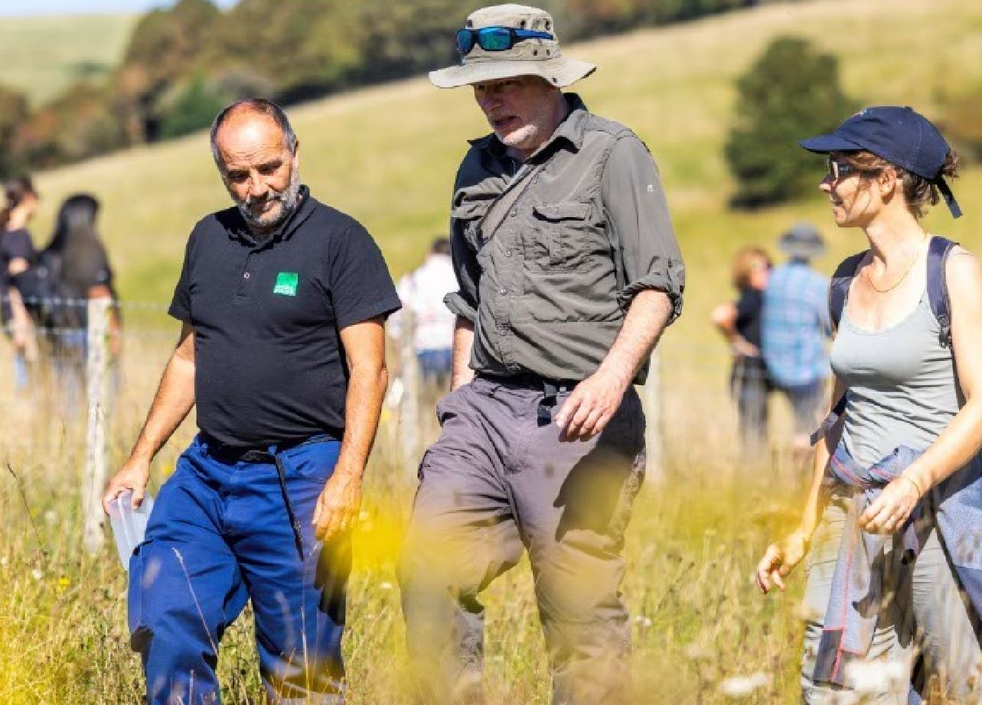

# Key risks

When analysing the climate risks that the business faces, we identified ten potential risks which, despite all being linked together, fall into three main areas:

## Water scarcity

• Drought risk to the amount of water we have available to supply our customers.

• Heatwaves where customer demand exceeds the amount we can supply.

## The resilience of our infrastructure

• Storms, flooding and high winds causing our infrastructure to fail.

• Increase in leaks and burst pipes.

• Loss of access to our infrastructure through sea level rise, coastal erosion and/or flooding.

• Increased sink hole occurrence.

## Water quality deterioration

• Drought and hot weather impacts on water quality.

• Reduction in water quality from effluent and surface water runoff.

• Rising sea levels and salt getting into our rivers and aquifers.

• Increase in invasive non-native species (INNS) from climate change and flooding.

Whether they’re short-term such as flooding or drought, or long-term such as rising sea levels and hotter temperatures, all risks are significant as they affect both our environment and our ability to provide water 24/7, 365 days a year.

It’s therefore important we work on solutions to all these risks both now and into the future, ensuring we can continue to provide the service our customers expect. When assessing the risks, we evaluated each risk based on its likelihood and potential consequences.

This information helped us determine the best course of action.

The risks we’ve identified are significant. They affect our environment and our ability to provide water.

Some risks are very much a reality for us as they’ve already impacted our ability to supply customers with drinking water in recent years, while others will impact us in the future.

Whether they’re affecting us now, or will do in years to come, we’re working on solutions that address each of these risks simultaneously.

# Our risk matrix

Through our research and modelling we’ve created the risk matrix below which underpins this report. We’ve also separated our region into the three areas of Kent, Sussex and the West, as each face different issues.

**Below image:** shows a table listing the low, medium, high and extreme risks and their level of severity.

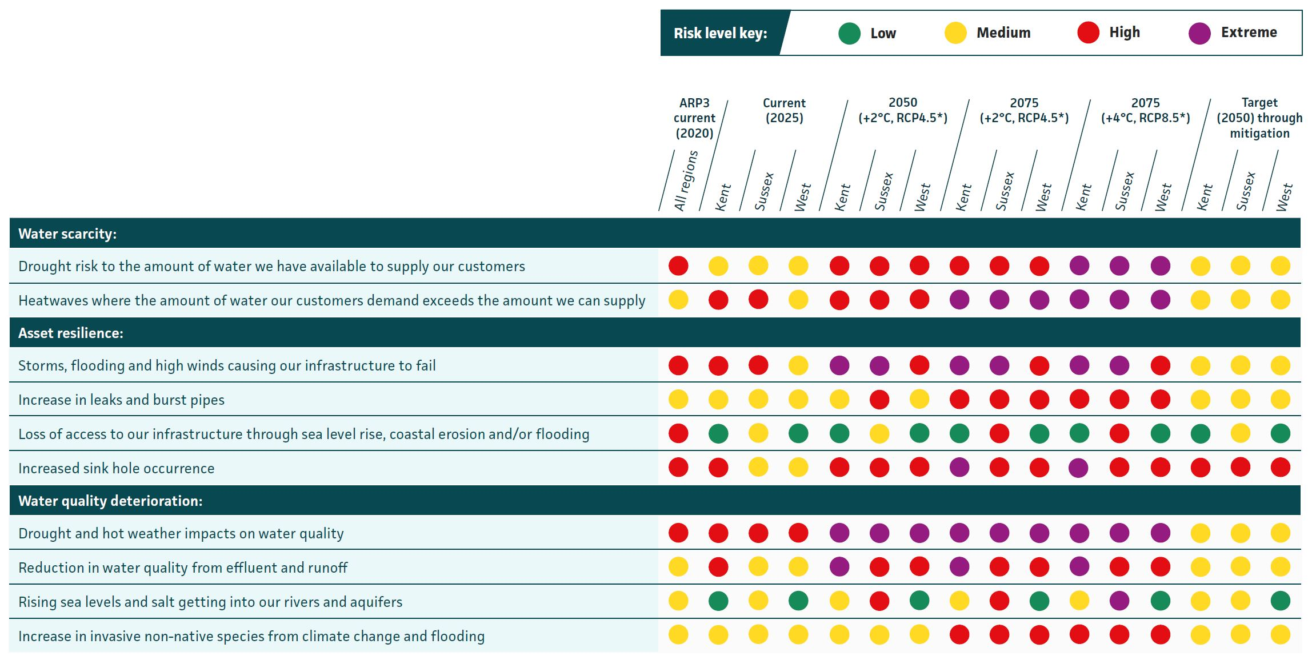

You can view our supply area map on page 2.

*RCP is Representative Concentration Pathway. This is one of the different climate scenarios used to model the effect of a temperature increase.

# Water scarcity risking water supply

## What’s the risk?

Climate change is increasing the likelihood of our supply area experiencing drought in the future.

A growing population, reductions in the amount of water we can abstract from the environment along with changing rainfall patterns and hotter temperatures, are going to create challenges.

We’re already seeing how the changing climate is impacting river levels, how our underground aquifers recharge as well as customer behaviour.

We’ve identified two main risks relating to climate change which could affect our ability to supply water:

• Drought risk to the supply demand balance (the amount of water we need to supply customers vs the amount of water available).

• Heatwave peak demand (when customers use the most water during hot weather) exceeding the amount of water we can supply.

According to Water Resources South East (WRSE), we’ll need an extra 2.7 billion litres of water a day by 2075 under a high population growth, high environmental standards and high climate change scenario. This is compared to 0.8 billion litres a day needed in 2025.

Our analysis shows that by 2050, hot spells could last up to 15 days, and by 2075, up to 22 days, putting immense pressure on our network.

[Our own Water Resources Management Plan (WRMP24) shows that we’ll have a shortage of water by 2050 if we don’t take action.](https://www.southeastwater.co.uk/about/our-plans/future-water/)

The typical daily demand for water is 544 million litres a day. In 2022, record-breaking temperatures combined with dry conditions, led to an exceptional demand of 675 million litres, and above the demand levels we are required to plan for under our Water Resources Management Plan. This increase was the equivalent of adding four towns the size of Maidstone or Eastbourne to our network overnight. As a result, more than 14,000 customers experienced supply issues as customers were using water faster than we could extract, treat and pump it into our pipeline network. To restore supplies to customers, we put a temporary use (hosepipe) ban in place within our Sussex and Kent regions.

**Below photo:** shows Ardingly Reservoir, East Sussex during the 2022 drought.

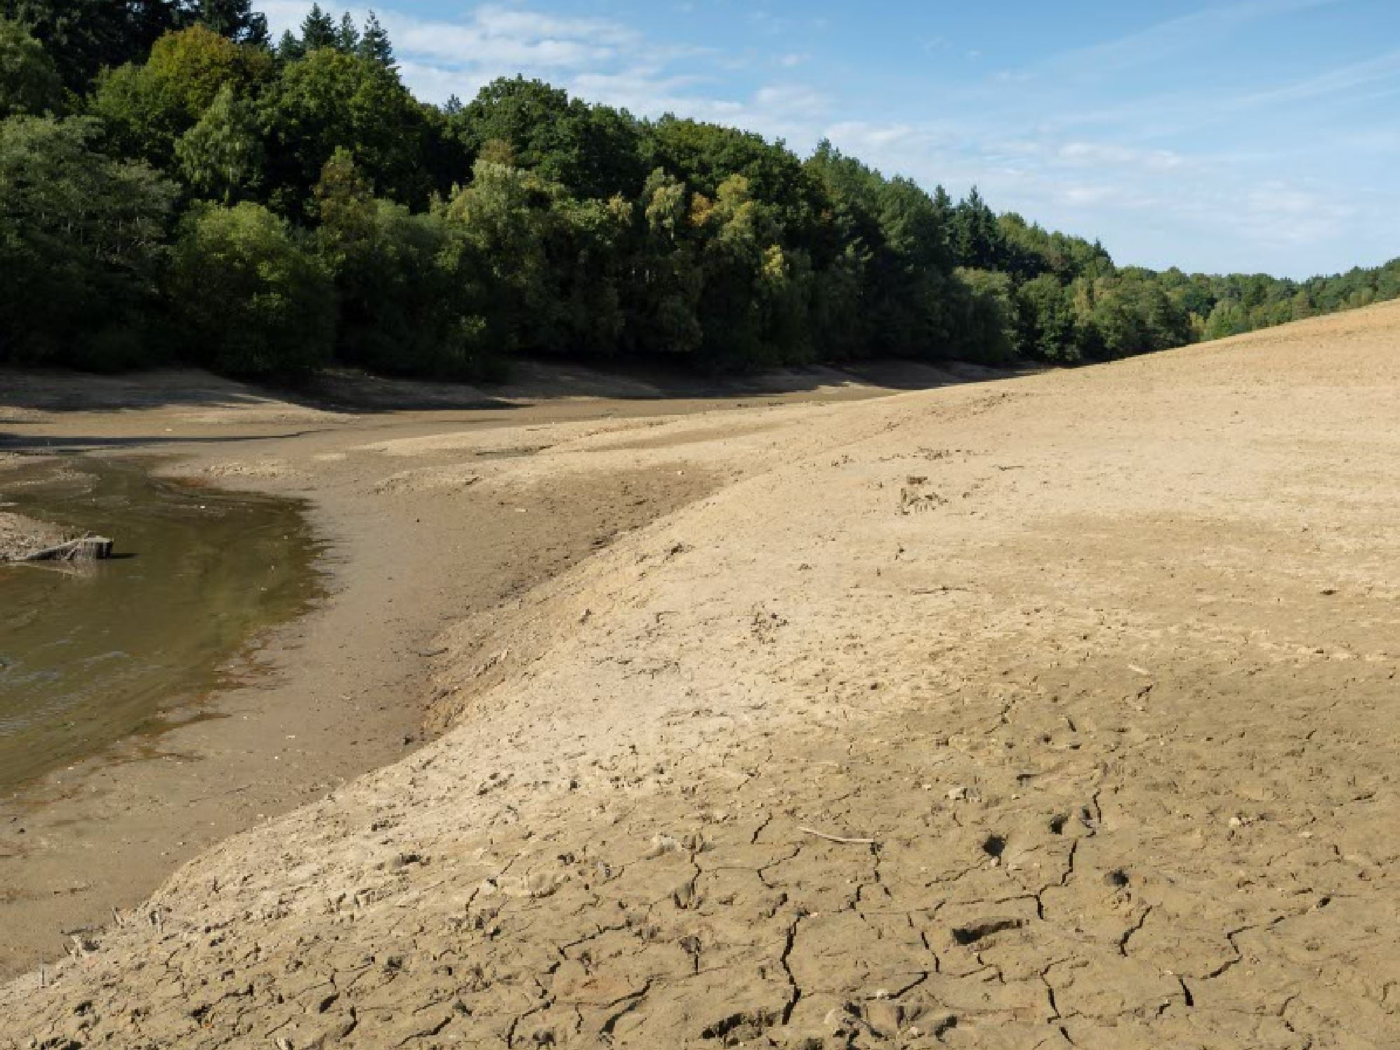

## Action we’re currently taking

We’re investing £39 million building a state-of-the-art water treatment works in Kent. Once complete, the site will extract and treat up to 20 million litres of water a day before pumping it to taps across central and eastern Kent.

The site is expected to be fully operational in 2025.

**Below photo:** shows construction of our new £39 million water treatment works in Kent.

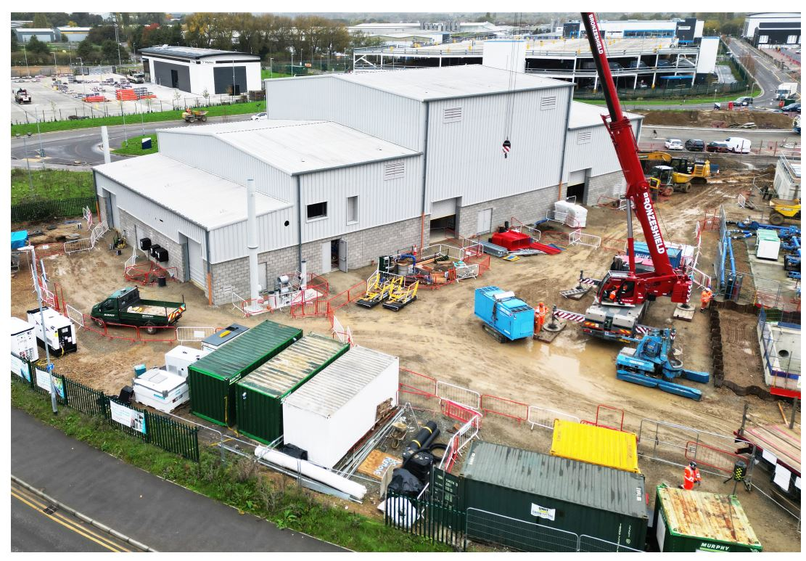

**Behaviour change campaigns**

Our ‘My Account’ platform features a neighbour comparison report that helps customers understand how much water they use compared to similar households in their area. This tool, combined with water-saving tips, is

a key part of our behaviour change programme. We estimate that in 2022 to 2023, this feature helped save 153.14 million litres of water.

In total, customers using ‘My Account’ have saved an estimated 640.8 million litres of water since the site launched in 2020. Elsewhere, we’re also:

• Reducing customer demand for water through water efficiency promotions, business and home water audits and our educational AquaSmart programme. In 2022, these initiatives alone resulted in estimated savings of roughly 22 million litres of water across 70,000 customers.

• Collaborating with our neighbouring water companies to share resources during extreme weather events.

• Through the PROWATER project, a European Union-funded initiative aimed at improving water supply through sustainable practices, we took part in three pilots which involved:

**1**.Protecting land to maintain healthy ecosystems and recharge groundwater.

**2**.Restoring habitats, aquifers and wetlands improving water quality and storage.

**3**.Using natural processes to address water challenges which enhance resilience to climate change.

[You can find out more about this project here.](https://www.southeastwater.co.uk/about/our-environment/prowater-project/)

## Plans for the future

We’re planning to invest £1.2 billion over the coming 50 years increasing the amount of water available.

**Investment plans up to 2075**

**Below image:** graphic of a map of south east England highlighting the work planned in Kent, Sussex and the west of the region.

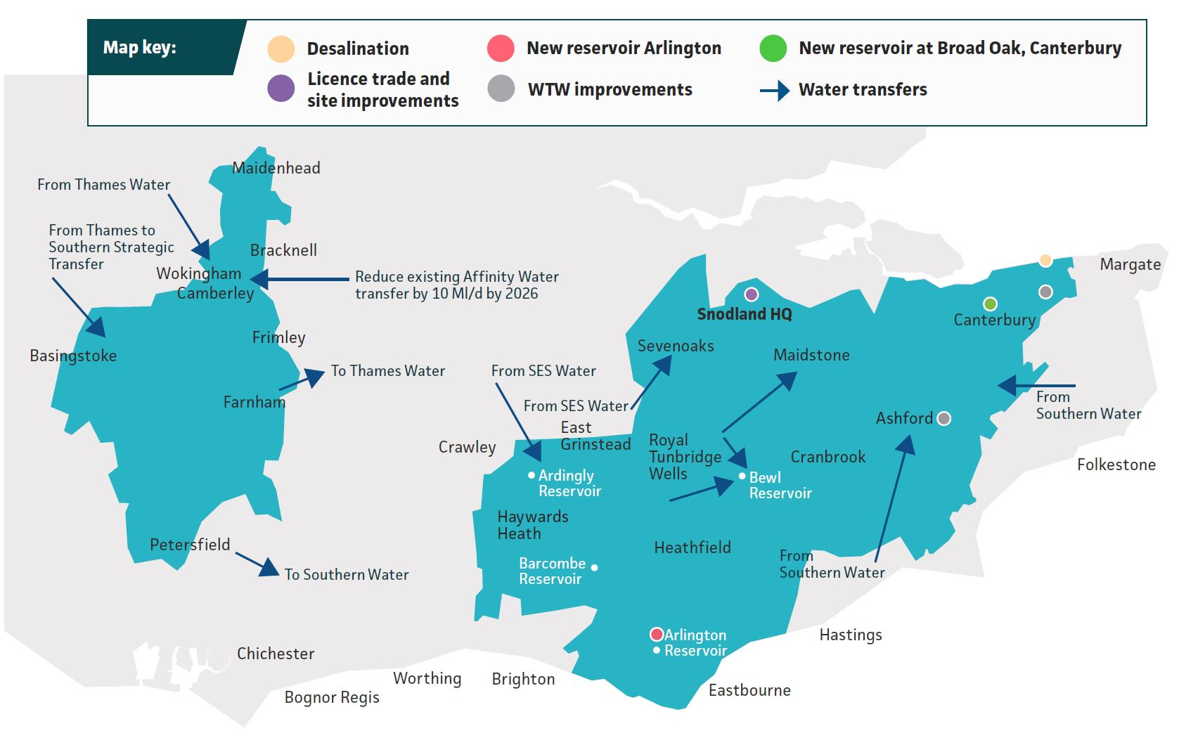

**We’re also planning to:**

• Further investigate the potential of water recycling.

• Improve the underground sources where we collect water from.

• Undertake water audits in homes and businesses, install water efficiency devices and offer online help to customers to manage their usage.

• Collaborate with organisations to promote water conservation and provide support to our customers.

• Roll out smart meter and smart network technology to allow us to better understand and manage water use.

• Continue our education programmes which teach children about water conservation and provide targeted advice.

• Invest in additional tankers and water storage tanks.

[For more information, take a look at our: Water Resources Management Plan 2024](https://www.southeastwater.co.uk/about/our-plans/future-water/)

# Asset resilience

## What’s the risk?

In recent years our supply area has experienced more frequent and severe extreme weather events such as storms, high winds, cold weather and flooding.

These events can damage our water treatment works, pumping stations and pipeline networks, disrupting our ability to supply water to customers’ taps.

They can also cause cascading risks, for example a tree can be uprooted in high winds which brings down a power cable that powers our water treatment works affecting supplies to customers. That same tree could have also damaged a water main as it toppled over, causing a burst, again disrupting customers’ supplies.

Additionally, rising sea levels, coastal erosion and saltwater intrusion into our rivers and aquifers pose a threat to our water treatment sites.

Sinkholes also pose a significant risk. In September 2020, a sinkhole formed at one of our drinking water storage tanks in Maidstone, Kent, which supplies 6,000 customers and a hospital.

Millions of litres of water were lost and the site was taken out of service while it was repaired. While freeze-thaw events may become less common as the climate warms, changes in soil moisture due to changing temperatures can increase ground movement which can then damage both our pipes and our customers’ pipes. These weather events can also result in our key water supply sites and infrastructure failing. We’ve identified four asset resilience risks which could affect our ability to supply water:

• Storms, flooding, and high wind and associated infrastructure failure.

• Increased leaks and pipe bursts.

• Loss of site access due to sea level rise, coastal erosion, or flooding.

• Increased sinkhole occurrence.

In February 2022, Storm Eunice highlighted our vulnerability to power cuts.

The 1 in 100-year event caused widespread power cuts lasting up to five days. We’re heavily reliant on electricity to run all our sites such as pumping stations and water treatment works. While many of these sites have backup power generators, they were unable to handle the demand, resulting in more than 100 of our assets becoming inoperable. It resulted in 35,000 customers going without water.

This event highlighted our reliance on the energy networks and led us to rethink our internal power resilience strategy, particularly at our key water treatment works.

**Below photo:** show flooding caused by prolonged rain falls and burst riverbanks.

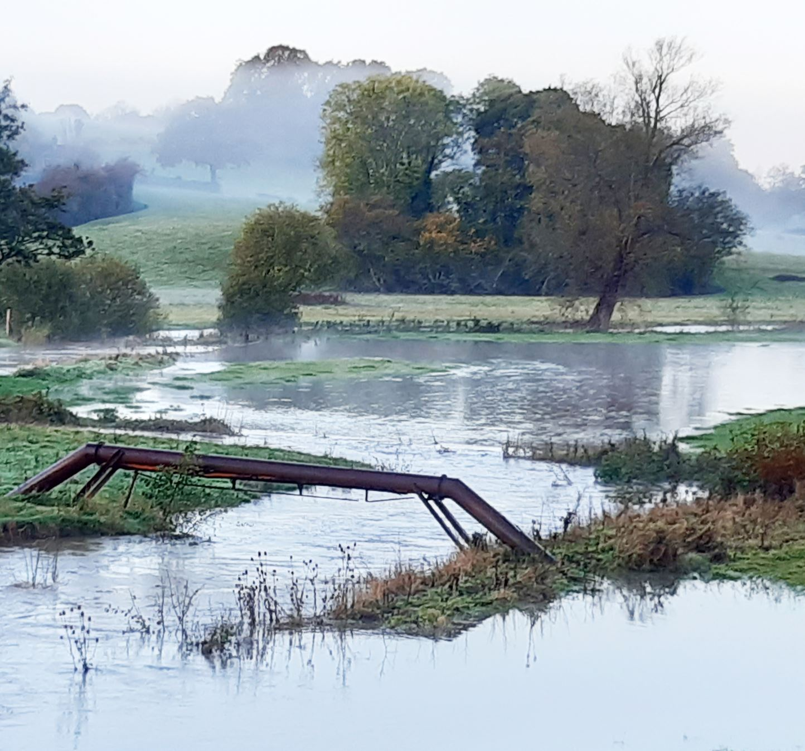

## Action we’re currently taking

We’ve implemented a range of measures in recent years to protect our sites. Flood defence work at 59 of our most critical water supply sites has been completed, with a further 33 sites due to undergo upgrades between 2025 and 2030.

We’ve also worked with Local Resilience Forums to minimise the impact of storms and flooding on our customers. To keep taps flowing when storms impact the power supply we have:

• Upgraded three key water treatment works in Sussex so they can treat more water.

• Installed three new booster pumps at key locations across Sussex, improving resilience during extreme weather and also providing greater network flexibility when other sites fail.

• Installed new generators at key sites.

We’re using new forecasting and response tools to monitor and identify areas likely to be affected by storms, allowing us to implement preventive measures far quicker.

Our leakage performance has improved over the past few years. During 2020/2021 and 2021/2022 we exceeded our targets, however, we fell short in 2022/2023 due to the freeze-thaw event in December 2022, which resulted in a high number of bursts and leaks due to ground movement.

To get back on track, we’ve developed a plan to ensure we meet our commitment to reduce leakage by 15 per cent from our 2017/2018 baseline by 2025, with a further ambitious goal of reducing leaks by at least 50 per cent by 2050.

We’re using GIS risk mapping to better understand sinkholes and the challenges they pose.

This specialist database also allows us to identify sites vulnerable to geological, hydrogeological and geomorphological issues.

**Below photo:** shows staff from South East Water’s Leakage Team using equipment to help detect leaks underground.

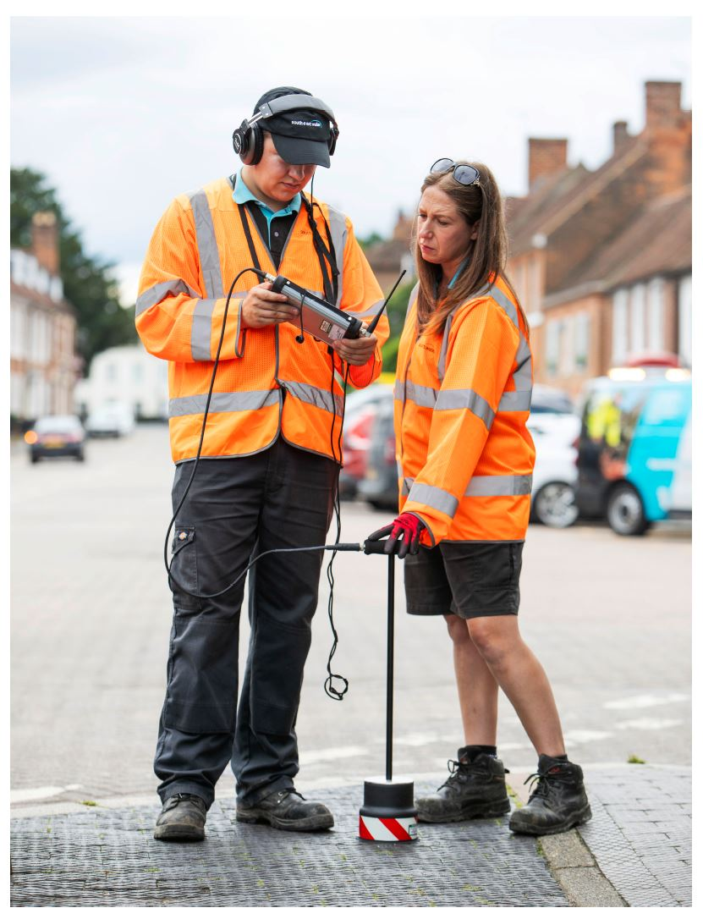

## Plans for the future

To protect our assets against the effects of climate change, we have a range of plans in place which build on the work already undertaken.

We’re working with the Environment Agency on their long-term flood protection strategy for the Pevensey Bay area of Sussex.

We’re also investigating how our infrastructure can be further protected from flooding such as elevating borehole kiosks.

Due to how reliant our sites are on a continuous supply of electricity, we’ve collaborated with UK Power Networks’ on infrastructure planning, explored alternative power sources and trialled batteries with solar backup at some of our sites.

We plan to commission research looking at how infrastructure failure could affect our customers, helping us assess risks far better and helping put plans in place should those assets fail. To do this we’re working with a range of universities, specialists and electricity providers.

In order for us to reach our ambitious target of reducing the amount of water lost through leaks by 11 million litres a day between 2025 and 2030, and reduce water use to 110 litres per person, per day by 2050, we’ve developed a comprehensive plan.

**This includes:**

• Replacing lead pipes, aging infrastructure and reducing the number of pipes we need to repair.

• Between 2025 and 2030 installing a total of 25,000 pressure and acoustic sensors across our 9,000-mile pipeline network which can detect leaks, as well as meters which will monitor our network in real time, helping us detect leaks more quickly.

Continuing our work with other water companies and stakeholders on leak reduction projects and leverage insights from our sinkhole research to identify and prioritise high-risk areas. We’ll also implement monitoring systems for sinkhole formation and ground movement.

**Below photo**: shows South East Water working with farmers to help them become more resilient to the effects of climate change.

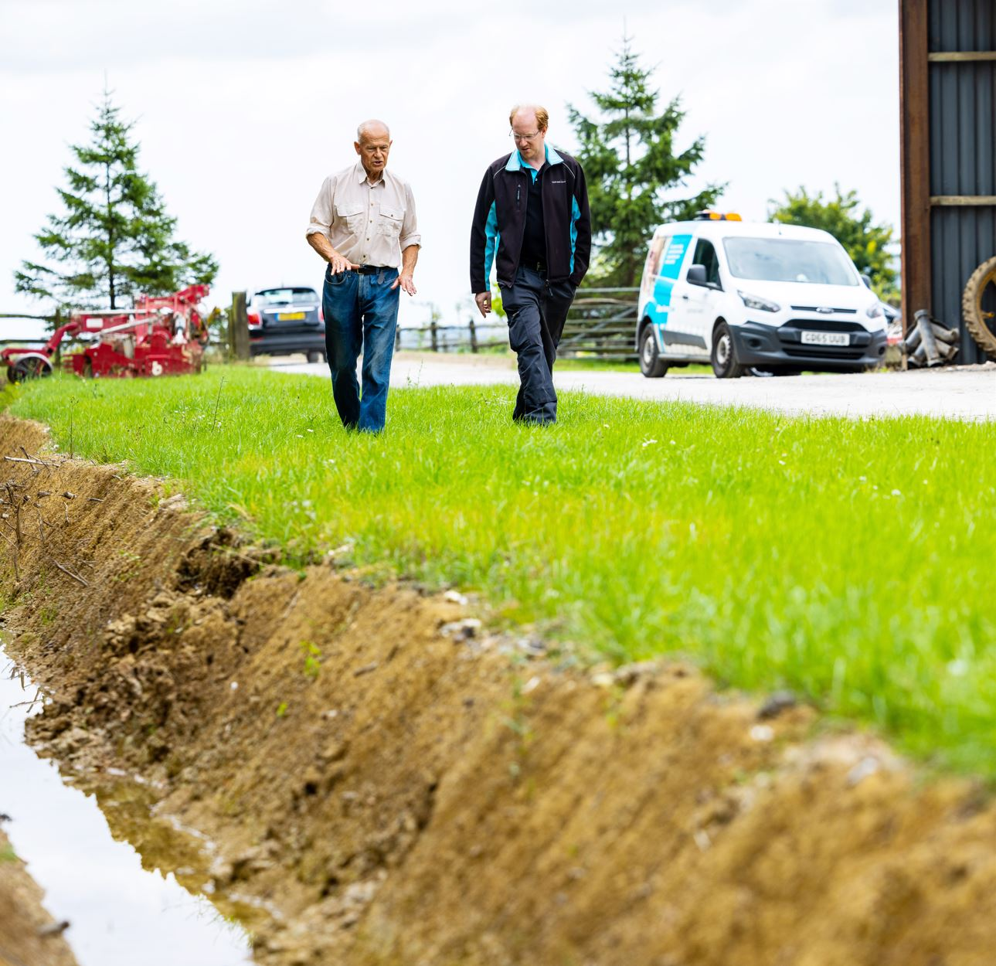

# Water quality deterioration

## What’s the risk?

Ensuring there’s plenty of water for both our customers and the environment in the future is reliant on the quality of the water we take from the environment being of the highest standard possible. We call this untreated water, raw water.

However, increasing temperatures caused by climate change can reduce the quality of that raw water, for example:

• Warmer temperatures are causing algae to grow year-round in our water bodies.

• Heavy rainfall can increase the risk of pollution incidents.

• Rising sea levels and saltwater intrusion threaten our coastal water sources.

• Changing temperatures and flooding can increase the risk of invasive non-native species (INNS) entering our water sources.

We’ve identified four risks which could affect the quality of raw water:

• Drought and hot weather impacting on water quality.

• Deteriorating water quality from effluent and runoff.

• Rising sea level and saltwater intrusion.

• Increase in invasive non-native species.

We’re proud to be the first UK water company to develop and implement a 25-year environment plan, known as H25. Based on science and data, the plan outlines how we’ll minimise our environmental impact and actively improve the environment for future generations.

It details how we’ll achieve environmental resilience while protecting our water resources through taking a systems approach that balances the needs of the environment and allows us to assess and address complex trade-offs.

**Our plan focuses on four key areas:**

**1. Future-proofing water:** ensuring a sustainable water supply for future generations.

**2. Adapting to climate change:** building resilience to climate change impacts.

**3. Protecting our natural environment:** enhancing and preserving our natural resources.

**4. Collaborating with partners:** working with others to protect rivers and underground water sources.

You can read the plan and take a look at our pilot project case studies here.

**Below image:** graphic of the H25 campaign logo.

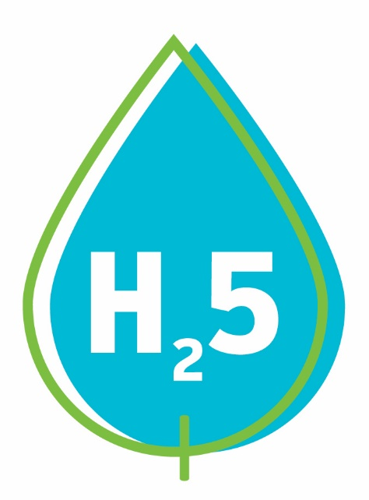

## Action we’re currently taking

We’ve implemented a range of catchment schemes which address a host of issues at key locations.

**These include:**

• Installing ultrasonic probes to reduce algal blooms.

• Working with farmers and landowners to plant cover crops which absorb nitrogen in the soil, reducing the risk of water pollution.

• Partnering with Catchment Sensitive Farming to promote best practice nutrient and pesticide management amongst farmers and land managers, while also educating them on the impact septic tank discharges have on groundwater quality.

• Developed schemes to prevent raw water quality deterioration from soil erosion and sediment runoff.

We’ve partnered with a range of organisations to undertake pilot projects or research into improving groundwater quality, such as:

• The EU funded PROWATER initiative which explored the impact of land use on infiltration and groundwater recharge.

• Working with the National Trust to monitor the levels of sea salt in river estuaries on the south coast.

To prevent the spread of INNS, we have:

• Provided specialist training to all relevant staff.

• Undertaken a pilot project to control both Himalayan balsam and New Zealand pigmy weed at our Arlington Reservoir.

• Implemented biosecurity protocols which help protect species and habitats and stopped all raw water inter-basin transfers to prevent the spread of INNS.

• At a national level, we’ve partnered with other water companies on two key projects.

The first is exploring how to reduce the spread of INNS through raw water rivers and pipes, and the second is developing innovative survey tools to help us identify INNS far more easily.

**Below photo**: shows South East Water’s Environment Team running one of its many catchment management events.

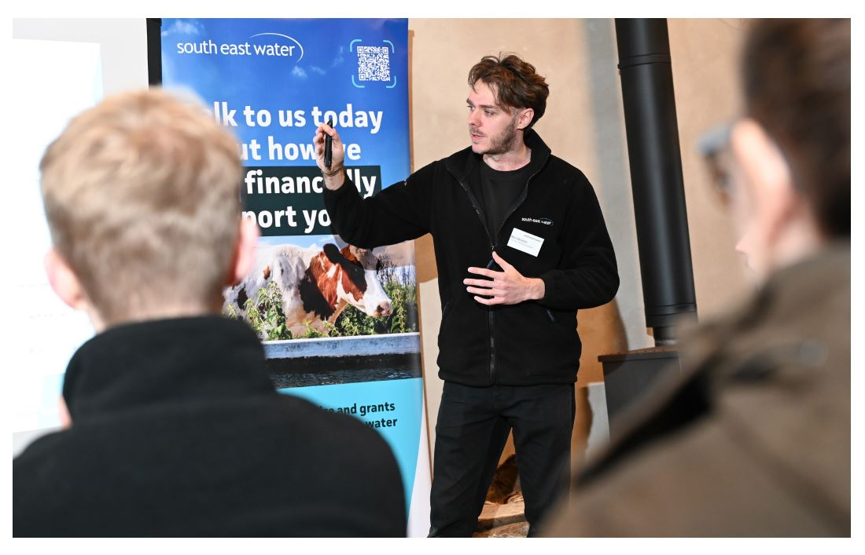

## Plans for the future

We have a whole host of future plans to improve the quality of raw water.

At key sites we’re planning to reduce algal blooms by:

• Upgrading a small raw water storage reservoir at a site in Sussex where we’re currently experiencing algal blooms.

• Undertaking studies at other water treatment works, where algal blooms could be an issue in the future so we can appropriately plan.

Between 2025 and 2030, we’ll continue working with a range of partners to deliver our catchment programmes.

During that period, we have 12 groundwater projects planned,

as well as 24 surface water schemes proposed which will all reduce risks to raw water quality.

We’ll investigate emerging risks associated with PFAS (polyfluoroalkyl substances) in our raw water catchments and conduct eight PFAS investigations at surface water sites.

We’ll also implement three PFAS management and removal schemes.

Where we’re seeing the risk of saltwater intrusion at our abstraction sites on the south coast, we’re going to:

• Install 215 chlorine residual monitors which check saltwater levels.

• Investigate the impact saltwater intrusion in our groundwater could have on the Seaford and Eastbourne Chalk Block.

• Introduce natural flood management strategies on the Cuckmere and Pevensey Levels.

• Begin operating water sources differently, by operating them alongside another source.

To reduce the spread of INNS, we will:

• Undertake eight programmes focused on reducing, monitoring and preventing the increase of INNS.

• Continue our work with the Environment Agency, South Downs National Park and University of Brighton to develop a strategy to reduce INNS in the River Ouse catchment, and if successful, we’ll extend this approach to other catchment areas.

• Continue monitoring INNS across our supply area to ensure we meet our biodiversity targets.

• Undertake an awareness program for staff, stakeholders and contractors and build engagement at catchment level.

**Below photo**: Bray Keleher WTW - one of our water treatment work facilities.

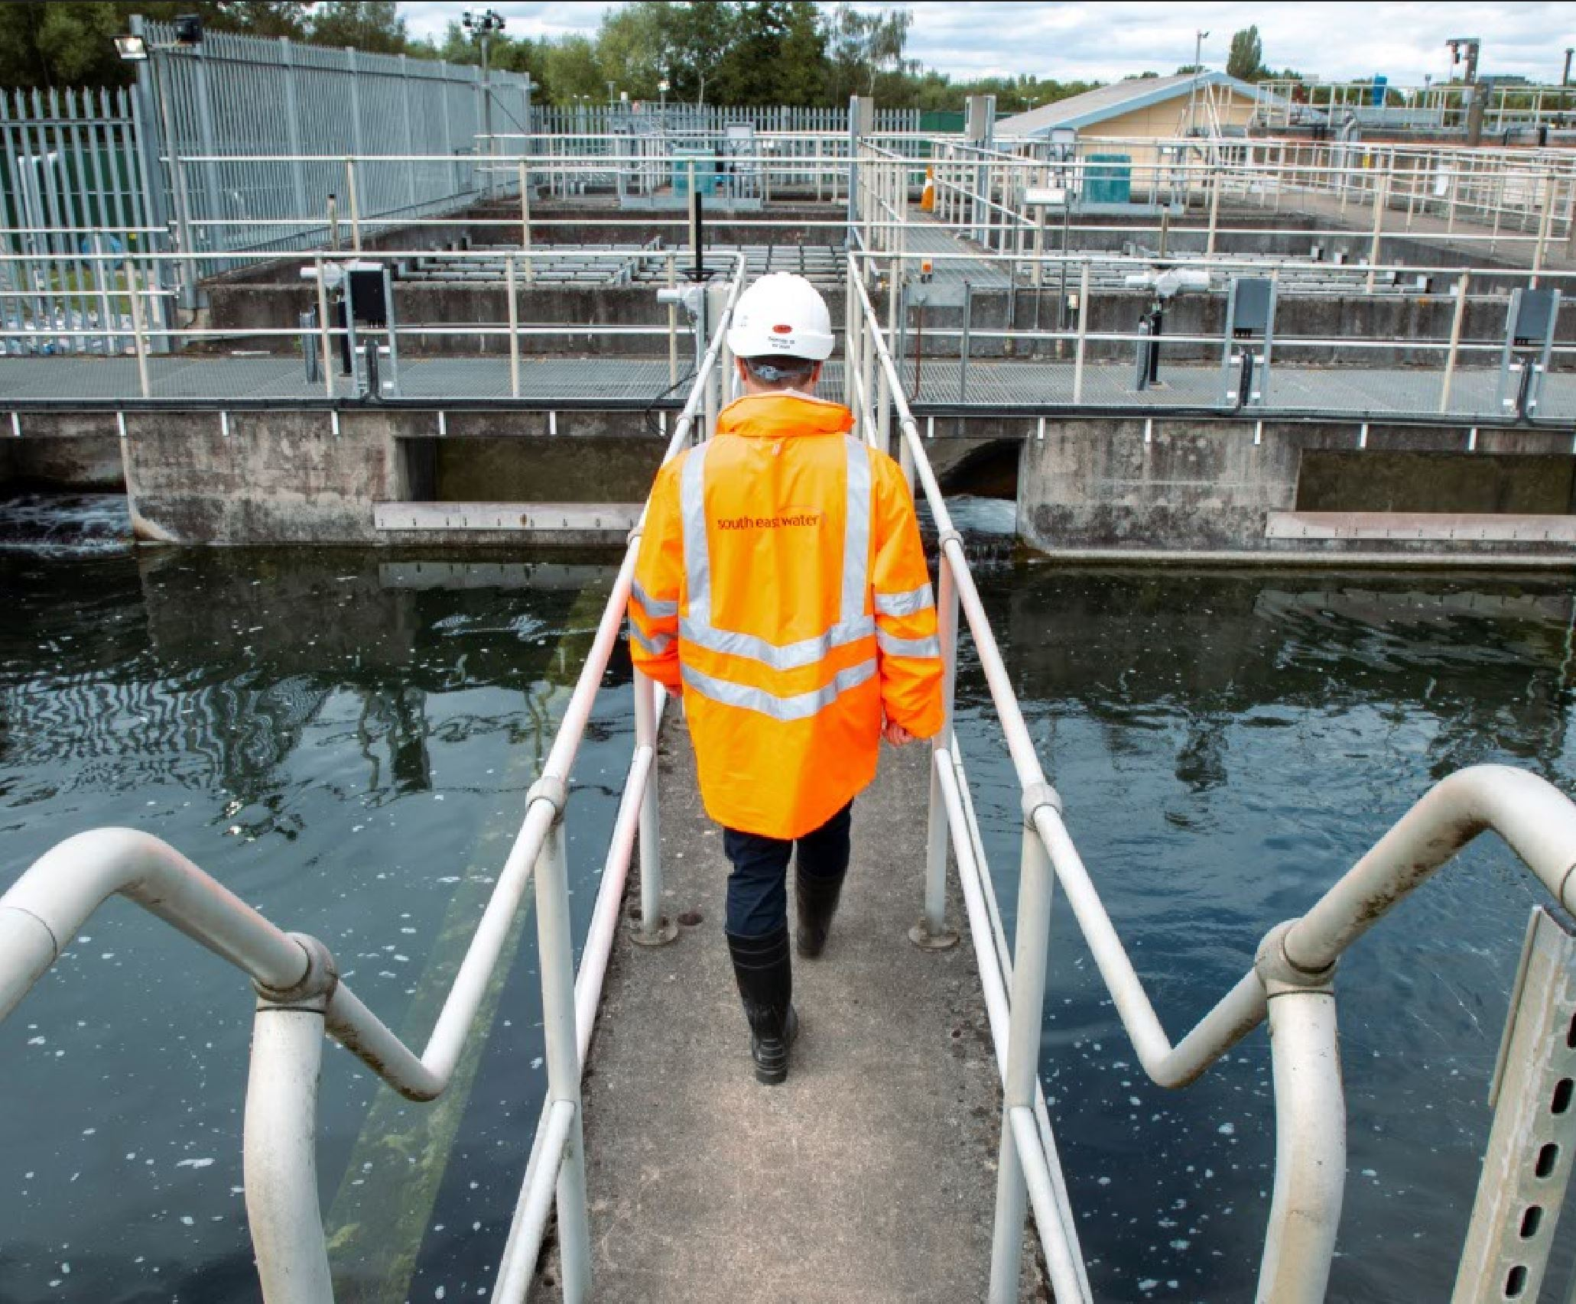

Publication details

**Publication**: How South East Water is adapting to a changing climate. A summery of our Climate Change Adaptation Report Round 4, 2024. V1 published December 2024.

**Document reference**: Large print SEW Comms 24 163 Customer Climate Adaptation Report Web V1.

# Company details

**South East Water, Rocfort Road, Snodland, Kent ME6 5AH.**

[southeastwater.co.uk](https://www.southeastwater.co.uk/)

South East Water © All rights reserved.  
Company number: 02679874.

**End of document.**