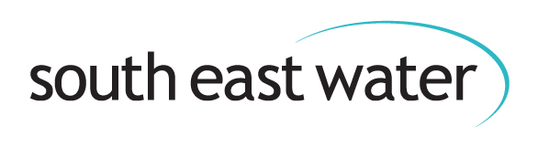
Beginning of document.

Draft Drought Plan 2027 – 2032
A non-technical summary
May 2026
Contents
Introduction 2
Our supply area 4
A special environment 4
Where does our water come from? 5
What is a drought? 7
What is high demand? 7
What is a drought plan? 8
Challenges facing us 9
Climate change 10
Housing and population growth 11
Planning for drought and dry weather 11
Managing drought and dry weather 14
Demand-side actions 15
Supply-side actions 16
Extreme drought (Level 3B) 16
Emergency drought plan 17
Lessons learned from the 2025/26 drought 18
Keeping you informed 19
How you can help 20
The end of a drought 21
Glossary 22
Publication details 24
Company details 24

Introduction
We’re proud to supply top quality drinking water to 2.3 million customers across 5,657 square kilometres of Kent, Sussex, Surrey, Berkshire and Hampshire.
Through our network of 9,000 miles of underground pipes, we deliver around 543 million litres of fresh drinking water to taps every day.
We’re one of the biggest water-only companies in the country which means we only treat and supply drinking water.
Making sure we have enough water for everyone and protecting the environment at the same time is a delicate balancing act.
We’re investing £2.1 billion over the next five years to protect our future water supplies and make them more resilient to extreme weather events such as drought.
We’ll do this by reducing leaks and bursts on our pipes and by replacing old mains. We’re using the latest smart technology to help us find and fix even more leaks than ever before and we’re rolling out smart meters so you can track and lower your own
water use at home.
Work is under way to build a new reservoir near Canterbury too. This is one way we’ll be increasing our future water supplies to keep up with demand.
Droughts and other extreme weather events are happening more often due to climate change and they can put these water supplies at risk.
This drought plan gives you more information about how we manage these risks, what we’ll do to protect water supplies if we have a long spell of very dry weather, and how you can help us.
This plan is being consulted upon until 6 August 2026. If you have any comments you wish to make you can email them to: water.resources@defra.gov.uk ?subject=South East Water and yourwateryoursay@southeastwater.co.uk?subject=South East Water
You must add “South East Water” to the subject field.
Or send them by post to:
Drought Plan Consultation, DEFRA, Drought, Seacole, 2 Marsham Street, London SW1P 4DF
David Hinton, CEO South East Water, May 2026.
Below image: headshot photo of South East Water’s CEO, David Hinton.


Our supply area
We split our supply area into eight individual water resource zones (WRZ) which are grouped into three regions: Kent, Sussex and the West.
We use these zones to plan water resources, manage water supply and demand, and decide our investment priorities. Some of the actions we take during a drought may affect WRZs or regions differently.

A special environment
Our water supply area includes lots of important sites and protected landscapes. These include:
• 196 Sites of Special Scientific Interest (SSSI).
• 17 Special Areas of Conservation.
• 11 National Nature Reserves.
This region is also the most wooded area in England, with a high percentage of the country’s protected ancient woodland. Ancient woodlands are rare and important habitats, rich in biodiversity.
We need to balance water demand and supply with the needs of this precious environment. It’s a top priority for us to protect and improve the natural environment around us.
This means we need to make decisions that help the environment to thrive as well as protect our water resources.
Below image: Illustration shows a map of South East Water’s supply area (in blue) and the eight labelled water resource zones (WRZ).
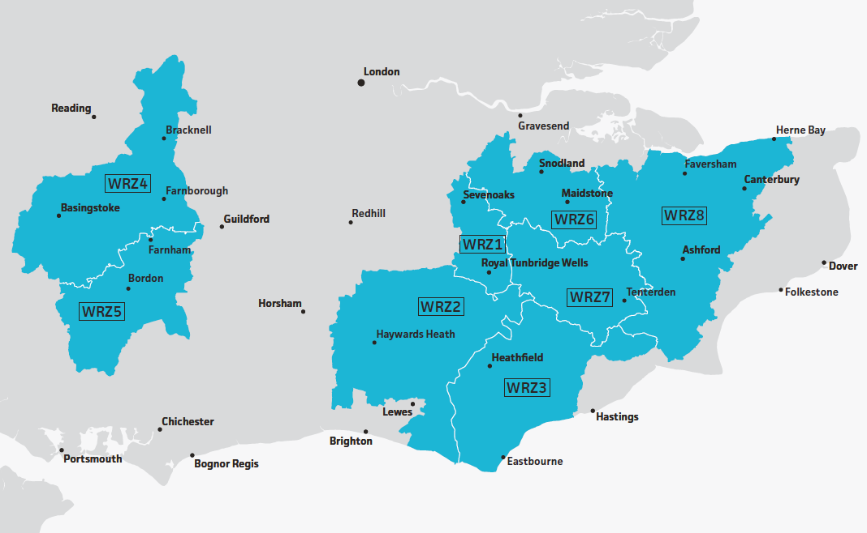

Where does our water come from?
An aquifer is an underground layer of rock that holds water. Most of the water we supply (around 73 per cent) comes from aquifers, through more than 250 boreholes and wells.
This is why it’s so important to manage these sources carefully as a drought develops. The rest of our water is surface water from rivers and reservoirs. We share some of our surface water supplies with other water companies, for example, Bewl Water reservoir.
We depend on winter rainfall to fill up (recharge) our aquifers but we also need to lower the amount of water we take from them and other sources as we balance supply needs with
protecting the environment.
The Water Cycle diagram
Below image: The Water Cycle diagram. The below illustration shows the continuous process (cycle) water takes as it moves from the land to the sky, and back again.
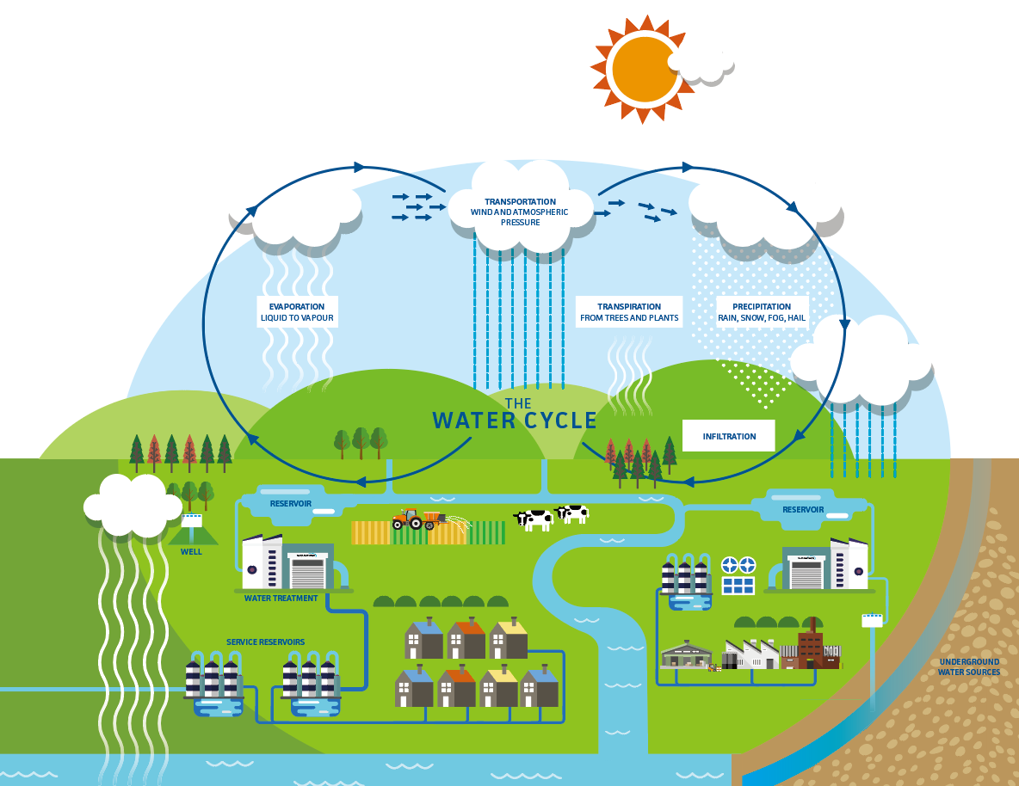

What is a drought?
A drought is a natural event where we have very little (if any) rainfall over a long period of time which leads to a water shortage. This can affect water supplies, farming and the environment. Every drought is different.
There are different types of drought including the following:
• Agricultural: Not enough rainfall (or moisture in the soil) to produce crops or keep them watered.
• Environmental: Lack of rain has a negative effect on the environment and ecology.
• Water supply: When a shortage of rain leads to worries about water supplies.
Longer, hotter summers and wetter winters are becoming more
common because of climate change. This means we’re likely to see more droughts and flooding events in the future.
The Environment Agency (EA) carefully monitors rainfall, river flows, groundwater levels, reservoir storage levels, ecology, and public water supplies, and decides the level of drought an area is in.
A drought only ends when there’s been enough rainfall to sufficiently restock groundwater sources, reservoirs and rivers.
This can sometimes take a long time.

What is high demand?
Since the COVID-19 pandemic, we’ve seen changes in the way customers use water.
This started with more people working from home during the pandemic and not travelling out of our supply area during the day to work, which led to a higher demand for water.
High demand for water can lead to water shortages and harm to the environment if we have to take more water from rivers.
High demand puts extra pressure on our available water resources, particularly during short-term events like heatwaves.
We typically see spikes in demand for water of about 20 to 30 per cent during heatwaves. These spikes are often even higher if the high demand or heatwave happens during longer spells of dry weather or during droughts.
We’ve seen this higher demand for water continue since the pandemic so we’ve developed ‘triggers’ based on how much water our customers use.
We track demand levels carefully, particularly during the summer, and compare them to what’s happened before.
This allows us to use past experience to protect customer
supplies and our water resources in the best way possible
in the future.
We have a set of actions we can take that are linked to these triggers. We explain these later in this plan.

What is a drought plan?
Under the Water Act 2003, we have to prepare and publish a drought plan and update it at least every five years.
This plan sets out how we’ll manage our water resources, keep taps flowing and protect our environment before, during and after a drought.
Our plan helps us make the right decisions as a drought situation develops and it links closely to our longer-term water resources management plan (WRMP) and our business plan.
Consulting our customers, stakeholders and our colleagues is an important part of preparing this document.
We’ve consulted with other water companies at a regional level too, through our membership of Water Resources South East.
Sharing information like this helps us improve coordination and communication during drought events.
Our drought plan also includes lessons we’ve learned from other recent droughts.
Our drought plan for 2027 – 2032 includes:
• Drought triggers (signs that a drought is developing, e.g. changes to river flows, groundwater and reservoir levels).
• Actions to manage water demand and supply in a drought.
• Extreme drought actions.
• A communications plan to keep you informed.
• An environmental assessment of drought actions.
• Signs (triggers) we’ll use to decide when a drought ends.
This version of our new drought plan is a simpler summary of our full technical document. You can read the full document at:
southeastwater.co.uk/draft-drought-plan

Challenges facing us
There are a number of challenges facing us as local communities, across a wider area and as a water company.
We’ve already mentioned the special environment and landscape we operate in. In line with the Environment Agency’s National Framework for Water Resources, we aim to protect and improve this environment, leaving it in a better state for future generations.
To do this, we have to find ways to tackle droughts that have a lower effect on the environment.

Climate change
The whole of our operational area is classified as being ‘seriously water stressed.’ This is where the demand for water is a high proportion of the rainfall that’s available to meet the demand.
We face a bigger shortage of water as our climate changes. We’re seeing wetter winters, drier summers and higher temperatures while severe weather events, such as droughts and floods, are happening more often.
We are also experiencing more water quality issues due to the changing climate which is adding to the pressure on our available water resources.
The 2025/26 drought shows how our climate’s changing. We had the driest spring in over 50 years followed by the hottest summer on record.
Four heatwaves led to a record demand for water. At the end of June, demand reached 680 million litres - that’s 105 million litres of water more than the average summer daily demand.
It was the driest August in 22 years and the National Drought Group called the situation a “nationally significant incident.”

Housing and population growth
Housing and population growth risk our future water supplies too. We plan to meet the needs of our growing population through the WRMP process. The Government also has a role to play to help ensure water is used as efficiently as possible.
Demand patterns
Since the Covid-19 pandemic, more people are working from home. This has changed how we all use water.
In recent years there have been times when the demand for water has been greater than our ability to extract, treat and pump water to customers. During hot summer weather demand can jump by 20 to 30 per cent, which is the equivalent of adding a town the size of Maidstone or Eastbourne to our network overnight.

Planning for drought and dry weather
We can’t predict when the next drought will be but we can be well prepared and ready to act quickly to protect water supplies and lower any impact on you and the environment.
Our long-term strategy to make sure we have enough water in the future to meet everyone’s needs is called a water resources management plan (WRMP).
This drought plan closely links to our WRMP but focuses on the short-term or temporary steps we’ll take to monitor and manage the impact of a drought.
Below average winter rainfall or dry spring weather can be an early warning of a risk of a drought developing. If either of these happen, we’ll start our messaging as soon as possible.
We constantly monitor water levels, including rainfall, river flows, groundwater levels and reservoir storage levels using our own information and real-time data from the Environment Agency.
We also use some key groundwater sites across our supply area to monitor specifically for signs of drought.
All the information we gather, which includes groundwater modelling and drought forecasting, tells us the likely impact of dry weather or a drought on our water resources and how and where a drought might develop.
We closely monitor demand all year round but we also track and forecast what peak summer demand is likely to be.
We’ve developed demand ‘triggers’ for action based on water use levels (demand).
We use a colour-coded ‘traffic light’ system (green, yellow, amber and red) for our drought trigger levels. This makes it easy to understand how serious the situation is and what action we’ll take. You can read more about the triggers and actions later in this plan.
As a drought develops, we’ll always focus first on lowering demand for water, by fixing even more leaks and burst pipes, and encouraging everyone to use water wisely.
You’ll see more messages from us in the early stages of a drought so you know what’s happening, what we’re doing about it and how you can help us.
We balance your needs with those of the environment so we’ll always try to choose actions that have the smallest impact on the environment when we decide how to manage droughts.
Below image: How a water company’s different plans work together to support its drought management. This image shows the coloured drought action levels
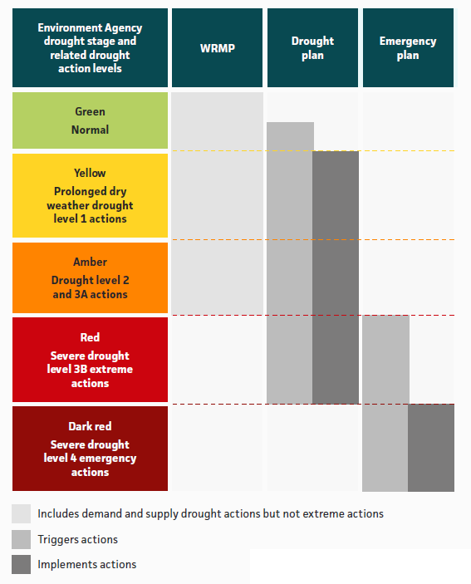

Managing drought and dry weather
This plan contains a toolbox of actions our drought management team can use to manage drought, dry weather and water shortages. Every drought is different, so we take a flexible approach to dealing with droughts.
These actions range from normal/business as usual monitoring activities (Level 0), through the start of a developing drought (Level 1), duration of the drought (Level 2 and up).
Managing the end of a drought is just as important so, when the drought situation starts to improve, we use our trigger levels again to monitor and, for example, remove restrictions, until we’re back to normal (Level 0) again.
We carry out regular environmental assessments and monitoring for signs of drought and these continue as a drought develops, and even after it’s ended. This happens with our communications activities too.
We assess the impact of our environmental and communications activities and change our actions if we need to. We review our activities and their effectiveness after each drought and make sure we learn from the experience for next time.
Our toolbox includes demand-side and supply-side actions. These have been developed from past drought plans, operational workshops, insight from customer research, work with Water Resources South East and other partners and stakeholders, and from lessons we’ve learned from previous droughts.

Demand-side actions
Our first priority is to lower demand for water by helping everyone lower their water use and by reducing the amount of water we lose through leaks in our pipe network.
We work on this all year round, not just during a drought, but ramp up our activities as a drought develops. Demand-side actions can include:
• Water conservation campaigns.
• Finding and fixing more leaks.
• Giving out more free water-saving devices.
• Supporting farmers and businesses install rainwater harvesting systems.
• Working with others to reduce the amount of water they take from the environment.
• Reviewing our operations to save water.
• Reducing our pipe flushing programme.
• Carrying out more water efficiency visits to business customers.
• Reducing pressure in the network to lower water use.
• Temporary use bans.
• Non-essential use bans.

Supply-side actions
We also have supply-side actions we can use during a developing drought to increase our supply of water. Some of these may need special approval from the Government or the Environment Agency. Actions include:
• Fast-tracking important engineering projects.
• Improving efficiency around our water network and
connections.
• Delaying non-essential maintenance work.
• Getting bigger bulk supplies of water from other water companies and sharing other resources. We get 8 per cent of our water from these inter-company supplies.
• Organising water tankers.
• Increasing the water sources available, by
possibly bringing older sources back into action.
• Changing our abstraction licences which allow
us to take water from rivers and other sources.
• Applying for Drought Permits and Drought Orders which give
us more flexibility to manage water resources during drought events.

Extreme drought (Level 3B)
If a drought becomes more serious, Level 3B is our final stage before emergency restrictions come into force.
Temporary measures at this stage include actions such as:
• Removing non-essential use ban concessions.
• Fast-tracking extreme drought supply projects.
• Lowering pressure in the network overnight.
• Using road tankers to transfer water to inject into the network where it’s needed most.
• Hard-hitting communications and media campaign aimed at
lowering demand for water.
• Drought Order application to increase abstractions (taking extra water from rivers).
• Laying emergency pipelines to move water from one area which has spare capacity, to an area which is in need.

Emergency drought plan
If we can’t maintain a secure supply of water to all our customers, we’ll trigger a Level 4 emergency drought response.
During the summer/autumn drought in 2025, water storage levels in Ardingly Reservoir in Sussex fell so low that we had less than 30 days’ worth of supply left. We started planning for a Level 4 emergency situation in the county because of this.
Level 4 emergency actions are rare and any emergency drought order applications have to be approved by the Government. These would ration water supplies by turning off
supplies at certain times.
All water companies now have to prepare a separate emergency drought plan to show how we’ll move from Level 3B to a Level 4 drought and work with local emergency planning
bodies to manage an emergency situation. Work on developing this document is ongoing.
We will develop our Emergency Drought Plan through the summer of 2026.

Lessons learned from the 2025/26 drought
Water is a finite resource and we all have a key part to play in making sure there is enough for the environment and communities. Every single one of us uses water every day.
Therefore, we, as a water company, can only do so much when it comes to saving water. We all need to play our part, whether it’s at home or at work.
We are still gathering feedback from local communities, our regulators and stakeholders following the 2025/26 drought and assessing research undertaken since the event.
See section 7 of our Drought Plan:
southeastwater.co.uk/drought-plan
The lessons we learn from this process, as well as insight from our own and others’ research, will continue to shape our new drought plan and how we respond to future droughts.
While we wait for the research conclusions to come through, some key points have already come out of this feedback which we have incorporated into our plan already:
• Water-saving messages need to begin much earlier and should be harder hitting.
• Our communications need to be more specific to individual areas.
• The way we communicate needs to be tailored to different customers.
• We need to clearly communicate restriction exemptions to reassure and support more vulnerable customers.
• We needed to use better information, live data and more monitoring sites to develop new drought triggers.
• We should update our water demand triggers to reflect the higher summer demand we are seeing each year.
• We needed to review how we handle a Level 3B extreme drought situation and make sure it’s consistent with actions of neighbouring water companies to avoid confusion.
• We should utilise trusted local partners such as catchment partnerships and wildlife trusts to help us tell people what’s happening.
• We should offer more support to farmers and landowners so they can develop their own water supplies, e.g. rainwater collection.
• We will work more closely with catchment partnerships to coordinate drought actions.
• We need to use local knowledge to give us more accurate information about river health and water levels during drought events.
• We should monitor key areas more closely for signs of a developing drought.

Keeping you informed
Keeping you up-to-date as a drought develops is really important.
Our customer insight and communications plan is part of our drought plan and sets out how we’ll communicate with you if things get worse. It includes some of the lessons we’ve learned so far from the 2025/26 drought and recent research we’ve done. The way we communicate with you might vary.
For example, we know that our younger customers like to see video-led content on social media, while our more vulnerable customers want to see reassuring messages about exemptions to restrictions.
Even in normal conditions (Level 0), we’ll still keep running our water efficiency campaign but we’ll step this up each spring.
We know that trust matters and this can affect whether you support our actions. When we’re asking you to save water, you quite rightly expect us to play our part too, by showing you what we’re doing to fix more leaks and invest in better infrastructure.
If we get our communication right, it’ll help to lower demand for water because you’ll understand how you can help us and why it’s important to protect our water resources.
Our communications aim to:
• Raise awareness of the water resources situation.
• Lower daily demand for water.
• Maintain high customer satisfaction levels.
Knowing where your water comes from and understanding the impact a drought can have on your local community and surrounding environment is important. Preparing you for what’s likely to happen next is also a key part of our approach.
Wherever possible, we’ll coordinate our communications with
other local water companies to avoid confusion.

How you can help
Many of you are already helping us to protect our precious water supplies so we can keep taps flowing during a drought situation and also protect the environment around us. By doing our best to follow some simple steps all year round, we’ll all
make a difference and even save some money.
• Collect rainwater - we offer discounted water butts, visit: southeastwater.co.uk/water butts
• Use a watering can instead of a hosepipe.
• Take shorter showers.
• Use a bucket and sponge to wash your car.
• Turn the tap off when brushing your teeth, cleaning or washing.
• Fully load your washing machine and dishwasher before using, and use the ECO setting.
• Only fill the kettle with the water you need.
• Check for leaky toilets - we offer free leak detection strips, visit: southeastwater.co.uk/free-devices
Visit our website for more information on how to save water: southeastwater.co.uk/save-water
You can even order simple, free devices or arrange a free home visit to help you save water.

The end of a drought
Our water resources (e.g. groundwater and reservoir storage levels) and customer demand for water all need to return to normal (Level 0) before we can say a drought has ended.
Even when this happens, we won’t normally remove any restrictions (temporary use bans or non-essential use bans) during summer months.
This is because there’s still a risk of high demand for water during summer heatwaves, and also to make sure we protect the environment.
We may even keep temporary use bans in place over the following autumn/winter if there’s a risk of the drought happening again the next year.
When a drought has ended, and also when any restrictions end, we’ll let you know. We’ll also begin a full review of our drought actions to see what we can improve for the next one. Even when a drought ends, we’ll carry on monitoring its impact on the environment.
After our review, we’ll update this drought plan and our longer-term water resources management plan with the lessons we learn.

Glossary
A
Aquifer
An underground layer of rock that holds water.
D
Demand-side
Work undertaken in customer properties, on our pipes and on our wider network.
Drought
A natural event where we have very little (if any) rainfall over a long period of time which leads to a water shortage.
Drought Plan
Details how we’ll manage our water resources, keep taps flowing and protect our environment before, during and after a drought.
G
Groundwater
Water we take from aquifers.
N
NEUB
Non-Essential Use Ban which applies to businesses.
P
PSR
Priority Services Register.
R
Recharge
Winter rainfall which fills up aquifers and reservoirs and replenishes rivers.
S
Supply-side
Work we can do at our water sources, treatment works and pumping stations.
Surface water
Water we take from rivers and reservoirs.
SSSI
Site of Special Scientific Interest.
T
TUB
Temporary Use Ban, also known as a hosepipe ban.
W
WRMP
Water Resources Management Plan.
WRZ
Water Resource Zones.
Publication details
Publication: Draft Drought Plan 2027 – 2032 (A non-technical summary). V1 published May 2026.
Document reference: Large print SEW_Comms_26_066 Web V1.

Company details
South East Water, Rocfort Road, Snodland, Kent ME6 5AH.
southeastwater.co.uk
South East Water © All rights reserved.
Company number: 02679874.
End of document.

