Bottle Description | Parameters Analysed | Preservation | Filling Instructions | Refrigerate?
BACT  Disposable 500mL PET Sterilised  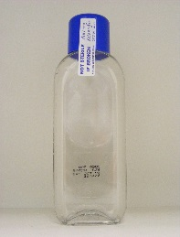  DRINKING WATER SAMPLES ONLY | Total coliforms  E coli  Colony Counts  Enterococci  Pseudomonas spp.  Pseudomonas aeruginosa  Clostridium perfringens | Supplied by manufacturer with sodium thiosulphate added  Must be used before expiry date shown on bottle  Do not use if seal is broken | Fill to shoulder  Do not rinse  Do not overflow | Yes
BACT  Disposable 500mL PET Sterilised  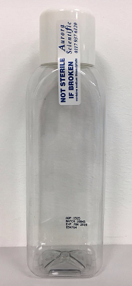 | Total coliforms  E coli  Colony Counts  Enterococci  Pseudomonas spp.  Pseudomonas aeruginosa  Clostridium perfringens | Supplied by manufacturer with sodium thiosulphate added  Must be used before expiry date shown on bottle  Do not use if seal is broken | Fill to shoulder  Do not rinse  Do not overflow | Yes

Bottle Description | Parameters Analysed | Preservation |  | Filling Instructions | Refrigerate?
BACT_1L  Disposable 1L PET Sterilised  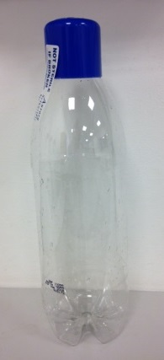 | Total coliforms (Large Volume)  E coli (Large Volume)  Clostridium perfringens (Large Volume) | Supplied by manufacturer with sodium thiosulphate added  Must be used before expiry date shown on bottle  Do not use if seal is broken |  | Fill to shoulder  Do not rinse  Do not overflow | Yes
LEGIONELLA  Disposable 1L PET  Sterilised  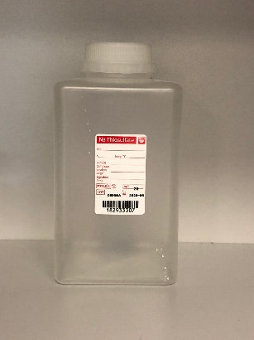 | Legionella |  | Supplied by manufacturer with sodium thiosulphate added  Must be used before expiry date shown on bottle  Do not use if seal is broken | Fill to shoulder  Do not rinse  Do not overflow | If transported on day of sampling, store at ambient temperature ideally between 6°C - 20°C otherwise store at 5±3°C. Store all samples in the dark, separate hot and cold samples.
Bottle Description | Parameters Analysed | Preservation |  | Filling Instructions | Refrigerate?
Crypto_10L  10L Grab  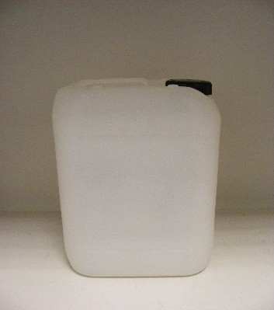 | Cryptosporidium  Giardia |  | None | Fill to shoulder  Rinse with sample before filling | No
Crypto_10L  10L Grab Disposable  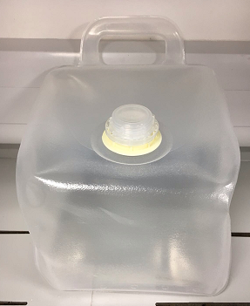 | Cryptosporidium  Giardia |  | None | Fill to shoulder  Rinse with sample before filling | No

Bottle Description | Parameters Analysed | Preservation | Filling Instructions | Refrigerate?
PLAS_1L  1L Disposable PET  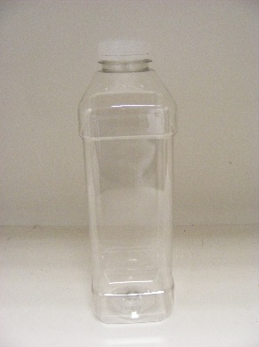 | Algae  Chlorophyll a  Oil & Grease  Biological Oxygen Demand  Chemical Oxygen Demand  Total Suspended Solids  Dry Residues  Total Dissolved Solids  Detergents | None | Fill to shoulder | Yes
GREEN  250mL disposable PET  with green lid  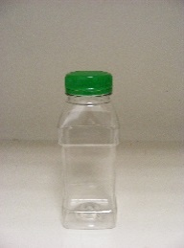 | Alkalinity  Hardness  Ammonium (Ammonia and Ammonium Ions)  Chloride  Nitrate  Nitrite  TON  Sulphate  Silica  Phosphorus-SRP  Chromium VI | None | Fill to shoulder | Yes

Bottle Description | Parameters Analysed | Preservation | Filling Instructions | Refrigerate?
RED  500mL disposable PET  with red lid  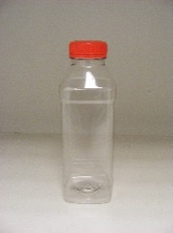 | Hydrogen Ion (pH)  Conductivity  Colour  Turbidity | None | Fill to top  No headspace should be present | Yes
PURPLE  125ml disposable PET  with purple lid  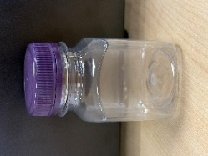 | Bromate  Fluoride  Bromide  Chlorate  Chlorite | None | Fill to shoulder | Yes

Bottle Description | Parameters Analysed | Preservation | Filling Instructions | Refrigerate?
TOC  125ml disposable PET  with opaque lid  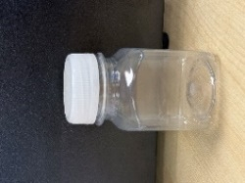 | Total Organic Carbon  Dissolved Organic Carbon  UV Absorbance  % Transmission  OES Metals (Process and Effluent Waters) – Ag, Be, Se, Sn, As, Cr, Cd, Ba, Ni, Pb, Mn, Na, Ca, B, K, Mg, P & Total Phosphate | None | Fill to shoulder | Yes
BLACK  125ml disposable PET  with black lid  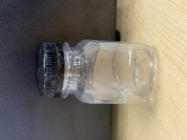 | Dissolved Metals  Fe, Mn, Al, Cu, Pb, Zn, Cd  OES-BSRIA Metals (Process Water) – Molybdate, Mo, Free & Total Fe, Zn, Cu & Al | None | Fill to shoulder | No

Bottle Description | Parameters Analysed | Preservation | Filling Instructions | Refrigerate?
BROWN  250mL brown PET  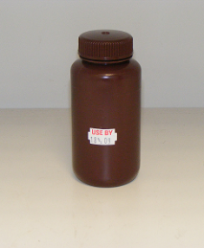 | Total Cyanide | 0.4g Sodium Hydroxide  CORROSIVE  (Gloves should be worn)  Must be used before expiry date shown on bottle | Fill to shoulder  Do not rinse  Do not overflow | Yes
METAL  125mL polythene  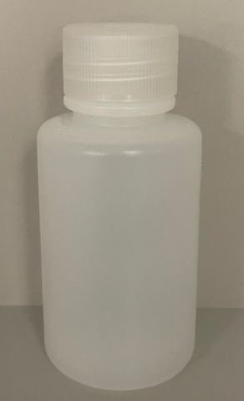 | METAL  Metals- Fe, Al, Mn, Pb, Cu, Ni, Zn  Toxics- Cd, Cr, Ba,  P, Ag, Sr, U  METAL_2  Hydrides- As, Se, Sb  Alk-Metals- Ca, Mg, Na, B,K  Li, Be, V, Co, Mo, Sn, Tl | None | Fill to  100ml mark | No
MERCURY  100ml Glass  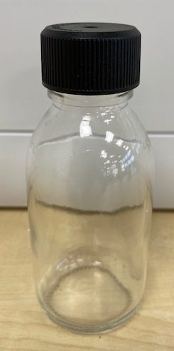 | Hg | None | Fill to shoulder | No

Bottle Description | Parameters Analysed | Preservation | Filling Instructions | Refrigerate?
FIRST-DRAW  1L polythene  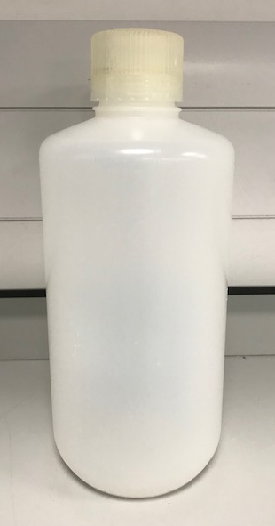 | First Draw Metals  Cu, Pb, Fe, Ni, Zn, Cr | None | Fill to just below shoulder | No
RADIOACT  1L polythene  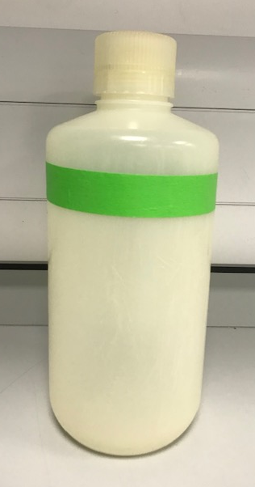 | Gross Alpha  Gross Beta | None | Fill to shoulder | No

Bottle Description | Parameters Analysed | Preservation | Filling Instructions | Refrigerate?
T-O-GLASS  Glass Duran 500ml  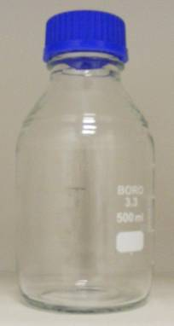 | Odour – Qualitative  Taste – Qualitative  Odour – Quantitative  Taste – Quantitative | None | Fill to top  – no headspace  should be present | Yes
PAH  500ml Amber glass  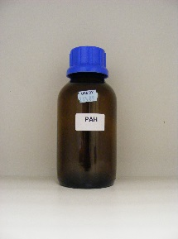 | PAH | 0.5mL of 6% Brij / 3% Sodium thiosulphate  Must be used before expiry date shown on bottle | Fill to shoulder  Do not rinse  Do not overflow | Yes

Bottle Description | Parameters Analysed | Preservation | Filling Instructions | Refrigerate?
THM  40ml Amber Vial  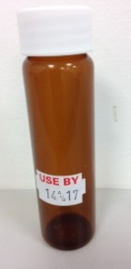 | THMs, HHC, Benzene, 1,2-Dichloroethane, BTEX, MTBE | 0.1ml of 3% sodium thiosulphate  Must be used before expiry date shown on bottle | Fill to top- no headspace should be present  Do not rinse  Do not overflow  Fill 2 bottles | Yes
PEST  1L Amber Glass  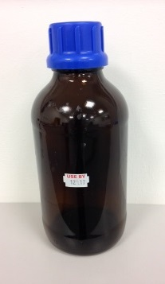 | Pesticides (Azuron, Acid Herbicides, Metaldehyde, PEST-GC-01, PHERBS, Chlorthal, OCP)  Hydrocarbons, Geosmin, MIB | 1mL of 3% sodium thiosulphate  Must be used before expiry date shown on bottle | Fill to shoulder  Do not rinse  Do not overflow | Yes

Bottle Description | Parameters Analysed | Preservation | Filling Instructions | Refrigerate?
RADON  500ml plastic  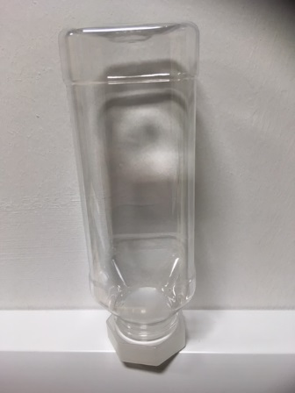 | Radon | None  Analysis MUST be carried out within 48 hours of sample being taken  The container should be stored and transported inverted after filling,  Sampling of Radon MUST be agreed with the Laboratory prior to sampling due to stability | Bottles should be filled with minimal amount of air present in bottle to prevent loss of gas from bottle from a slow-moving water source. | Yes
TRITIUM  125ml disposable PET  with blue lid  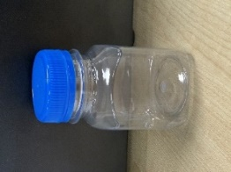 | Tritium | None | Fill to top | Yes
Bottle Description |  |  | Parameters Analysed |  | Preservation |  | Filling Instructions |  | Refrigerate?
PLAS_500ML  500ml clear plastic  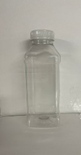 |  |  | Waste Water Metals- Molybdate, Mo, Free & Total Fe, Zn, Cu & Al  As, Cr, Cd, Ba, Ni, Pb, Mn Na, Ca, B, K, Mg, P & Phosphate  Ag, Be, Se, Sb, Sn. Hg  Free Cr, Free Ni, Free Pb, Free Cd |  | None |  | 250ml Minimum Volume  Please subsample if customer does not provide separate bottle |  | No
STL17  1ltr clear glass  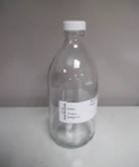 |  |  | Tributyl Tin  Pesticides & PCBs |  | None |  | Fill to shoulder |  | Yes
 | Bottle Description | Parameters Analysed |  | Preservation |  | Filling Instructions |  | Refrigerate?
 | STL33  250mL clear glass  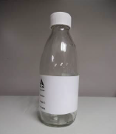 | TPH  Glycol |  | None |  | Fill to shoulder |  | Yes
 | STL101  500ml Plastic  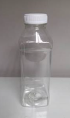 | PV  Colloidal Silica |  | None |  | Fill to shoulder |  | Yes
 | STL51  40ml clear glass vial  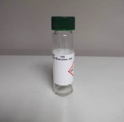 | VOC  BTEX  VPH |  | Supplied by ALS with 0.5ml Hydrochloric Acid (50% v/v) solution added  CORROSIVE  (Gloves should be worn)  Must be used before expiry date shown on bottle |  | Fill to top- no headspace should be present  Do not rinse  Do not overflow |  | Yes

Bottle Description | Parameters Analysed | Preservation | Filling Instructions | Refrigerate?
STL53  40ml amber glass vial  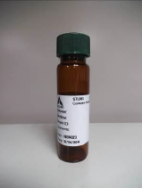 | Vinyl Chloride  Epichlorohydrin | Supplied by ALS with 0.3ml 1% (w/v) Sodium Thiosulphate solution added  Must be used before expiry date shown on bottle | Fill to top- no headspace should be present  Do not rinse  Do not overflow | Yes
STL430  250ml Amber Glass  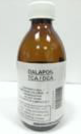 | HAAs | Supplied by ALS with 0.25ml 10% (w/v) Ammonium Chloride solution added  Must be used before expiry date shown on bottle | Fill to shoulder  Do not rinse  Do not overflow | Yes

Bottle Description | Parameters Analysed | Preservation | Filling Instructions | Refrigerate?
STL701  1ltr Plastic  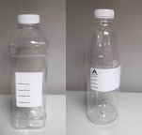 | NDMA | Supplied by ALS with 40mg Ascorbic Acid added  Must be used before expiry date shown on bottle | Fill to shoulder  Do not rinse  Do not overflow | No
ALS036  White plastic  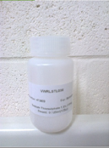 | Glyphosate  Chlormequat  PFAS Wakefield | Supplied by ALS with 0.125mL of 18mg/L Thiosulphate added  Must be used before expiry date shown on bottle | Fill to the top  Do not rinse  Do not overflow | Yes

Bottle Description | Parameters Analysed | Preservation | Filling Instructions | Refrigerate?
ALS058  500ml Amber Glass  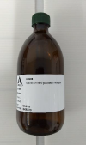 | Acrylamide  ALS WPC43 Pesticides  ALS WPC45 Pesticides  ALS WPC46 Pesticides | Supplied by ALS with Sodium Thiosulphate solution added  Must be used before expiry date shown on bottle | Fill to shoulder  Do not rinse  Do not overflow | Yes
PFAS  125ml polythene  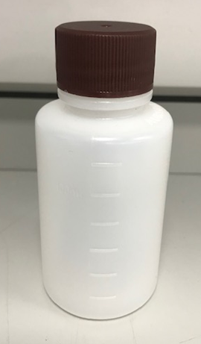 | PFAS 48 | None | Fill to  100 ml mark | Yes  (Freeze on arrival at laboratory)

Bottle Description | Parameters Analysed | Preservation | Filling Instructions | Refrigerate?
ALS060  100ml Amber Glass | Phenols | 0.1 ml of 3% (w/v) Ascorbic Acid solution  Must be used before expiry date shown on bottle | Fill to the top  Do not rinse | Yes
STL24  125ml Plastic | PFAS | None | Fill to shoulder  2 full containers | Yes

Bottle Description | Parameters Analysed | Preservation | Filling Instructions | Refrigerate?
STL81  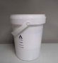  1.5kg Round Container | One container required  Particle Size Distribution | None | Fill to lid  If sample contains large stones, please fill two sample pots | No
STL200  250ml Glass with Red Stopper  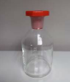 | One container required  Redox Potential | None | Carefully fill the bottle with sample with minimum aeration  Place the stopper in the bottle to displace air and excess liquid, and then remove the stopper  Replace the stopper avoiding inclusion of air bubbles | No
STL105  250ml Round Plastic  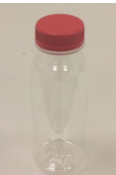 | One container required  Iodide | None | Fill to shoulder | Yes

Bottle Description | Parameters Analysed | Preservation | Filling Instructions | Refrigerate?
ALE204 | Effluent:  Silver Total  Silver - Filtered | Bottle contains 0.57ml (40% Nitric Acid)  SDS 11  Contains a hazardous Preservative.  Shelf life: 18 months | Total Analysis  Carefully fill to the neck of the bottle only  Filtered Analysis  Place the filter on the end of the syringe.  Fill the syringe with sample.  Carefully insert plunger and apply pressure to filter sample into the bottle, ensuring to only fill to the neck of the bottle.  When filtering, rest the syringe and filter disc on the neck of the bottle to aid with filtering, ensuring to hold the bottle.  The bottles are date stamped and must be used by the expiry date shown  Do not rinse | Yes
ALE001  60ml plain DIGI tube  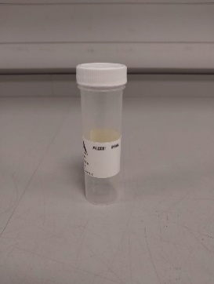 | Effluent PFAS | None | Fill to lid | No

