Deliverable 8.1

Plan for the Dissemination, Exploitation and Communication Activities (PDEC)

Version 2.0
21.06.2024
Marieke Reuver, Karla Corrales
ERINN Innovation Ltd (ERINN)
PUBLIC

Document Information

Grant Agreement | 101084204
Project Acronym | Cure4Aqua
Project Title | Curing EU aquaculture by co-creating health and welfare innovations.

Deliverable Number | D8.1
Work Package Number | WP8
Deliverable Title | Plan for the Dissemination, Exploitation and Communication Activities (PDEC)
Lead Participant | 3 – ERINN Innovation Ltd (ERINN)
Author(s) | Marieke Reuver (ERINN), Karla Corrales (ERINN)
Due Date
Submission Date
Dissemination Level | PU
Type of Deliverable | R

Version 2.0 | June 2024  Marieke Reuver (ERINN), Karla Corrales (ERINN). Validated by the Cure4Aqua consortium.  - Typographical edits throughout document  - Correction of formatting errors and structure throughout document where needed  - Correction of grammatical errors  - Update of “Communication & Dissemination activities” section  - Modifications to “Open Access” section with official information from the EC and the Annotated Grant Agreement (Horizon Europe)  - Modifications to “Repository requirements” from the Annotated Grant Agreement (Horizon Europe)  - Update of “Licensing requirements and IPR” section  - Update of missing funding number for Tissue Labs (TL)  - Update of Prior Notice protocol: adding the shorter email template  - Addition of Process Groups members  - Addition of Executive Board members  - Addition of External Expert Advisory Board members (EEAB)  - Update of “Cure4Aqua-Specific Stakeholder Events” section  - Continuous Reporting of Dissemination Activities and Communication Activities update from RP1  - Update of social media links from “Twitter” to rebranded “X”  - Addition of new social media profile: LinkedIn  - Deletion of examples of projects from FP7 and non-FP  - Updates to Knowledge Collection process (KMKT)  - Included updates of promotional material: factsheet and pull-up banner  - Included the protocol for participants wishing to communicate via the LinkedIn project account  - Inclusion of playdough workshop as communication activity
Version 1.0. | April 2023  Matteo Capodicasa (ERINN), Marieke Reuver (ERINN), Avril Hanbidge (ERINN). Validated by the Cure4Aqua consortium.

Executive Summary
The Cure4Aqua Plan for the Dissemination, Exploitation and Communication Activities (PDEC) outlines the EC rights and obligations of the consortium for dissemination, exploitation and communication (DEC) of the project results. It adopts EC best practice guidelines and defines the objectives of Cure4Aqua’s DEC. It also identifies target stakeholders, proposes communication tools and channels, and outlines responsibilities and resources to carry out effective knowledge management, and to measure the impact.
All project participants have an obligation to participate in the DEC of Cure4Aqua results and outputs to create impact, especially in their own countries and in their own communities. Within the PDEC, the DEC activities to be performed are described, along with protocols and processes to be followed.
Cure4Aqua has a work package dedicated to these activities (WP8 led by ERINN Innovation) specifically designed to support project communication activities to a wide audience and targeted dissemination and exploitation of results to specific stakeholders. To support participants in DEC of results, a portfolio of resources is available, developed within WP8. This portfolio is updated regularly, and additional resources are made available as required. Cure4Aqua makes use of the latest tools and communication channels to ensure cost effectiveness and maximum impact.
The PDEC has been developed by ERINN Innovation, who will also oversee its continuous implementation. This is the second version of the PDEC and as it is a dynamic document, it will be evaluated throughout the project and updated at EC reporting stages.
Contents
Document Information 2
Executive Summary 4
1. Introduction 6
1.1 Rationale 6
1.2 Objectives 6
2. Key Principles Guiding the PDEC 7
2.1 Definitions and Terminology 7
2.2 Rights, Rules and Obligations related to Results 7
2.3 General Data Protection Regulation Implications 13
3. Pre- and Post-Dissemination Requirements 14
3.1 Pre-Dissemination Requirements 14
3.2 Post-Dissemination Requirements 17
4. Stakeholder Engagement 19
4.1 Internal Stakeholders - Project Bodies 19
4.2 Stakeholder Engagement Strategy 22
4.3 Cure4Aqua-Specific Stakeholder Events 24
5. Knowledge Management, Transfer and Exploitation of Results 27
5.1 Knowledge Management and Transfer Overview 27
5.2 Knowledge Management and Knowledge Transfer (KMKT) 29
6. Dissemination and Communication Resources 34
6.1 Promotional Materials 34
7. Dissemination and Communication Activities 41
7.1 PDEC Tools, Channels and Target Groups 41
7.2 External Events 42
7.3 Scientific Publications – Relevant Journals 44
8. PDEC Monitoring and Evaluation 44
9. Project participants involved in the work 45
Appendix 46
Annex 1 – Glossary 46
Annex 2 – IP Assessment Form 48
Annex 3 – Cure4Aqua Continuous Reporting Log 50

Introduction
Through active engagement with key stakeholders, Cure4Aqua aims to jointly improve the resilience of EU aquaculture under environmental, biological, and socio-economic stress, by improving aquatic animal health and welfare and supporting the environmentally friendly, inclusive, safe, and healthy production of seafood. Cure4Aqua will do so by 1) Developing cost-effective vaccines to prevent disease caused by five pathogens of economic significance to EU aquaculture; 2) Identifying markers with diagnostic capacity to be integrated to selective breeding programs to improve stress and disease management; 3) Developing innovative, bio-based and sustainable solutions as an alternative to antibiotics for controlling fish pathogens at various life stages and alleviate the pressure of global antimicrobial resistance; 4) Developing new tools and technology to improve health and welfare monitoring at the fish farm level and diagnostics of fish pathogens both at the laboratory and the fish farm levels; 5) Placing fish welfare at the foreground of aquaculture production, through the development of high welfare standards that consider different life-stages, production systems, and knowledge of welfare needs.
To guarantee the adoption of Cure4Aqua solutions, support uptake and to maximise the impact and legacy of Cure4Aqua, the project has put in place effective communication, dissemination, engagement and knowledge transfer (KT) strategies in a standalone work package (WP8 Ensuring Impact: Dissemination, Communication, Exploitation and Training) in which all project participants are involved.

Rationale
The Cure4Aqua PDEC outlines the DEC strategies to be implemented by the consortium throughout the project lifetime and beyond.
Adopting the EC’s best practice guidelines and aligning with rights and obligations outlined in the Cure4Aqua Grant Agreement (GA) related to dissemination and exploitation, the PDEC describes internal processes and protocols set up to support communication, manage generated knowledge and to ensure exploitation of the Cure4Aqua results. It identifies key project stakeholders, communication tools and channels and describes the means (tools, messages) of dissemination and measures to support exploitation.

1.2 Objectives
The PDEC aims to:
- Promote the project activities and results beyond the consortium by employing a range of communication and dissemination tools;
- Provide a useful guide to all members of the Cure4Aqua consortium about rules and responsibilities surrounding DEC;
- Identify and profile the target stakeholders for the different project results;
- Define the most effective dissemination and exploitation channels, tools, and means, tailored to the relevant stakeholders;
- Outline the knowledge management and transfer principles and protocols to ensure effective transfer of Key Exploitable Results (KERs);
- Ensure timely and efficient knowledge management and transfer while safeguarding intellectual property (IP);
- Maximise post-project uptake by developing thorough and forward-thinking plans that clearly outline the potential users and applications of the project’s KERs and KT activities required to ensure objective and measurable short and long-term project impacts.
The Cure4Aqua PDEC describes the DEC activities to be performed to ensure the exploitation of the project’s outputs, its maximum impact, and the availability of the gained knowledge for all interested organisations. It is a dynamic document and will be evaluated and updated at EC reporting stages, allowing for adjustments as needed.

Key Principles Guiding the PDEC

Definitions and Terminology
The foundation of the Cure4Aqua PDEC is the knowledge management process which has been implemented from the start of the project and which informs communication, dissemination, and exploitation (KT), in line with the European Commission (EC) definitions as follows:
- Communication is a strategically planned process that starts at the outset of the project and continues throughout its entire lifetime. It is aimed at promoting Cure4Aqua and its results. It requires strategic and targeted measures for communicating about Cure4Aqua and the project’s results to a multitude of audiences, including the media and the public, and possibly engaging in a two-way exchange. Activities used for communication purposes are, for example, a public website, press releases or social media.
- Dissemination is the public disclosure of the project results by any appropriate means (other than resulting from protecting or exploiting the results), including by scientific [or professional] publication in any medium. It makes research results known to various stakeholder groups in a targeted way, enabling them to use the results in their own work. Activities used for dissemination purposes are, for example, conferences, education and training events, clustering activities and collaboration with other EU-funded projects.
- KT and exploitation of results is more advanced than communication and dissemination, it involves the use of results in further [innovation and deployment] activities other than those covered by the project, including among other things, commercial exploitation such as developing, creating, manufacturing and marketing a product or process, creating and providing a service, or in standardisation activities. It requires several steps including identifying exploitation mechanisms and activities, focused on identified end users to ensure impact and uptake of the results, which will provide measurable impacts for Cure4Aqua, while ensuring any project-generated IP is properly managed.

Rights, Rules and Obligations related to Results
This section outlines a summary of some key aspects of the rights and obligations relating to the protection of these results; however, it is not an exhaustive summary. For further details on the project and Horizon Europe rules surrounding ownership and protection of results please refer to the Grant Agreement (GA), Consortium Agreement (CA) and on specific rules for data outputs, please see D1.1 Data Management Plan (DMP; the most recent update has been updated in M18).

Ownership of Results
Results are owned by the participant that generates them. Two or more project participants own results jointly if they have jointly generated them and it is not possible to establish the respective contribution of each participant, or separate them, for the purpose of applying for, obtaining, or maintaining their protection (GA Article 16.2 – Annex 5). The joint owners must agree (in writing) on the allocation and terms of exercise of their joint ownership (joint ownership agreement), to ensure compliance with their obligations under the GA. If valuable results are not protected, the Commission may under certain circumstances assume ownership of the results (see GA Article 16 – Annex 5 for further details).

Protection of Results
Each participant has an obligation to protect its results. Project participants which have received funding under the grant must adequately protect their results — for an appropriate period and with appropriate territorial coverage — if protection is possible and justified, taking into account all relevant considerations, including the prospects for commercial exploitation, the legitimate interests of the other project participants and any other legitimate interests.

Exploitation of Results
Each participant has an obligation to exploit its results. Project participants which have received funding under the grant must — up to four years after the end of the action — use their best efforts to exploit their results directly or to have them exploited indirectly by another entity, in particular through transfer or licensing.
If, despite a participant’s best efforts, the results are not exploited within one year after the end of the action, the project participants must (unless otherwise agreed in writing with the granting authority) use the Horizon Results Platform to find interested parties to exploit the results (see GA Article 16 – Annex 5 for further details). Project participants must also continue to use their best efforts to exploit their results themselves throughout the subsequent four years.

Intellectual Property Rights (IPR) & Management
Cure4Aqua will follow the rules for IP set out and regulated by the EC. More information can be found in GA (Article 16.4) “Intellectual Property Rights (IPR) — Background and Results — Access Rights and Rights of Use”.
The Intellectual Property Use and Dissemination Committee (IPUDC) is a Cure4Aqua consultative body that will support project participants with the management of results, dissemination activities and IP. The project participants will ensure that adequate steps towards protection are taken prior to DEC, preventing unapproved public disclosure of results, tools, products and services. An IP Assessment Form (Section 3.1.2) for screening DEC activities will be implemented and shared on the project’s intranet for project participants to complete to ensure protection of results.

Communication and Dissemination of Results
Each participant must disseminate their results as soon as possible by disclosing them to the public. However, no dissemination may take place before a decision is made regarding possible protection (section 3.1). Other participants may object if their legitimate interests in relation to their results or background could potentially suffer harm. Results that are disclosed too early (before the decision on their protection) may run the risk of making protection impossible.
Therefore, project participants who intend to disseminate their results must give at least 15 calendar days prior notice (see section 3.1.1) to other project participants (unless agreed otherwise), together with sufficient information on the results they intend to disseminate (GA Article 17 – Annex 5).
Any other participant may object within (unless agreed otherwise) 15 days of receiving notification if it can show that its legitimate interests in relation to the results or background would be significantly harmed. In such cases, the results may not be disseminated unless appropriate steps are taken to safeguard those interests.
NO dissemination at all may take place, if:
- the results in question need to be protected as a trade secret (i.e. confidential knowhow) or
- dissemination conflicts with any other obligations under the grant (e.g. personal data protection, security obligations, etc).

Open Science and Open Access (OA) to Scientific Publications
‘Open Science’ is an approach based on open cooperative work and systematic sharing of knowledge and tools as early and widely as possible in the research process.
The open science provisions in Horizon Europe contain a set of requirements and encouraged practices that cover some of the most important aspects of open science. They concern research outputs such as scientific publications and research data and additional open science practices.
‘Research outputs’ are results to which online access can be given in the form of scientific publications, data or other engineered outcomes and processes, such as software, algorithms, protocols, models, workflows and electronic notebooks.
This section outlines OA requirements for scientific publications. For more information on open science in relation to research data management and FAIR principles, please see the Cure4Aqua Data Management Plan (D1.1 – DMP).
Providing OA to peer-reviewed scientific publications in Horizon Europe-funded projects is an obligation for all grants (GA Article 17 – Annex 5).
Beneficiaries must ensure open access to peer-reviewed scientific publications relating to their results. This includes articles and long-text formats, such as monographs and other types of books. Immediate open access is required i.e. at the same time as the first publication, through a trusted repository using specific open licences.
How to provide open access (source: Annotated Grant Agreement HE):
Beneficiaries/authors may publish in the venue of their choice, either in a closed venue (i.e. access to all content is restricted), an open access publishing venue or in a hybrid publishing venue, provided that all their open access-related obligations as detailed in the Grant Agreement are complied with.
‘Open access publishing venues’ are publishing venues whose entire scholarly content is published in open access (e.g. open access journals, books, publishing platforms, repositories or preprint servers).
‘Hybrid publishing venues’ are publishing venues which provide part of their scholarly content in open access, while another part is accessible through subscriptions/payments (e.g. hybrid journals and books). These are often journals/books based on subscription/purchase which provide open access to part of their content when an open access fee is paid by their authors/institutions (paid ad hoc or on the basis of an institutional agreement with the publishers).
‘Mirror and sister journals’ (i.e. more recently established open access versions of existing subscription journals, which may share the same editorial board as the original journal and usually have (at least initially) the same or very similar aims, scope and peer review processes and policies; these journals often have a name similar to the subscription title (but a different ISSN) are considered open access publishing venues for Horizon Europe grants (not hybrid journals).
In parallel, beneficiaries/authors must deposit their publication in a machine-readable format (i.e. structured format that can automatically be read and processed by a computer) in a trusted repository — before or at publication time — and immediately provide open access to the publication through that repository.
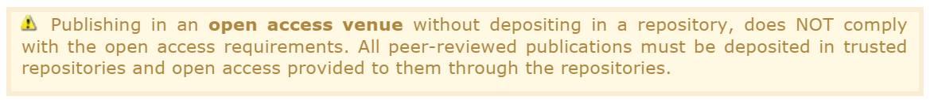
Best practice: Beneficiaries are encouraged to provide open access to ALL publications, even if they are not peer-reviewed.
When choosing the publishing venue and the repository, beneficiaries/authors must keep in mind that licensing requirements, metadata requirements and validation requirements must also be complied with at this time.
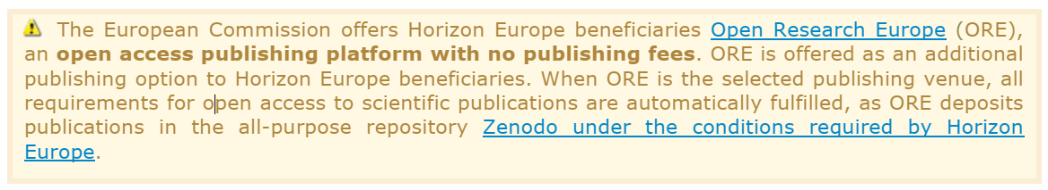
Immediate open access through the repository must be provided either to the final peer-reviewed manuscript accepted for publication or to the final published peer-reviewed version.
Please also note that publication fees are only eligible when publishing in full open access publishing venues (venues in which the entire scholarly content is openly accessible to all) and not in hybrid venues. Publication fees may, in particular, include peer review fees, including where the peer review service has been provided by an organisation different from the one providing the publishing venue. Peer review fees for publications are eligible for reimbursement only for the first round of peer reviewers.
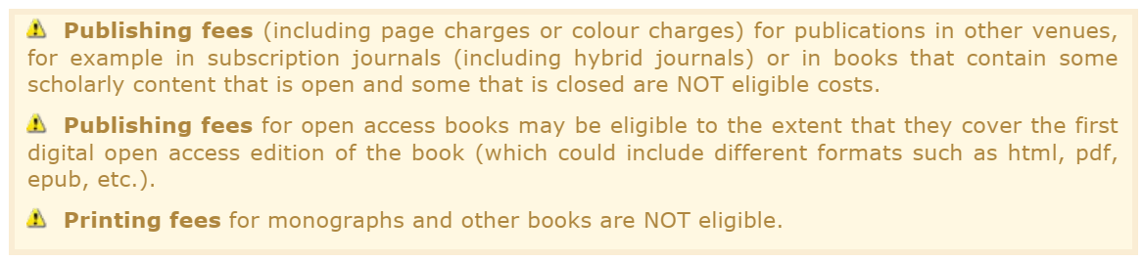
Repository requirements (source: Annotated Grant Agreement HE):
Beneficiaries must ensure deposition of and open access to publications (and research data, where the case) through trusted repositories.
‘Repositories’ are online archives, where researchers can deposit digital research outputs and provide (open) access to them. Repositories help manage and provide access to scientific outputs and contribute to the long-term preservation of digital assets. They can be institutional, operating with the purpose to collect, disseminate and preserve digital research outputs of individual research organisations (institutional repositories, e.g. the repository of University X) or domain-specific, operating to support specific research communities and supported/endorsed by them (e.g. Europe PMC for life sciences). There are also general-purpose repositories, such as for example Zenodo, developed by CERN.
Personal websites and databases, publisher websites, as well as cloud storage services (Dropbox, Google drive, etc) are NOT considered repositories. Academia.edu, ResearchGate and similar platforms do not allow open access under the terms required and therefore are also NOT considered repositories.
For more information on OA, please consult GA Article 17 - Annex 5 (Communication, Dissemination, Open Science and Visibility), in particular the Annotated Model Grant Agreement provisions.
Licensing requirements and IPR:
Scientific publications must be licensed under the latest available version of a Creative Commons Attribution International Public Licence (CC BY) or an equivalent licence. For monographs and other long-text formats the licence may exclude commercial uses and derivative works (as in CC BY-NC, CC BY-ND or CC BY-NC-ND or equivalent licences).
For more guidance, including an explanatory checklist of the rights conferred by the above licences that will help researchers to understand publisher-equivalent licences, see the HE Programme Guide.
Beneficiaries (or authors, where the case) must retain sufficient intellectual property rights to be able to comply with their open access requirements.
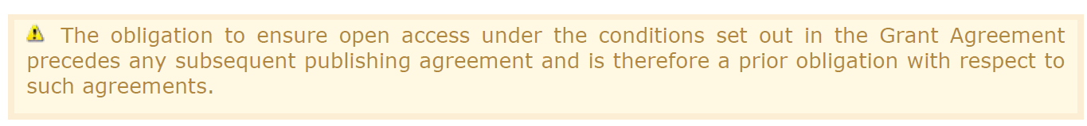
Best practice: Beneficiaries/authors retain the copyright on their work and grant, insofar as possible, non-exclusive licences to publishers. To facilitate this, beneficiaries should put in place institutional policies to ensure copyright retention by authors and/or beneficiaries and compliance with the open access requirements.
To help you find publishing venues that comply with Horizon Europe open access requirements, you can use:
- the Journal Checker Tool (Journal Checker Tool: Check which publishing options are supported by your funder’s OA policy |) — can help to determine whether a specific publishing venue allows compliance with the open access obligations of Horizon Europe
- the Directory of Open Access Journals (Directory of Open Access Journals – DOAJ) — can help to identify full open access journals that allow open access publishing under CC BY or an equivalent licence
- Open Research Europe (Open Research Europe | Open Access ... | Open Research Europe (europa.eu)) — open access publishing platform of the European Commission, allows automatic compliance with the Horizon Europe requirements.

Visibility of funding
Project participants are obligated to use the EU emblem when publishing and/or presenting work carried out under the Cure4Aqua project (GA Article 17.2). Unless the Agency requests or agrees otherwise or unless it is impossible, any dissemination of results (in any form, including electronic) must display the EU emblem. This includes conferences, seminars, in information material (such as brochures, leaflets, posters, presentations, etc.), including electronic form via social media, etc. and any infrastructure, equipment or major result funded by the grant. When displayed in association with another logo, the EU emblem must have appropriate prominence. For the purposes of their obligations under this Article, the project participants may use the EU emblem without first obtaining approval from the Agency. This does not, however, give them the right to exclusive use. Moreover, they may not appropriate the EU emblem or any similar trademark or logo, either by registration or by any other means.
Any communication or dissemination activity related to the project must include the following EU emblem and funding acknowledgement:
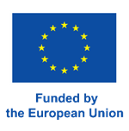
Any communication or dissemination activity related to the project in which non-EU funded participants are involved must include the emblem and acknowledgement above, as well as the following non-EU funding emblems and acknowledgements where relevant:
Funded by the European Union under the Horizon Europe Programme, Grant Agreement No. 101084204 (Cure4Aqua). Views and opinions expressed are however those of the author(s) only and do not necessarily reflect those of the European Union or the European Research Executive Agency (REA). Neither the European Union nor the granting authority can be held responsible for them.
- Swiss State Secretariat for Education, Research and Innovation (SERI) logo and funding acknowledgement for Swiss partners (FGCZ, TL, PATH), as follows:
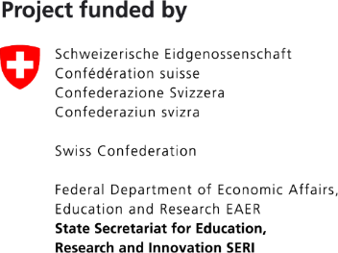
Swiss participants in Cure4Aqua have received funding from the Swiss State Secretariat for Education, Research and Innovation (SERI) under Contract No. 23.00290 (TL), No. 22.00432 (FGCZ) and No. 22.00431 (PATH).

- Agencia Nacional de Investigación y Desarrollo (ANID) logo and funding acknowledgement for Chilean partner (PUCV), as follows:
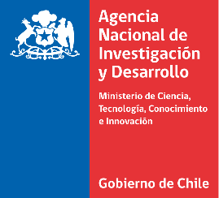
The Chilean participant in Cure4Aqua has received funding from the Agencia Nacional de Investigación y Desarrollo (ANID) under Grant No. FONDECYT N°1200521 and FOVI210032 (PUCV).
- UK Research and Innovation (UKRI) logo and funding acknowledgement for UK partners (THL, MRI, UNIAB, SWU, ICL), as follows:
UK participants in Cure4Aqua are supported by the UKRI’s Horizon Europe Guarantee under the Grant No. 10054306 (UNIAB); and Innovate UK under the Grant No. 10061596 (THL); Grant No. 10050496 (MRI); No. 10061148 (SWU); and No. 10054089 (ICL).

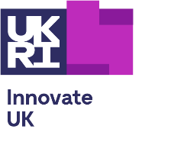


When displayed in association with these non-EU funding emblems and acknowledgements, the EU emblem must have appropriate prominence.
The EU and non-EU funding emblems and acknowledgements are available on the project intranet (https://3.basecamp.com/5521393/buckets/30698771/uploads/7358783118). If you have any queries about their use, please contact ERINN Innovation (marieke@erinn.eu).

General Data Protection Regulation Implications
The General Data Protection Regulation (GDPR) (EU 2016/679) provides enhanced protection to individuals’ data privacy rights. Organisations storing or using personal data (anything that allows identification of an individual) must clearly disclose what data is being collected and how, why it is being processed/used, how long it is being retained, and if it is being shared with any third parties. Personal data can be names, email addresses, job titles, phone numbers, and anything that allows identification of an individual.

GDPR compliance (website, mailing list and events)
The Cure4Aqua project website (cure4aqua-project.eu) managed by ERINN, is fully compliant with GDPR by incorporating a Privacy Statement and Cookie Bar informing website visitors about what Cure4Aqua does with any personal data gathered. A ‘Subscribe to News’ button is clearly visible on the Homepage, allowing people to voluntarily sign up to the Cure4Aqua mailing list. The sign-up page contains a link to the Privacy Statement. Subscription is on a double opt-in basis, whereby people who sign up need to confirm their email address to complete the subscription process and ensures compliance regarding consent under GDPR. The subscription system will send an automatic Cure4Aqua email to the subscriber who then needs to click on the link in the email sent to them. The mailing list will only be used to share Cure4Aqua-related information and news. Photographs and videos taken at Cure4Aqua project events, workshops, meetings and promotional activities will comply with the GDPR through the use of consent forms to be signed by all persons involved when relevant. Personal data collected at events will be stored on secure databases and will not be used /shared for any other purpose. For more information on the use of Personal Data and associated ethics, please see D1.2 – Ethics Report.

Pre- and Post-Dissemination Requirements

Pre-Dissemination Requirements

Prior Notice Procedure
For all types of Publications, Dissemination and Communication Activities (including scientific publications, oral and poster presentations, non-scientific and non-peer reviewed publications, etc.) where Cure4Aqua results or outputs are presented, the Prior Notice Procedure (protocol below) must be applied.
The main participant involved in the dissemination of results from the Cure4Aqua project (owned by one or several parties) must give the other project participants at least 15 calendar days together with sufficient information on the results they will disseminate (CA Article 8.4.2.1, GA Article 17 – Annex 5).
PROTOCOL – Prior Notice Procedure

- Participant(s) proposing a dissemination activity (submission/communication/publication) should inform all project participants of their intent via the Cure4Aqua Basecamp WP8 folder at least 15 calendar days before submitting/communicating/publishing using the ‘Prior Notice Email Templates’ below and upload/attach the planned submission/communication/publication (full draft, if possible, but at a minimum this must include an abstract including title, author(s), project participants involved and details on where it will be submitted/communicated/published and/or presented). In the M18 update of the PDEC, an additional Prior Notice Email template for shorter timelines has been included, to streamline the process for urgent situations or unexpected changes.

- Project participants have 14 calendar days to object if they can show that their legitimate interests in relation to the submission/communication/publication would be significantly harmed if the disclosure is permitted.

- Any objection to the planned submission/communication/publication shall be made in accordance with the GA by written notice to the Cure4Aqua Coordinator and to the participant(s) proposing the submission/communication/publication, within 14 calendar days after receipt of the notice. Any objection needs to be justified and precise suggested modifications given. An objection is justified if:
  - It adversely affects protection of results/background of the objecting party.
  - Legitimate interests of the objecting party would be significantly harmed.

- If no objection is made within the above stated timeline, or if objections are addressed and accepted by the objecting participant(s), the submission/communication/publication is permitted.

Prior Notice Email Template (normal timeline):
Dear Cure4Aqua colleagues,

We have prepared a [insert planned disclosure e.g., communication/publication] to be submitted to [insert communication/publication name/item] / presented at [insert event name/location] on [insert date]. Please see the [insert document type/information] attached.

In accordance with the Grant Agreement, any Cure4Aqua participant who intends to disseminate their results must give prior notice to other project participants, who are then provided 14 calendar days to object to the proposed dissemination activity. In exceptional circumstances where a dissemination activity is planned unexpectedly in a shorter timeframe, then notice to other project participants must be as soon as possible.

Objections are justified if:
a) The protection of the objecting Party's Results or Background would be adversely affected, or
b) The objecting Party's legitimate interests in relation to its Results or Background would be significantly harmed, or
c) The proposed dissemination activity includes Confidential Information of the objecting Party.

Any objection must include a precise request for necessary modifications. Please submit justified objections, with precise modifications, to [main participant email] and the project coordinator (Ivona Mladineo ivona.mladineo@paru.cas.cz) within 14 days, so before [insert date].

If no objections are received within this timeline, we assume that all parties agree with the dissemination of these results.

Prior Notice Email Template (shorter timeline):
Dear Cure4Aqua colleagues,

We have prepared a [insert planned disclosure e.g., communication/publication] to be submitted to [insert communication/publication name/item] / presented at [insert event name/location] on [insert date]. Please see the [insert document type/information] attached.

In accordance with the Grant Agreement, any Cure4Aqua participant who intends to disseminate their results must give prior notice to other project participants, who are then provided 14 calendar days to object to the proposed dissemination activity. Since the deadline for submission is already on [insert date], we exceptionally ask for a shorter feedback timeframe, namely [insert date]. Apologies for any inconvenience this may cause.

Please note that objections are only justified if:
a) The protection of the objecting Party's Results or Background would be adversely affected, or
b) The objecting Party's legitimate interests in relation to its Results or Background would be significantly harmed, or
c) The proposed dissemination activity includes Confidential Information of the objecting Party.

Any objection must include a precise request for necessary modifications. Please submit justified objections, with precise modifications, to [insert main participant email] and the project coordinator (Ivona Mladineo ivona.mladineo@paru.cas.cz) by [insert date].

If no objections are received within this timeline, we assume that all parties agree with the dissemination of these results.

Intellectual Property (IP) Assessment Form
As outlined in the Grant Agreement, an IP check is implemented as part of the prior notice process, whereby participants who intend to disseminate results will be asked to confirm that there is nothing exploitable in relation to the results they intend to disseminate, to ensure no IP is accidently exposed. Participants must send a completed IP Assessment Form to WP8 lead ERINN who will check the form, with support from relevant WP leads where needed, as outlined in the protocol below.
PROTOCOL – IP Assessment Form

- Participant(s) proposing a dissemination/communication/publication activity involving Cure4Aqua results should send information on the intended activity to WP8 lead ERINN (marieke@erinn.eu) with the completed IP Assessment Form for the respective results (Appendix Annex 2). Timeline = latest 15 days in advance of the intended dissemination.

- ERINN will review and communicate with the proposing participant(s) in case of necessary clarifications. The assessment consists of:
- Preliminary screening, i.e., checking if all information required from the participant is included in the IP Assessment Form;
- Reviewing of the activity (at least the abstract, but ideally the whole publication draft or similar) to identify potentially exploitable knowledge;
- Identification of potential conflicts of interest related to ownership, authorship and institutions involved, including entities or other projects.

- If any information is lacking or insufficient, ERINN will request further details from the proposing participant(s) and the assessment period will be suspended until the participant responds with adequate clarification.

- If ERINN indicates that the result(s) could (potentially) be considered commercially exploitable, and this is confirmed by the coordinator, then the participant must carry out their best effort to protect and exploit the result and the planned activities should be postponed:
- In this case, firstly, ERINN will inform the proposing participant(s) about this situation and request that the relevant participant(s) (together with their technological transfer/IP legal officer(s)), confirm whether these results indeed are commercially exploitable and indicate whether there is an interest in exploiting such results, and how they want to proceed (each participant institution will have a disclosure of invention system).
- If it is deemed that the result is commercially exploitable, and if no IP exploitation is envisaged by the owner(s) of the results, it is best practice to consider offering to transfer it to other project participants or third parties better positioned for the exploitation of the results and willing to seek their protection. In such case, the project participants’ or third parties must accept to protect the results by written consent within 10 days to all project participants.
- If such transfer is not done, project participants that have received European Union funding but do not intend to protect their results, must inform the European Commission (EC) Cure4Aqua Project Officer before any dissemination activity is carried out – by means of informing the Cure4Aqua Coordinator as only the Coordinator can directly contact the EC Project Officer. This notification is mandatory for up to four years after the end of the project. Non-EU funded project participants must follow their funding body’s policies.
- The EC may – under certain circumstance – assume ownership of the results, except in any of the following cases:
  - It is not possible, reasonable or justified to protect;
  - There is a lack of potential for commercial or industrial exploitation;
  - The consortium participant intends to transfer the results to another participant, or third party established in an EU Member State or associated country that will protect them;
  - An extension of protection would not be justified given the circumstances.
In the case that the EC will assume the ownership, the EC must formally notify the concerned participants within 15 days of receiving notification.
- If owner(s) of the results, other project participants or third parties, and the EC do not assume the ownership and do not take the necessary measures to protect it, ERINN’s assessment is complete with a recommendation in the IP Assessment Form. The IP Assessment Form is then signed by ERINN and sent to the proposing participant(s), with the Coordinator (ivona.mladineo@paru.cas.cz) and the Project Manager (anna.holcakova@paru.cas.cz) in cc.

- If the intended dissemination or communication activity involving Cure4Aqua results does not involve exploitable results, ERINN’s assessment is complete once the recommendation(s) is/are included in the IP Assessment Form, and it is signed by ERINN.

- If there is any doubt on whether the result(s) could (potentially) be considered commercially exploitable, then ERINN will share the completed IP Assessment Form with the IPUDC and other WP leaders and ask them to support the assessment (following the steps above)

- If no exploitable information is identified, all documents (including the completed IP Assessment Form) are sent to the proposing participant(s), with the Coordinator (ivona.mladineo@paru.cas.cz) and the Project Manager (anna.holcakova@paru.cas.cz) in cc to inform them that they can go ahead with the intended dissemination activity (submission/communication/publication) as planned.

Post-Dissemination Requirements
As part of the EU contractual requirements all Scientific Publications, Dissemination Activities and Communication Activities are reported as part of the Continuous Reporting of the project in the EC Funding and Tender Opportunities Portal (EC Portal).

Continuous Reporting of Scientific Publications
NOTE: Scientific Publications resulting from Cure4Aqua will be collated and uploaded to the EC Portal by ERINN. Project participants do NOT need to upload this information to the Portal themselves. Participants are encouraged to send their publications to ERINN (marieke@erinn.eu ,karla@erinn.eu) and BCAS (ivona.mladineo@paru.cas.cz, anna.holcakova@paru.cas.cz) as soon as available and no later than two weeks after the official publication date, see detailed Protocol in section 3.2.2 below.
Scientific Publications must be uploaded to the EC Portal once they have been accepted for publication. This includes articles in journals, publications in conference proceedings/workshops, books/monographs, chapters in a book, thesis/dissertation, etc.

Continuous Reporting of Dissemination Activities and Communication Activities
NOTE: All Dissemination Activities and Communication Activities will be collated and uploaded to the EC Portal by ERINN. Project participants do NOT need to upload this information to the EC Portal themselves. To successfully manage the recording of these activities, ERINN requires all participants to routinely update the “Cure4Aqua Continuous Reporting Log” which will be shared with all participants and located on the Cure4Aqua Basecamp (Appendix Annex 3). For RP1, ERINN collated all DEC activities collected during RP1 and created a Continuous Reporting Log MASTERFILE. To facilitate a common understanding of the process and to gather information on potential inaccuracies or missing data, this document was circulated to all partners.
PROTOCOL – EC Reporting of Scientific Publications, Dissemination Activities and Communication Activities

- All project participants are required to keep track of all their Scientific Publications, Dissemination Activities and Communication Activities during project implementation.

- The “Cure4Aqua Continuous Reporting Log” has been developed by ERINN to support with the reporting of these activities (Appendix Annex 3). The Continuous Reporting Log has been shared with all project participants.

- Project participants should regularly contribute information to update the Log which contains separate worksheets to report on 1) Scientific Publications and 2) Dissemination Activities and 3) Communication Activities.

- The log will be reviewed by ERINN for completeness and correctness at EC reporting stages.

Patents (IPR) Reporting
Cure4Aqua participants are responsible for tracking their Intellectual Property (IPR) resulting from the project. Whenever new IPR has been filed (the EC recommends filing with the European Patent Office), participants are required to notify the coordinator (ivona.mladineo@paru.cas.cz, anna.holcakova@paru.cas.cz) and ERINN (marieke@erinn.eu) with the relevant information. ERINN will share the completed IP Assessment Form with the IPUDC (see section 3.1.2). Project participants are responsible for uploading the required information in relation to their IPR directly to the EC Portal.
Participants are required to provide the following details:
- Identification of IPR type and Confidentiality
- Type of IPR (Patent/Trademark/Registered Design/Utility Model/Other)
- Confidentiality (Yes/No)
- Application Title
- Embargo end date

Datasets
Cure4Aqua participants are responsible for recording and uploading all datasets resulting from the project to the EC Portal. For further details on the project and Horizon Europe specific rules for data outputs, please see D1.1 Data Management Plan (DMP; updated in M18).

Overview of Post-Dissemination Continuous Reporting Protocols
Item | Action needed by acting participant | Participant uploading to EC Portal
Scientific Publications | - Record Scientific Publications in the ‘Cure4Aqua Continuous Reporting Log’  - Send Scientific Publications to ERINN and BCAS | ERINN
Dissemination Activities and Communication Activities | - Record all Dissemination Activities and Communication activities in the ‘Cure4Aqua Continuous Reporting Log’ | ERINN
Patents (IPR) | - Record and upload the required information  - Notify BCAS and ERINN of new IPR filed | Participant owning the IPR
Datasets | - Record and upload all datasets | Participant owning the dataset(s)

Stakeholder Engagement
The purpose of the engagement activities described in the Cure4Aqua PDEC is to facilitate dialogue, build relationships and generate exchanges between Cure4Aqua and relevant stakeholders as described below.

Internal Stakeholders - Project Bodies

Moderator Group
The Moderator Group (MG, chaired by UAB), composed of WP leaders and key participants, has been formed and tasked with inviting relevant stakeholders to establish five Process Groups (PGs, i.e., PG Vaccines, PG Epigenetics, PG Control, PG Detection, PG Welfare) with five to ten members and each focusing on a particular R&D WP (3-7). As of M18, the Moderator Group is composed of WP1 – WP7 leaders. The MG compiles information from literature and past projects on health-related performance and success indicators (SI) used in human and animal health management and identifies the most suitable key success indicators (KSI) for aquaculture subsectors.

Process Groups
The direct involvement of stakeholders and end users in the assessment and transfer of Key Exploitable Results (KERs) will ensure effective exploitation of project results that have been assessed by the target stakeholder groups as having a good potential for achieving expected outcomes and long-term impact. PGs will support the transfer of KERs.
As mentioned above, five PGs have been setup and will engage more than 40 stakeholders representing each of the relevant target stakeholder groups. KSIs for aquaculture subsectors are being co-developed with the PGs to be used within the project for measuring the impact of our solutions. KSIs are validated by the PGs (during online meetings) and stored in the project repository, Basecamp and Zenodo. Utilising a co-creation approach, PGs participate in annual project meetings; engage in economic modelling; Delphi analysis and the Knowledge Management and Knowledge Transfer (KMKT) activities.
Methodology for Identifying and Engaging Experts:
- Identification of Experts: Experts were selected using databases and platforms to ensure a diverse representation, including Scopus, AGRICOLA, CAB abstracts, social media, Wikipedia, news articles, websites, blogs, and forums.
- Engagement of Experts: Experts were approached via an official letter and asked to sign a Non-Disclosure Agreement (NDA) to ensure confidentiality.
As of M18, the Process Groups consist of:
- PG Vaccines:
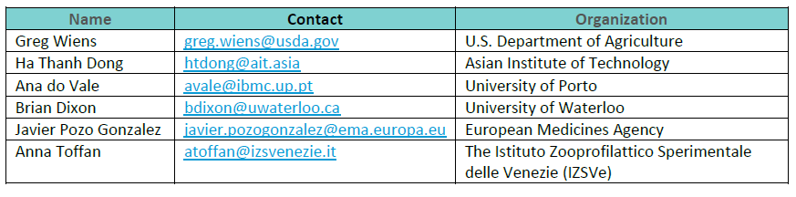
- PG Epigenetics:
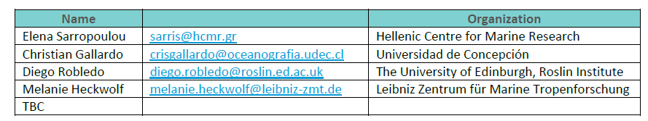
- PG Control:
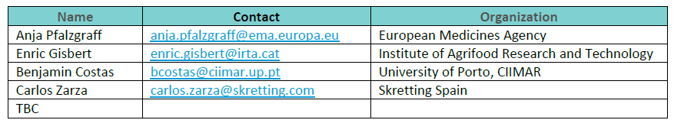
- PG Detection:
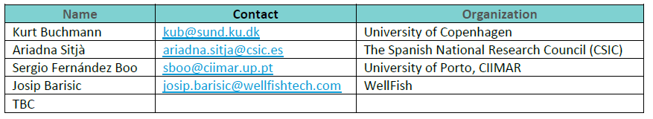
- PG Welfare:
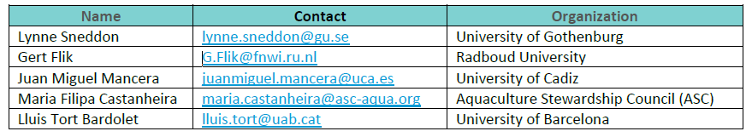
The PGs will be involved throughout the project duration to ensure that the work meets the requirements of the target stakeholder groups, and our project results follow the most efficient pathway to achieving the expected outcomes and impacts. For detailed information on the roles and responsibilities, please refer to the full Terms of Reference for Process Groups (https://3.basecamp.com/5521393/buckets/30681215/uploads/7536856391).

Executive Board Committee (ExB)
The Executive Board (ExB) as the supervisory body for the execution of the Project, consists of one representative of each WP leader and the Project Coordinator. The ExB is the decision-implementing body of the Cure4Aqua. It oversees the operational management of all activities of the project and also prepares and supervises the proper scientific and technical execution of the project, in particular integrating the recommendations from the Intellectual Property Use and Dissemination Committee (IPUDC). The members of the ExB committee are:
WP1 | Ivona Mladineo (BCAS)
WP2 | Francesc Padros Bover (UAB)
WP3 | Kim Thompson (MRI)
WP4 | Sofia Consuegra (SWU)
WP5 | Pantelis Katharios (HCMR)
WP6 | Astrid Holzer (VUV)
WP7 | Michalis Pavlidis (UoC)
WP8 | Marieke Reuver (ERINN)

External Expert Advisory Board (EEAB):
An External Expert Advisory Board (EEAB) has been appointed and is steered by the ExB. The EEAB assists and facilitates the decisions made by the General Assembly. In RP1, 2 nominees for the EEAB were appointed by the Executive Board: Øystein Evensen (Norwegian University of Life Sciences) and Sonia Rey Planellas (Stirling University). They will provide external points of view as to how to conduct the project to maximise beneficial outcomes to society and to advise the consortium on how best to exploit the most promising results. In particular, the EEAB:
- Advises the consortium on industrial and societal changes or concerns that may influence the projects objectives, priorities, methodologies, and expected impacts;
- Proposes changes to the direction of the project in line with stakeholder/user priorities for maximising the exploitation and benefits of the project for the aquaculture sector;
- Supports and amplifies the dissemination of the project results;
- Advises the consortium where and how the most promising results, in terms of exploitation, should be transferred.

Intellectual Property Use and Dissemination Committee (IPUDC)
The IPUDC is a consultative body and advises the consortium on the management of results, dissemination activities, IPR and any other innovation-related activities arising in the project. In RP1, nominations for the IPUDC were confirmed and are:
- UAB – Prof. Lluis Tort Bardolet, Dpt. Cell Biology, Physiology & Immunology (Lluis.Tort@uab.cat) and chair of IPUDC

- BCAS - Ing. Petr Maršík, Head of Technology Transfer Department (petr.marsik@bc.cas.cz)
- UoC - Mrs Kyriaki Agoraki, Legal office Technology Transfer Unit, UoC (agorakik@uoc.gr)
The IPUDC also monitors the implementation of the principles governing IPR which will partially be covered by the CA dispositions. Upon request of the ExB the IPUDC will:
- Assist the project participants in identifying results that could be the subject matter of protection, use or dissemination, based on publications and activity reports issued by activity leaders;
- Assist the project participants (or the ExB) in proposing and exploring measures to protect or disseminate results;
- Submit on demand, a proposal to the ExB and to the concerned project participants on the allocation of co-ownership shares over knowledge obtained by several participants. It shall propose solutions to the concerned participants in case of co-ownership issues between different participants having different policies and shall endeavour to assist the participants in resolving amicably possible conflicts related to IPR or dissemination activities in accordance with the CA section 11.8.
IPUDC members include, among others, technology transfer specialists and will collaborate closely with the industry project participants to present the project results and tangible outcomes to the industrial stakeholders.

Stakeholder Engagement Strategy
To engage with its stakeholders, Cure4Aqua implements a structured KMKT methodology. By focusing on Individual Outputs and associated Impact Plans, appropriate target and end users will be identified, along with potential application and exploitation routes.
The consortium has extensive experience in multinational, multi-lingual, multi-disciplinary and multi-participant collaborative research and innovation activities, and in effective communication of progress and results. By applying the Stakeholder Engagement Strategy, we have identified these various groups in society to have a vested interest in the Cure4Aqua results.
Likely end users of Cure4Aqua KERs include:
- Industry: aquaculture farmers, breeding companies (Finnforel, AquaGen, Troutlodge, Salmobreed, Andromeda, Sysaaf, Cromaris), disease diagnostics companies (MSD Animal Health, RPC, FishFarm Solutions), aquaculture feed additive companies, veterinarians, animal and human biotech and pharmaceutical companies, nutraceutical companies, insurance and investing companies, technology, service and supply companies, EU referent labs (EURLs), diagnostics, Skretting (phage product group), industry representative bodies such as FEAP, EATiP.
- Scientific community: academics and researchers, e.g., veterinarians, fish health biologists, immunologists and vaccinologists, microbiologists and parasitologists, ichthyopathologists, nanomaterials, public health epidemiologists and biostatisticians, welfare.
- Policy and regulation: European Medicines Agency, World Organisation for Animal Health or the Codex Alimentarius, Veterinary International Conference on Harmonisation, Federation of European Laboratory Animal Science Association, Royal Society for the Prevention of Cruelty to Animals (RSPCA), European Food and Safety Authority (EFSA), DG AGRI, CLIMA, ENV, SANTE, MARE, National Government Departments relating to Aquaculture, Medication, etc., National Animal Health Regulatory Authorities.
- Society: Aquaculture NGOs, consumers, general public, media, animal welfare organisations (FELASA, AWI, RSPCA, UFAW, WAZA), benchmarking associations (Marine Stewardship Council, World Benchmarking Alliance).
The Cure4Aqua Stakeholder Engagement Strategy is outlined below in Table 1. It includes the objectives, activities and expected impact of engagement per main target stakeholder group throughout the full project duration.

Table 1: Cure4Aqua Stakeholder Engagement Strategy
Target and End User Groups | Tools of Engagement | Expected Impact
Academics and Scientists | - Publishing peer-reviewed articles in OA journals and popularised field-specific magazine  - Oral/Poster presentations at transdisciplinary conferences, workshops and events (EAFP, EAS)  - Data published in OA repositories  - Public deliverables | - Transfer of new knowledge  - Raise awareness of the project results  - Reuse of the project’s scientific data  - Boost the project sustainability through the development of new related research projects
Policy and Decision makers | - Participation and presentation of the project results at events  - MG meeting with EMA Interaction Task Force  - EMA invited to join PGs  - Relevant regulatory authorities at the national level that are involved in the approval and licensing of vaccines and treatments will be represented in the PGs  - Involvement of Cure4Aqua participants in EFSA-launched initiatives  - Presentation of the project results at high-level conferences/to advisory bodies  - Meeting with FELASA Working Group  - OL activities directed at policy and regulatory bodies | - Expert opinions to EFSA proposed roadmaps and forums  - Development of monitoring protocols  - Creation of a panel of Epimarkers  - Cloud Data Collection System  - Deep learning algorithms  - Welfare score index  - QoL scaling system  - Economic model  - Biosecurity auditing and assessment protocols
Businesses/Industry | - Project website, news articles, blogs  - Publications in sector specific and  industry relevant magazines  - Workshops, OL activities  - Press releases | - Demonstrate the business potential and opportunities for ensuring sustainable, new approaches to prevent aquatic fish diseases by introducing and validating novel technologies for early detection of diseases, while also supporting the advancement of alternative treatments to replace pharmaceuticals in disease control
Citizens and society as a whole | - Project website, news articles, blogs  - Project branding and promotional materials (factsheets, banners)  - Media campaigns, press releases  - Social media channels (X and LinkedIn) and campaigns  - Engagement with relevant activists and influencers  - Inspiring audio-visual material (video clips, vlogs, GIFs)  - Infographics  - Outreach activities | - Increase citizens’ participation in Cure4Aqua-related activities  - Increased awareness of the benefits of positive interactions with aquaculture  - Raise awareness on the importance of Cure4Aqua for the consumers, and inform about the benefits of the project towards sustainable, healthier and resilient aquaculture industry
Other EU projects and networks in similar domains | - Invitation to Cure4Aqua events  - Joint presentations at conferences  - Joint participation in workshops from other projects  - Joint events with EU projects from other calls | - Coordinated dissemination activities in order to maximise project impact, exchange on R&D results and improve robustness of project results  - Stronger collaborations and networks  - Increased opportunities to work together, coordinated research efforts and better use of resources

Cure4Aqua-Specific Stakeholder Events

Training Courses
Cure4Aqua will develop and deliver, over the full duration of the project, four types of state-of-the-art training courses for assessors, health professionals and other relevant stakeholders, providing internationally recognised certification that will improve the professional skills and competences of those working and being trained to work within the blue economy.

Target group: Scientists, including students
T8.4 (Exploitation and Professional Development) will develop state-of-the-art disease-specific and general training (both online and site-based) for veterinarians and fish health biologists to be Approved Biosecurity Assessors (ABA) that will be recognised internationally (four courses per annum for three years). A second training course will address «Fish Health» (four courses per annum for three years), targeting students (vocational, BSc, MSc and PhDs in aquaculture, engineering, veterinary medicine, applied biology, etc.) that will cover disease prevention, vaccination, diagnostics, treatments, welfare and risk mitigation amongst others. In RP1, the 1st training course on “Fish Health”, was carried out on April 25th 2024 and delivered in-person to almost 100 students at the Universidad of Leon, Spain. The course focused on Fish Health, covering topics like disease prevention, vaccination, diagnostics, treatments, welfare and risk mitigation amongst others (https://cure4aqua-project.eu/news-and-events/cure4aqua-s-1st-training-course-on-fish-health/). In addition, education related participants will transfer project knowledge through their established institute courses, to undergraduate, post-graduate and vocational/part-time students to improve the competences of those being trained to work within the blue economy. For example, project participant FGCZ will offer practical four-day courses (theory and practice) to PhD students/postdocs on-site with focus on various topics like genomics, transcriptomics, metagenomics.
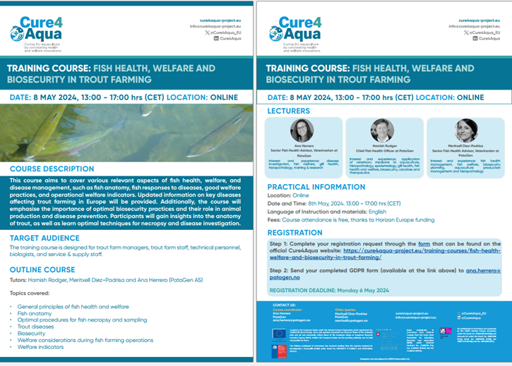
Promotional leaflet developed for Training course on: Fish Health, Welfare and Biosecurity in Trout Farming (May 8th, 2024)

Target group: Industry
Cure4Aqua’s industry partners are direct end users of many of the expected KERs, and many of the participants have direct and regular contacts with several relevant aquaculture producers. In addition, addressing fish farm staff and engineers, fish farm developers, investors, insurers, service and supply companies, PatoGen will develop certified biosecurity training (four courses per annum for three years) that will cover stress, disease and fish health, pathogens, sampling for disease diagnostics, biosecurity principles in aquaculture, hygiene, cleaning & disinfection, quarantine, biosecurity farm plans, and best management practice. The first training course from this series took place on 8 May 2024, and focused on Fish Health, Welfare and Biosecurity in Trout Farming (https://cure4aqua-project.eu/training-courses/fish-health-welfare-and-biosecurity-in-trout-farming/). ERINN developed a dedicated promotional leaflet for this training course, and supported the widespread promotion of the course (see below). The fourth training course will be provided through the European College of Aquatic Animal Health (ECAAH), focusing on “Fish diseases caused by intracellular bacteria: a patholomic approach” addressing ECAAH’s Residents and Diplomates, interested participants and external (fish) pathologists.
T2.3 will develop a fish farm simulation to assess the impact of the Cure4Aqua inventions across all WPs on farm economics. The simulations will be benchmarked and validated against actual operating farm performances (high, medium, and low). Expected performance changes resulting from adoption of each of the Cure4Aqua research solutions will be introduced to the simulation to compute the individual and combined economic impacts. D2.3 Economic model to improve farm performance will demonstrate an operational economic model developed by Thalassa Limited that will have been guided by project research activities and key success indicators (KSIs) (T2.1). This model will guide individual fish farms on where they can improve performance, reduce risk and simulate adoption of recommendations. The model will be developed for one species, in one geographic area with a wide range of performance, to allow for benchmarking of high vs medium vs low performers and transferred to end-users (via games). If successful, but beyond the scope of Cure4Aqua, versions of the simulation could be tailored to individual farms to help their management prioritise adoption of the Cure4Aqua inventions.

Individual brokerage meetings
Other exploitation activities will be developed depending on the final KERs and their associated KT routes. Ongoing identification and networking during the project will identify personal contacts within industry groups with whom Cure4Aqua can conduct focused individual brokerage meetings.

Delphi expert consultation assessment
T7.1 will undertake a Delphi expert consultation assessment to determine the suitability of welfare indicators in three species of commercial importance for aquaculture: common carp, European seabass, gilthead seabream, through three workshops (Greece and Czechia) with practitioners, aquaculture scientists and stakeholders from Greece, Spain, France, Italy, Turkey, Germany and Czechia. The first Delphi Workshop was held in Athens on November 24th, 2023: https://cure4aqua-project.eu/news-and-events/cure4aqua-workshop-european-sea-bass-welfare/.
The Delphi approach seeks to harness the value of expert judgment through consultation rounds and is based on the tenet that the views of a group are more authoritative (and thus more likely to gain support and become adopted) than the views of individuals. This approach is increasingly being used to prioritise knowledge needs in fields where opinions may differ among knowledge users, and when properly carried out, it can increase the reliability, validity and trustworthiness of the consultation process.

Questionnaire to assess fish farm personnel on their quality of life
T7.4 will develop a questionnaire that will assess fish farm personnel on their quality of life, working situation, occupational well-being and stress, and to explore whether and how fish farmer’s occupational well-being and stress are associated with animal welfare and farm expansion. The online questionnaire will be provided to several fish farms located in Greece, Spain, Germany and Czechia. Factor analysis will be used to examine the covariation among a set of observed variables about the fish farmers and fish welfare. Results from the questionnaire and cost/benefit (from T2.3) will be used to assess the economic and environmental impacts of welfare monitoring in relation to fish farm size and production system.

Questionnaires to enable identification for hazard areas in relation to biosecurity
T7.5 will work with fish health professionals, producer organisations and specific aquaculture companies, as well as other stakeholders in a region using questionnaires to enable identification for hazard areas in relation to biosecurity. A scoring system will be produced based on the combined results from the questionnaire, identified hazards and cleanliness results (ATP level and qPCR swab results). The programme developed for a site will aim to control one, or more specific pathogens. The score per site can then be compared anonymously between same species farming sites to provide benchmarking. Specific biosecurity plans will be developed for each site and company and reviewed annually. Codes of Good Practice will be developed with freshwater and Mediterranean aquaculture stakeholders.

Knowledge Management, Transfer and Exploitation of Results

Knowledge Management and Transfer Overview
The European Commission has identified the importance of improving knowledge transfer (KT) between public research institutions and third parties, including industry and civil society organisations, as one of ten key areas for action. Cure4Aqua will employ a proven Knowledge Management and Knowledge Transfer (KMKT) methodology to effectively address this key aspect of facilitating project impact.
This methodology was originally developed in the FP7 MarineTT project (GA #244164) and further developed and applied by the H2020 COLUMBUS project (GA #652690 - www.columbusproject.eu). This methodology has been applied in many FP7, Horizon 2020 and Horizon Europe funded projects such as AQUAEXCEL, AQUAEXCEL²⁰²⁰, AQUAEXCEL3.0, AquaInnova, ParaFishControl, performFISH, SIMBA, ERGO, REvivED water, RES4BUILD, SEALIVE, BIOGEARS, SEArcularMINE, TechOceanS and WaterLANDS.
Knowledge Management (KM) is the process of identifying, capturing, organising, analysing, and storing knowledge to ensure its availability to be transferred effectively to specific and relevant users.
Knowledge Transfer (KT) is the process of creating, organising, capturing/sharing/distributing knowledge to ensure its availability for future users, focusing the research being conducted on the wider needs of society and industry. KT encompasses both commercial and non-commercial activities such as research collaborations, consultancy, licensing, spinoff/spinout creation, researcher mobility, and publications, etc. KT aims to support mutually beneficial collaborations between universities, businesses and the public sector. The ultimate end benefit of successful KT is the application and influence of knowledge on targeted communities with greater impact (short and long term) across academia, industry and society.
Project Outputs/Knowledge Outputs (KOs) are described as “a unit of knowledge or learning generated by or through research activity”. It is not limited to de-novo or pioneering discoveries but may also include new methodologies/processes, adaptations, insights, alternative applications of prior know-how/knowledge” [Definition developed by AquaTT in the context of the COLUMBUS project]. Typically, such knowledge might be referenced as a small part of a published paper, potentially three to five years after the approach is pioneered in a research project.
Key Exploitable Results (KERs) within Cure4Aqua are tangible or intangible outputs of the action, such as data, knowledge and information whatever their form or nature , which have been deemed to be of high priority for project transfer actions. The means by which KERs will be identified from KOs is described in this section, but it is important to note that Cure4Aqua is not implying any sort of value judgement between KOs and KERs. Rather, the project is simply using this distinction to allow knowledge that is of the most direct impact to the project, or is most feasibly transferable by the project, to be prioritised when assigning resources for transfer. By focusing on identifying KERs and transferring them when they have been assessed as having potential application and impact, it is possible to fast track them, providing a faster impact on target- and end-users external to the project.
End User(s) are the individual(s) who are identified as being in a position where they could feasibly apply a given unit of Knowledge (KO/KER) and by doing so create the desired eventual impact of that knowledge. The KO/KER may need to evolve to reach the end user.
Target User is an individual(s) (organisations should be avoided where possible as specificity is crucial), whose position makes them a potential stepping-stone needed for a KO/KER to progress towards an identified end user and eventual impact. Target users are individuals with a specific mandate or responsibilities relevant to the specific KO/KER being evaluated. Target users should not merely be potential users of knowledge but should be individuals whose application of the knowledge is likely to advance it down the Pathway to Impact.
A Knowledge Transfer Plan (KTP) / Pathway to Impact Plan is an informed stepwise plan for achieving the identified eventual impact of any piece of knowledge, regardless of whether this impact is achievable in the short, medium or long term. In Cure4Aqua these will be developed for all selected KERs. The KTP identifies the end user capable of producing the desired eventual impact and outlines a specific series of transfer activities to intermediate target users.
Eventual Impact is the ultimate end benefit of the application of the knowledge (KO/KER). It is defined as an overall enhanced situation, generally for society but it can also be research or industry specific. Eventual impacts can be the adoption of new technologies, products or innovation identified and refined within the project, or a change in protocols.
The KMKT of Cure4Aqua KERs is integrated into the project through WP8 and is based on regularly collecting KOs/KERs through structured templates and interviews with project participants responsible for developing the results. Collected results will be assessed by ERINN, IPUDC and Process Groups (PGs) based on criteria related to their innovation capacity, relevance to the sector, and expected impact. Knowledge Transfer Plans (KTPs) or Impact Plans will be developed for individual or clusters of KERs assessed as being of high potential for contributing to the project’s objectives. This customised approach will increase the likelihood that 1) KERs will be transferred and exploited successfully, and the result applied; 2) there is an increased potential for impact from the transfer; and 3) it is possible to measure and demonstrate the impact of the transfer.
ERINN will coordinate and collaborate with the IPUDC, PGs and other Cure4Aqua WPs to support out KT. All project participants will contribute to the project’s KMKT activities by adhering to the protocols and assisting in the collection and analysis of KOs and the transfer of high potential KERs to end users.
The KMKT methodology consists of the following three overall phases and is further described in detail below:
- Collect and Understand
- Validate and Analyse
- Transfer and Exploit

Knowledge Management and Knowledge Transfer (KMKT)
This section of the PDEC outlines the stepwise process, which will be carried out within Cure4Aqua Task 8.3. This methodology will see KOs identified, collected, reviewed, and prioritised to project KERs with developed KTPs. The figure below outlines an example of a full Pathway to Impact. The following subsections will refer to Figure 1. to demonstrate how each step contributes to the development of this.
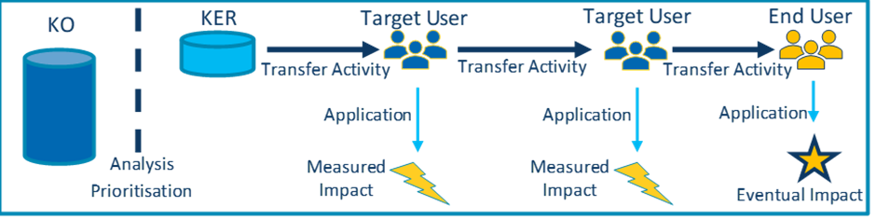
Figure 1: Cure4Aqua Knowledge Transfer Methodology

Collect & Understand
Phase 1: Capturing of KOs in an internal KO Collection Template.
Effective KT relies on careful identification and description of KOs to ensure that all key information is provided which will result in effective transfer (Figure 2). Quality control measures will be performed, to ensure that the knowledge output(s) can be clearly understood by others who may not be experts in the relevant disciplines. Each project participant will treat information from other participants as confidential unless otherwise stated and not disclose it to other parties unless the information is publicly available. It is important for all project participants to note that knowledge outputs are not only the final results of research, but they can also be part of the methodology to obtain the final result, which could be an innovation for a research area or process.


Phase one aims to understand the positioning of a KO to be better able to carry out impactful KT activities. It intends to help clarify how the KO could be beneficial to different target and end users. This step identifies potential applications, target and end users and the eventual impact of a KO. This information will also inform the development of Knowledge Output Pathways (KOPs) of KOs that progress to being a KER, having been assessed as having high potential application and impact.
Figure 2: Cure4Aqua Knowledge Transfer Methodology: Collect and Understand
KER
KO
Target User
Target User
End User
Transfer Activity
Transfer Activity
Transfer Activity
Application
Application
Application
Measured
Impact
Measured
Impact
Eventual Impact
Analysis Prioritisation
It should be noted that KOs/KERs, especially those collected early in the project, are likely to continue to develop over the course of Cure4Aqua. Collected knowledge will be periodically reviewed by ERINN, IPUDC, PGs and participants asked to provide updates if applicable. As the KO Collection Template will be available on the Cure4Aqua Basecamp, participants will be able to advise ERINN if a given KO/KER needs to be updated.
PROTOCOL – Knowledge Collection

- ERINN sends the Knowledge Output Collection Template to Cure4Aqua Task Leaders, who will be requested to complete it and update as necessary for any KOs developed in the concerned period.

- If the Task Leader thinks another project participant is better placed to provide the requested information, then they should send it on to the relevant person(s).

- For each identified KO, all fields of the template should be completed. Explanations are provided with each question.

- KO owners can indicate whether they prefer to provide their KO information through means of an interview with ERINN instead of completing the KO Collection Template themselves.

- ERINN carries out the first assessment of each completed KO template:
- Each KO is carefully reviewed and edited as necessary for typographical errors etc.;
- Each section is carefully reviewed to ensure it is adequately informative and comprehensive enough for a non-expert to adequately understand the nature of the KO;
- Additional potential target/end users of the KO may be suggested, as well as additional potential applications and impacts on each of the end users identified;
- If deemed necessary, ERINN will contact the KO owner/s to discuss the KO, clarify that all information is correct and identify if anything is missing or unclear.

- In addition, an IP check will be carried out:
- The KO-generating participant will be asked to complete an IP Assessment Form (see also section 3.1.1). Assessment Forms will be reviewed by ERINN, and if needed PGs and IPUDC, who will provide guidance as necessary until all relevant parties believe sufficient IP protection rules have been, or will be applied to the further dissemination, communication, and exploitation of the output.

- After the first assessment, the KO owner(s) will receive an updated draft of the KO Collection Template to check for accuracy and respond to any queries. This step will be repeated as necessary until both ERINN and the KO owners agree on the final version that can advance to the next phase (validation and analysis).

Analyse & Validate
Phase 2: The collected KOs are reviewed and assessed for potential application and impact.
Once validated, KOs go through a Due Diligence process, whereby a more thorough examination and evaluation of the output and its applicability and readiness for transfer will be investigated (Figure 3). Due Diligence will be undertaken so that any factors that could affect the transfer potential (confidentiality, competition, IPR) of the output and ultimately the uptake and impact of the knowledge can be identified. Following Due Diligence, KOs will be prioritised and those with potential to have impact will go through to the next step. An essential step in the Cure4Aqua KMKT methodology is the identification of output applications, potential impact and respective end users (e.g., applications could be in various areas and sectors not just the one in the research area of the project) for each KO which has been assessed as having high potential application and impact.
Important aspects are prioritisation of high potential KOs and profiling target and end users to gain valuable data to inform successful Impact Plans. This is not a ranking of their importance but rather a method to help Cure4Aqua identify where to focus transfer and exploitation efforts. For those prioritised, the expert groups will attempt to identify potential target users whose application of the knowledge would be of benefit in transferring it towards its eventual impact.
Those KOs that are validated and deemed to be of priority for the project will be re-labelled as Key Exploitable Results (KERs) and progressed to the third phase. Any KO that is not made a KER will continue to be periodically reviewed and any remaining at the end of the project will still be captured as evidence of project results for final reporting. The identification of target users in the analysis stage is critical to laying the groundwork for transfer and exploitation plans in the third phase. The exercises in this phase may also serve to identify potential stakeholders that are worth connecting with, even in cases where the knowledge may not yet be ready for transfer.
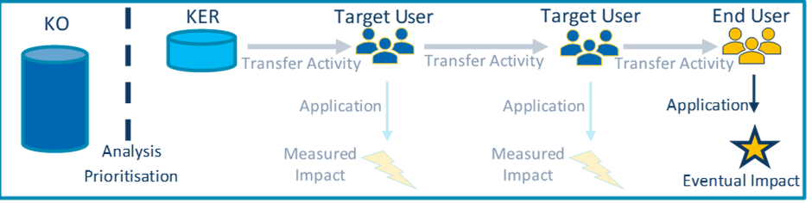
Figure 3: Cure4Aqua Knowledge Transfer Methodology: Analyse and Validate
PROTOCOL – Knowledge Analysis

At periodic intervals, ERINN will organise “expert analysis meetings” together with IPUDC and the related Process Groups (PGs).

The frequency and makeup of these meetings will be determined in collaboration with the Project Coordinator as well as based on the current status of knowledge collection and management in the project.

The expert analysis meetings will carry out a thorough examination and evaluation of the KOs (collected so far) and their applicability and readiness for transfer. Particular attention will be paid to:
- Identification of all likely target- and end-users. We encourage project participants to be as specific as possible and innovative when determining potential end users.
- It is important to consider the following when profiling target- and end-users:
  - Understand the user’s mandate or responsibilities;
  - Consider their background knowledge, attitude, and practice in relation to the issue;
  - Understand their knowledge needs;
  - Understand what and who may influence their decisions;
  - Be aware of their preferred sources of information and knowledge.
- Identification of associated application and impact potential.

Assess the Technology Readiness Level (TRL) that could inform the development of an appropriate output pathway to impact, where the output requires further research, validation or scale-up.

Experts in these meetings will be asked to:
- Confirm the accuracy and feasibility of transfer both within and beyond the project (but as a direct result of the project) for each presented output, to the best of their understanding.
- Assign to each KO a ranking to determine whether it should be prioritised as a KER based on its current status.
- Discuss and identify potential target users to whom the knowledge should be transferred to progress it towards its eventual impact.

If any questions emerge from the expert analysis meeting, ERINN will reach out to the relevant KO owners to attempt to provide an answer.

Transfer & Exploit
Phase 3: Carry out and report on KT activities; while measuring the impact of both the activity and the application of the Knowledge by the User(s).
For each KER, a Knowledge Transfer Plan (KTP)/Pathway to Impact Plan will be developed. Implementing an efficient KTP that is tailor-made to the needs and capacities of specific target and end users (profiled in Phase 2) will maximise the chance of successful transfer resulting in uptake and application. The key to success is achieved through fully understanding the target- and end-user, and developing the KTP around them. There are several steps included in the KTP, and there are different downstream routes to reach its eventual impact. KTPs are the accumulation of numerous KT activities as represented in Figure 4.
KTPs will ensure KERs go through a Due Diligence process, whereby a more thorough examination and evaluation of the KER and its applicability and readiness for transfer will be investigated. Due Diligence will be undertaken so that any factors that could affect the transfer potential (confidentiality, competition, IPR) of the KER and ultimately the uptake and impact of the knowledge can be identified. The individual project participant within Cure4Aqua best positioned to conduct the transfer will be identified and this phase will attempt to clearly describe how the impact of Cure4Aqua’ KERs will be measured, even after the project has come to a close.
The work carried out in this phase will not only be important for accurately reporting the full breadth of impact of the project to the EC, but it will also assist all participants in carrying out exploitation activities. Not every KER transfer plan will be able to be reasonably executed during the lifetime of the project but, by delivering clear plans, the KM methodology will help establish how exploitation actions within the project will feed into the overall impact of the project as a whole, and help achieve the societal goals of Cure4Aqua.
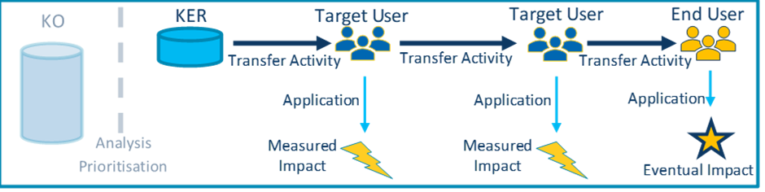
Figure 4: Cure4Aqua Knowledge Transfer Methodology: Transfer &Exploit

PROTOCOL – Knowledge Transfer and Exploitation

For any knowledge that has been determined to be a KER:

- ERINN will collaborate with IPUDC, the dedicated Process Group(s) (PG) and the owner(s) of a KER to develop a Knowledge Transfer Plan (KTP)/Pathway to Impact for each KER. In particular, this effort will focus on the following considerations regarding the first target user(s) in the plan:
- Building on the impact potential identified in the validation and analysis step, ensure that a concise and compelling narrative for the opportunity/business case is developed.
- The technical level of the target user; the depth of information needed; and the style of language most effective for communicating with them.
- The background knowledge of the target user.
- Any preconceived ideas that the target user may have relating to the area of interest.
- Ways in which to relate the knowledge to examples with which the target user is familiar, or ones they can easily envisage.
- The level of evidence or validation that the target user requires.

- ERINN will be responsible for drafting these plans, which will then be provided to the Project Coordinator and generating project participant(s).

- Once a KTP has been drafted and reviewed, it will be opened up for feedback from IPUDC and the dedicated PG(s).

4. ERINN will work with all relevant project participants to assist where possible in the translation of KTPs into exploitation activities. The nature of these exploitation activities will be highly dependent on the KER, the target user, the transferring participant, the timeline, resources available, foreseen activities in the DoA, and other variable considerations. The exploitation activities themselves may be carried out within a range of externally focused tasks.

Dissemination and Communication Resources
All Cure4Aqua project participants dedicate time to perform communication and dissemination activities and are encouraged to engage in a two-way exchange with the public at large, and where possible the media, with the aim to show how EU research and innovation funding has a positive impact on society. Through its communication activities, Cure4Aqua will demonstrate why working together in a European consortium is important in addressing a challenge that affects society.
To facilitate communication and dissemination throughout the project, a portfolio of promotional project material has been developed, and will continue to be elaborated upon during the project lifetime.

Promotional Materials

Logo and Brand
A specific project logo has been developed to visually represent the project. The project logo is an integral part of the brand as it is, and will be included in all project’s promotional materials both print and online. The Cure4Aqua project logo is available in three different versions, a full colour, a black and a white version. The different versions and guidance on how to properly utilise the Cure4Aqua logo (correct use of the logo in relation to the background, spacing, etc.) can be found in the Brand Guidelines that have been developed alongside the logo.
The logo suite and Brand Guidelines are available on the project intranet and can be requested from ERINN (contact: marieke@erinn.eu).

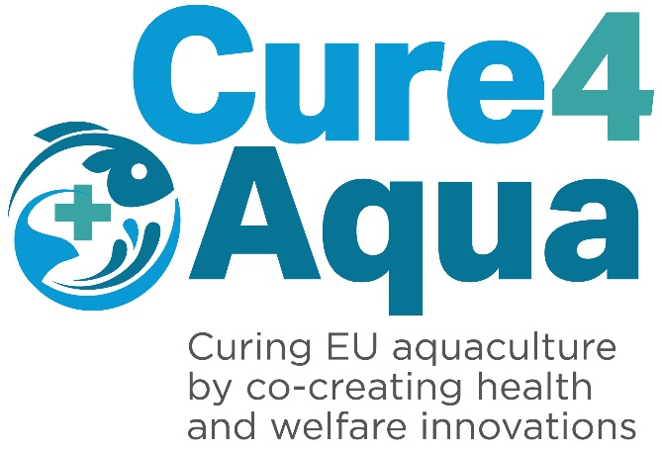
Figure 5: Cure4Aqua logo (full colour)

PROTOCOL – Utilising Cure4Aqua Branding alongside other Institutional Branding

While it is preferable that all participants use Cure4Aqua branded resources when disseminating the project’s results, we recognise that some institutions will require participants to use their own institutional branding for conferences and various presentations. To balance the interests of Cure4Aqua, and our contractual obligations to the EC, with various institutional requirements, we require the following requirements to be included at minimum:

- The Cure4Aqua logo must be included on at least the Title Page and Conclusion/Thank You slide, however usage on all slides would be preferred.

- The EU emblem and funding acknowledgement (GA Article 17) must be visibly present on the first and last slide.

Project Dissemination Templates
Cure4Aqua PowerPoint and Poster Presentation Templates, Factsheet, Pull-up Banner and Slide Deck have been developed to use at internal and external events when presenting the Cure4Aqua project and/or its outcomes and can be downloaded from the project intranet and can be requested from ERINN (contact: marieke@erinn.eu). In M18, all templates have been updated to incorporate the latest changes from the social media accounts of the project: incorporating the LinkedIn social media account and the updated logo from X (former Twitter).
PROTOCOL – Dissemination Templates

Project participants should use the Cure4Aqua Dissemination Templates when promoting the project’s objectives or presenting project results.

Download the Template from the project intranet and/or request from ERINN (contact: marieke@erinn.eu).

- When using the PowerPoint Presentation Template, choose to insert “new slide” and pick your preferred content template.

- Respect all of the Templates’ format (background, font and layout).

- Always ensure that the correct EU Emblem, EU and non-EU funding logos and acknowledgements are present on any Cure4Aqua presentations, deliverables and reports etc.

Factsheet
A promotional factsheet presenting the Cure4Aqua objectives and expected results has been developed. The factsheet can be shared digitally and distributed at relevant events, both virtually and in-person. The factsheet will be used to raise awareness of the project and its goals. It can be found on the Cure4Aqua website and the project intranet or it can be requested from ERINN (marieke@erinn.eu). During RP1, the factsheet has been updated with latest changes from the social media accounts of the project: incorporating the LinkedIn social media account and the updated logo from X (former Twitter). Project participants are encouraged to distribute the factsheet through their networks and at relevant events. If participants wish to have the factsheet available in another language, they should follow the protocol outlined below.
PROTOCOL – Factsheet Translation

- Contact ERINN (contact person: marieke@erinn.eu) requesting the original factsheet template with English text.

- ERINN supplies the template with the original text in English to requesting project participant.

- Project participant translates the text (as laid out in the template) into their language.

- Project participant then sends translated text back to ERINN.

- ERINN applies the translated text to the factsheet template and publishes the new version of the factsheet, after validation and sign-off from the project participant responsible for the translation.

Pull-up Banner
A Cure4Aqua Pull-up Banner has been designed and developed for use at internal and external events to raise awareness about the project, for example at exhibition booths. In M18, the pull-up banner has been updated with the latest changes from the social media accounts of the project: incorporating the LinkedIn social media account and the updated logo from X (former Twitter). The banner can be found on the Cure4Aqua website, project intranet or it can be requested from ERINN (marieke@erinn.eu).
PROTOCOL – Pull-up Banner Printing

Project participants can make use of the Cure4Aqua Pull-up Banner at internal and external events to raise awareness about the project.

- The template is designed to print as a standard pull-up banner measuring 800 mm wide by 2000 mm high, however if a partner requires different dimensions, ERINN will endeavour to adjust the banner template to the partner’s needs.

- Please print the pull-up banner in full colour, making no adjustments to the colour settings.

- The pull-up banner can be found on the Cure4Aqua website, project intranet or it can be requested from ERINN (marieke@erinn.eu) for any queries around dimensions, printing and material requirements.

Website
The project website, (https://cure4aqua-project.eu/) went live on time in M3 (January 2023) and has been developed following the EU’s best practice guidelines for project websites. The website is fully compliant with the General Data Protection Regulation (EU 2016/679, GDPR) by incorporating a privacy statement and cookie bar informing website visitors about what Cure4Aqua does with any personal data gathered. Google Analytics is used to track traffic and monitor the use of the website, which will be used to inform Continuous Reporting.
To ensure successful promotion of the project and to sustain the interest of the target audience and attract new users, the website’s content will be maintained, continuously updated and populated with new information throughout the project’s lifetime. The website will remain live for five years after the end of the project, serving as a valuable public resource of research information on the subject and promoting the outputs of this publicly funded research.
Key features of the website include:
- A News & Events category: being regularly updated with news about the project and events organised by the Cure4Aqua consortium.
- A Resources category: houses the latest resources that have been delivered from the Cure4Aqua consortium, including printed media, digital media, audio and videos.
- A Results category: which includes the latest scientific papers, posters and public deliverables from the project.
- Training Courses category: which includes information on the upcoming training courses and the registration protocols
- Consortium web page: The Cure4Aqua consortium is displayed on a visual map, including several species, systems and institute types that are participating in the project.
PROTOCOL – Website Content: Requests for posting and uploading

- ERINN will manage the Cure4Aqua website and will be updating it on a regular basis.

- Project participants who might have feedback on the site or wish to upload materials, news or events to the website (e.g., calendar) should contact ERINN (marieke@erinn.eu).

- Project participants are requested to include a link to the Cure4Aqua website on their own institution websites as well as promote it through the Cure4Aqua social media channels (see section 6.1.6).

Social Media
Social networking is an integral part of the Cure4Aqua communication strategy. The project results and outputs are actively disseminated through the Cure4Aqua X (former Twitter and managed by ERINN) and LinkedIn accounts. Cure4Aqua decided to set up a LinkedIn page in April 2023, following the global developments surrounding X. LinkedIn enables the project to establish a strong online presence, expand our network to build long-lasting professional relationships, and is a dedicated platform to showcase the project, results and activities. Stakeholders are encouraged to follow Cure4Aqua’s social media, which are forums for engagement with interested parties and contribute to capacity building, showing participant expertise and knowledge through active discussions. To ensure a consistent flow of social media content, a proactive communication cycle was established. ERINN directly requests information from partners regarding their communication and dissemination activities according to a predetermined timeline. This ongoing cycle allows to maintain a readily available pool of up-to-date content for social media use.
As of June 2024, the statistics of Cure4Aqua’s social media profiles were:
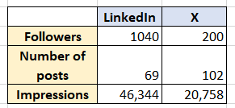
As with other means of communication, attention should be paid to the content being shared on social media. The consortium should determine which information to keep private and which to publish, where and to what extent. If you have questions about what is appropriate, please contact ERINN (marieke@erinn.eu).
For Cure4Aqua to keep its reputation and create an engaging and thriving online community, it is necessary to effectively manage potential risks. The following are guidelines for all participants who participate in social media and apply whether participants are posting to the Cure4Aqua account, their own accounts or commenting on other accounts.
PROTOCOL – Cure4Aqua Internal Code of Social Media Conduct

Participants should try to contribute to social media channels where possible. Support can be requested from ERINN.

General Rules
- Ensure the content is yours to share (research or opinions) or acknowledge the source accordingly.
- Ensure there are no IP issues.
- Use appropriate tags and hashtags to acknowledge funding.
- Do not use offensive language, argumentative or illegal content, etc.
- If you communicate publicly about Cure4Aqua or Cure4Aqua-related matters, you must disclose your role within the project.
- Be professional, use good judgement and be accurate and honest in your communications; unprofessional language or behavior reflect poorly on the project, and may result in liability.
- Unless approved by the coordinator BCAS, your social media name, handle and URL should not include Cure4Aqua project’s name or logo.
- Be mindful around controversial subjects, where emotions may run high e.g., politics. It is important to show respect for others’ opinions.

X
Participants wishing to communicate via the X accounts have the following options:
- Send a short message (280 characters max) to ERINN (email karla@erinn.eu and marieke@erinn.eu) who can post from the Cure4Aqua account on your behalf. Ideally, include an image or short video to make it more visually appealing.
- Refer to Cure4Aqua by tagging the project (using @Cure4Aqua_EU on X) in your own tweets; ERINN will always aim to retweet/share such posts.
- Retweet/share Cure4Aqua posts through your personal and institutional social media accounts.

LinkedIn
- Send the message you would like to communicate to ERINN (email karla@erinn.eu and marieke@erinn.eu) who can post from the Cure4Aqua account on your behalf. Ideally, include an image or short video to make it more visually appealing.
- Refer to Cure4Aqua by tagging the project in your own post; ERINN will aim to repost such posts.
- Repost Cure4Aqua posts through your personal and institutional social media accounts.

Tips
- Social media is highly visual — it’s ideal to post pictures, videos, GIFs or data visualisations.
- Engage with your audience using replies, retweets/shares or tags.
- Ask questions instead of making statements to drive conversation.
- Leverage existing social media presence e.g., the host institution, researchers, team members or other relevant organisations, and tag and follow relevant accounts, particularly EC accounts (i.e., @HorizonEU, @EUScienceInnov)
- Follow the news and use trending hashtags where appropriate.
- Content could include the announcement of milestones, results, scientific publications, press releases, newsletters, etc. or when the project is featured at a conference or event.

Press Releases
Press releases are issued to appropriate media outlets (trade press, journals, web portals) to ensure that industry, communities, civil society, policymakers, and the wider community are aware of the project, its objectives and its later outcomes. The strategy is intended to ensure that there is media coverage at local, regional, European and international levels. ERINN will share project news through internal (consortium mailing list, stakeholder database and project participant networks) and external (press releases, social media, etc.) channels, which ensures a broad awareness of the project across the spectrum of relevant stakeholders. Project participants are encouraged to publish articles and press releases at regional, national, and international levels, making use of their own communication networks and channels. ERINN can support project participants in these activities.
PROTOCOL – Press Releases

Project participants should notify ERINN if there is news suitable for an official project press release:
- ERINN will develop a draft and seek approval from the Cure4Aqua Coordination team.

- Once approved, press releases will be disseminated using appropriate channels.

- They will be uploaded to the project website and all project participants are encouraged to distribute at national or regional level.

- Where necessary the project participants can adapt the press releases to customise them to their audience and if needed translate the articles.

NOTE: Project participants may also initiate the writing of press releases (e.g., local, national). ERINN can then support writing and editing if required. Participants are asked to provide a short summary in English if the original communication is in another language. Participants who publish any article/press release at a regional or national level must send a copy to ERINN and where possible provide metrics to demonstrate uptake by other news channels/readership.

Video
At the start of RP2, a Cure4Aqua professional video will be developed for project participants to disseminate and promote the Cure4Aqua project at events and on social media. The video will showcase the project to the general public, explaining the approach and the value of the research being conducted by Cure4Aqua. The video will be promoted on the Cure4Aqua project website under the Resources section and participants will be encouraged to add it to their accounts of video-sharing websites, such as YouTube and Vimeo. Participants are also encouraged to share the video with their wider networks and so it is hoped the video will be adopted by the consortium for use in their existing international outreach activities.

Cartoon
In RP1, Cure4Aqua created a cartoon as an outreach resource, explaining fish vaccination, and so raising awareness on the topic to the general public. Two versions are available: a colour version and a black and white version, that can be used at e.g. outreach activities, as a fun way for children to familiarise with the topic. The cartoon could also be used to supplement science lessons, or as end of day tasks. 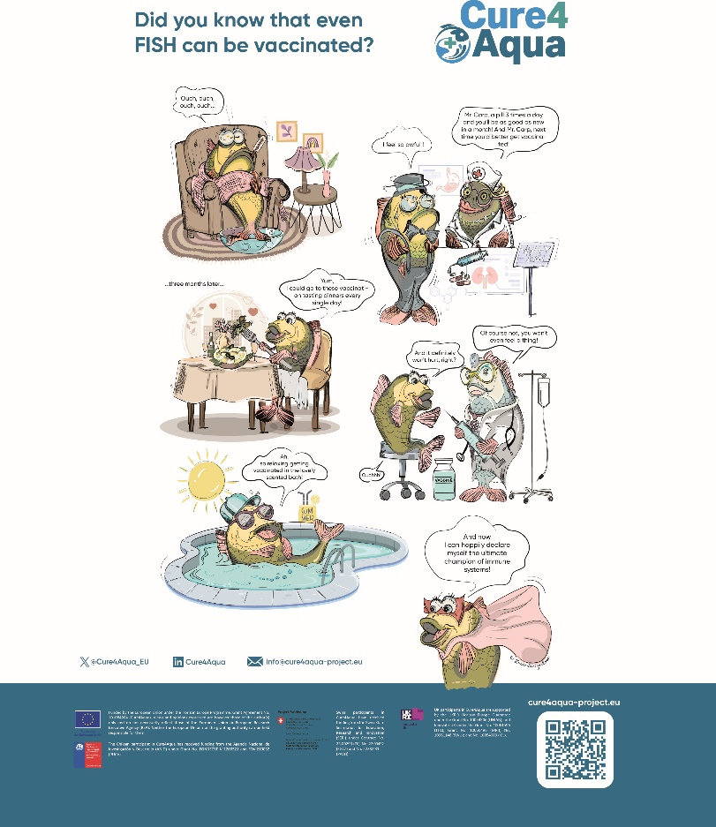

Playdough workshop
Cure4Aqua coordinator, BCAS, developed an engaging and interactive workshop for children during RP1. This workshop utilised playdough to simulate fish vaccination, fostering a fun and educational experience. The activity proved highly successful at events like the SciFair and Researchers Night in the Czech Republic, and its implementation is encouraged for all partners.
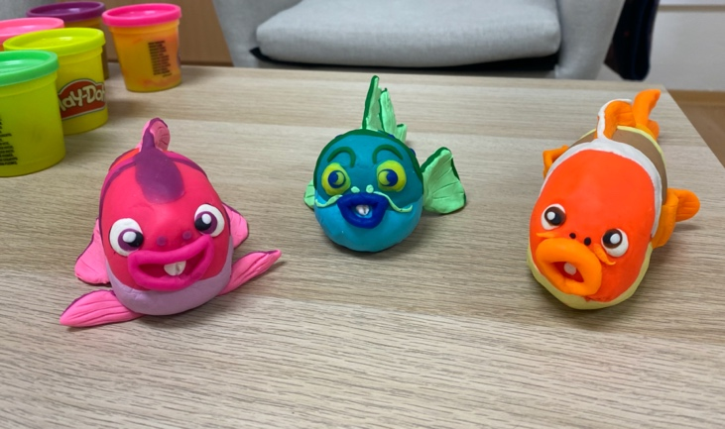

Other Resources and Tools
As the project progresses podcasts, infographics, blogposts, social media visuals, etc. will be created to present the project activities in an attractive and dynamic way. At least five short video clips will be developed for participants to disseminate and promote the Cure4Aqua project and its outcomes. These other resources and tools will be uploaded to the Cure4Aqua website under the Resources section and participants will be encouraged to share them through their channels. Other promotional material can be developed as required, depending on budget availability and considering sustainability. Please contact ERINN (marieke@erinn.eu, karla@erinn.eu) with any other ideas for promotional material to support your communication and dissemination activities.

Dissemination and Communication Activities
The purpose of Cure4Aqua’s dissemination and communication activities is to make the project, its results and activities known to society at large so that all stakeholders, also beyond the project’s own community, will be able to understand its messages. All Cure4Aqua participants will dedicate time to perform dissemination and communication activities and will be encouraged to engage in a two-way exchange with the public at large, and where possible the media, with the aim to show how EU research and innovation funding has a positive impact on society. Through its dissemination and communication activities, Cure4Aqua will demonstrate why working together in a European consortium is important in addressing a challenge that affects all societies.

PDEC Tools, Channels and Target Groups
A key component of the Cure4Aqua communication strategy is co-development by ongoing engagement with key stakeholders and as the project progresses, it will be critical to ensure that the project outcomes are effectively and efficiently transferred to the relevant applications by policy, community, and research users, etc. A distinct strategy will be applied to each targeted audience, using appropriate messages, means, and language. To effectively promote and spread awareness about the Cure4Aqua concept and results to achieve the expected impacts, the following communication tools and activities (Table 2) are designed and implemented by the consortium and coordinated and monitored by WP8.
Table 2. Cure4Aqua PDEC tools, channels and target groups (high level)
Cure4Aqua Communication and Dissemination tools & channels | Industry | Scientists | Policy actors | Society
Project website: The project website constitutes the main communication tool as it provides easy access to a broad audience around the world. Target: > 10,000 visits over the project, >250 directly signed up to ‘subscribe to news’ through website. | ☑ | ☑ | ☑ | ☑
Press releases & Promotional articles: Press releases will be produced regularly making use of a range of services and publications aiming at increasing awareness about the project’s objectives, progress and outcomes. Target: at least 10 original press-releases or promotional articles published, leading to further publication of at least 25 articles in websites, the press, and specialised publications. | ☑ | ☑ | ☑ | ☑
Videos: Target: At least one professional and at least 5 shorter media clips are expected to be viewed by more than 10,000 people in total. | ☑ | ☑ | ☑ | ☑
Social media strategy: The project has an X and LinkedIn account which target the general audience as well as specific targeted stakeholders. All project participants’ social media outlets share content and point out the relevance for their specific target groups, and thus direct their audience to Cure4Aqua’ channels and website. Target: social media presence latest from M3 and for the full duration of the project, with X and LinkedIn activity and targeted promotional campaigns (for promoting specific topics) expecting to reach more than 50,000 people. | ☑ | ☑ | ☑ | ☑
Participation in relevant virtual and physical events: Cure4Aqua is represented in the major relevant international (research, policy and industry) events over the full duration of the project. Meetings are planned in synergy with the EU-funded project IGNITION; sessions were organised together with IGNITION at EAS conference 2023 and the EAFP conference 2023 and similar future events will be organised. Target: participation in more than 10 events during the duration of the project. | ☑ | ☑ | ☑
Project network and events: Cure4Aqua actively cooperates with IGNITION, the other project selected under this call topic, and complementary successful projects, such as the EU Reference Centre for the Welfare of Aquatic Animals. Target: established cooperation, e.g., common events, exchange of information, collaboration in the Horizon Booster programme, etc. | ☑ | ☑ | ☑
Outreach activities: The project is exhibited at local science outreach events. Target: participation in more than 10 events during the duration of the project. |  |  | ☑ | ☑
Open access scientific publications (in high impact peer-reviewed journals), review articles and editorials: The consortium will publish at least 40 open access articles over the full duration of the project. A selection of science, industry and social science journals will be identified that are the most appropriate (e.g., PNAS, PLOS Computational Biology, Frontiers in Animal Science, Journal of Fish Diseases, Diseases of Aquatic Organisms, Frontiers in Immunology, Transboundary & Emerging Diseases, Aquaculture, Trends in Parasitology, Applied & Environmental Microbiology, Environmental Microbiology). Target: More than 40 publications. | ☑ | ☑ | ☑
Training: 4 training courses on different topics, offered in total on more than 10 different occasions, addressing a diverse range of at least 270 stakeholders: (fish)pathologists, farm managers, technical staff, biologists, service & supply staff, vets & aquaculture students, etc.  Target: at least 270 stakeholders. | ☑ | ☑

External Events
All project participants have a responsibility to engage the public in their research activities and results and take advantage of the potential for public interest that Cure4Aqua generates. Project participants are encouraged to initiate dissemination activities that are appropriate for the irrespective contributions and ERINN can provide support as required. Examples include live broadcasts, blogs, institute open days, etc.
The project results are also presented as oral presentations, posters, etc. at major international meetings and conferences of relevance to Cure4Aqua. Conferences, seminars, workshops, and other meetings are very useful forums to consult with Cure4Aqua target audiences in a face-to-face capacity and to address issues relevant to the work done in the project. Cure4Aqua and the EU-funded project IGNITION collaborated through joint workshops at the EAFP (11.09.2023) and EAS conferences (18.09.2023). This collaboration was established to enhance impact through shared knowledge and resources. International and sector relevant conferences, meetings, etc. are frequently attended to communicate the results of the project to the maximum number of persons. See protocol for public outreach activities below.
Table 3 shows a list of potential events that may be of interest to Cure4Aqua participants or stakeholders. These events will be added to the project website.
Table 3. Relevant events for Cure4Aqua consortium and stakeholders
Event | Location | Date
EAS | Europe | Annually
WAS | Global | Annually
EAFP | Europe | Every two years
ISAAH | North America/Global | Every four years
ISVLV | Global | Every three-four years
ICOPA | Global | Every four years
EMOP | Europe | Every four years during summer
International conference of Fish Pathology | Global | Annually
International conference of Fish and Shellfish Immunology | Europe | Every three years
Viruses of Microbes | Global | Annually
Oxford Phage Meeting | Oxford (UK) | Annually
Workshop at 21st EAFP Conference Aberdeen 2023 | Aberdeen (UK) | 11-14 September 2023
Workshop at Aquaculture Europe 2023 | Vienna (Austria) | 18-21 September 2023
One day parallel session with other consortia at AQUA2024 | Copenhagen (Denmark) | 26-30 August 2024
One day parallel session with other consortia at EAFP | Heraklion, Greece | 1-4 September 2025
Workshop at Aquaculture Europe 2025 | Valencia, Spain | 22-25 September 2025

PROTOCOL – Public Outreach Activities: Internal and External Events

Project participants should notify ERINN if there is news suitable for an official project press release:

- Project participants should inform the Project Coordinator and ERINN of their planned outreach activities so they can be promoted.

- Project participants should inform other participants about the event via email. If the planned outreach activity involves the dissemination of Cure4Aqua results, the pre-dissemination requirements of the prior notice protocol and the IP assessment form must be carried out (see section 3.1).

- All activities, including attendance at external events should be added to the Cure4Aqua Continuous Reporting Log, providing insight on type of activity, objectives, target audiences, reach (number of people) and the total cost allocated for the activity (see section 3.2).

- All public engagement and outreach activities must be reported during (internal and external) reporting periods.

- ERINN will include events on the Cure4Aqua website.

- ERINN will update the EC Portal on all Dissemination and Communication Activities.

Scientific Publications – Relevant Journals
The consortium expects to publish at least 40 OA articles over the full duration of the project. A selection of science, industry and social science journals that are relevant to the project include: PNAS, PLOS Computational Biology, Frontiers in Animal Science, Journal of Fish Diseases, Diseases of Aquatic Organisms, Frontiers in Immunology, Transboundary & Emerging Diseases, Aquaculture, Trends in
Parasitology, Applied & Environmental Microbiology and Environmental Microbiology.
At M18 stage, four Cure4Aqua publications have been published:
1. Cantillo Villa Y, Triga A, Katharios P. 2023. Polyinfection in fish aeromoniasis: A study of co-isolated Aeromonas species in Aeromonas veronii outbreaks. Pathogens 12(11), 1337. doi:10.3390/pathogens12111337 IF=3.7 (WP3)
2. Mladineo I, Rončević T, Gerdol M, Tossi A. 2023. Helminthic host defense peptides: using the parasite to defend the host. Trends in Parasitology 39(5), 345-357. doi:10.1016/j.pt.2023.02.004 IF=9.6 (WP5)

3. Mladineo I, Volpatti D, Beraldo P, Rigos R, Katharios P, Padros F. 2024. Monogenean Sparicotyle chrysophrii: the major pathogen of the Mediterranean gilthead seabream aquaculture. Reviews in Aquaculture 16(1), 287-308. doi:10.1111/raq.12839 IF=10.4 (WP2)
4. Rigos G, Padrós F, Golomazou E, Zarza C. 2024. Antiparasitic approaches and strategies in European aquaculture, with emphasis on Mediterranean marine finfish farming: present scenarios and future visions. Reviews in Aquaculture 16(2), 622-643. doi:10.1111/raq.12857 IF=10.4 (WP2)

PDEC Monitoring and Evaluation
The PDEC functions as an operation manual and will be updated throughout the project. WP8 leader ERINN will continue to review and amend the PDEC in line with the latest DEC activities and project results. As part of the revision process, each subsequent version of this deliverable will be validated by the consortium. Furthermore, the project coordinator (BCAS) and project participants will also review the PDEC at each review stage and provide recommendations. The current version will function as the operational manual and will be revised as part of D8.3 – Updated PDEC, including exploitation outcomes (M54 – April 2027).

Project participants involved in the work
All project participants are expected to carry out dissemination and exploitation activities as well as communication activities. ERINN provides coordination and support to all activities.

Appendix

Annex 1 – Glossary
“Access rights” are the rights to use results or background related to the project, as set out in the Grant Agreement (https://ec.europa.eu/info/fundingtenders/opportunities/portal/screen/support/glossary).
“Background” Any data, know-how and/or information, whatever its form or nature (tangible or intangible) – including any rights such as intellectual property rights – which are needed to carry out the project or exploit its results. (https://ec.europa.eu/info/funding-tenders/opportunities/portal/screen/support/glossary) .
“Dissemination” means the public disclosure of the results by any appropriate means (other than resulting from protecting or exploiting the results), including by scientific publications in any medium. (https://www.iprhelpdesk.eu/sites/default/files/newsdocuments/FS-Plan-for-the-exploitation-and-dissemination-of-results_1.pdf)
“End Users” are last Target User identified on the Knowledge Output Pathway, i.e. individual(s) who will apply the Knowledge Output at the end of the Knowledge Output Pathway. Once they apply the KO, Eventual Impact is reached. The Knowledge Output may have undergone several revisions/adaptations through the value chain before reaching/being relevant to the needs of the end-user. Definition according to COLUMBUS (Horizon 2020 project: 652690).
“Exploitation” means the use of results in further research activities other than those covered by the action concerned, or in developing, creating and marketing a product or process, or in creating and providing a service, or in standardisation activities. (https://www.iprhelpdesk.eu/sites/default/files/newsdocuments/FS-Plan-for-the-exploitation-and-dissemination-of-results_1.pdf)
“Eventual Impact” the ultimate end benefit of the application of the Knowledge Output, and its influence/effect once taken up and applied by the target community. It is defined as an enhanced situation that is contributing to a need (political, industrial, scientific or societal). Definition according to COLUMBUS (Horizon 2020 project: 652690).
“Knowledge Management” is the process of identifying, capturing, analysing, organising, and storing knowledge to ensure its availability and ability to be transferred effectively to specific users. It comprises a range of practices used by organisations to identify, create, represent, and distribute knowledge for reuse, awareness and learning. Definition according to MarineTT (FP7 project number 244164); COLUMBUS (Horizon 2020 project: 652690).
“Knowledge Outputs” are units of knowledge or learning generated by or through research activity. They are not limited to de-novo or pioneering discoveries but may also include new methodologies/processes, adaptations, insights, alternative applications of prior know-how/ knowledge. Definition according to COLUMBUS (Horizon 2020 project: 652690).
“Knowledge Output Pathway” can be a single step or a series of steps required to carry a Knowledge Output to its Eventual Impact. Where there are a series of steps, it will include detailed mapping of the steps, the users involved at each step and their predicted role in the pathway to Eventual Impact. Definition according to COLUMBUS (Horizon 2020 project: 652690).
“Knowledge Transfer” is the term for the overall process of moving knowledge between knowledge sources to targeted potential users of knowledge. Knowledge Transfer consists of a range of activities which aim to capture, organise, assess and transmit knowledge, skills and competence from those who generate them to those who will utilise them. Definition according to COLUMBUS (Horizon 2020 project: 652690).
“Target User” is the individual(s) who you have identified in your Knowledge Output Pathway to whom a Knowledge Output will be transferred. They are not necessarily the end-user or participant of the KO; rather they can be the steppingstone needed for a KO to progress towards an Eventual Impact. More than one Target User can be part of one KOP. Definition according to COLUMBUS (Horizon 2020 project: 652690).

Annex 2 – IP Assessment Form
Table 4. IP Assessment Form for screening of dissemination and communication activities to ensure protection of results. Cells in teal to be filled by author, cells in turquoise to be filled by WP8 lead ERINN.

IP Assessment Prior to Dissemination | Description / Comments
Title of the Dissemination or Communication Activity
Type of Dissemination or Communication activities, including details on names, dates, places, etc.
Scientific Publications: Article in Journal; Publication in Conference proceedings/ Workshop; Book/ Monograph; Chapter in a Book; Thesis/ Dissertation; Other
Dissemination and Communication activities: Organisation of a Conference; Organisation of a Workshop; Press release; Non-scientific and non-peer-reviewed publication (popularised publication); Exhibition; Flyer; Training; Social Media; Website; Communication Campaign (e.g., Radio, TV); Participation to a Conference; Participation to a Workshop; Participation to an Event other than a Conference or a Workshop; Video/ Film; Brokerage Event; Pitch Event; Trade Fair; Participation in activities organized jointly with other Horizon Europe project(s); Other
Where to find it (if it is/will be published)?
Give information on where to find the Dissemination or Communication Activity, if it will be in the public domain, e.g., website address, scientific journal details, etc.
Have all contributors to the Dissemination or Communication Activity been included in the author list where relevant, or are otherwise properly acknowledged?
Include the names of the authors here
Do all authors agree on this Dissemination or Communication activity?
Declaration of the main/ corresponding author
- Q1: Have different institutions been involved in this Dissemination or Communication Activity?  - Q2: If yes, have you taken care of ownership issues? How? | - Answer to Q1:  - Answer to Q2:
Is appropriate acknowledgment to EU included?
Note: always include the statement indicated in the Cure4Aqua Brand Guidelines into any Cure4Aqua Dissemination or Communication Activity.
If possible, also include the EU emblem
Which part of the Cure4Aqua project does the Dissemination or Communication Activity correspond with?
Include WP number and, if possible, tasks numbers
Does the Dissemination or Communication Activity include work originating also from non-Cure4Aqua work, e.g., from other EU or nationally funded projects?
Include name/ code (Grant Agreement number) of the project
- Q1: Is the result you are aiming to disseminate considered to be commercially/ industrially exploitable?  - Q2: If yes, have you protected the result prior to dissemination, please give details? | - Answer to Q1:  - Answer to Q2:
Do you, as a reviewer, consider the result that is aimed to be disseminated here, to be commercially/ industrially exploitable? Please give clarifications.
Does the information contain any personal data?
If yes, has permission been obtained for the public use of such data? If yes, please include this.
Do all authors agree on the Dissemination or Communication Activity being disclosed through the Cure4Aqua channels (e.g., project website) once accepted/ presented?
A declaration of the main/ corresponding author indicates that all participants agree
Which stakeholders could be interested in knowing about the results and the conclusions of your Dissemination or Communication Activity?

Choose the relevant target group(s) among:
- Industry
- Policy/ decision-makers
- Scientists
- Consumers/ general public
- Other stakeholders (please specify)
Please specify as detailed as possible
Date of submission to WP8 Lead ERINN

Recommendations:
WP8 lead ERINN recommendation
(to publish or protect)

Authorisations:
Main author publication | WP8 lead ERINN
Date:  Signature: | Date:  Signature:

Annex 3 – Cure4Aqua Continuous Reporting Log
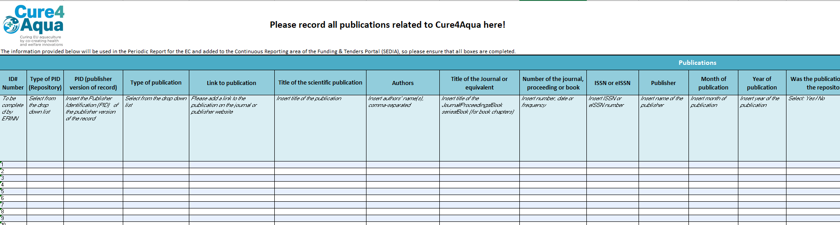

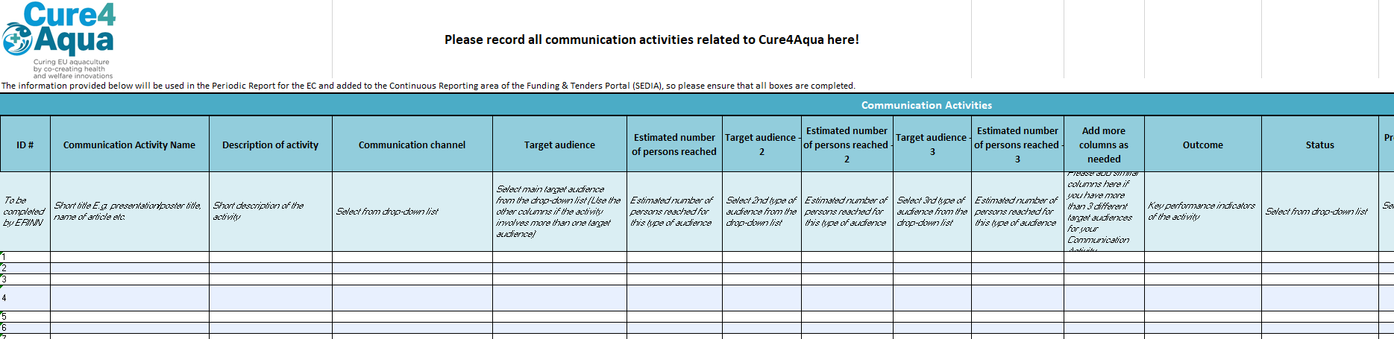

Project Coordinator
Ivona Mladineo | ivona.mladineo@paru.cas.cz

Project Manager
Anna Holčáková | anna.holcakova@paru.cas.cz

Press and Communications
Marieke Reuver | marieke@erinn.eu

Website: cure4aqua-project.eu
X: @Cure4Aqua_EU
LinkedIn: Cure4Aqua

Dissemination level: PU: Public
Type of deliverable: R: Report
http://ec.europa.eu/research/participants/portal/desktop/en/support/reference_terms.html; https://ec.europa.eu/info/funding-tenders/opportunities/docs/2021-2027/common/temp-form/report/periodic-report_horizon-euratom_en.pdf
https://ec.europa.eu/invest-in-research/pdf/download_en/knowledge_transfe_07.pdf
http://europa.eu/rapid/press-release_MEMO-07-127_en.htm?locale=en
https://intellectual-property-helpdesk.ec.europa.eu/

