The Better Sleep Programme:
An impact case study
- An Impact Case Study of your project
Executive summary (200 words max)
Young people experience high levels of sleep difficulties that significantly affect their mental health. Despite this, sleep difficulties are rarely addressed within mental health services. The Better Sleep Programme has adapted Cognitive-Behavioural Therapy for Insomnia (CBT-I) to be suitable for young people with mental health difficulties. After showing positive outcomes in secondary mental health services, Norfolk and Waveney Integrated Commissioning Board have funded us to improve access to help with sleep across the wider youth mental health system.
We provide training and supervision to mental health professionals from services across Norfolk and host workshops to increase awareness around the role of sleep in mental health. Our aim is to embed this intervention into routine practice, allowing young people in Norfolk timely access to first-line NICE recommended treatment for insomnia. The project relies heavily on digital solutions to achieve this ambitious target whilst working with multiple organisations across a wide geographical area.
Background and context (250 words max)
The ambition of The Better Sleep Programme (TBSP) is to have an effective intervention for sleep difficulties offered in routine clinical practice. This needs to be widely available and easily accessed. The Better Sleep Programme uses digital solutions to make this a reality.
After showing effectiveness and feasibility within secondary mental health services, we undertook a 6-month scoping project with over 30 local mental health providers. Similar to recent research findings, we found a high level of sleep difficulties, a low level of provision and services keen for further training.
The implementation of a sleep intervention into a mental health system is novel. Our strategic approach involves:
- An accreditation programme for therapeutic practitioners (two days of online training and six months of online supervision)
- A half-day online skills workshop for wider staff groups alongside a self-help guide we have developed
- Projects to adapt the intervention for more specialist clinical populations and
- Improved access to digital resources and information
Our overall ambition is to improve the awareness of the role of sleep and the availability of effective interventions across youth mental health services nationally. Raising awareness of our work is central to this, as is disseminating our findings and widening access to the online training and digital resources we have developed. Ultimately, we want access to sleep interventions to become part of routine clinical practice.
What the evidence indicates (500 words max)
Sleep difficulties are particularly prevalent in young people and are well-documented as a risk factor contributing to all forms of mental health difficulties (Hertenstein et al., 2019). Results from the 2022 NHS survey show that 34% of 7-16yr olds struggle with their sleep three times a week and this prevalence increases to 72.3% in those experiencing mental health difficulties. In those aged 17-25yrs these sleep difficulties rise to 64% and reach 89.5% in 17-25yr olds struggling with mental health difficulties.
Recent research has found that insomnia precedes the onset of mental health difficulties (Hertenstein et al., 2019; Orchard et al., 2020) and that treating insomnia can improve mental health, however treating mental health difficulties does not show the same reduction in insomnia. Moreover, insomnia has been shown to increase the risk of developing mental health difficulties such as anxiety, psychosis and depression (Hertenstein et al., 2019; Harvey et al., 2008). Targeting sleep can therefore improve outcomes in both sleep and wellbeing and is often viewed as a more accessible intervention by young people.
Not only does insomnia increase the likelihood of mental health problems, it also contributes to higher risk behaviours such as suicidality, self-harm and impulsivity (Glenn et al., 2021; Liu et al., 2017; Wong et al., 2011). Therefore, it is vital to treat sleep difficulties to reduce mental health symptoms and risk of young people acting on their thoughts.
Cognitive Behavioural Therapy for Insomnia (CBTi) is recommended as the first line of treatment for insomnia (NICE, 2024). This therapeutic intervention typically consists of psychoeducation, sleep scheduling, stimulus control, sleep hygiene, cognitive restructuring, and relaxation training (Davidson, 2019; NICE, 2024). Research has demonstrated that CBTi is as effective as sedating hypnotics in the short term and supersedes these in the long term (Smith et al., 2002; Okajima et al., 2011). Furthermore, research has demonstrated the therapeutic interventions’ efficacy in both young people with mental health difficulties and those without (Muench et al., 2022). However, in secondary mental health services, CBTi is seldom considered, and mental health treatment is typically the only focus (Hertenstein et al., 2022).
To summarise, research to date demonstrates high efficacy of CBTi for sleep problems in individuals with mental health difficulties, but it is yet to be rolled out nationally as an intervention offered in youth mental health services.
Summary of findings (500 words max)
At the start of the project, we set a target to train 180 practitioners across two years and have currently trained 137 in less than one year. We have provided our workshop to 130 professionals to date. The training feedback has been extensively positive with 100% of attendees reporting that they would recommend the training.
To date, we have outcome data collected for 94 young people. Interim analyses indicate high baseline levels of insomnia and significant improvements being seen in sleep and wellbeing after six sessions of sleep work. We have found 68% of service users no longer reaching clinical threshold for insomnia and 35% scoring below the clinical range on wellbeing measures (compared to 80% and 93% scoring above respectively at baseline). The meaning of this change is captured in positive feedback and quotes from service users:
“It works!” “So good to see the impact it makes on [my] sleep but also mood and wellbeing,” (service user).
“I don't think about sleep anymore, it just happens naturally. It's never on my mind” (service user).
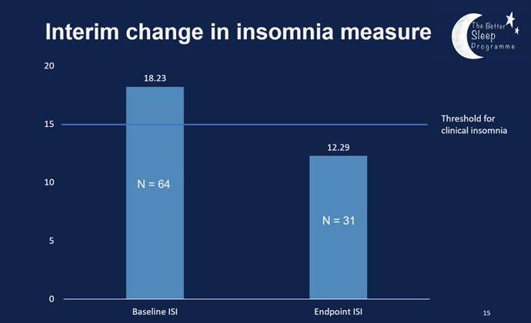

Beyond the measures collected, practitioners report drawing on their new skills in their work with ‘many/most’ of the young people they are working with. We estimate at least 1000 young people will already have benefitted from more informed help with their sleep to date.
Recommendations for commissioners and future research (500 words max)
Disturbed sleep plays a critical role in the onset and maintenance of mental health difficulties. We are seeing a high level of need around sleep in young people accessing mental health services with medication being the main treatment offered. Preliminary findings suggest that The Better Sleep Programme has led to improvements in sleep and psychological wellbeing for young people in Norfolk and Waveney. Increasing the availability of this first-line NICE recommended offer should help to reduce costs associated with medication use in young people.
We recommend continuing to fund projects like The Better Sleep Programme to ensure:
- Ongoing training and supervision for existing services to maintain current provision
- Continued support and adaptations for specialist services including case studies to guide implementation
- Further workshops to increase knowledge and awareness in the wider system
- Ongoing development of resources for young people with different presentations and needs
- Continuation of data collection to monitor effectiveness
We recommend future research is needed such as:
- Randomized controlled trials (preferably single blind) to determine the effectiveness of a CBTi-based intervention vs a singular mental health intervention
- Use of CBTi in children under 14 years old
- More screening options to detect sleep difficulties early on
- Researching the impact of psychological interventions for sleep in inpatient settings
Publications
Rollinson, R., Price, I., Gee, B., Lyons, J., Carroll, B., Wilson, J., & Clarke, T. (2021). Low-intensity sleep intervention in a youth mental health service: a case series analysis. Behavioural and Cognitive Psychotherapy, 49(1), 62-75. https://www.cambridge.org/core/journals/behavioural-and-cognitive-psychotherapy/article/abs/lowintensity-sleep-intervention-in-a-youth-mental-health-service-a-case-series-analysis/9E814C18943D46A72A1A02CF4227F2D4?utm_campaign=shareaholic&utm_medium=copy_link&utm_source=bookmark
Rollinson, R., Cole, A., Gee., B., Tofan, I., Graham, A., Hatton, J., Lyons, J., Reeve, S., Wilson, J., Beardsworth, K., Clarke, T. (2024). Delivering a sleep intervention across an NHS youth mental health service using non-expert practitioners: a service evaluation. Early Intervention in Psychiatry (In submission).
The Norfolk and Waveney Integrated Commissioning Board (ICB) funded us to improve access to effective help with sleep across the wider youth mental health system.
The research was supported by UEA Health and Social Care Partners (UEAHSCP). The views expressed are those of the author(s) and not necessarily those of the University of East Anglia or UEA Health and Social Care Partners.

