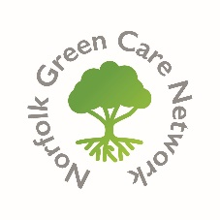**GREEN GATHERING**

**Friends Meeting house, Upper Goat Lane, Norwich NR2 1EW**

**PROGRAMME**

10.00- 10.20am- Registration and refreshments

10.20am- Welcome- Nigel Boldero, Convenor

***Themes for the Day:***

* **Morning- Green Care to promote health and respond to ill health**
* **Afternoon- Nature connection for children and young people**

10.30am  Workshops, with panel questions and discussion

**1. Nature connections to promote health and wellbeing (small meeting room)**

* Forest bathing- Ruth Taylor (Norfolk & Waveney MIND)
* SING- Rev. Dr. Fiona Haworth (St.Peter Mancroft Church)
* Parks and open spaces- Paul Rabbitts (Norwich City Council)

**2. Nature connections to respond to ill health (main meeting room)**

* **Strong Roots- Lucy Scurfield**
* Nature Prescriptions Project- Sarah Walker (RSPB) and Claire Dyke (Norfolk & Waveney ICB)
* Green Social Prescribing- latest developments- NASP video

***12 noon Lunch and networking***

1pm The Nature Premium Campaign- Dr. Sara Collins (plus questions)

1.30pm Social Farming and the Farm Buddies model- Stephen Sellers (Farm Buddies) (plus questions)

2.00pm Forest Schools and nature connection for children- Louise Ambrose (Birchwood Learning) (plus questions)

***2.30pm Refreshments and networking***

3.00pm The First Nature Campaign and Bishop of Norwich Award- Nigel Boldero

3.10pm The nominees and the winner (profiles)

3.45pm Closing words- Bishop Graham

4pm Close