The Walk-A-Cise Mobile Phone Application Impact Case Study

1 Title and names of researchers and organisations involved
Prof Philip Stather, Norfolk and Norwich University Hospital
Mr Michael Robinson, Guy’s and St Thomas Hospital
The Cardiovascular MIC
East Suffolk and North Essex Foundation Trust
James Paget University Hospital
Queen Elizabeth Hospital King’s Lynn
Peterborough City Hospital
Addenbrookes Hospital

2 Executive Summary
Patients with cramps in their legs when they walk often have a poor blood supply termed peripheral arterial disease. The first-line treatment option for this condition is exercise therapy to improve the blood supply. NICE guidelines recommend supervised exercise therapy, however this is very poorly provided in the NHS with only 40% of hospitals having a programme, and only 25% attending even when they do.
A new method of delivering exercise therapy is needed to make it more accessible. The Walk-A-Cise mobile phone application enables remotely monitored exercise therapy, that patients can undertake at a time and place convenient to them. Using GPS tracking, walking distances can be accurately measured, and monitored by their healthcare professional.
This project has expanded the use of the prototype Walk-A-Cise app across the East of England, and also enabled both patient and public input, and stakeholder input into the design and development of the new version of the app, which is now UKCA marked, registered with MHRA, and being further spread across the NHS.

3 Background and Context
Every year over 6000 people lose a leg due to blocked blood vessels. Typically there are signs of blocked blood vessels much earlier than this, and with the right lifestyle changes this can be prevented.
Early treatment including blood thinning medications, cholesterol lowering tablets and stopping smoking can help to prevent this disease progressing, however in order to improve the blood supply to the leg patients need exercise therapy.
Exercise therapy is hard. These patients get cramps in the calf muscle when they walk, due to a build up of lactic acid. For new blood vessels to develop patients need to walk through that pain as much as possible.
Unfortunately, most hospitals do not have an exercise therapy programme. In NNUH we have an exercise therapy programme, however this covers the whole region, include patients who attend Queen Elizabeth Hospital Kings Lynn, and James Paget University Hospital. This means patients would have to travel up to 50 miles each way to attend, and therefore only a quarter of patients actually come. This situation is the same throughout the UK, therefore we are not providing recommended care to the majority of our patients.

4 What the evidence indicates
The efficacy of supervised exercise therapy to improve walking distances, functional status and Quality of Life has already been established. A Cochrane review of 21 studies revealed that supervised exercise therapy improves maximal walking distances by approximately 120 to 210 metres when compared with home-based exercise therapy and walking advice. A network meta-analysis also showed that supervised and home-based exercise therapy improved daily physical activity levels. When comparing endovascular revascularisation and supervised exercise therapy there was no statistical difference between these groups, suggesting that supervised exercise therapy is as good as endovascular revascularisation, especially in long term outcomes.
Despite the encouraging evidence supporting SET, it is an underutilised tool with low availability, uptake and adherence. In a recent US study only 1.3% of those diagnosed with peripheral arterial disease were enrolled to supervised exercise therapy and only 5.1% successfully completed the program. A survey conducted in 2021 revealed only 48% of vascular units have access to SET in the UK and only 22% meet the NICE recommendations with patient uptake rates around 25%. Funding is a key barrier for the lack of accessibility (94.3% in the 2016 survey), followed by a lack of suitable staffing, facilities and expertise. Patient-specific barriers that may prevent a patient from partaking include compliance (affected by travel arrangements, inconvenience, and cost), lack of motivation, trivial improvements and medical co-morbidities (such as Chronic Obstructive Pulmonary Disease, Congestive heart failure, arthritis, and angina).
Tracking-based technologies have been studied for patients with peripheral arterial disease previously. This includes using Smart Watches, and mobile phones. We undertook a recent meta-analysis which identified 15 studies using either smartwatches or free apps. Analysing that data statistically through a meta-analysis identified that these technologies increased patient walking, defined as 6-minute walk test, claudication onset time, peak walking time, maximum walking distance, and through scores on the walking impairment questionnaire and quality of life. However, these apps and watches will not work outside of small clinical trials due to a lack of healthcare professional connectivity, and reproducibility on a large scale.
The Walk-A-Cise app has been used in NNUH, and early uptake data identified overall 66% of eligible patients were enrolled. GPS walking distance was compared to self-reported walking distance showing mean self-predicted walking distance was significantly lower than GPS distance (202.63m v 509.37; p=0.0002). Walking distance has significant implications in decision making regarding surgical intervention in these patients. Over the duration of use of the app, participants increased their walking distance by a mean difference of 163.43m. Some barriers to uptake were identified including lack of availability on Apple phones (now addressed), and 26% didn’t have a smartphone.

5 Summary of findings
The Walk-A-Cise mobile phone application has undergone significant development, through further funding from Innovate UK, based on the patient and public involvement and stakeholder groups undertaken during the UEA Health and Social Care Partnership funding. The app has also been rolled out to additional hospitals, with these hospital now being updated to the new version of the app, and further dissemination to the wider NHS.
Feedback suggested converting the app into a treatment rather than monitoring platform. The main components of this included not only ensuring GPS accuracy, but also including a wider range of walking outputs, such as claudication onset distance, claudication onset time, total walking distance, and maximum walking distance. In addition, we have developed a 6 minute walk test. Each of these outputs are commonly published in the literature and used for monitoring purposes.
The app now also includes a communication platform so that patients can contact their healthcare professional directly, avoiding unnecessary delays should they deteriorate, enables input of other exercise activities, and can connect with the users Smart Watch.
The component that transforms the new app into a treatment, and therefore required registering with MHRA and obtaining Class 1 UKCA mark status was the development of bespoke animated exercise classes. Animations were developed based on national guidelines, with Jon Dunleavy at the Norwich University of the Arts leading, and co-design being undertaken alongside the Vascular Society Peripheral Arterial Disease Special Interest Group. These are at 5 levels of difficulty, with patients able to work through these until they reach the appropriate level for them.
The Walk-A-Cise mobile phone application is now ready for uptake throughout the NHS, and the next stage is to monitor uptake and outcomes on an individual hospital level, and spread throughout the UK and beyond.
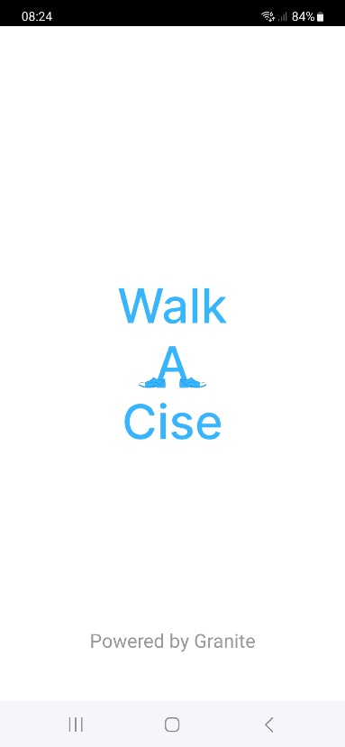 | 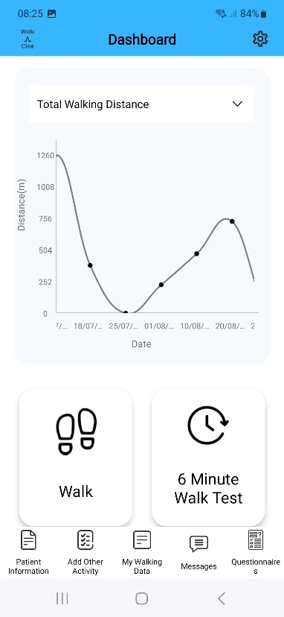
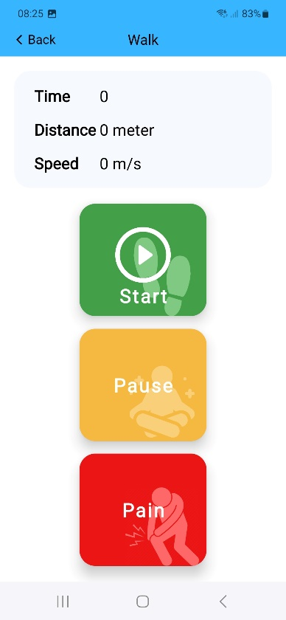 | 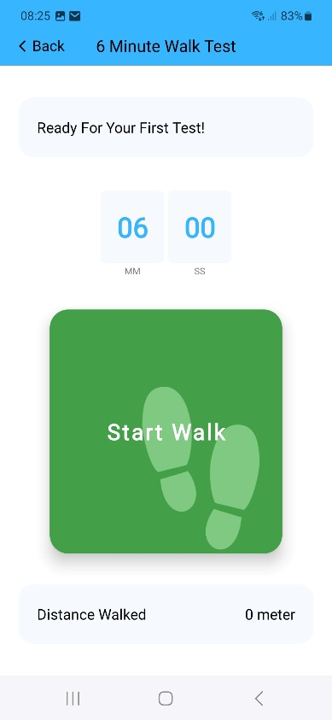

6 Recommendations for commissioners and future research
The Walk-A-Cise mobile phone application is now ready for widespread adoption. At present this is undertaken at a hospital level, where patients have already got significant peripheral arterial disease warranting referring to a vascular surgeon.
We believe that intervening earlier in the pathway will further reduce the need for referral, and reduce the need for invasive surgical intervention. We would therefore like to trial the app within the community, working with Integrated Care Boards to enable GPs to refer to the app directly with oversight from community support such as leisure centres and health hubs.
We are developing the Walk-A-Cise app further to include additional patient groups, such as paediatric obesity and cardiology, where remote exercise therapy can also be used as part of their treatment plan.
A national clinical trial utilising the Walk-A-Cise app is being developed to compare the app to supervised exercise therapy and home based exercise therapy.

7 Key publications
https://www.nice.org.uk/guidance/cg147/chapter/Recommendations#management-of-intermittent-claudication
www.ncbi.nlm.nih.gov/pmc/articles/PMC6513337/
www.ejves.com/article/S1078-5884(18)30923-7/fulltext
https://pure.coventry.ac.uk/ws/portalfiles/portal/29651511/Binder5.pdf
www.ncbi.nlm.nih.gov/pmc/articles/PMC9941040/

