CTPAT and TC Portal 3.0 Login.gov Account Creation

Link to Portals:
CTPAT Portal / TC Portal: https://trade.cbp.dhs.gov/ctpat/ctpat-portal-ui

Step 1 - Initiate the login process:
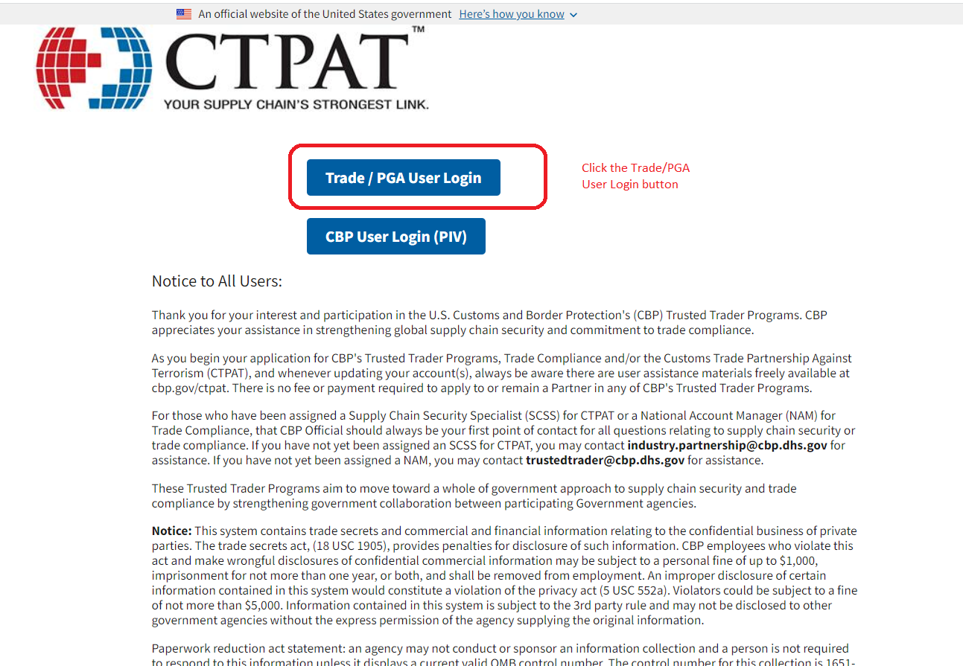

Step 2 - Create a new Login.gov account:
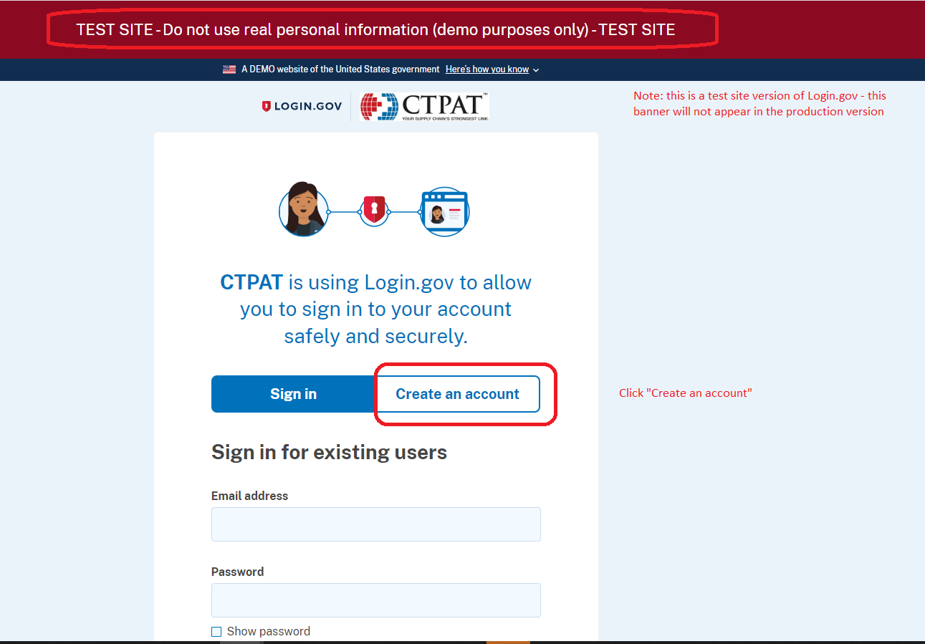
Note - Disregard red banner on instructions that says test site. This is now deployment of 3.0 Portals for both CTPAT and Trade Compliance.

Step 3 – Provide email address and email preference:
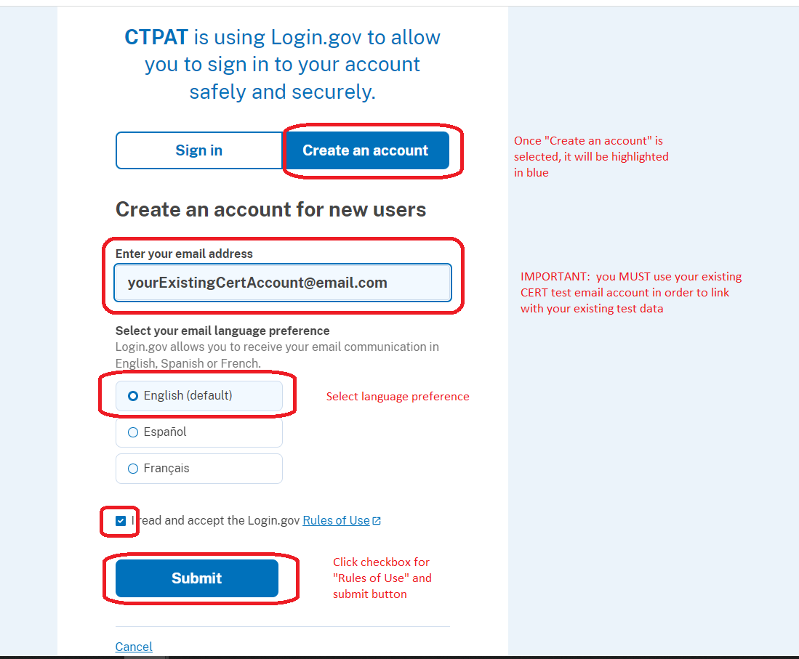
Note – Instructions say, “must use previous CERT email account”. Disregard this statement. You will need to use your current user email address for CTPAT and/or TC Portals. Even if you were a tester, you will need to create an account.

Step 4 – Check email for message from Login.gov:
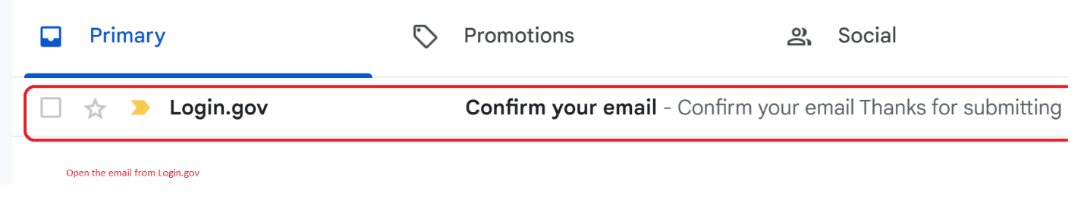

Step 5 – Confirm your email address
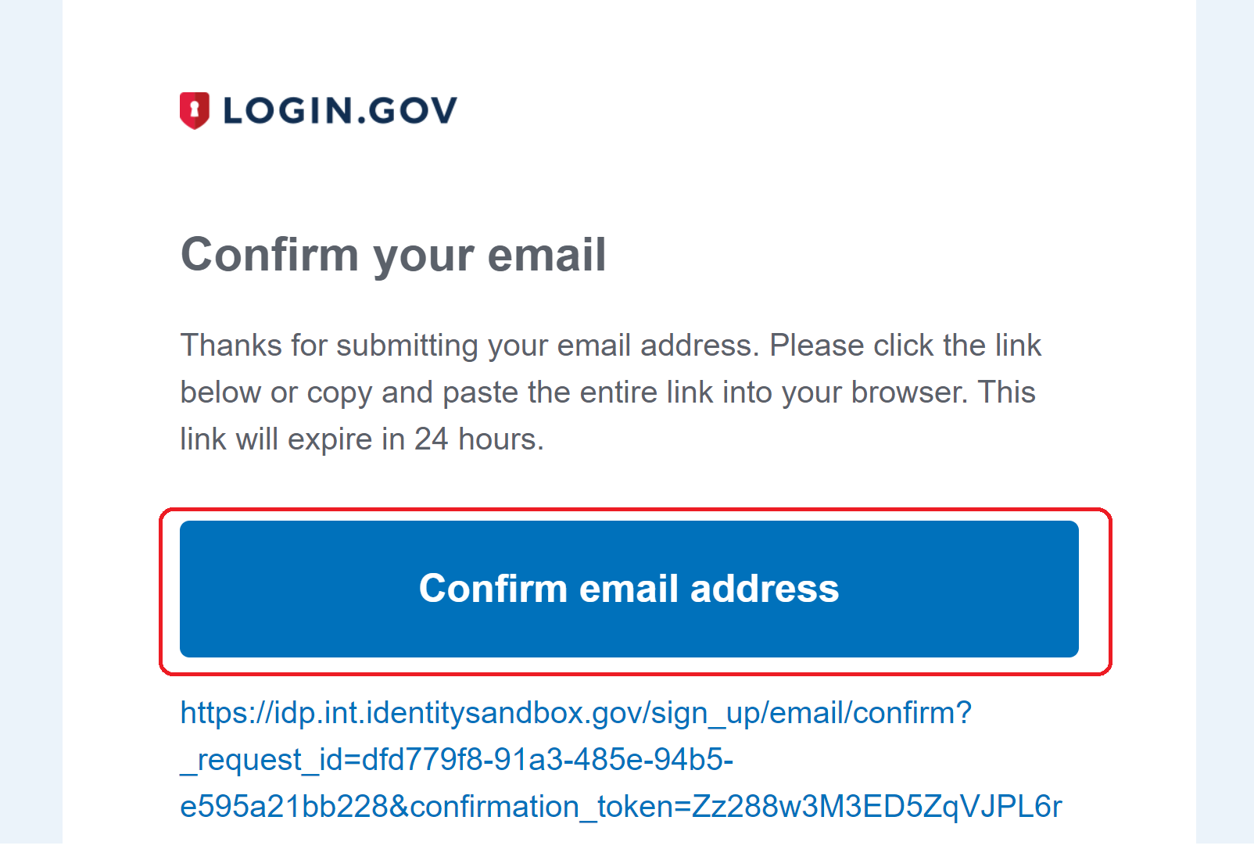

Step 6 – Choose a secondary authentication method:
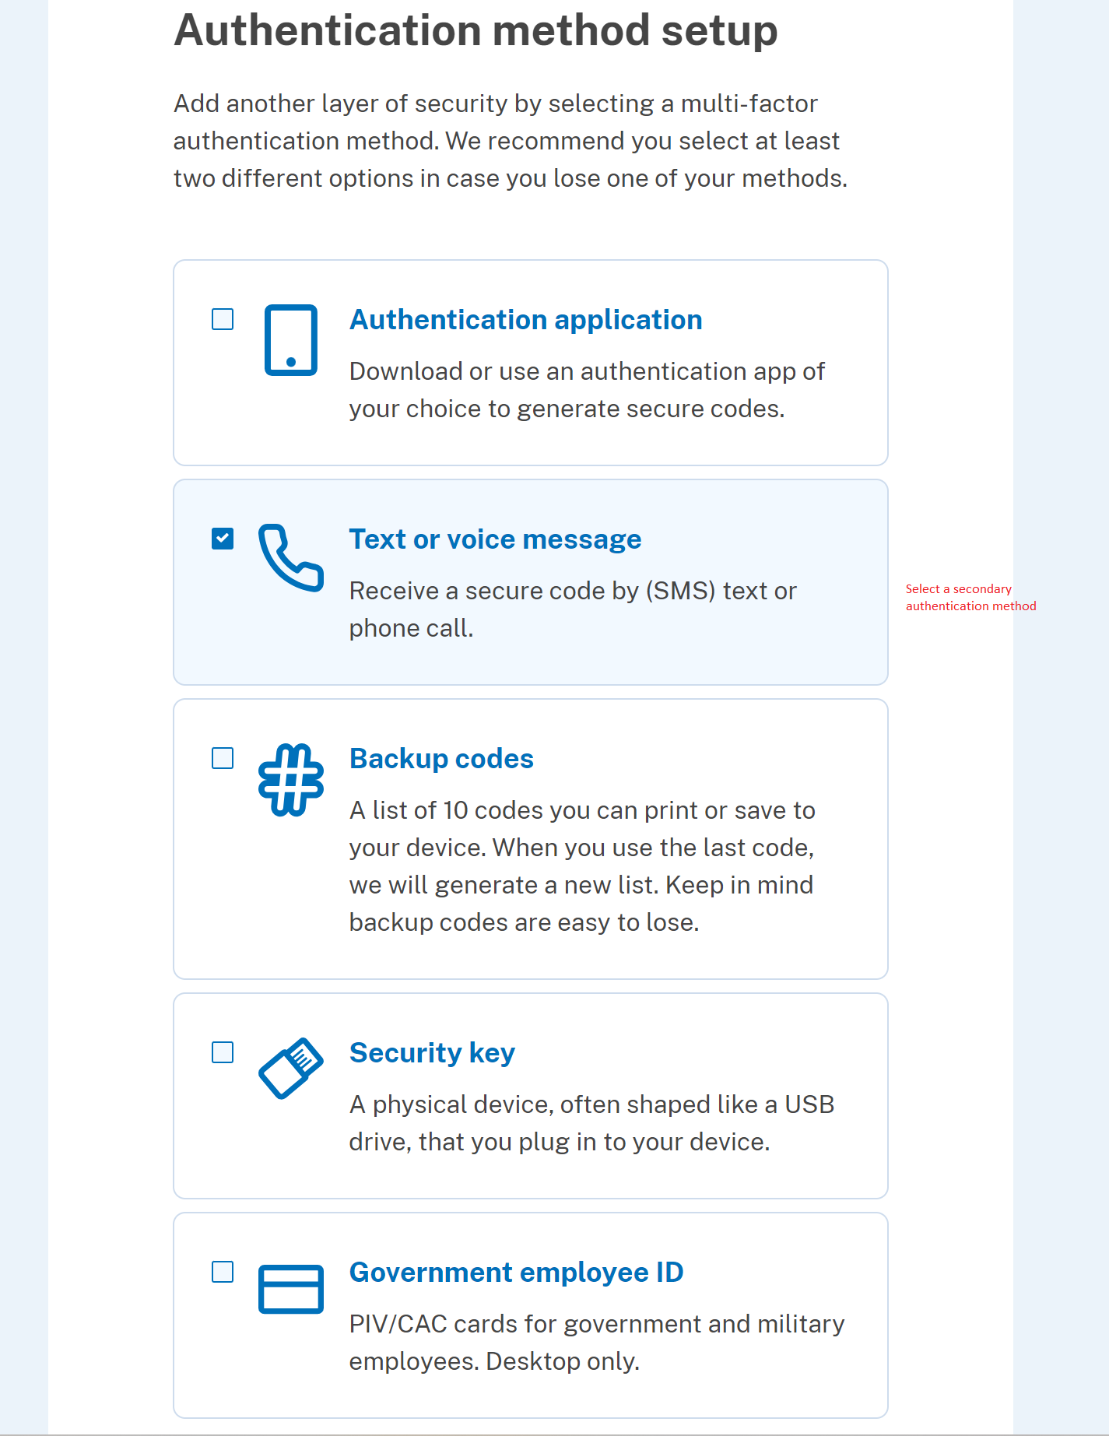

Step 7 – Enter information needed for secondary authentication:
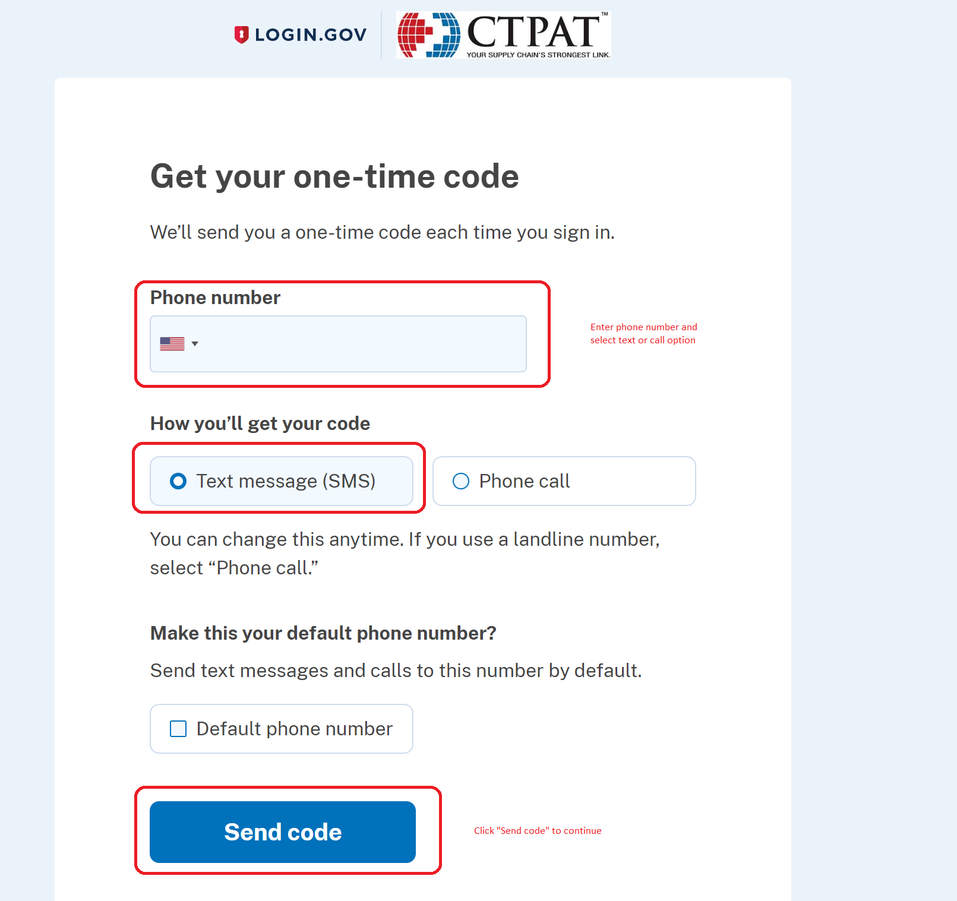

Step 8 – Since text method was selected as secondary authentication, enter time sensitive code and continue:
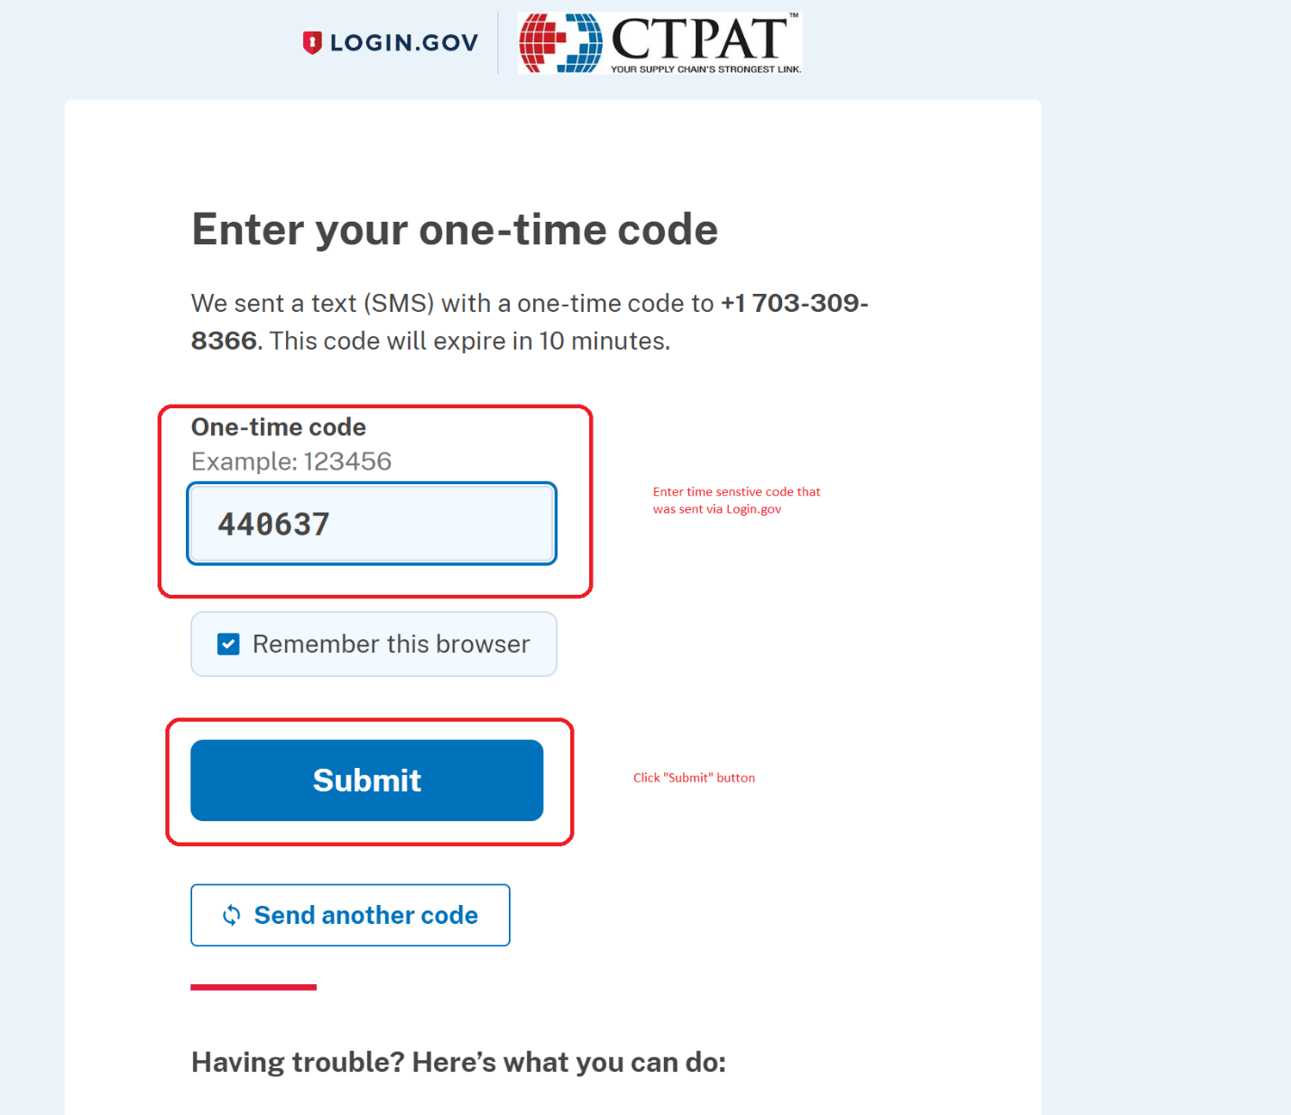

Step 9 – Confirmation your Login.gov account has been successfully created (note you can choose to add additional authentication methods):
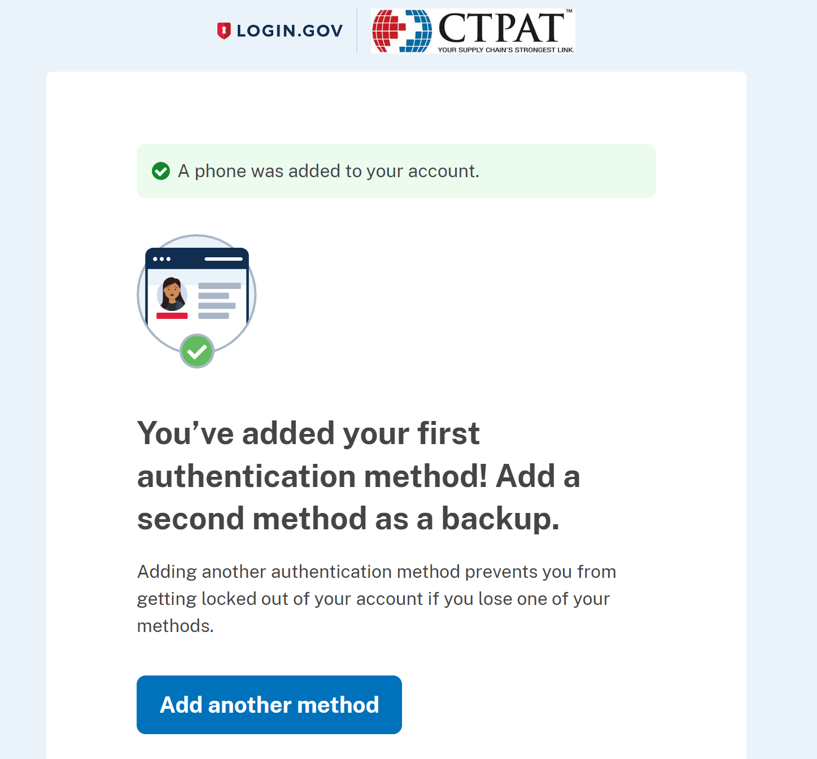

Step 10 – Return to initial login screen and select “Trade/PGA User Login” button (note: this is the same screen and button as in Step 1):

Link to Portals:
CTPAT Portal / TC Portal: https://trade.cbp.dhs.gov/ctpat/ctpat-portal-ui

Step 11 – Select “Sign in” and enter the email address you registered with Login.gov and your password to continue:
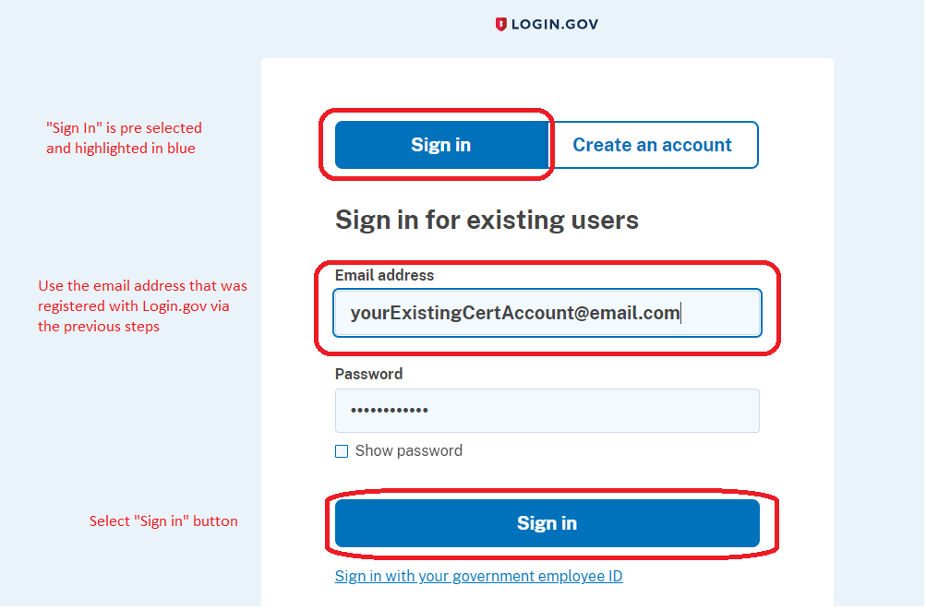

Step 12 – Enter secondary authentication information to continue:
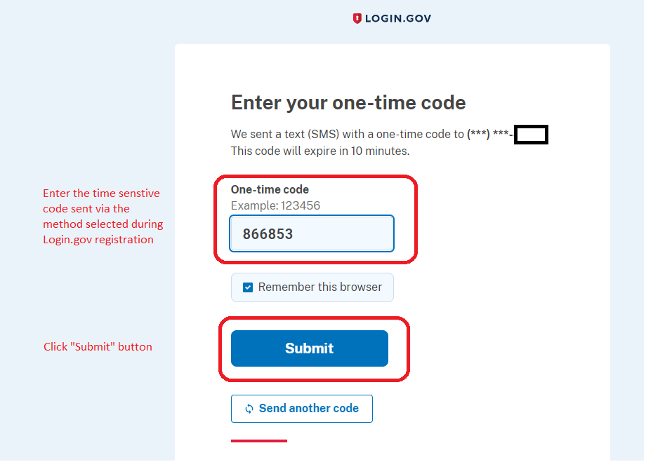

Step 13 – Agree and continue:
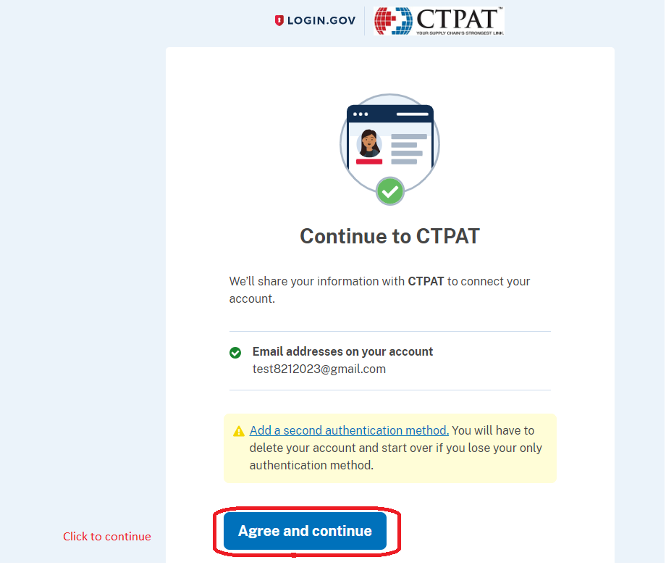

Step 14 – Verify your account information on the new CTPAT portal landing page:
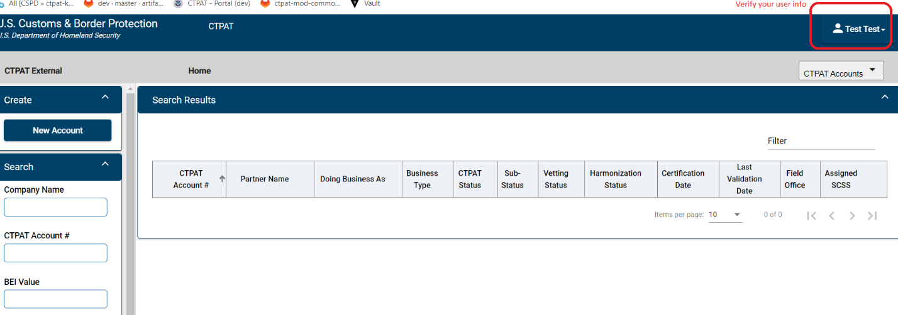
Initial Login Instructions:
- Verify your account information.
- Walk through all tabs and verify information.
- Report any inaccurate information, issues or bugs found to:
CBP’s Technology Service Desk
Email: CBP.TECHNOLOGY.SERVICE.DESK@cbp.dhs.gov
Phone: 800-927-8729

