Daily Lunch Menu – Dr. Franklin Perkins School

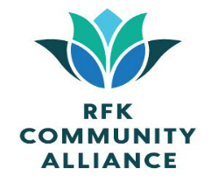 | Monday | Tuesday | Wednesday | Thursday | Friday | 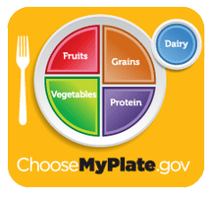
Menu subject to change without notice when unforeseen issues arise. Before placing your order, please inform your teacher if you have a food allergy. | 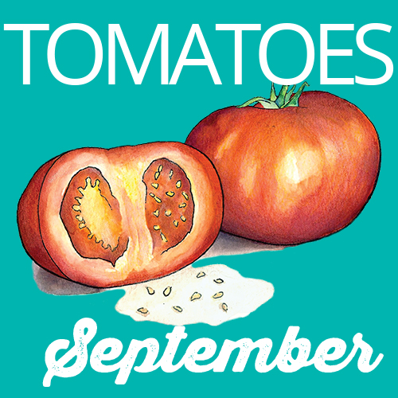 | 1  Blackened Chicken, Apple Cider Roasted Butternut Squash & Smashed Potatoes or Korean Tofu Bibimbap Veggie Noodle Bowl | 2  Chili Con Carne with Tostitos Chips, and a Baked Potato Bar or Tuna Salad Chef Salad | 3  Chicken Nuggets, Green Beans and Creamy Carrot Mac & Cheese or Southwestern Chicken Power Bowl | 4  Cheese Pizza with Spaghetti Squash or Roasted Chickpea Chopped Kale Fall Salad | 5  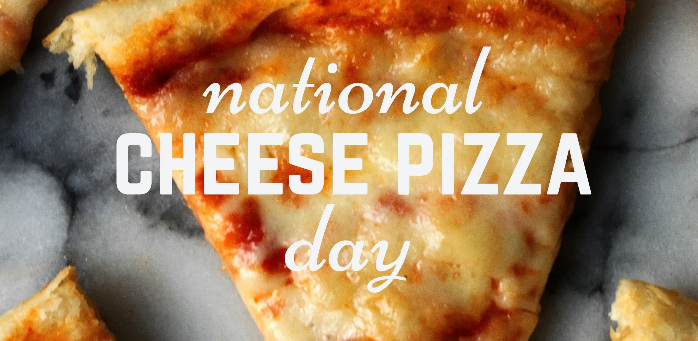
6   | 7  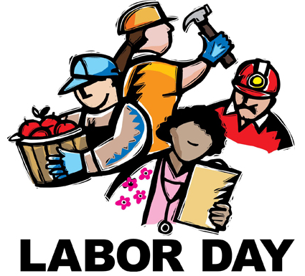 | 8  Italian Subs, a bag of Popcorners Chips & Homemade Pickles or Korean Tofu Bibimbap Veggie Noodle Bowl | 9  Orange Chicken with Carrot Ginger Crunchy Veggie Slaw with Sesame Rice or Tuna Salad Chef Salad | 10  Old Bay Cracker Crusted Cod with Lemon Spinach and Corn on the Cob or Southwestern Chicken Power Bowl | 11  Flatbread Friday  Meat Lovers, Twister Fries, Veggies & Dips or Roasted Chickpea Chopped Kale Fall Salad | 12  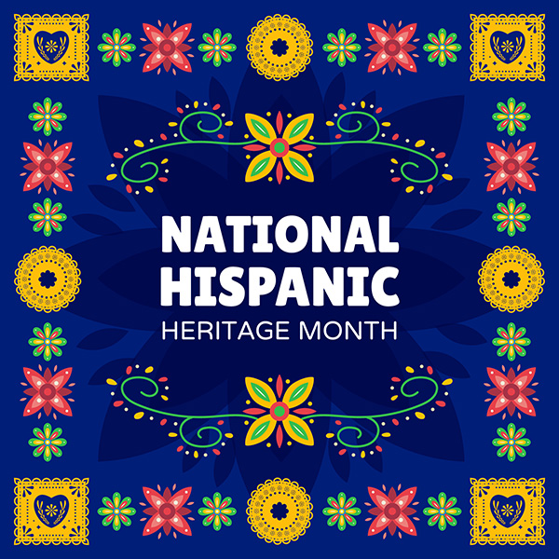
13  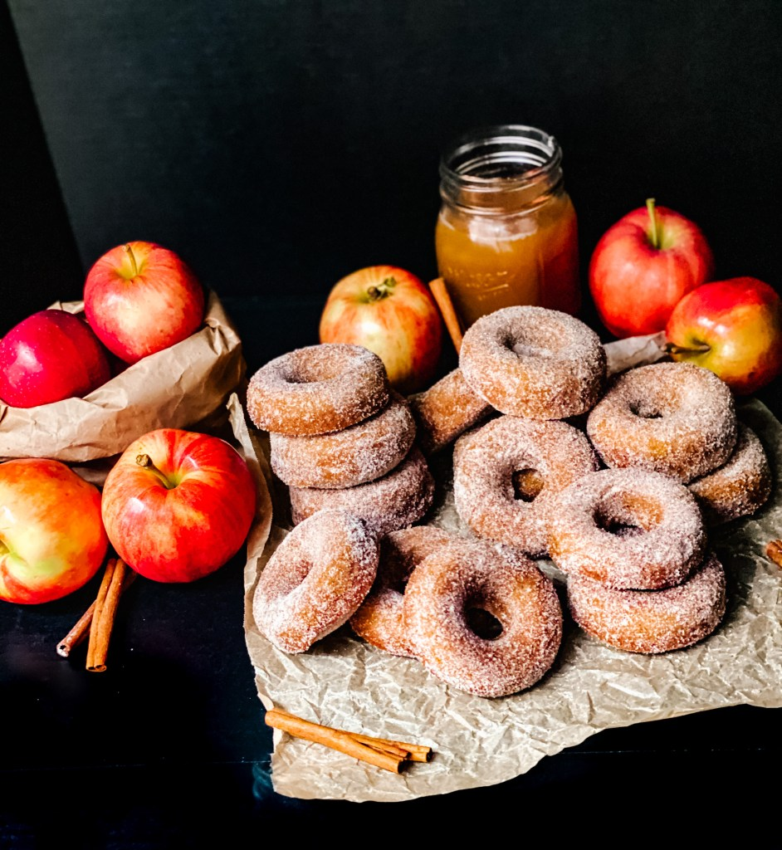 | 14  Macaroni & Cheese with Broccoli and a Betty Bar or Nut Free Pesto Chicken Caprese Salad | 15  Sausage, Egg & Cheese Breakfast Bagel, Hashbrowns & a Fruit Parfait or Korean Tofu Bibimbap Veggie Noodle Bowl | 16  Apple BBQ Sloppy Joes, Cowboy Beans, and Honey Roasted Brussel Sprouts or Tuna Salad Chef Salad | 17  Bagged Lunches  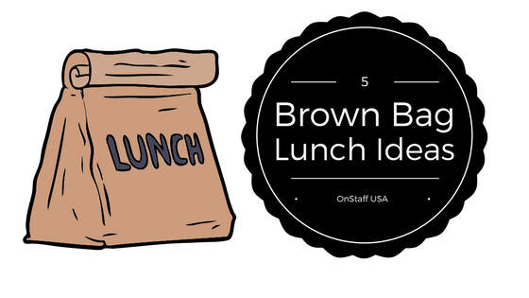 | 18  Grilled Cheese with “Harvest of the Month” Tomato Soup & Summer Squashes or Roasted Chickpea Chopped Kale Fall Salad | 19  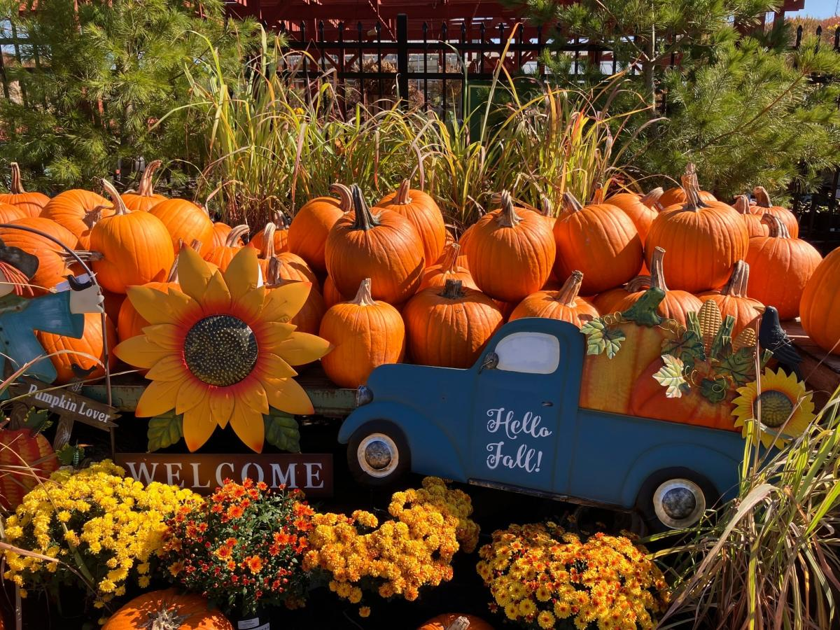
20   | 21  Chicken & Waffles with Maple Glazed Rainbow Carrots or Nut Free Pesto Chicken Caprese Salad | 22  Cheeseburgers with Roasted Ranch Potato Wedges, Veggies & Dips or Korean Tofu Bibimbap Veggie Noodle Bowl | 23  Pasta with Red Sauce made with Local Tomatoes, Italian Chicken & Ratatouille or Tuna Salad Chef Salad | 24  Filet o’ Fish Sandwich with Peas and Sweet Potato Fries or Southwestern Chicken Power Bowl | 25  WORLD LUNCH  Celebrating the Cuisines of Hispanic Countries for National Hispanic Heritage Month | 26  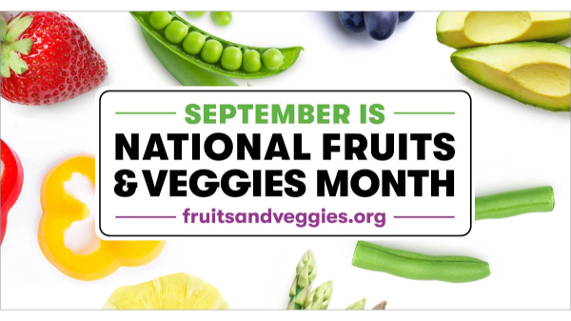
27   | 28  “Build Your Own” Birria Beef Nachos  ~sour cream, guacamole, salsa, cheese~ with Refried Beans or Nut Free Pesto Chicken Caprese Salad | 29  Blackened Chicken, Apple Cider Roasted Butternut Squash & Smashed Potatoes or Korean Tofu Bibimbap Veggie Noodle Bowl | 30  Chili Con Carne with Tostitos Chips, and a Baked Potato Bar or Tuna Salad Chef Salad | 

