Daily Lunch Menu – Dr. Franklin Perkins School

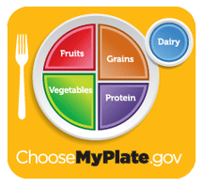 | Monday | Tuesday | Wednesday | Thursday | Friday | 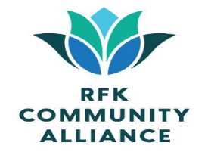
Menu subject to change without notice when unforeseen issues arise. Before placing your order, inform your teacher if you have a food allergy. | 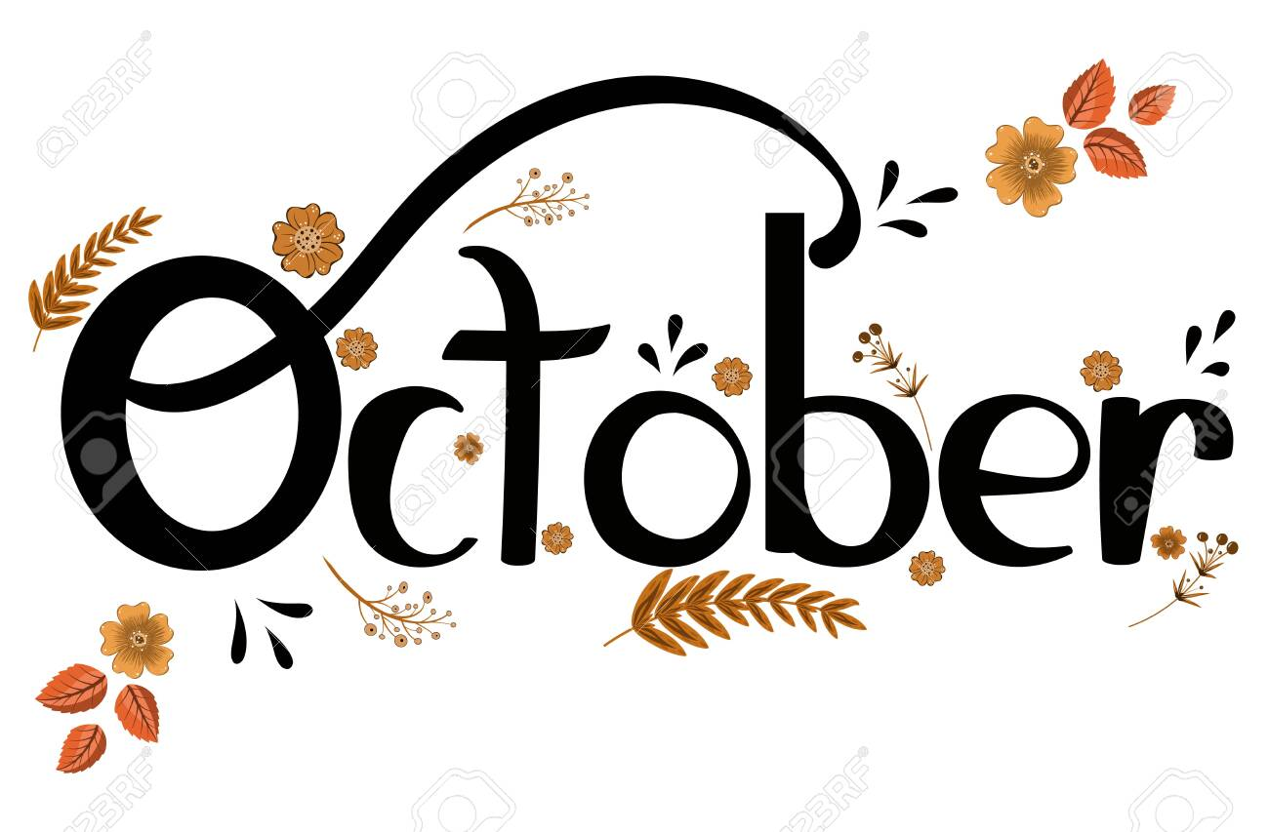 |  |  | 1  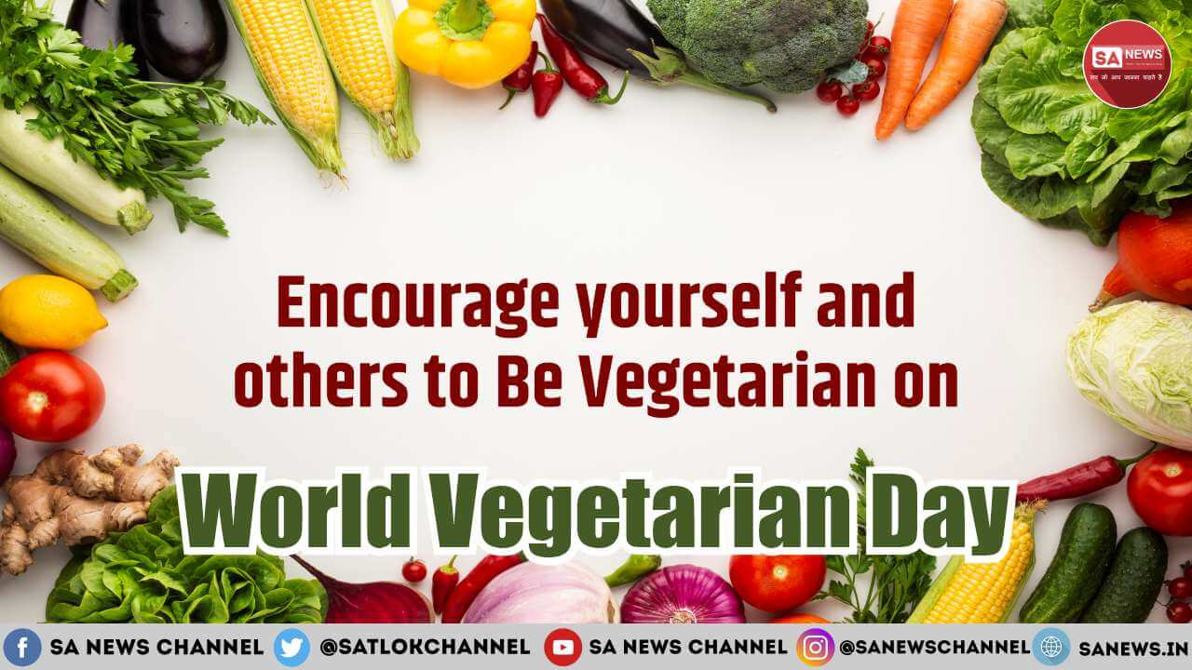  General Gao’s Glazed, Tofu, Broccoli & Rice or Falafel Greek Salad | 2  Cheese Pizza with Spaghetti Squash  or Buffalo Chicken Caesar Salad | 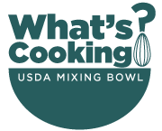
4  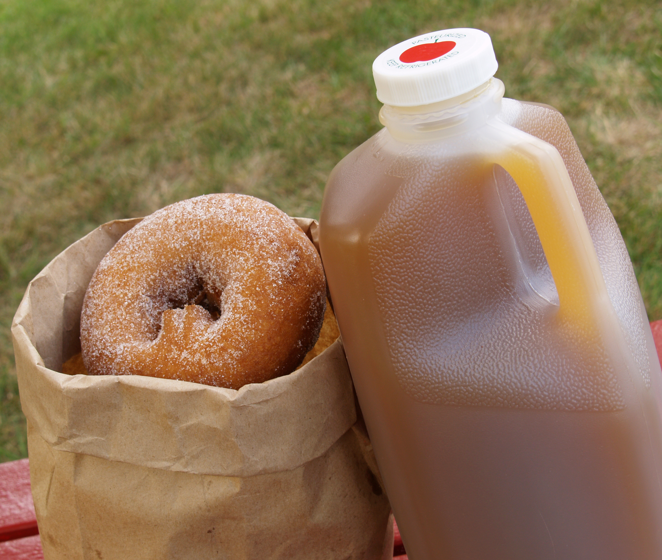 | 5  Chicken Pot Pie with a Biscuit and Green Beans or New Orleans Muffaletta Chef Salad | 6  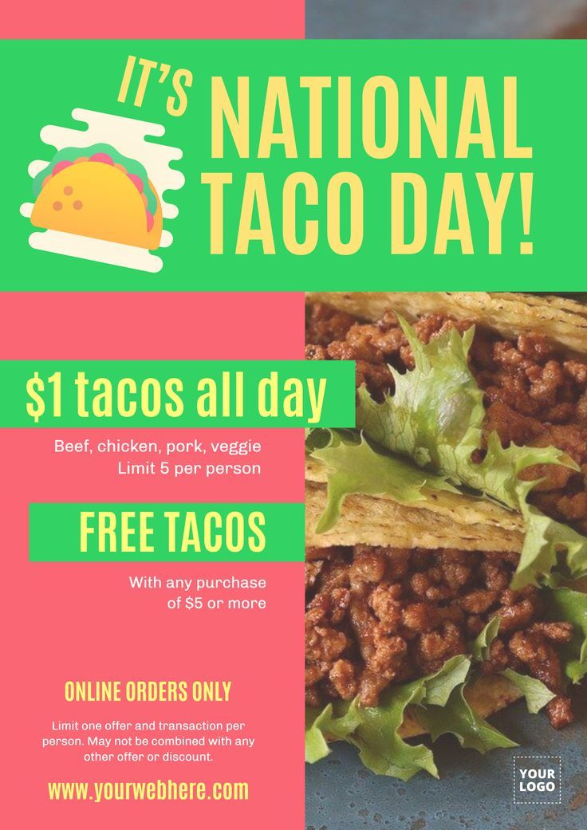 Tex Mex Chicken Tacos, Citrus Slaw & Refried Beans or Korean Tofu Bibimbap Veggie Noodle Bowl | 7  Egg, Cheese & Sausage Breakfast Sandwich, Hashbrowns and “Harvest of the Month” Pear Parfait  or Tuna Salad Chef Salad | 8  Old Bay Cracker Crusted Cod with Lemon Spinach and Corn on the Cob or Southwestern Chicken Power Bowl | 9  “Flatbread Friday”  Tortellini Al Fredo with Twister Fries, Fresh Veggies & Dips or Buffalo Chicken Caesar Salad | 10  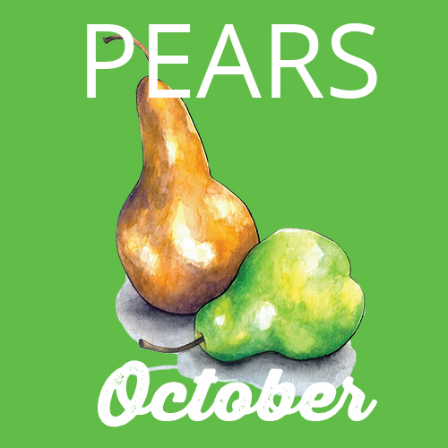
11  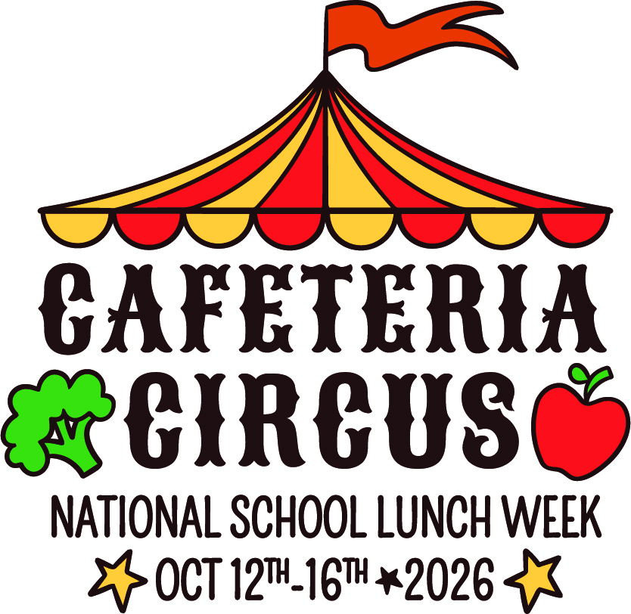 | 12  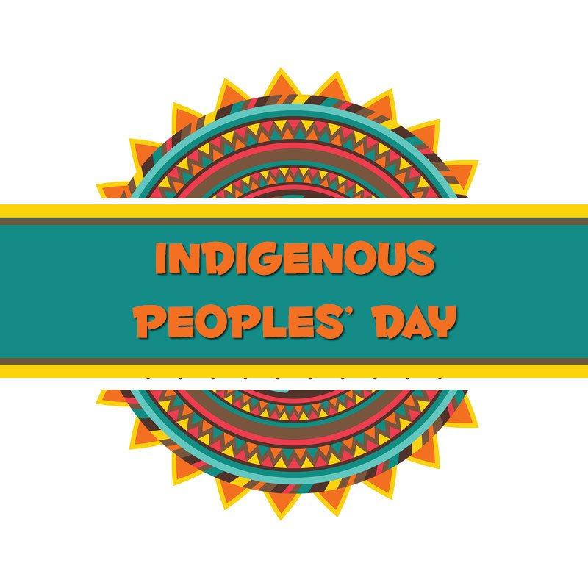 | 13  Circus Corndogs with Cowboy Beans & Cole Slaw or Korean Tofu Bibimbap Veggie Noodle Bowl | 14  Waffle Fry Nacho Bar  ~beef, cheese, salsa, sour cream, guacamole, lettuce~ with Fresh Veggies & Dips or Tuna Salad Chef Salad | 15  Big-Top Bacon Burgers & Buffalo Cauliflower or Southwestern Chicken Power Bowl | 16  Ringmaster BBQ Chicken with Apple Cider Glazed Butternut Squash. Local Apple Slices & Caramel Dip or Buffalo Chicken Caesar Salad | 17  
18  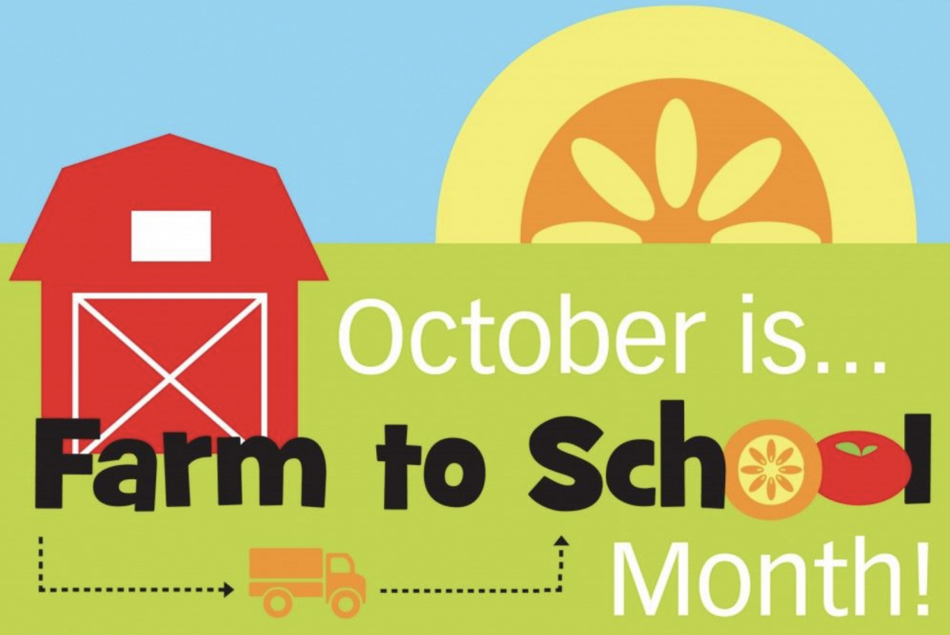 | 19  Macaroni & Cheese with Broccoli or New Orleans Muffaletta Chef Salad | 20  Philly Cheesesteak Subs with Roasted Mushrooms/ Peppers/Onions or Korean Tofu Bibimbap Veggie Noodle Bowl | 21  Oktoberfest  Herb Roasted Chicken, Potato Salad, Pretzel Bites & Honey Mustard or Oktoberfest Salad | 22  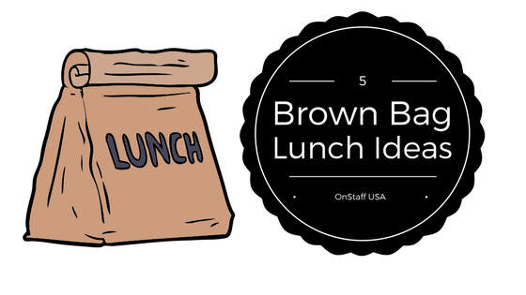  Bagged Lunches | 23  Roast Turkey with Gravy, Cornbread Stuffing, Cranberry Sauce, Carrots & Mashed Potatoes or Buffalo Chicken Caesar Salad | 24  
25   | 26  Chili Con Carne with Tostitos Chips, and a Baked Potato Bar or New Orleans Muffaletta Chef Salad | 27  Italian Subs, Popcorners, & a Pickle with “Harvest of the Month” Pear Crisp or Korean Tofu Bibimbap Veggie Noodle Bowl | 28  Pasta with Marinara Sauce, Italian Chicken & Parmesan Brussel Sprouts or Tuna Salad Chef Salad | 29  Filet o’ Fish Sandwich, Peas and Sweet Potato Fries or Southwestern Chicken Power Bowl | 30  Special Spooky Lunch   | 31  