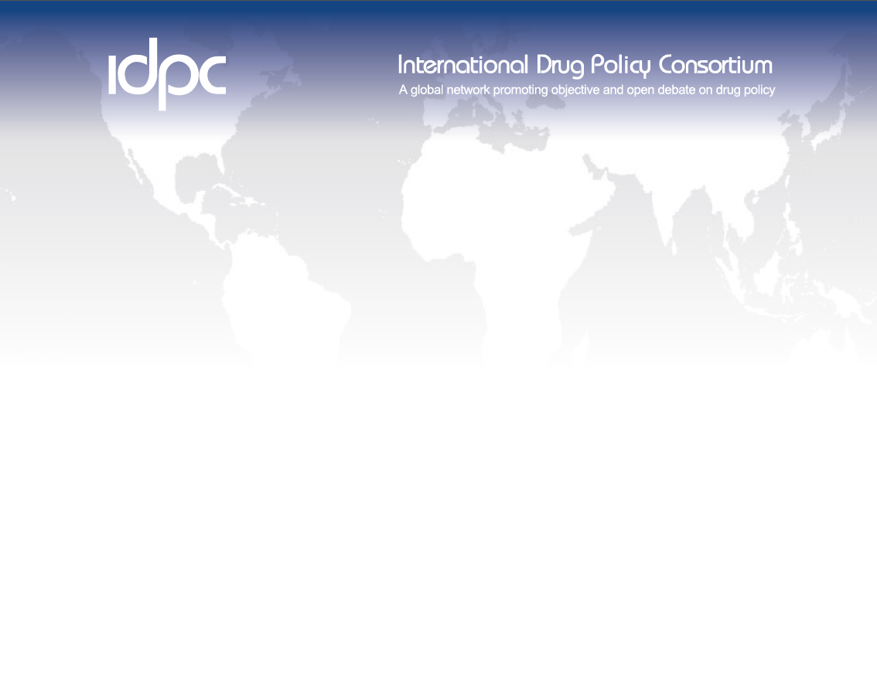

IDPC Programme Officer
Full-time position based in Bangkok, Thailand
Salary: USD 1,900 per month
11 months fixed term contract (with possibility of extension, budget allowing)

The International Drug Policy Consortium (IDPC) is a global network of NGOs and professional networks that aims to promote objective and open debate on the effectiveness, direction and content of drug policies at national and international level, and supports evidence-based policies that are effective in reducing drug-related harm. We have over 180 member organisations worldwide, and extensive communication and contacts with a range of experts in the field. The IDPC Secretariat is based in London with a smaller presence in Bangkok.

The IDPC office in Bangkok is looking to appoint a Programme Officer to provide support to the IDPC regional work programme in Asia.

The successful candidate will report to IDPC’s Regional Director: Asia and support financial management and reporting to donors, communications, administration, networking amongst IDPC members in the region with the potential to take on policy research and analysis work.

The successful candidate will be highly motivated, flexible, capable of working both independently and as part of a team, and will possess a willingness to combine financial management and administrative work with communications, networking and other tasks requiring more autonomy and creativity.

Experience & Qualifications:
Essential:
- Demonstrable experience and/or interest of issues relating to human rights, public health, HIV/AIDS and harm reduction, criminal justice and law reform as it relates to drug policy in Asia
- Demonstrable project and financial management skills with experience of managing budgets, expenditures and project and financial reporting to donors
- Excellent interpersonal, representational and communications skills, especially in developing and sustaining relationships with a wide range of stakeholders in a professional and courteous manner at all times
- Excellent organisational skills with attention to detail
- Strong problem-solving skills along with the ability to work independently
- Ability to multi-task and manage competing priorities, including those that arise on an ad hoc and urgent basis
- Excellent spoken and written English and Thai language skills

Desirable:
- Strong capabilities in policy research, analysis, and writing
- Experience working on strategic social media communications

Please note that we can only accept applications from individuals who already have the right to live and work in Thailand.

Please click here to access the job description [NEED TO HYPERLINK].

If you wish to apply for this post, please complete the application form [HYPERLINK] and send it to Ms. Daisy Bowdery (dbowdery@idpc.net) by 5:00 pm (Bangkok time) on Monday 3 February 2020.

It is expected that interviews will be held from 10 February 2020, with a commencement date as soon as possible afterward.

