Shortage of Methadone in Albania
Aksion Plus asks Albanian government to take measures

Aktion plus sounds the alarm bell about running out of their methadone stock because of delays of the next shipment procurement from USA. Aksion plus expects that the methadone will arrive by the first/second week of May, and in the meanwhile they are desperately trying to manage what they have in hands. They have in stock a small quantity of methadone of 40mg tablets only for the next week providing therapy only for those most in need – other cities have some few leftover, or are closing in the meanwhile.

That means that 500 clients (including those in Probation Service whom Aksion Plus supervise and those inmates in prison treated by Methadone Maintenance Treatment (MMT) are becoming aggressive and exposing themselves to crime, the risk of getting infected with HIV and Hepatitis, the threat that violence will rise up within families and communities, and that some of the clients will start injecting again, etc. Parents are losing patience and complaining every day. This situation is present at least since December-January when Aksion Plus was advising clients to be on reduced doses because of the fear of running out of stock. Times and again Aksion plus did what they could trying to alert everyone at the Institute of Public Health, the Public Information Unit and the Ministry of Health, sending e-mails, calling them, talking directly, but they were not heard.

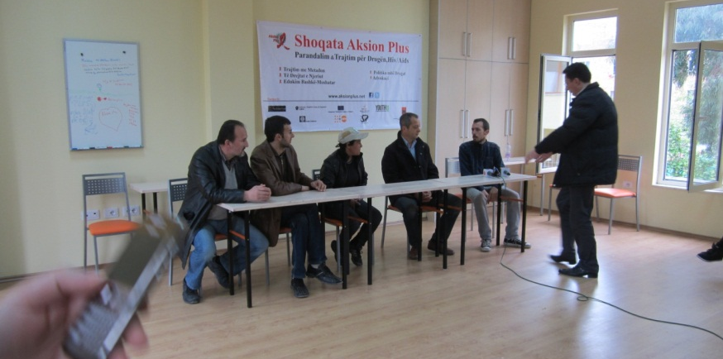
Last Friday 13 of April Aksion Plus invited 5 TV stations and three newspapers in a press conference at their centre along with 4 clients where they explained the situation. The press conference had generated a lot of publicity but Aksion Plus is concerned that this remains by words, while clients and parents want that the therapy goes on. Parents and clients fear and complain that they will be forced to go back to the state run facility on Addiction, but Aktion Plus ensured them that the treatment will be supported for two more years by the Global Fund to fight Aids, Tuberculosis and Malaria (GFATM) and there will be enough quantity of methadone for all of them, but the coming days will be difficult until methadone arrives.

