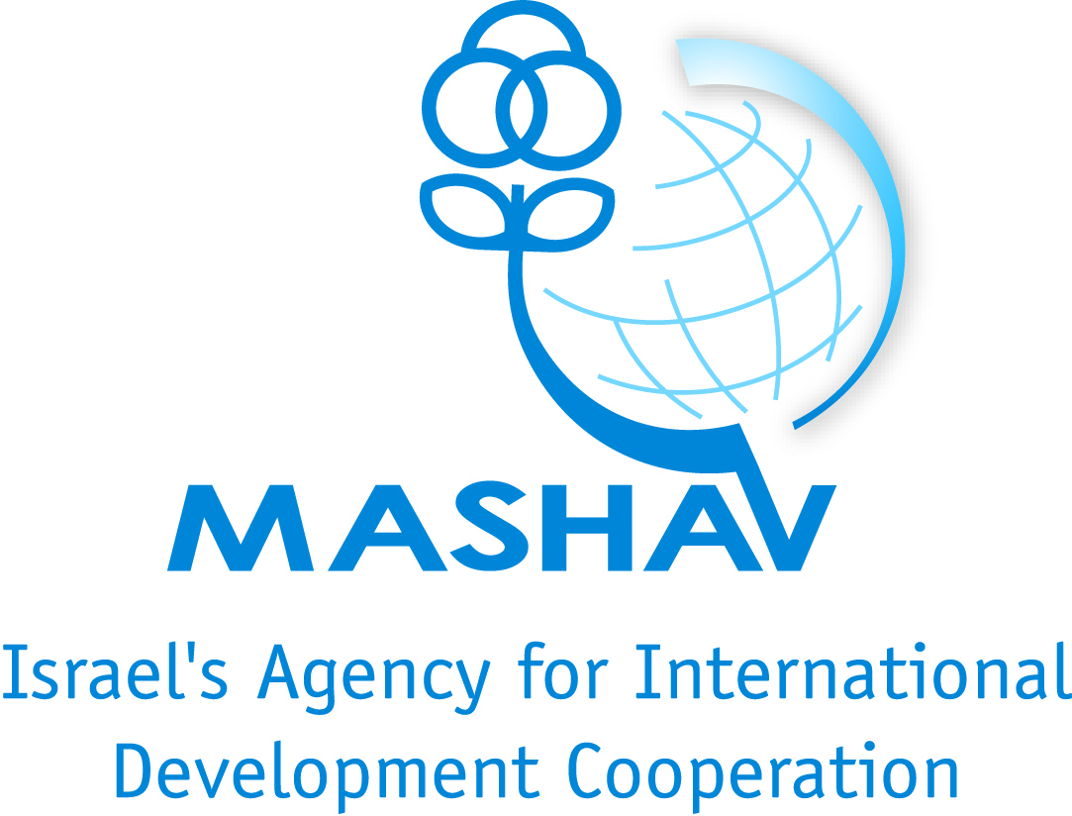
ISRAEL ANTI-DRUG AUTHORITY
THE OFRI INTERNATIONAL TRAINING CENTER

The Ofri International Training Center – MASHAV
The Israel-Anti Drug Authority

A comprehensive drug control strategy - Israel’s mode

25 June – 19 July 2012

Background

Drug abuse is a global problem. It destroys lives and communities and affects people world wide, in all countries. Drug abuse has devastating social and economic consequences for all members of the community and society. Over the years, it has become clear that the drug problem needs to be addressed both in terms of demand and supply reduction, interconnected issues which must be incorporated as part of an integral drug control strategy.
Governments are increasingly establishing integrated demand and supply reduction approaches and strategies, however, in many cases there is still a lack of coordination between relevant agencies.
Israel would like to share some of its experience in assisting other countries to incorporate demand reduction approaches into their national drug control strategies, while emphasizing the essential need for effective cooperation and coordination between the relevant government ministries and non-governmental entities involved in the battle against drugs.
Since 1988, Israel's drug control efforts have been coordinated by the Israel Anti- Drug Authority (IADA). IADA is a statutory corporation, established by virtue of the "Drug Control Authority Law, 5748-1988". Under IADA's umbrella, professionals in government and non-governmental agencies work together to rid Israel of the plague of drugs. This cooperation and coordination stretches across all areas of drug control, from prevention and treatment, to law enforcement. Key to Israel's drug control strategy is the issue of demand reduction, which is an integral aspect of the national strategy.
Demand reduction is addressed at all levels, with programs ranging from primary prevention programs at schools and at the communities and prevention programs for soldiers at the IDF to harm reduction programs aimed at drug abusers. Programs are based on the belief that different communities and subpopulations have different needs, and all programs are culture and gender sensitive. Israel's diverse population is composed in large by immigrants from all over the world. The various predominant religious and ethnic groups, as well as large immigrant populations from the former Soviet Union and Ethiopia in particular form a very heterogeneous population with vary different backgrounds, cultures and customs. Over the years, Israel has learned to appreciate this diversity and recognizes their individual needs. With this in mind, it has created culture sensitive programs, addressing the needs and characteristics of each group. Treatment and rehabilitation programs are offered to all those harmed by drugs, with the belief that each individual needs a different kind of treatment. Programs include drug substitution methods, detox. centers and residential treatment facilities, and are tailored specifically for all types of subpopulations, ranging from youth to drug abusers in the prison system.
Overall Goals

- To address the specific needs of the participating countries.
- To generate personal commitment among course participants to promote drug control efforts in their countries and communities based on the models developed in Israel.
- To encourage continuing and meaningful partnerships between Israel and the participating delegations, including assistance in the implementation of programs and strategies in their countries.
- To provide an exceptional platform for exchange of knowledge between participants based on their national experiences.

Aims of the Course

To offer participants an in depth overview of Israel's drug control strategy, based on the work done by the Israel Anti-Drug Authority as the principal coordinating body in the field.

To enable participants to learn more in depth about Israel's demand reduction strategy, an integral component of the national drug control strategy, by emphasizing all related issues: prevention, treatment and rehabilitation, community action and more.

To stress the importance of coordination between all agencies involved in the country's drug control strategy.

Course Content

The course will be conducted in the form of lectures and workshops, including group work, interactive teaching, role playing, and other participatory techniques.
Some of the topics which will be dealt with during the course:

- IADA's structure, goals and strategies
- Prevention programs, approaches, theories and policies
- Treatment and rehabilitation programs and policies
- Community development
- Surveys and evaluation methods
- Human resource training

A final and thorough syllabus will be presented later, after an assessment of the participating countries’ individual needs.

Important information for prospective candidates:

The language of instruction will be English.
A good command of spoken and written English is essential.

Duration & Location
25 June – 19 July, 2012.
The Aharon Ofri International Training Center at Ramat Rachel Hotel, located in the outskirts of Jerusalem.

Target Population
The course will be aimed at professional staff working in the field of drugs from developing countries around the world. Each country will send a team consisting of 3 professionals from each one of the following areas: prevention, treatment, law enforcement.

Professional Study Tours
Several professional visits will be organized throughout the workshop, such as: visits to rehabilitation centers; visits to prisons with treatment programs; participation in community work in different settlements.

Social Activities and Excursions
Excursions to the Holy Places as well to sites of general and historical interest will be organized. During the workshop social and cultural activities will also be arranged.

Certificate
A Certificate of Studies will be awarded to all the participants who have attended classes regularly and have fulfilled all of their obligations.

Scholarships
Full scholarships will be awarded to all participants including: full board accommodation, training, workshops, professional visits, social activities and excursions, transportation and health insurance (does not include dental care, glasses and chronic illnesses). Flight fares are not included.

Accommodation
The participants of the seminar will stay at Ramat Rachel Hotel, two participants in each room.

Passport and Visas
Make sure that your passport is valid for your stay in Israel. To obtain a visa, please contact Israeli authorities in your country.

Application forms and other information may be obtained at the nearest Israeli mission and at MASHAV's website: http://mashav.mfa.gov.il (in Contact Us → Information and Registration).
Application forms should be send to the relevant Israeli Mission and to the Ofri Center by or before 20.5.2012
Aharon Ofri International Training Center and Israel Anti-Drug Authority (IADA)
The belief that sharing knowledge and working together are essential elements in the global war against drugs has lead to the strategic partnership between the Israel Anti Drugs Authority and the Center for International Cooperation of the Israeli Ministry of Foreign Affairs. Both government entities bring to this partnership tremendous experience in the field of teaching and knowledge sharing.
The Ofri Center was established in 1989 as a core extension of MASHAV, the Center for International Cooperation of the Israeli Ministry of Foreign Affairs, in cooperation with the Ministry of Education. The Center's area of expertise is the transmission of knowledge about education, which is essential for the development of civil society.
Adopting the UN's development goals for the new millennium and the world agenda, the Ofri Center has made it its goal to contribute to the sustainable development of human resources internationally, based on knowledge and experience accumulated in Israel.
The Aharon Ofri International Training Center has organized courses and seminars in Israel and in many countries throughout the world, and during the past 18 years has trained more than 4000 alumni who have participated in 200 courses on diverse subjects related to education and community development.
IADA's vast experience in sharing and exchanging knowledge can be attributed to the developing and fostering of relations with countries all over the world. Over the years, IADA has hosted a number of foreign delegations from countries including Croatia, Singapore, Russia, Costa Rica and Romania, who come to Israel to learn about its drug control efforts. Regional cooperation has also been on the rise, and with the assistance of the UNODC's Regional Office in Cairo, IADA has built up its relations with the Palestinian Authority, hosting workshops and study tours. Remarkable efforts have also been made by Jordan and Israel to work together.

For more information:
Yudith Rosenthal, Director
The A.Ofri International Training Center
Mashav-Ministry of Foreign Affairs, Israel
Ramat Rachel, D.N Tsefon Yehuda 90900
Tel: 972-2-6702539/08
Fax: 972-2-6702538
Email: yudith@ofri.org.il

A brief summary of the international workshop in 2009:

The first international workshop on "Enhancing Cooperation as Part of an Effective Demand Reduction Strategy based on the Israel Anti-Drug Authority’s Model" took place in the end of 2009, with 23 participants from the following countries:
Argentina, Bolivia, Brazil, China, Georgia, India, Kenya, Mexico, Nepal, Nigeria, Sri Lanka
Ukraine, Venezuela, Zimbabwe.

The 2009 course syllabus included:

- Treatment and Rehabilitation
- Educational Drug Prevention Programs
- The Problem of Drug and Alcohol among Addicted Immigrants
- Crime among Youth in Israel
- “Where Different Cultures Meet” – Dilemmas and Working Tools
- The Ministry of Health – Policy and services
- Police Enforcement of the Law against Drug Abuse
- General Law Enforcement
- Tax Enforcement within National Anti Drug Activities
- Pharmaceutical Crime Unit’s Projects
- Community Development at the National and Local Levels
- Dealing with Parents’ Alcoholism
- The Importance of Research Findings for Drug Policy

Mr. Mohamed Abdul-Aziz -Regional Representative in the Middle East and North Africa, UNODC, commended Israel’s efforts regarding this event and presented a keynote lecture during the course.

Some of the comments expressed by participants:
“My country is very poor regarding the support of the government in prevention and treatment; the course gave new ideas and motivation to create something new”
“… is the amazing cooperation between the ministries institutions and NGO’s ;what you had reach , that is what I am taking with me and hope that in the future we will be able to apply it step by step in my country”
“the addicts are human that is what I learnt here” …: the human side of life skills given to the patient”… “Even the legal aspects are so humanitarian…”
“Actually “wow “…from kindergartens…Congratulations to the Israeli educational system”
“…the IADA model practical aspects, especially the way they cover the different populations in the country, the mobile treatment and prevention aspects and even the movie are very good ideas that I am taking to my country “

